Data Intake Report

Name: Predict iris species

Report date: 30/Jun/2022

Internship Batch: LISUM10: 30

Version:<1.0>

Data intake by: Moath Bin Musallam

Data intake reviewer:

Data storage location: local storage

Tabular data details:

|  |  |
| --- | --- |
| Total number of observations | 150 |
| Total number of files | 1 |
| Total number of features | 5 |
| Base format of the file | .csv |
| Size of the data | 4,49 KB |

Machine learning model:

Using knn because it is better model.

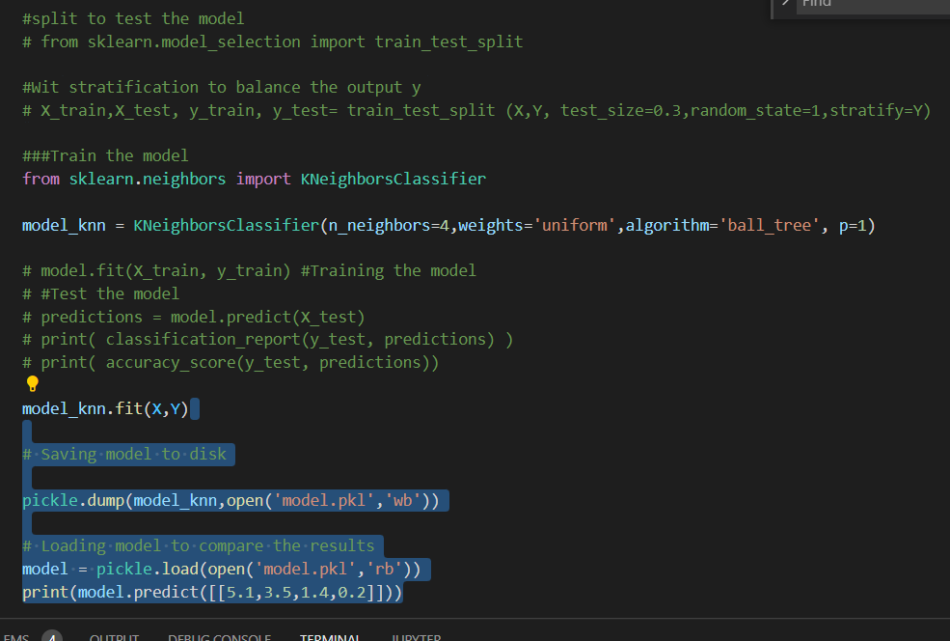

Flask app:

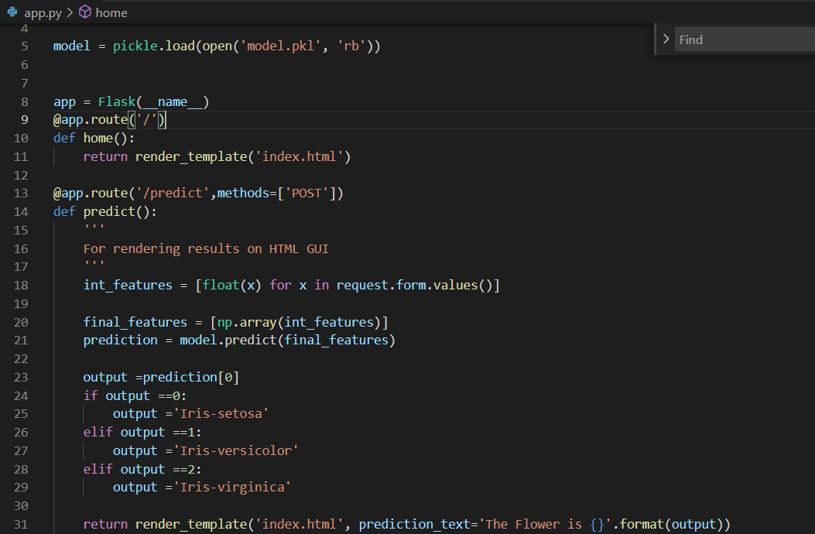

HTML:

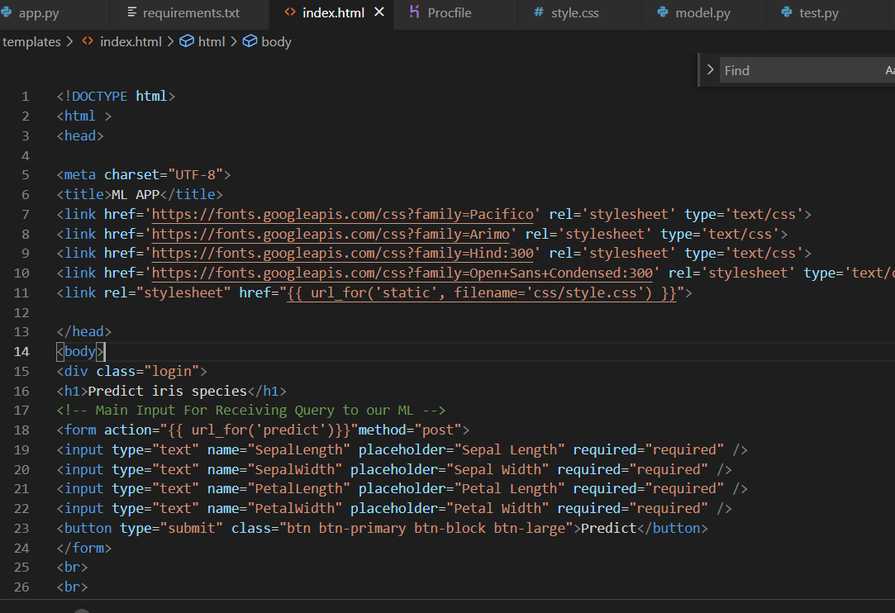

final product:

after deploying the project to Heroku

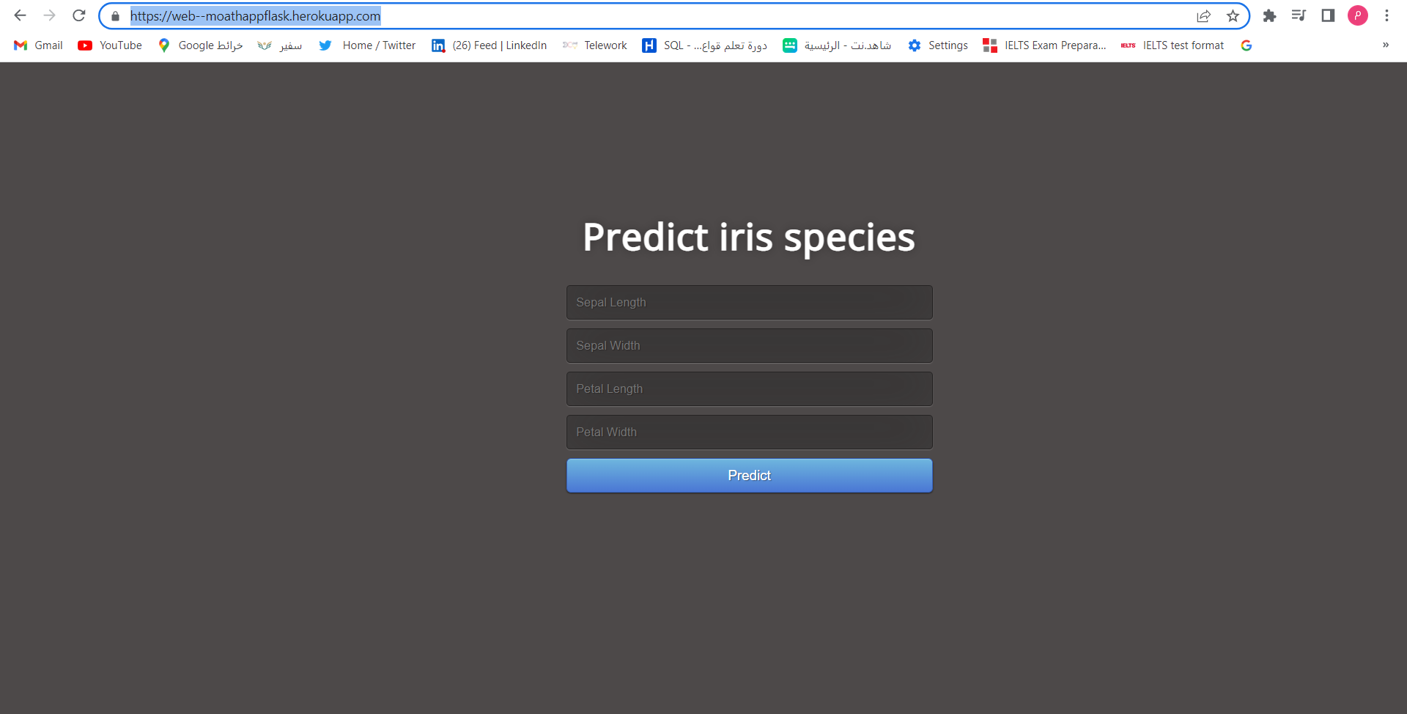

Create API method

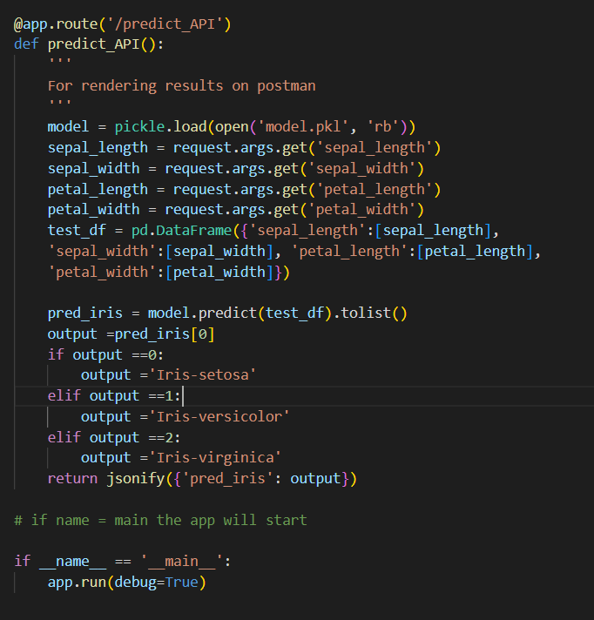

Try the API method with Postman, and its work.

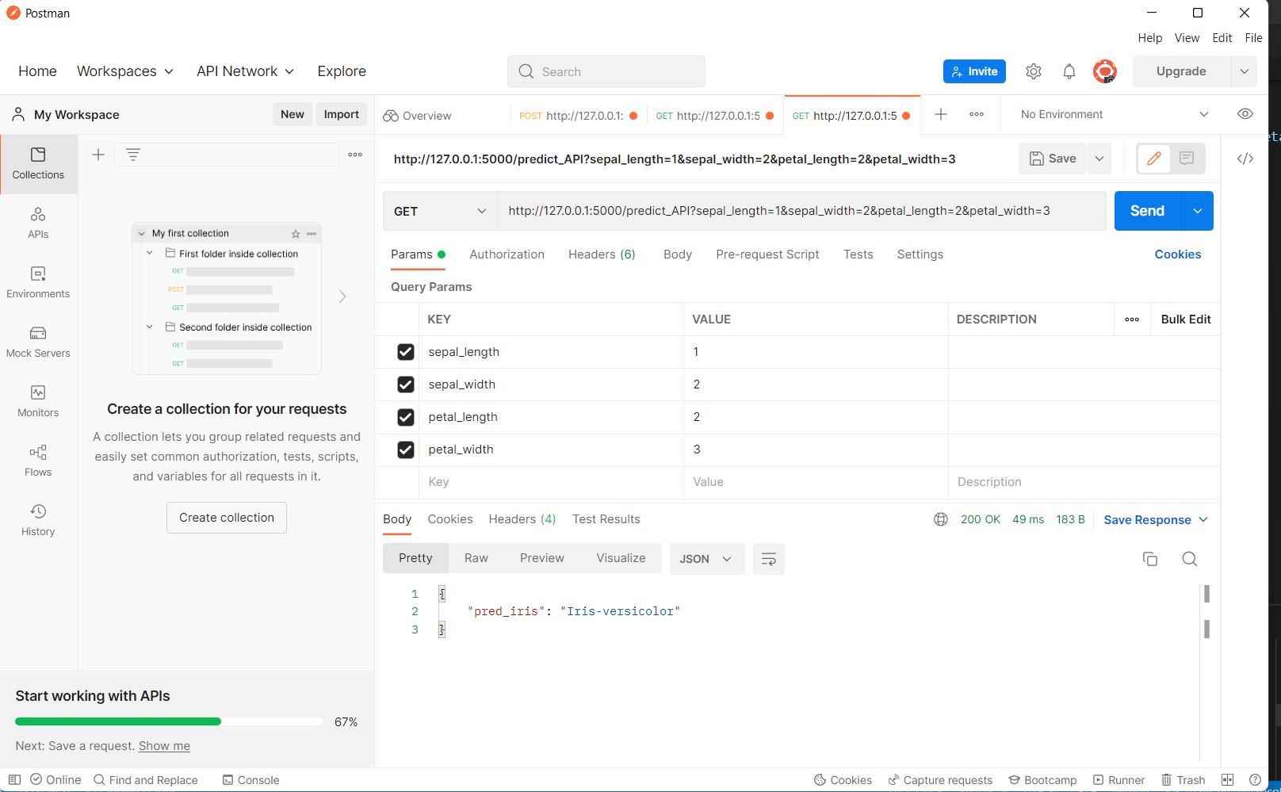

Create new project in Heroku called iris-predict-web-app:

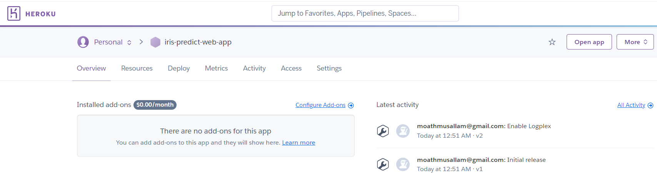

Deploy from GitHub:

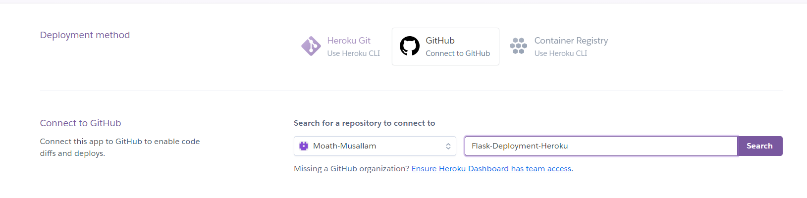

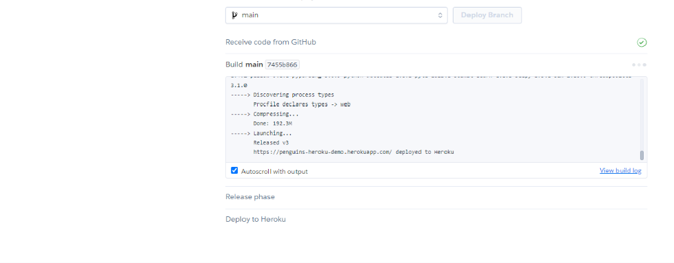

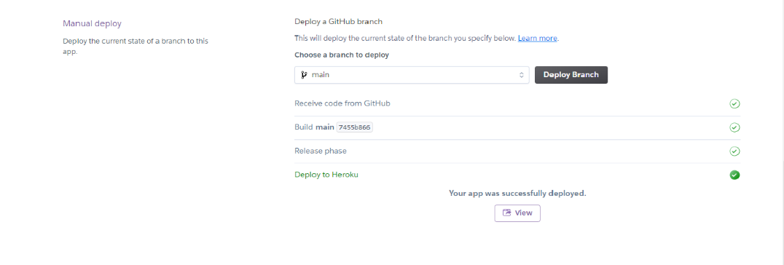

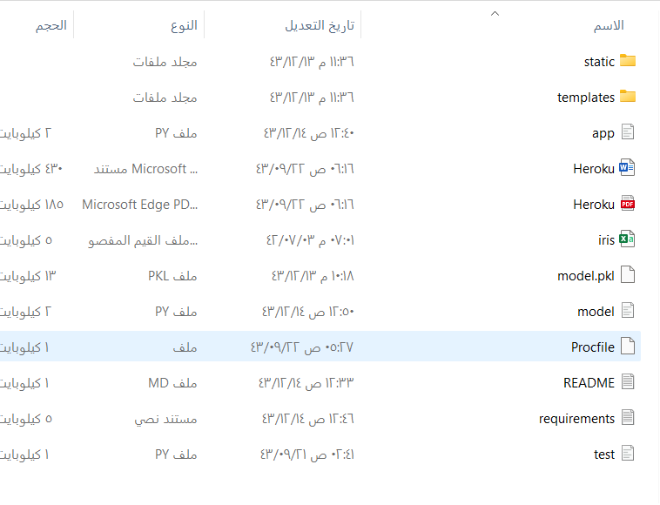project file: