Data Intake Report

Name: Predict iris species

Report date: 23/Feb/2022

Internship Batch: LISUM06

Version:<1.0>

Data intake by: Moath Bin Musallam

Data intake reviewer:

Data storage location: local storage

**Tabular data details:**

|  |  |
| --- | --- |
| **Total number of observations** | 150 |
| **Total number of files** | 1 |
| **Total number of features** | 5 |
| **Base format of the file** | .csv |
| **Size of the data** | 4,49 KB |

**Machine learning model:**

**Using knn because it is better model.**

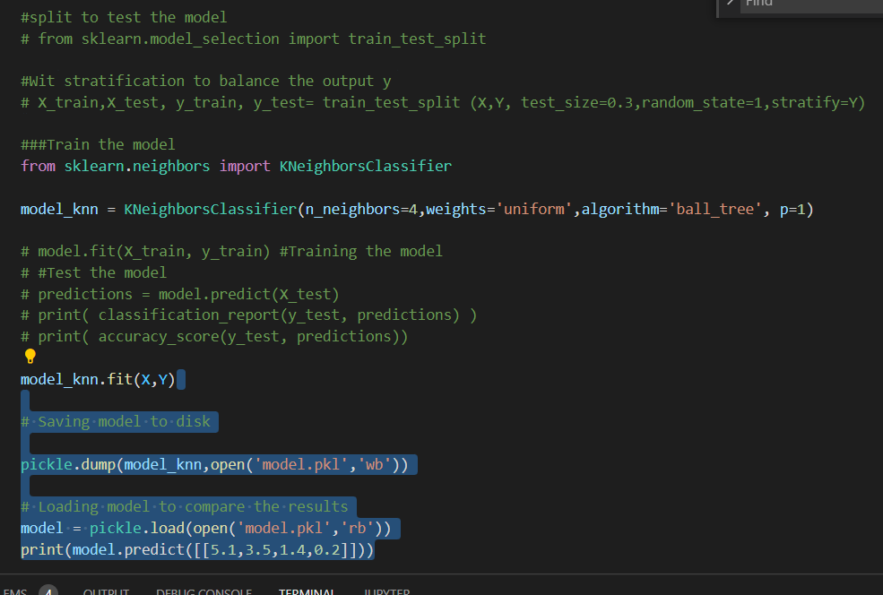

**Flask app:**

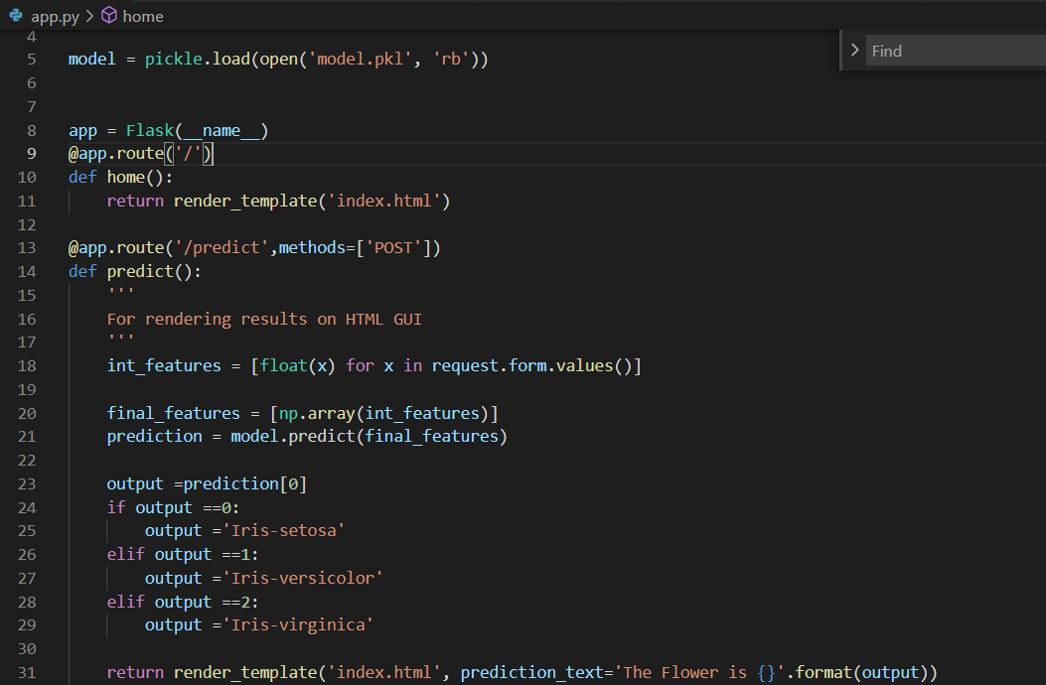

**HTML:**

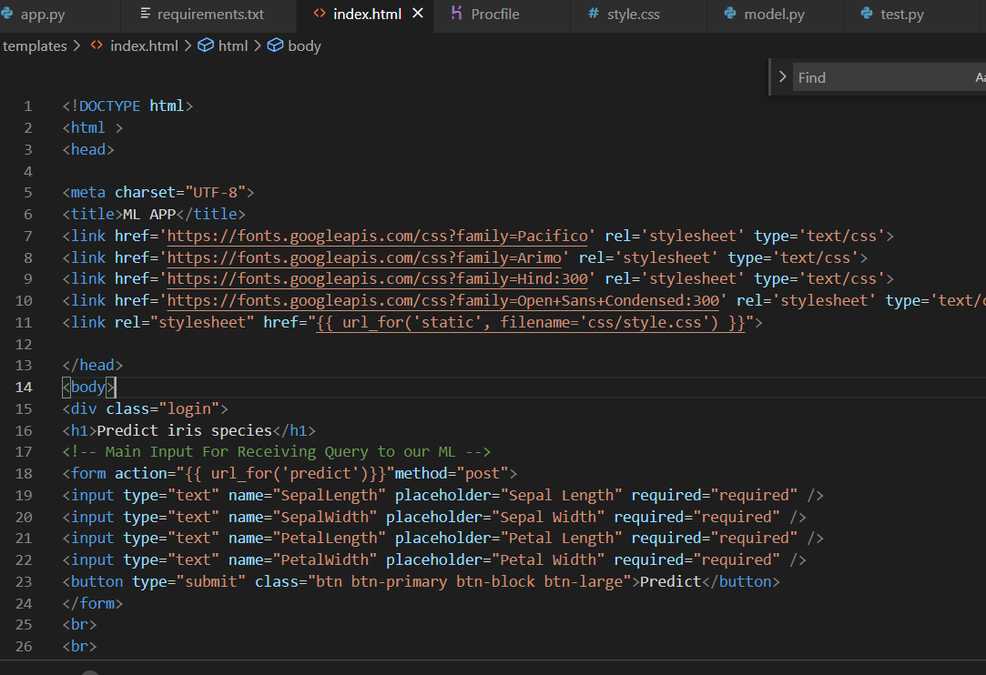

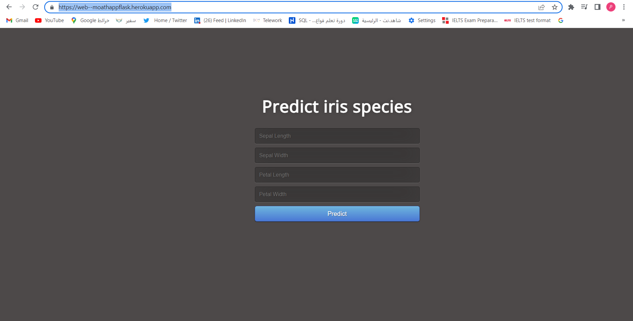**final product:**

**after deploy the project to Heroku**