SEDCO

User Manual

# This manual contains

1. Introduction to Bank Configuration Web Portal.
2. Requirements.
3. Instructions to create/upgrade the database.
4. Instruction to configure Bank Configuration Web Portal.
5. Information about the Bank Configuration Web Portal, what Bank Configuration Web Portal does, how it works, and how to use it.

**January/2021**

**Version 1.0**

Introduction

Bank Configuration Web Portal is a web application that allow users to add configuration to the bank.

The web application is allows user to login to an existing bank, add branches to the bank, define services on that bank and define the counters that will serve in the branch and what services those counters will provide.

# Web application Features

1. User Login:

* User login to an existing bank which was created before.

1. Branches:

* Create a new branch.
* Edit an existing branch.
* Delete an existing branch.

1. Services:

* Create a new service.
* Edit an existing service.
* Delete an existing service.

1. Counters:

* Create a new counter.
* Edit an existing counter.
* Delete an existing counter.
* Support two type of buttons (Teller, Customer Service).

1. Allocate services to counter:

* Allocate specific services for specific counter.
* Delete an existing service from counter.

# Requirement

1. Computer device (pc or laptop) which running “windows”.

* Microsoft SQL Server Express (2012 or higher).
* Connection to internet.

1. Microsoft SQL server management studio on any machine that has access on Customer’s machine.

* You need to download it, because the data will be saved into the database.

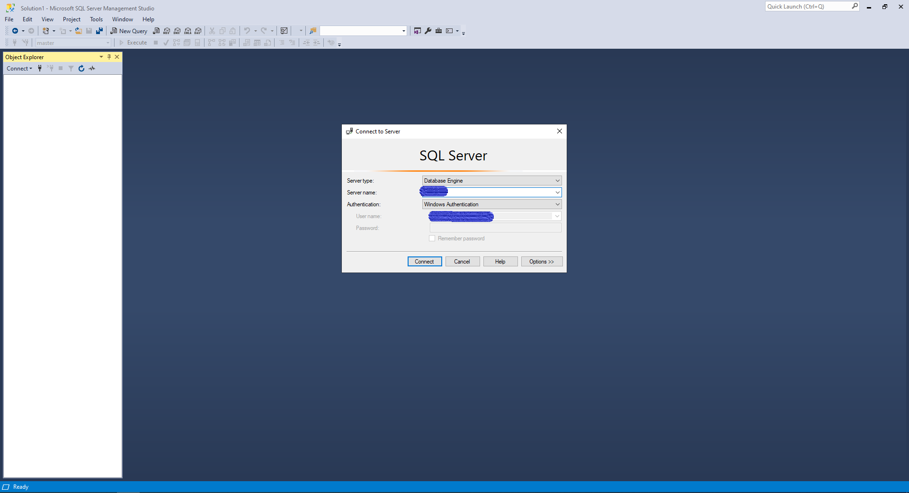

1. IIS – Internet Information Services.

* You need it to publish the web application through it.

1. Modern web browser like (*chrome, edge*).

# Deployment

Deployment Folder: You will get folder that contains the web application folder and the scripts for the database.



### Database:

#### Upgrade Database

* Open the folder that called “Resource”,

You will find scripts and the user manual as shown below:

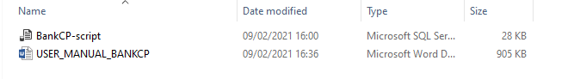

1. Open the script that called “BankCP-script”, and then execute the script.

#### Add banks to DB

* + If you are new to this web application or database doesn’t have bank created before, you *need to add bank to the table (tblBanks):*
  + Right click to tblBanks and click on (Edit Top 200 Rows):
  + Fill data for bank (name).  
    Capture2

#### Add Users to Banks to DB

1. Right click to tblUsers and click on (Edit Top 200 Rows):  
   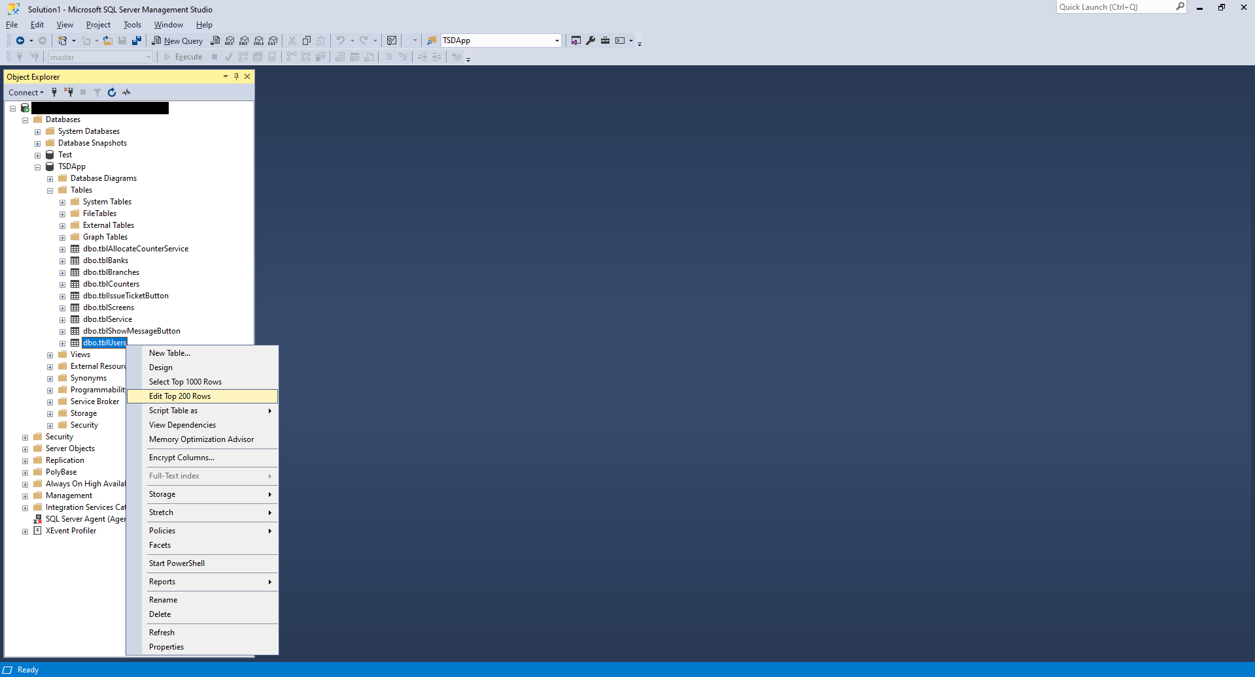
2. Fill data for user (User-Name, Password, BankId: get the id to the bank that you already have in database).

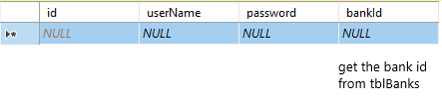

# Configuration

### Set up DB connection string

1. First you need to open the folder called BankCP”.

C:\Users\Moayad\AppData\Local\Microsoft\Windows\INetCache\Content.Word\Capture.PNG

You will find these folders and files

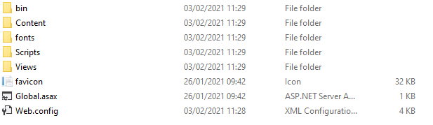

1. Now we are going to update the “Web.config”, you need to set up your own connection string to database.
2. Open the file called “Web.config” with notepad,

Find the tag that is called “connectionStrings” and put your own data (Data Source, Initial Catalog (DB name), Username and Password) in it as it shown below:

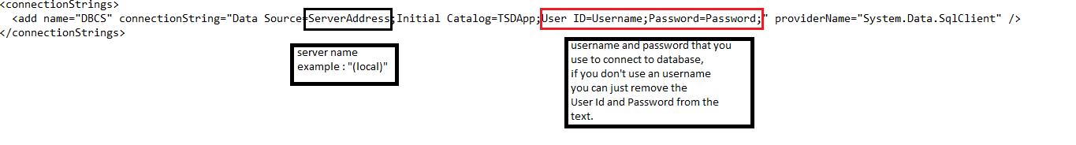

Fields to change:

1. Server Address: set your server name
2. Initial Catalog
3. Username: use your username that you use to login into SQL server management studio program.
4. Password: use your password that you use to login into SQL server management studio program.

Note: if you don’t use username and password to login remove the section within the red rectangle in the picture above.

### Host web application under IIS

1. First you need to open IIS (Internet Information Services):

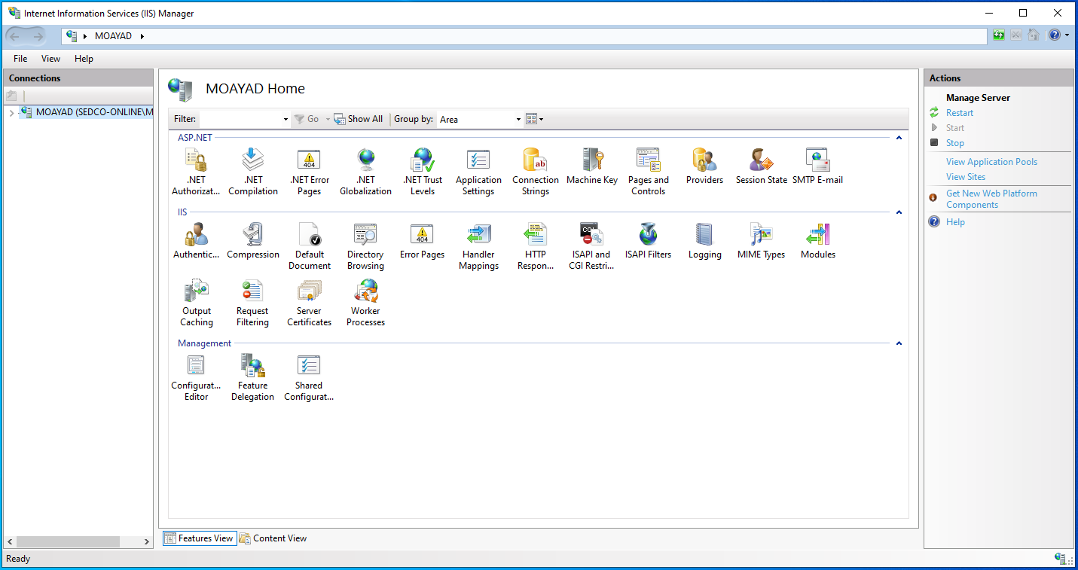

1. Right click on Sites and click on (Add Website…):  
     
     
     
   * you will see this below window

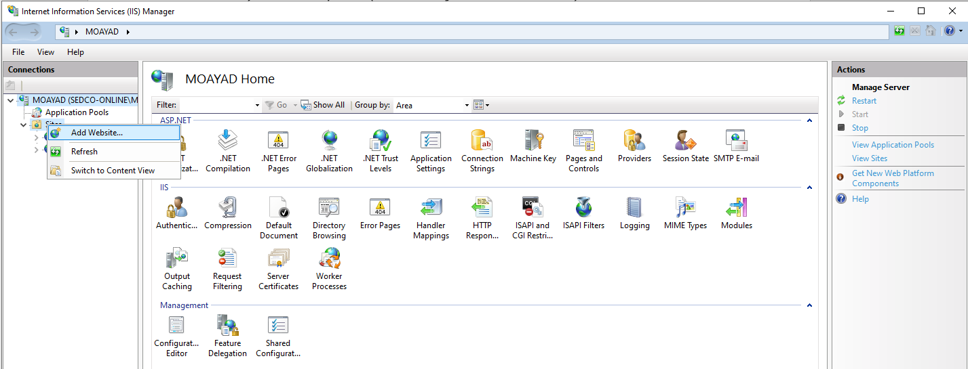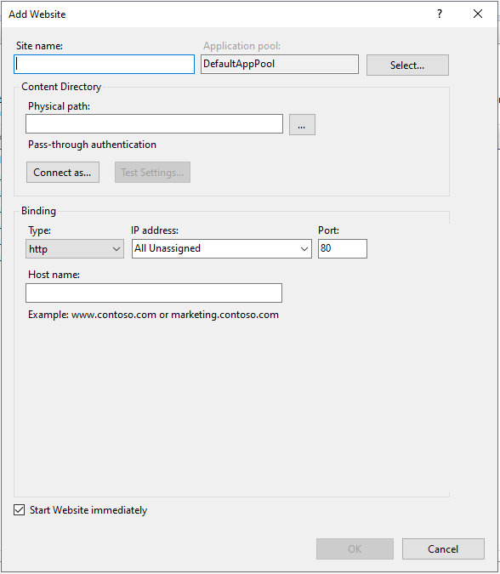

1. You need to fill data as explain below:
   1. Site name: the name of the web application could be any name, in this manual we used (BankCP).
   2. Physical path: choose the path inside the folder that called “BankCP”.
   3. Port: set up port number that is not used in any other website on your device, in this manual we used (1010).
   4. Click on (OK) to add the site.

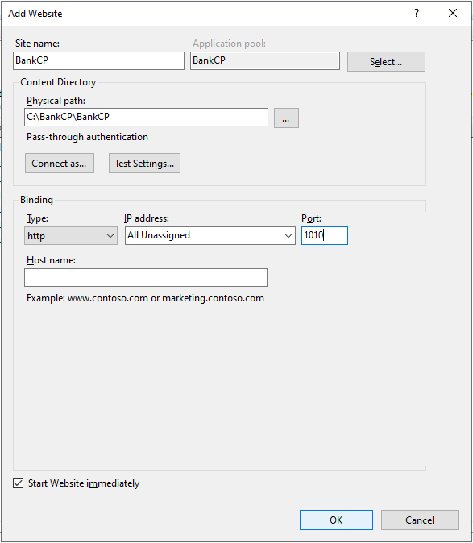

1. You will see the site you added in the left menu in the IIS home page:

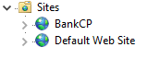

1. If you have to log in into your windows you need to do (step 6), else just ignore this step.
2. Now we must update the application pool for the web application that we host:
   1. Choose Application Pools from the left menu:  
      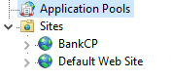  
       you will see this below screen

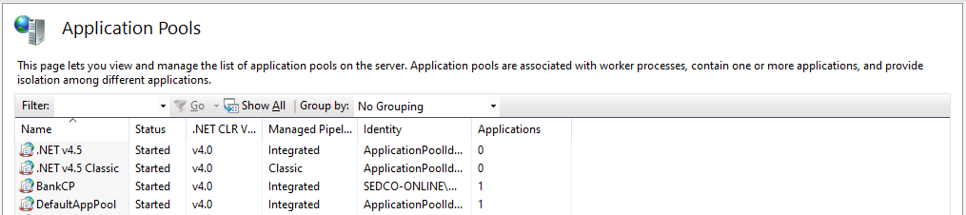

* 1. You will see application pool with the same name that you assign to the web application before, here was (BankCP).
  2. Right-click on the application pool and click on the (Advanced Settings…),  
     you will see this below screen:

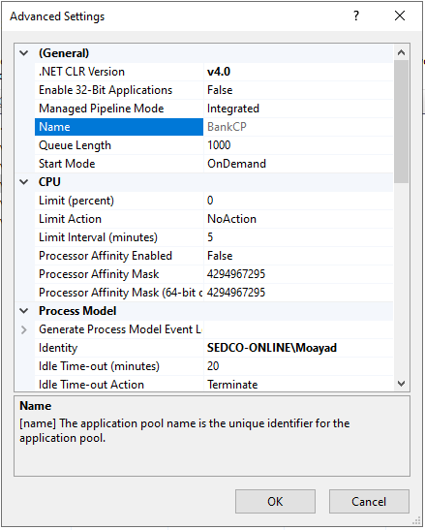

* 1. Now you need to change the Identity and set your username and password that you use to login to your device.

# User Interface

To open the web application you can open any modern browser as (Edge, Chrome), then go to link as “localhost: Port”, you need to change “Port” with the port that you setup to the hosted website, in this manual we did use “1010” as a port so the link will be “localhost:1010”.

## Login page

This page will display

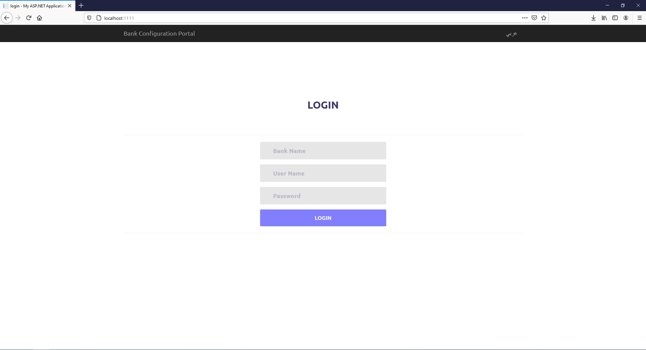

In this page you can:

1. *Login to bank by entering bank name and username and password for a bank user.*
2. *Change language from English to Arabic and vice versa.*

## Branches Page

### Branches home

After entering the bank name, username and password it will redirect you to branches page as shown below:

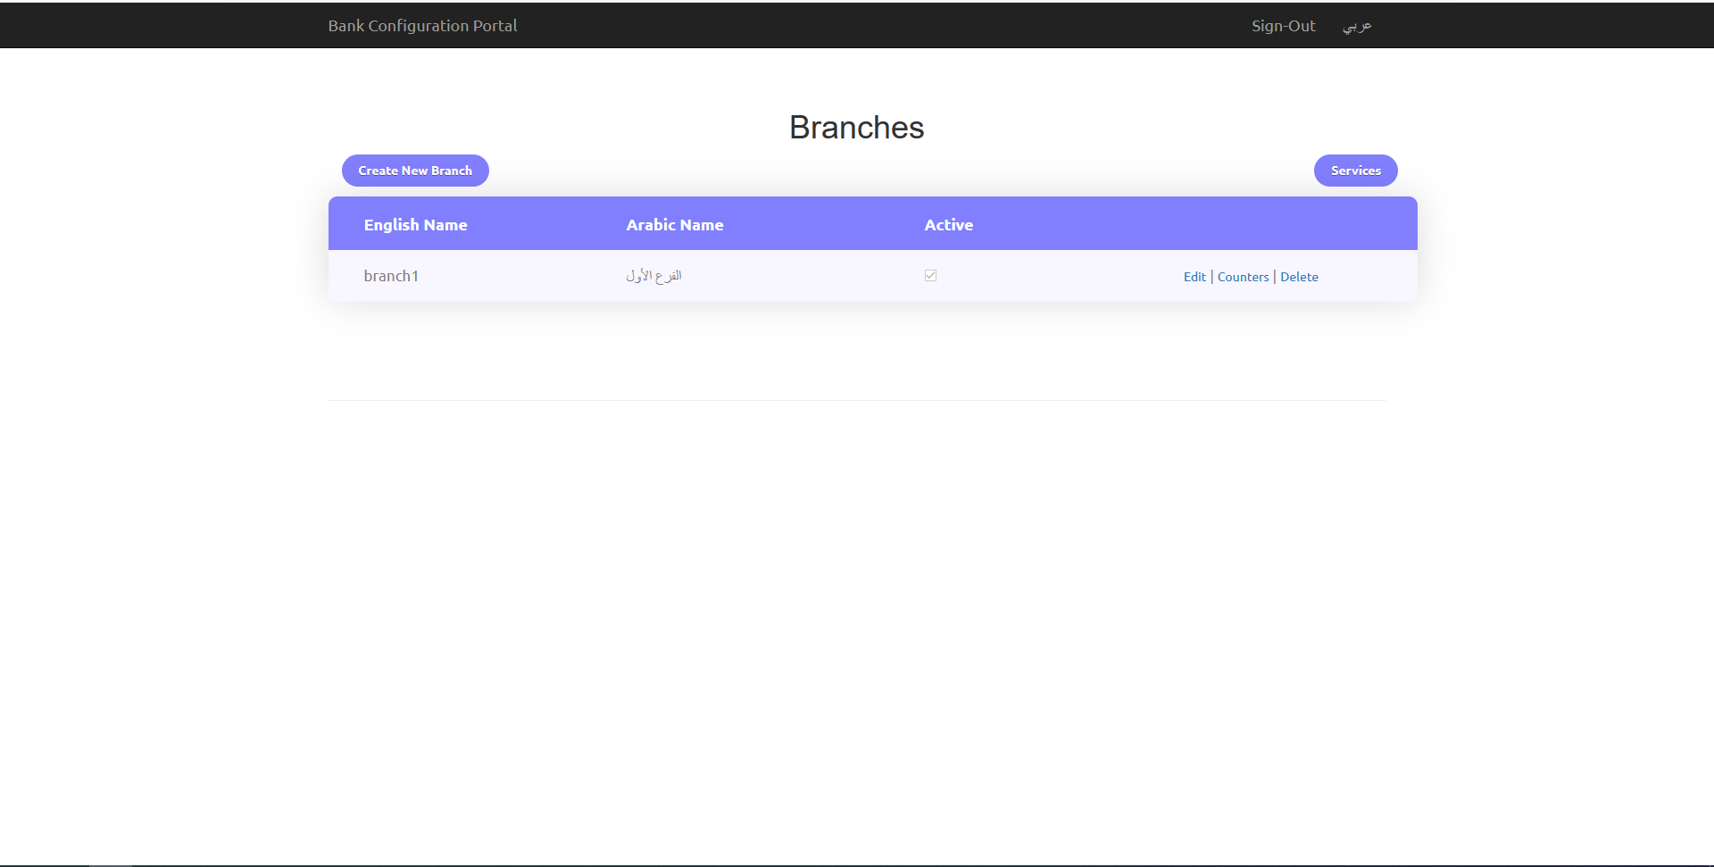

In this page you can:

1. See a list of branches for the current bank.
2. Add new branch by clicking on (Create New Branch) button.
3. Edit existing branch by clicking on (Edit) link-button.
4. Delete existing branch by clicking on (Delete) link-button.
5. Add counters to existing branch by clicking on (Counters) link-button.
6. Add services for the current bank by clicking on (Services) button.

### Create branch page

After click on (create new branch) link-button it will redirect you to add branch page as shown below:

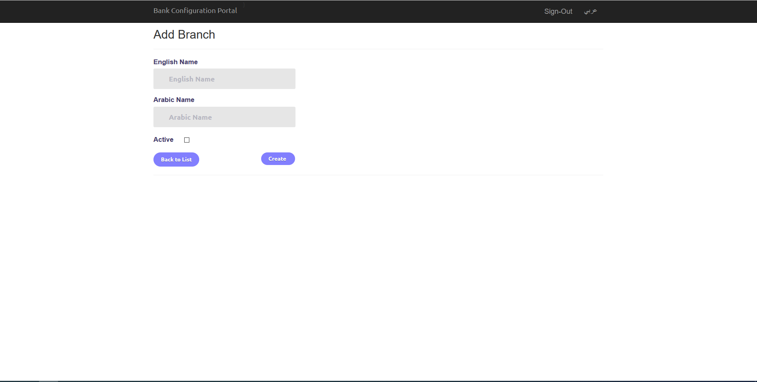

In this page you can:

1. Add branch: fill (English name, Arabic name, Active) and click on (Create) button to add new branch.
2. Go back to branches page by clicking on (Back to List) button.

### Edit branch page

After click on (Edit) link-button it will redirect you to edit branch page as shown below:

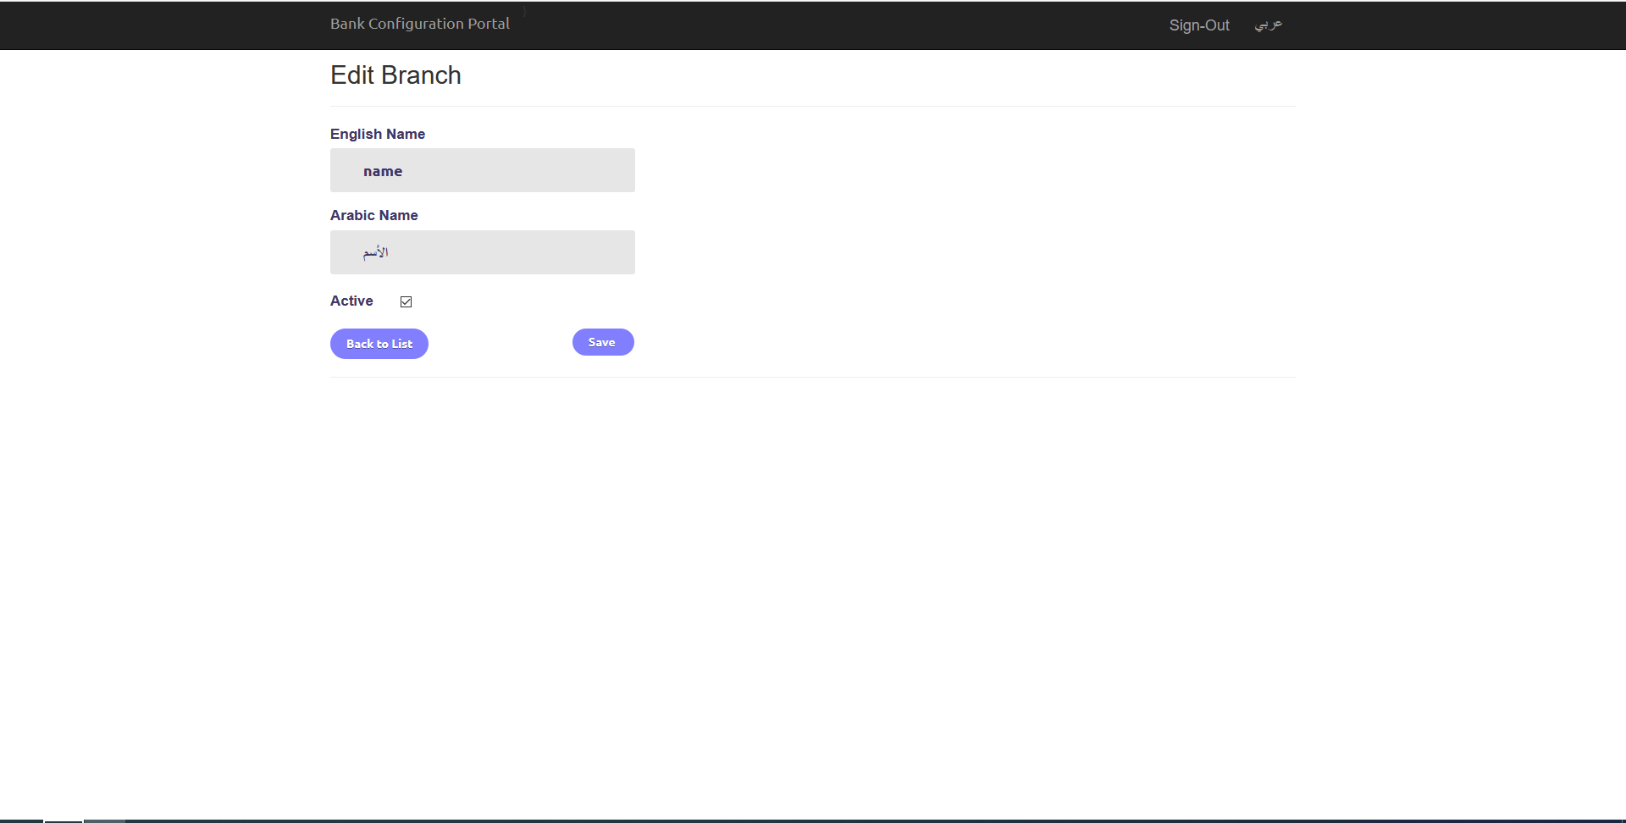

In this page you can:

1. Edit branch: fill (English name, Arabic name, Active) and click on (Save) button to edit selected branch.
2. Go back to branches page by clicking on (Back to List) button.

## Services Page

### Services home

After you clicking on (Services) button-link it will redirect you to services page as shown below:

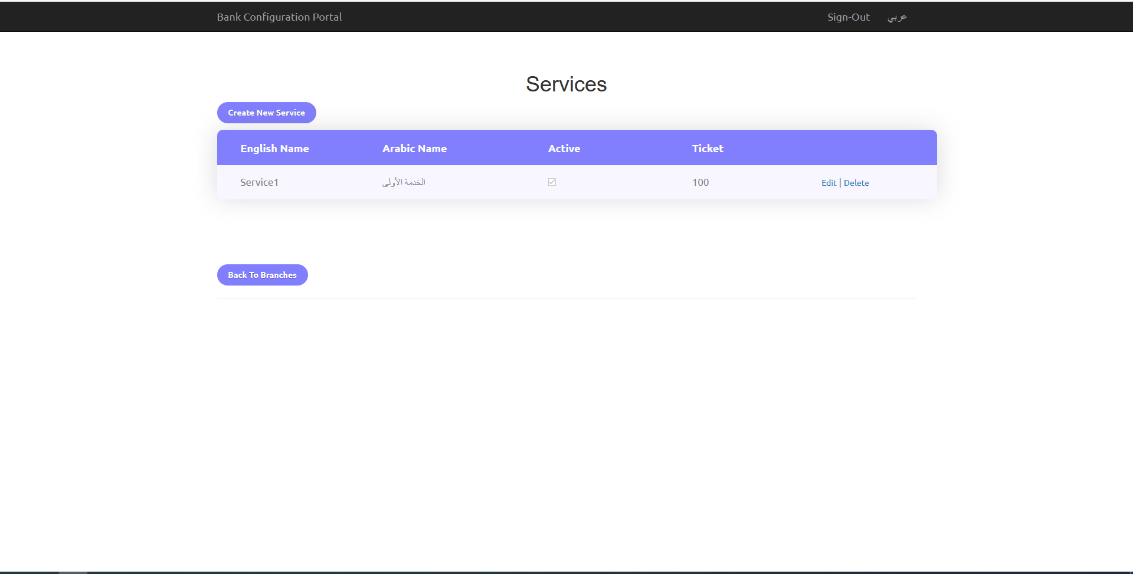

In this page you can:

1. See a list services defined for the current bank.
2. Add new service by clicking on (Create New Service) button.
3. Edit existing service by clicking on (Edit) link-button.
4. Delete existing service by clicking on (Delete) link-button.
5. Go back to branch page by clicking on (Back to Branches) button.

### Add service page

After click on (create new service) link-button it will redirect you to add service page as shown below:

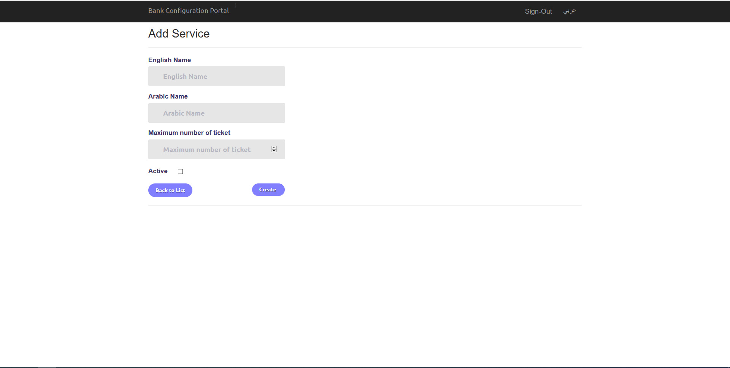

In this page you can:

1. Add service: fill (English name, Arabic name, Maximum number of ticket, Active) and click on (Create) button to add new service.
2. Go back to services page by clicking on (Back to List) button.

### Edit service page

After click on (Edit) link-button it will redirect you to edit service page as shown below:

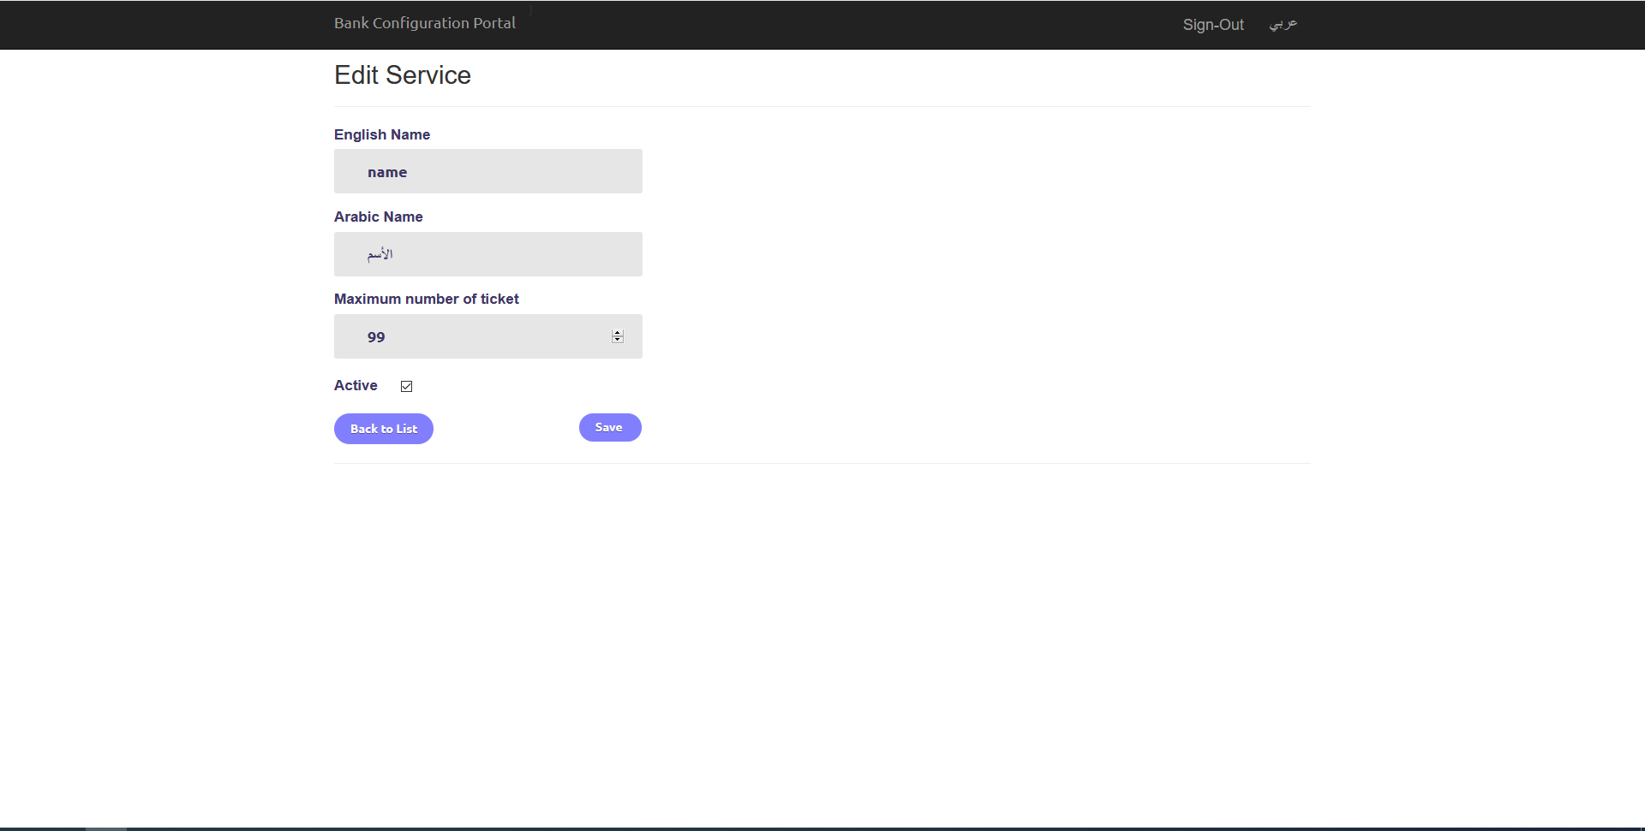

In this page you can:

1. Edit service: fill (English name, Arabic name, Maximum number of ticket, Active) and click on (Save) button to edit selected service.
2. Go back to services page by clicking on (Back to List) button.

## Counters Page

### Counters home

After you clicking on (Counters) button-link for existing branch it will redirect you to counters page as shown below:

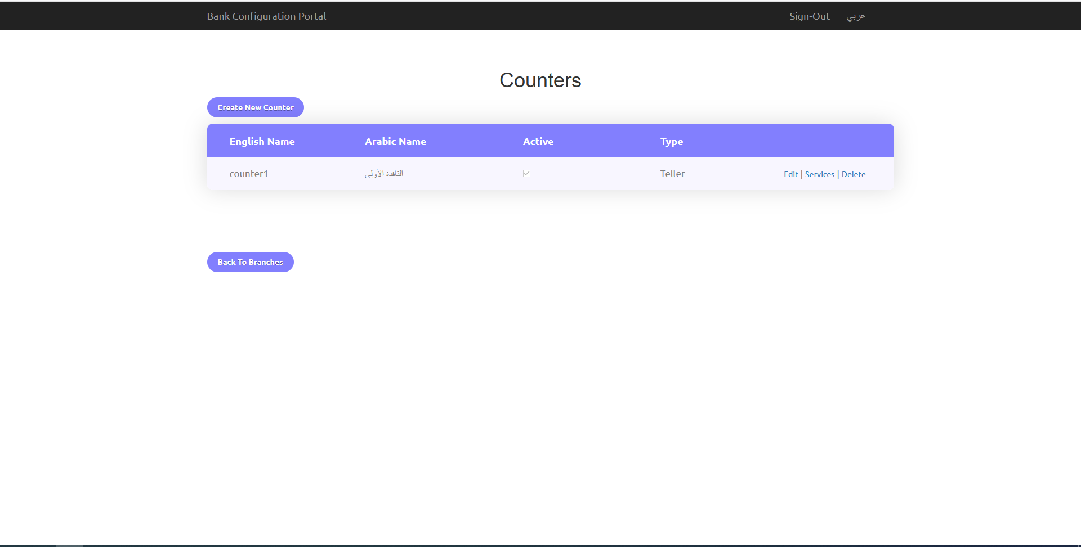

In this page you can:

1. See a list counters defined for the selected branch.
2. Add new counter by clicking on (Create New Counter) button.
3. Edit existing counter by clicking on (Edit) link-button.
4. Delete existing counter by clicking on (Delete) link-button.
5. Allocate services to counter by clicking on (Services) link-button.
6. Go back to branches page by clicking on (Back to Branches) button.

### Add counter page

After click on (create new counter) link-button it will redirect you to add counter page as shown below:

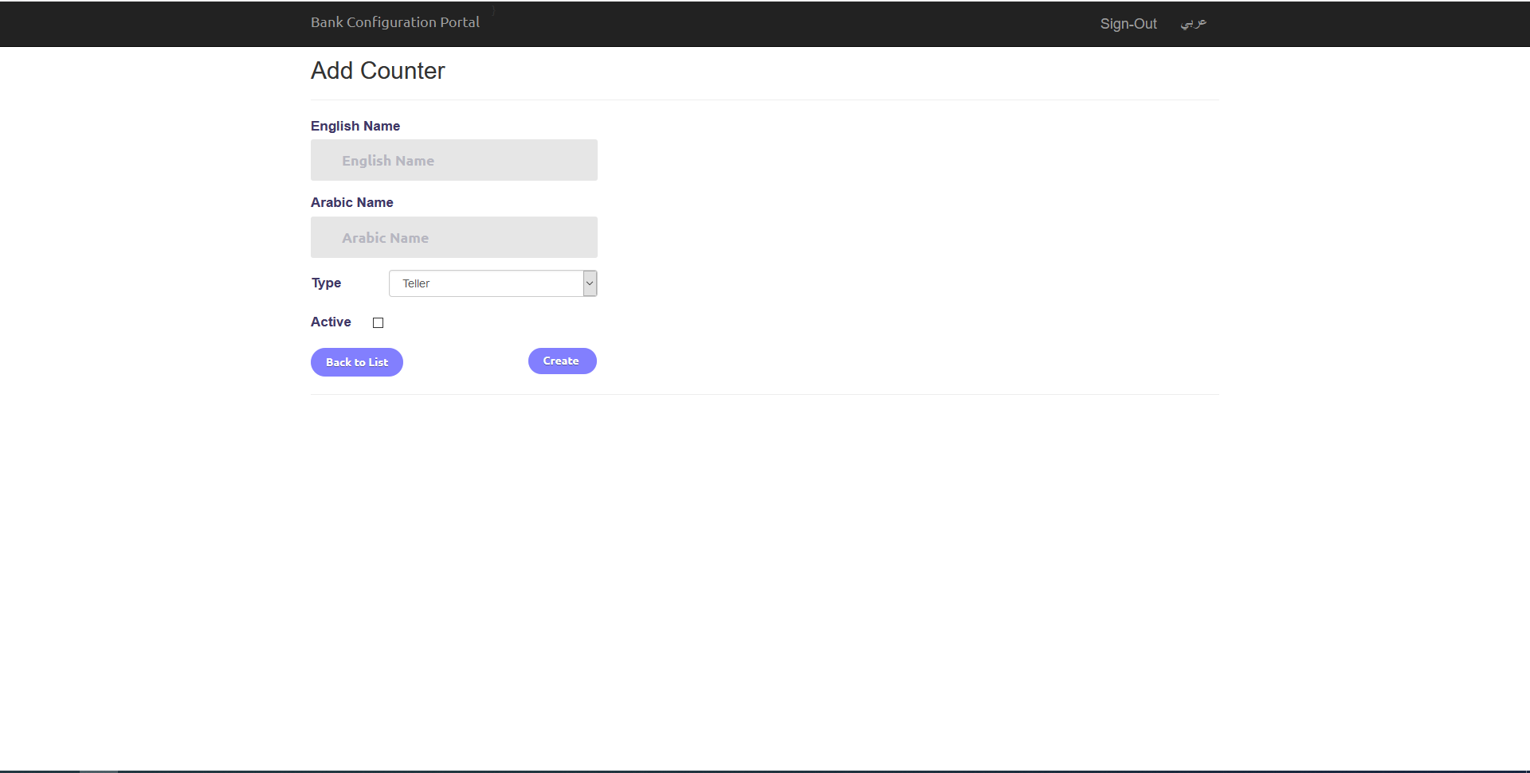

In this page you can:

1. Add counter: fill (English name, Arabic name, Type, Active) and click on (Create) button to add new counter.
2. Go back to counters page by clicking on (Back to List) button.

### Edit counter page

After click on (Edit) link-button it will redirect you to edit counter page as shown below:

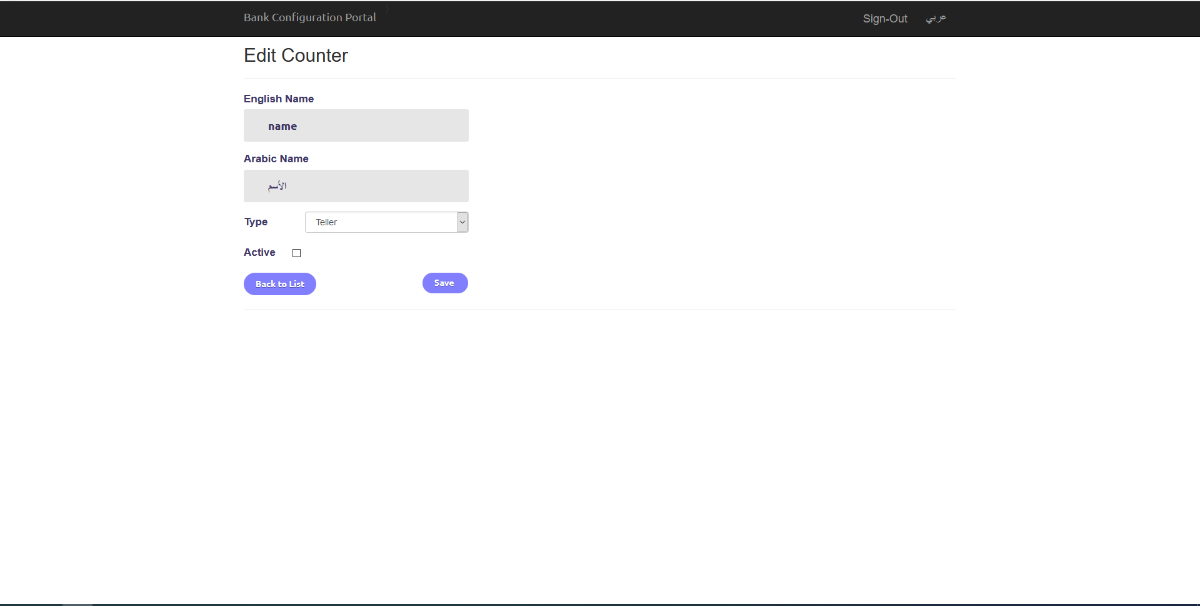

In this page you can:

1. Edit counter: fill (English name, Arabic name, Type, Active) and click on (Save) button to edit selected counter.
2. Go back to counters page by clicking on (Back to List) button.

## Allocate Services to Counter Page

After you click on (Services) button-link for existing counter it will redirect you to allocate services to counter page as shown below:

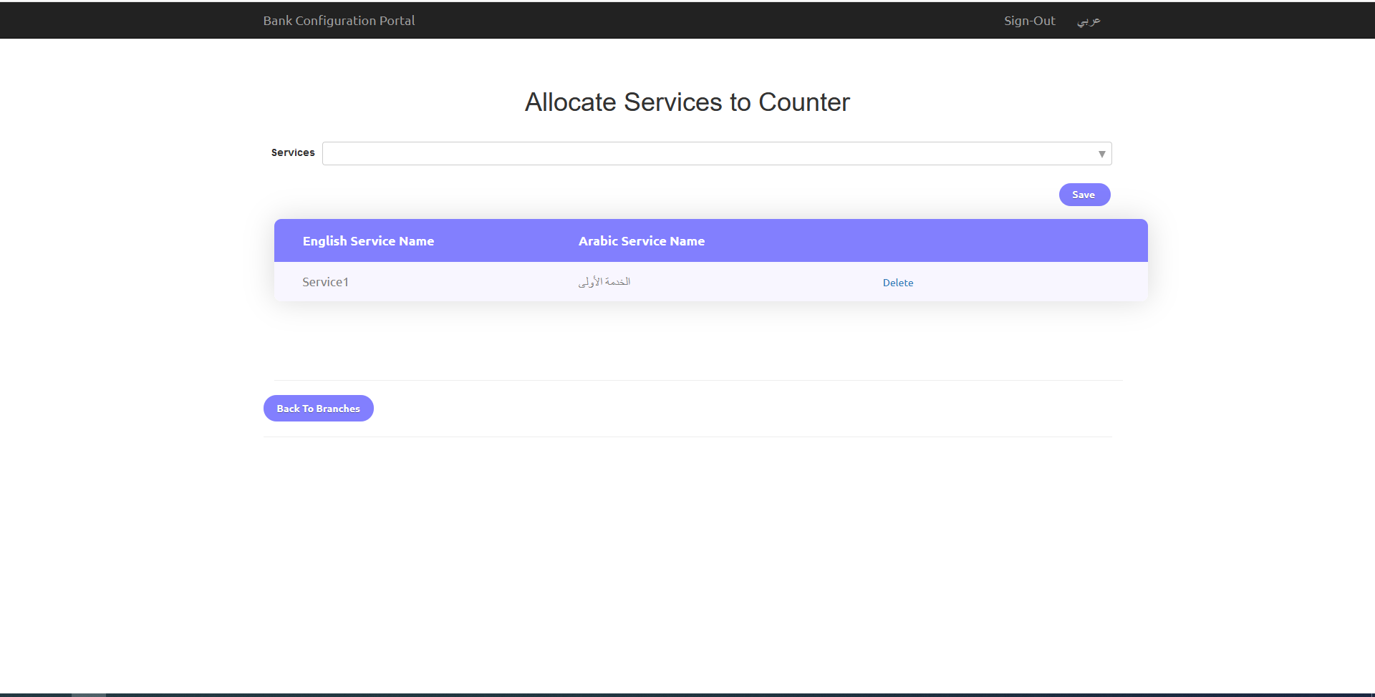

In this page you can:

1. See services that allocated to selected counter.
2. Allocate services to selected counter:
   1. Select services that you want to allocated them to selected counter  
      (multi-selection).
   2. Click on (Save) button to allocated selected services to the counter.
3. Go to branches page by clicking on (Back To Branches) button.
4. You can delete allocated service by clicking on (Delete) link-button.

## General Features

1. You can sign-out from any page if you where logged-in.
2. You can change web application language from English to Arabic and vice versa from any page in the site.
3. You can go back to branch page which it the main page by clicking on the name of the site  
   in the header.

# Warnings

## Warning that maybe occurred

* If this warning shows up you must check your connection to database is right.

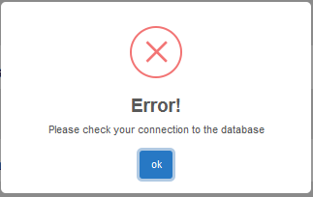

* If this warning shows up you must check your username, password and bank name is right.

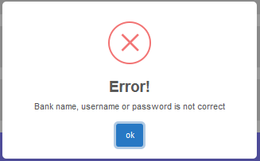

* If this warning shows up you are not authorized to access this item.

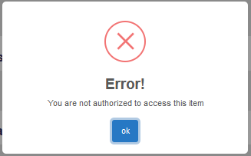

* If this warning shows up when you are trying to delete item that someone already delete it.

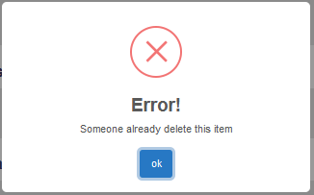

* *Missing page and server errors*

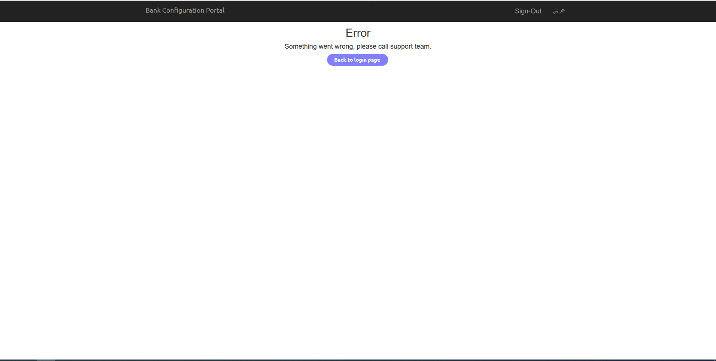

Bank Configuration Portal manual

Created by: Moayad Raddad