SEDCO

Document

## This document contains

1. Introduction.
2. WCF.
3. How to use these WCF.

## Introduction

Those APIs will be used in a “Ticketing Application” that will show the buttons configured in the screen design to allow customers of the bank to click on those buttons and either issue a ticket or see a message based on the screen design configuration.

## APIs

1. Retrieve the “Active” Ticketing Screen Design configured for a branch in a bank.
2. Retrieve issue ticket buttons and show message buttons related to the “Active” Ticketing Screen Design configured for a branch in a bank.

## Tester Application

### WCF Bank Services Tester

This Application will be used to test the WCF services, The Application have two main tabs:

1. Screen tab: which will retrieve the active ticketing screen design configured for a branch in a bank:

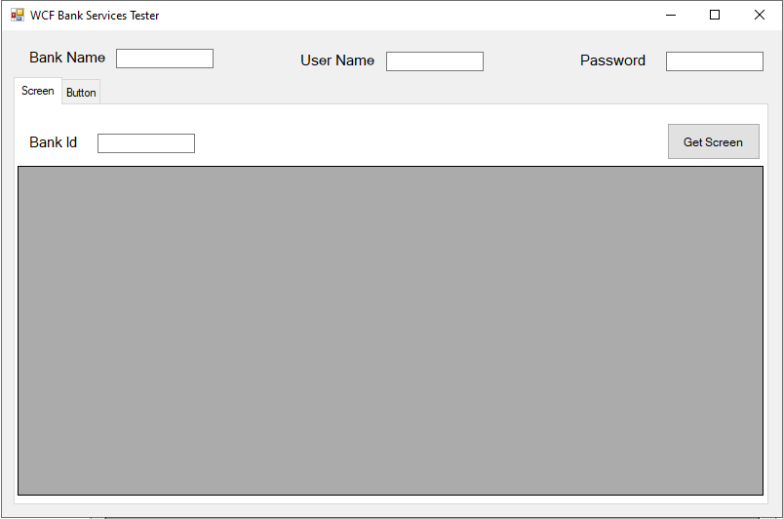

* 1. Fill (Bank Name, User Name, Password and Bank Id).
  2. Click on “Get Screen” button to get the active screen.

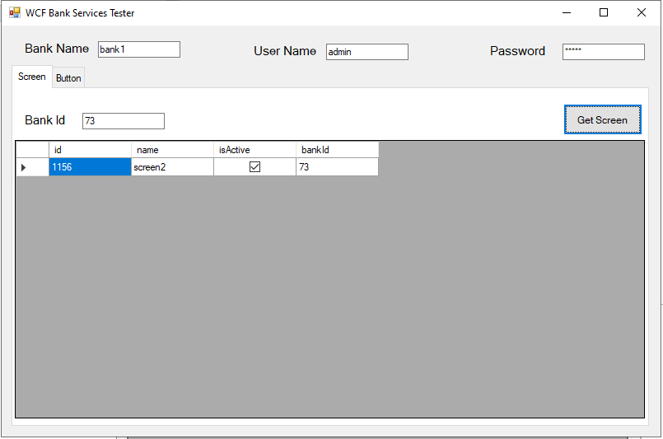

1. Button tab: which will retrieve issue ticket buttons and show message buttons related to an active ticketing screen design configured for a branch in a bank:  
   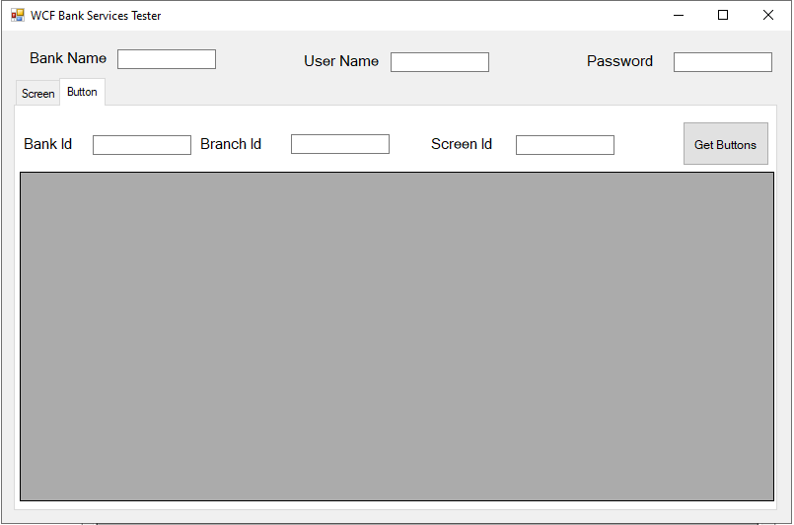  
   1. Fill (Bank Name, User Name and Password).
   2. Fill (Bank Id, Branch Id and Screen Id).
   3. Click on “Get Buttons” button to get the issue ticket and show message buttons for the active screen in specific bank.

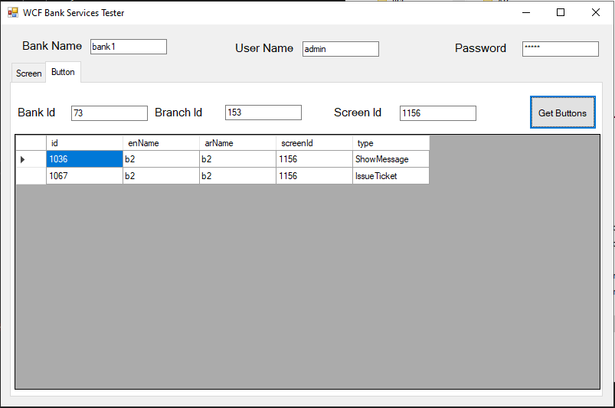

### Warning that maybe occurred

1. If this warning shows up that means your username, password or bank id is wrong:

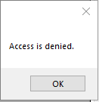

1. If this warning shows up that means there is no item found with these entry’s:

