SEDCO

User Manual

# This manual contains:

1. Introduction to TSD Application.
2. Requirement needs.
3. Instruction to create the database.
4. Instruction to setup the application on your device.
5. Information about the application, what application do, how it work, and how to use it.

**January/2021**

**Version 1.0**

Introduction

Ticketing screen designer application is an application that design the screens for the banks to show to customers.

The application is responsible to create multiple screens for each bank and each screen can have multiple buttons.

There will be an employee from the bank to create these screens and buttons.

# Application Features:

1. Bank:

* Create new bank.
* Login to an exist bank which created before.

1. Screens:

* Create a new screen.
* Edit an existing screen.
* Deleting an existing screen (multiple selection).
* Select the active screen.

1. Buttons:

- Create a new button.

* Edit an existing button.
* Deleting an existing button (multiple selection).
* Two type of buttons (Issue Ticket, Show Message).

# Requirement:

1. Computer device (pc or laptop) which running “windows”.

* The device must have multi-core processor.
* Download .net framework (4.7.2 or higher).
* Microsoft SQL Server Express (2012 or higher).

1. Microsoft SQL server management studio on any machine that has access on Customer’s machine.

* You need to download it, because the data will be saved into the database.

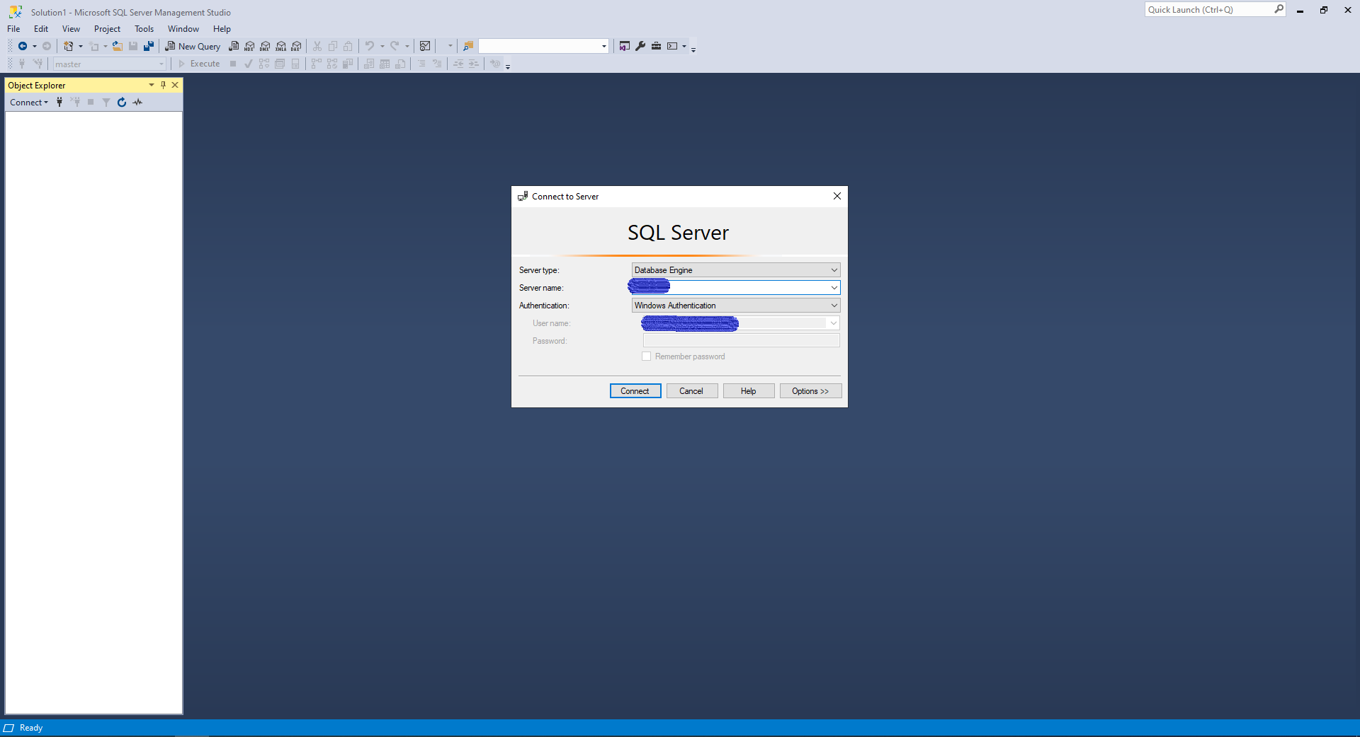

# Deployment:

Deployment Folder: You will get file that contain the application file and the script for the database.

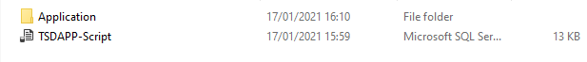

1. First you need to open the script that called “TSDAPP-Script”,

It will open in SQL server management studio, you will need to execute the script.

1. After the script is executed successfully you can close the SQL server management studio program.

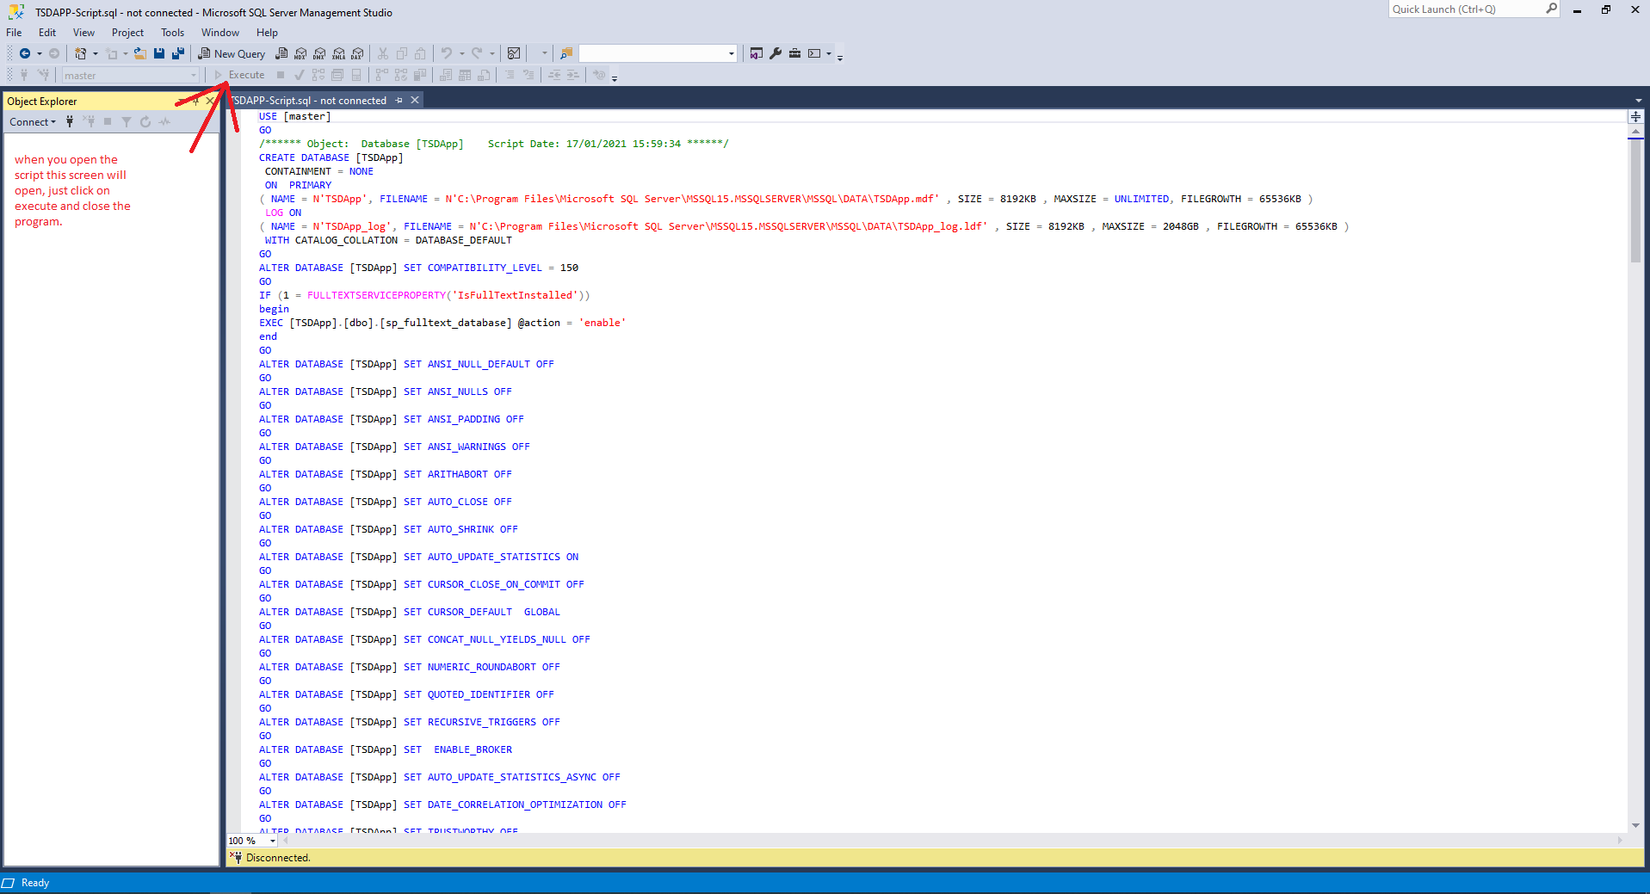

# Configuration:

Set up your connection string:

1. First you need to open the file called Application”.



You will find these files

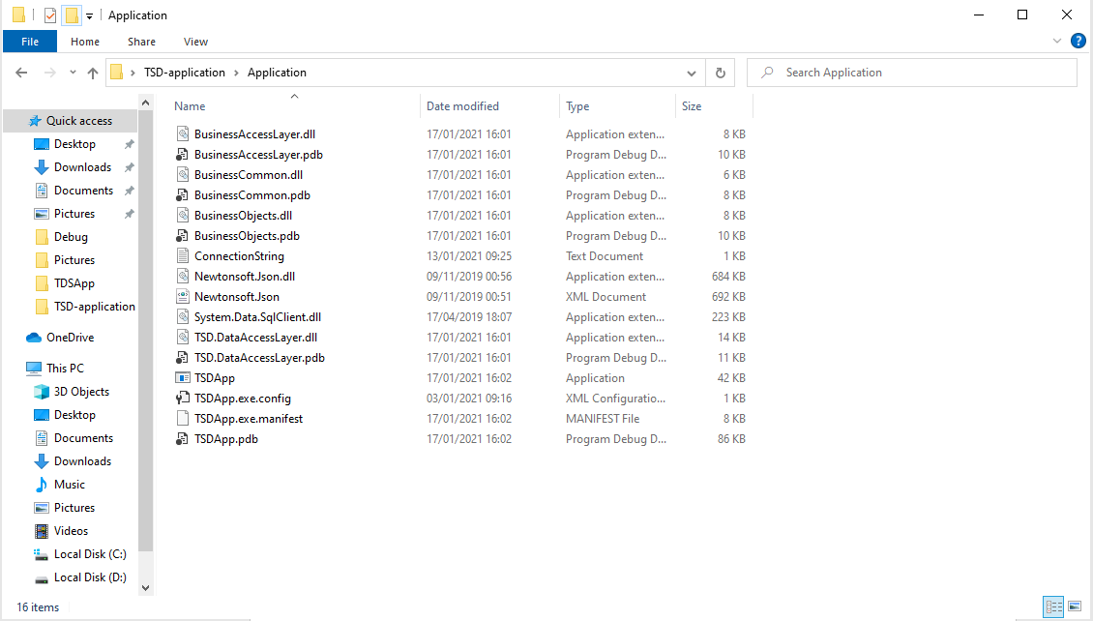

1. Now we are going to update the “ConnectionString.txt” file, you need to set up your own connection string to database.
2. Open the file called “ConnectionString.txt” and put your own data in it as it shown below:

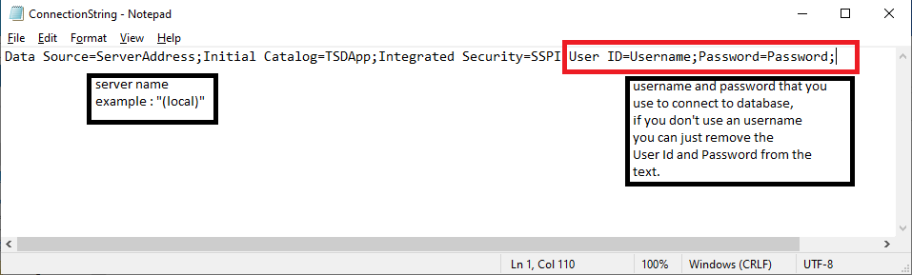

Fields to change:

1. Server Address: set your server name
2. Username: use your username that you use to login into SQL server management studio program.
3. Password: use your password that you use to login into SQL server management studio program.

Note: if you don’t use username and password to login remove the section within the red rectangle in the picture above.

# User Interface:

Open the Application called “TSDApp.exe” within the files below:



The app will start after double click on it and you will see the main form

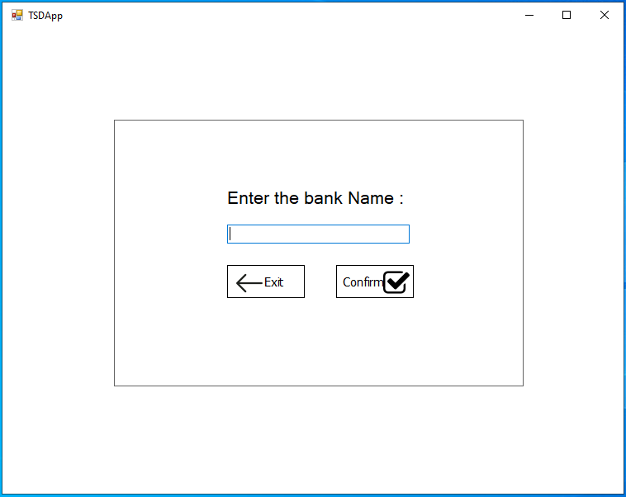

In this window you can either create a new bank or login to your bank if exist:

1. It will automatically create a new bank if the bank name does not used before, to do that you can easily write the bank name in the textbox and click on confirm button.
2. You can login to your old bank by using the same name you used before
3. Click on confirm button.
4. Exit button: used to exit the application.

After entering the bank name and click confirm this form will be shown:

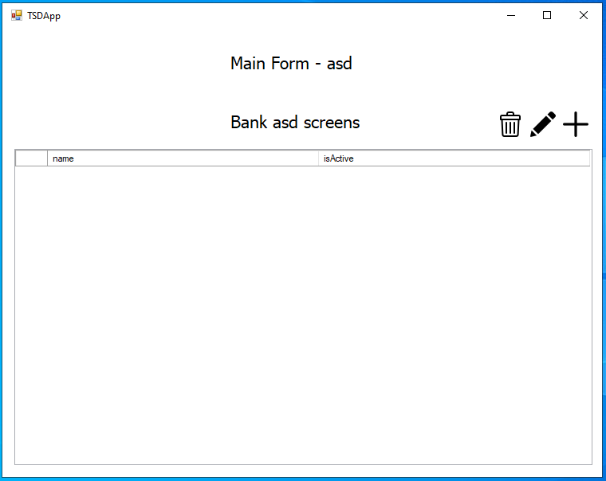

* You will see the bank name on the top of the form.
* You can see your screens in the grid view (if there is).
* You can add a new screen by clicking on the button, you will see how to do in action.



* You can edit a screen that already exist by clicking on the button, you will see how to do this in action.



* You can delete one or more screens that already exist by clicking on the C:\Users\Moayad\Documents\GitHub\TDSApp\TSDApp\TSDApp\Resources\trash(1).png button, you will see how to do this in action.

## Add Screen:

After clicking on C:\Users\Moayad\AppData\Local\Microsoft\Windows\INetCache\Content.Word\plus.png button this form will be shown:

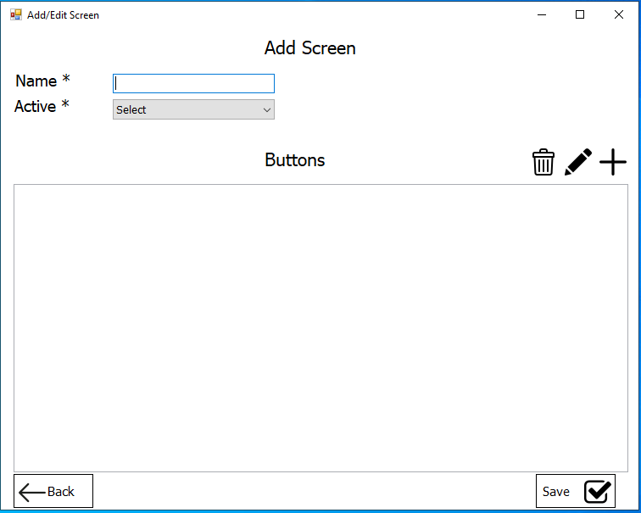

* You can enter the screen name in the textbox, and select if you want to active this screen or not. (* only one screen can be active at the same time).
* You can see buttons related to this screen in the grid view (if there is).
* You can add a new button by clicking on the C:\Users\Moayad\AppData\Local\Microsoft\Windows\INetCache\Content.Word\plus.png button, you will see how to do in action.
* You can edit a button that already exist by clicking on the C:\Users\Moayad\AppData\Local\Microsoft\Windows\INetCache\Content.Word\draw.png button, you will see how to do this in action.
* You can delete one or more buttons that already exist by clicking on the C:\Users\Moayad\Documents\GitHub\TDSApp\TSDApp\TSDApp\Resources\trash(1).png button, you will see how to do this in action.
* Save button: to save the screen after adding buttons or modified the screen.
* Back button: to go back to the main form.

Note: You can add screen only if it the screen contain at least one button

## Add button:

1. After clicking on C:\Users\Moayad\AppData\Local\Microsoft\Windows\INetCache\Content.Word\plus.png button this form will be shown:

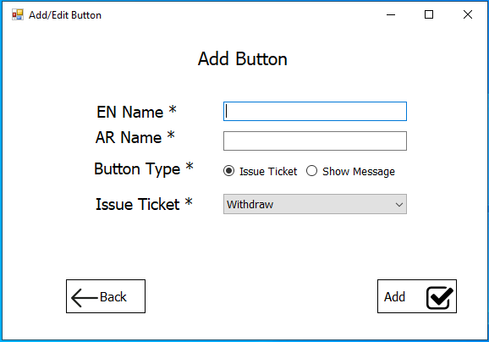

* Here you can add the button details, and select the type of button, if you choose the “Show Message radio button” the form will be like this:

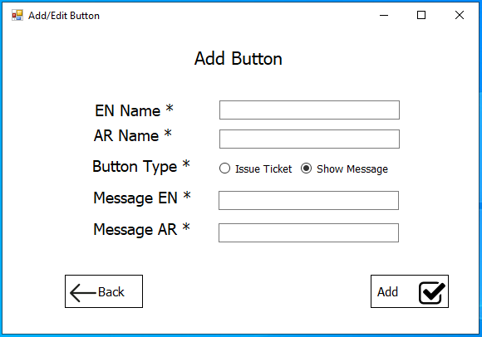

1. After filling the information for this button you can easily click on Add button to add the button to the screen and this form will closed and the screen form will open as show below:

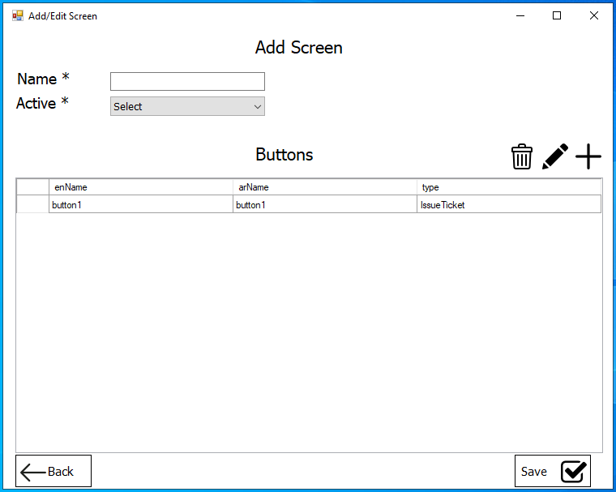

1. You can now fill the screen name and active mode and click on save button to save the screen and it will automatically back to the main form where all screens are shown:

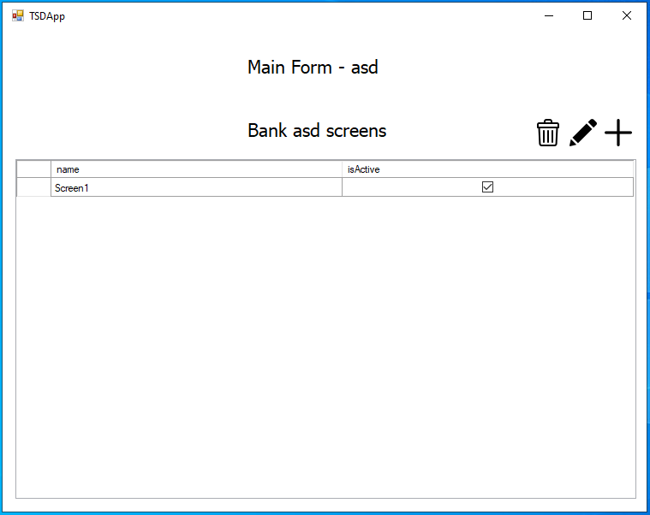

## Edit Screen:

To edit a screen you easily select the screen that you want to edit, after select the screen you can click on the C:\Users\Moayad\AppData\Local\Microsoft\Windows\INetCache\Content.Word\draw.png button as show below

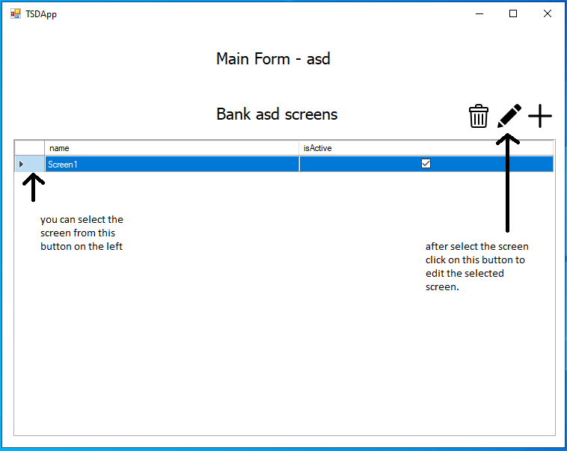

In this form you will see the screen details and the button that we add previously as shown below

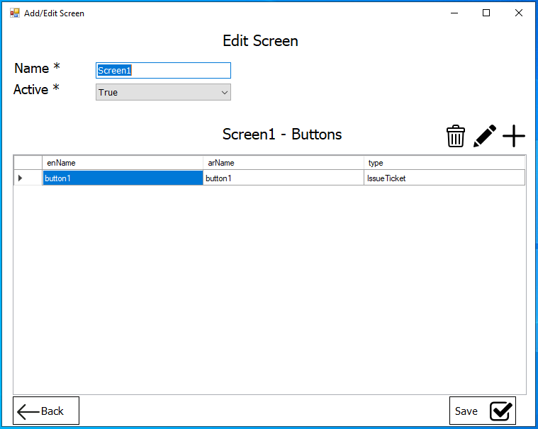

* You can now see the button in the grid view and the details for the screen (screen name and active mode).
* You can add edit or delete buttons and modified the screen details and save the screen.

**Ticketing Screen Designer Application/ Desktop Application**

## Edit Button:

1. You can edit button from the screen form by selecting the button as you see before and click on the C:\Users\Moayad\AppData\Local\Microsoft\Windows\INetCache\Content.Word\draw.png on the top right of the form as show below

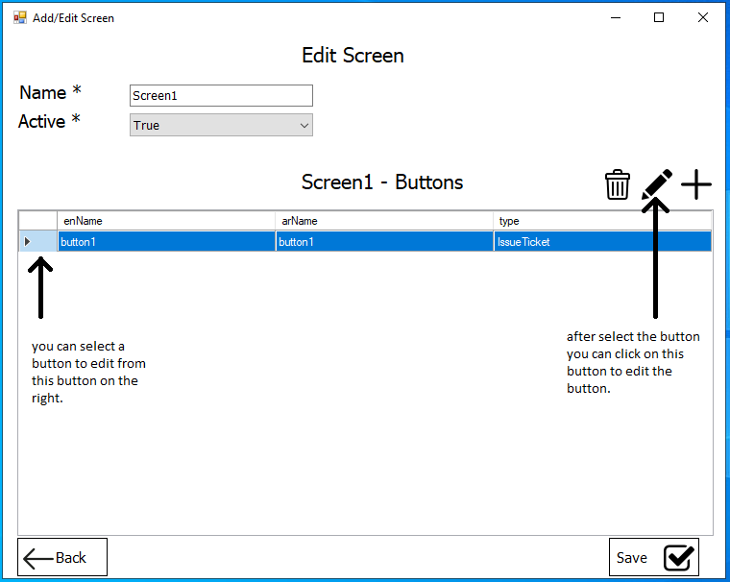

1. After that you will see a button form that fill with button details you can modified the details and save the button by clicking the edit button:

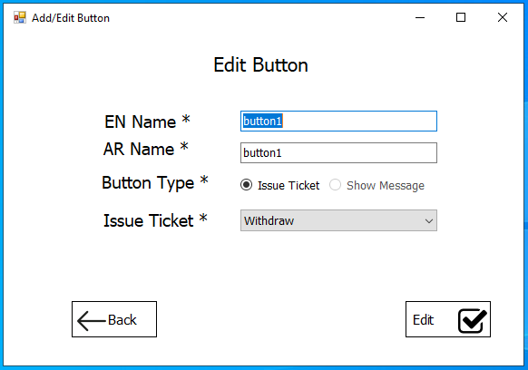

* You will be return to the previous form with the changed data and

You must save the screen to save the new data to the database.

## Delete Button:

1. You can delete button from screen by selecting the button and click on the C:\Users\Moayad\Documents\GitHub\TDSApp\TSDApp\TSDApp\Resources\trash(1).png button.
2. The button will be deleted from the grid view and from the database.

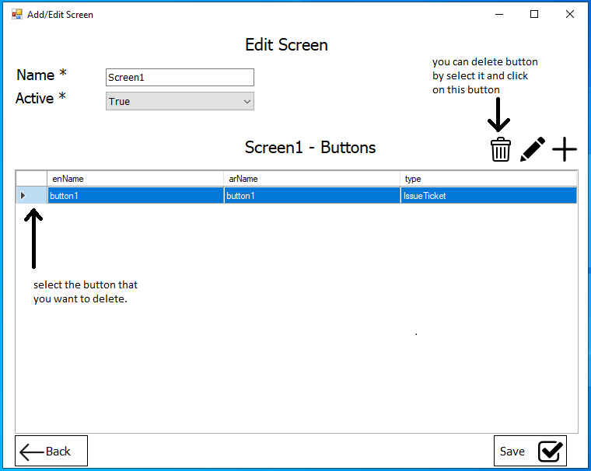

1. Confirmation message box will appear to confirm deleting the button:

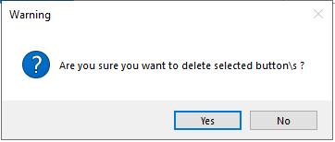

## Delete Screen:

1. You can delete screen from screen by selecting the button and click on the C:\Users\Moayad\Documents\GitHub\TDSApp\TSDApp\TSDApp\Resources\trash(1).png button.
2. All the button related to this screen will be deleted.
3. The screen will be deleted from the grid view and from the database.

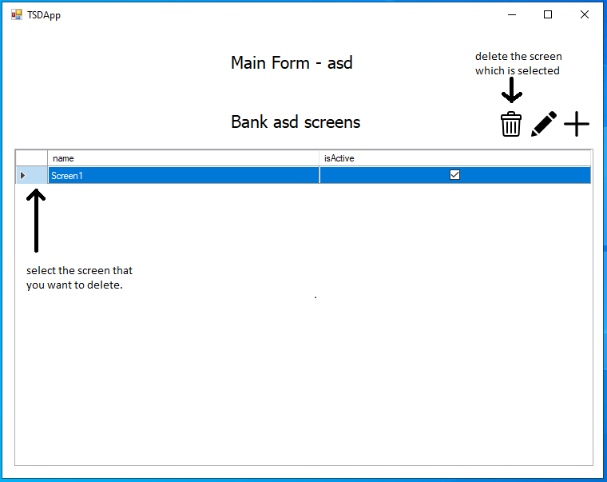

1. Confirmation message box will appear to confirm deleting the button:

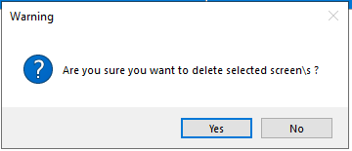

# Warnings:

## Warning that maybe occurred:

* If this warning shows up you must check “ConnectionString.txt” file and make sure that your connection string is right.

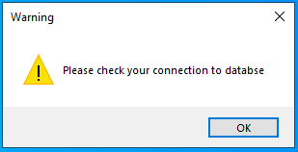

* If this warning shows up that means someone already delete the button you are trying to edit.

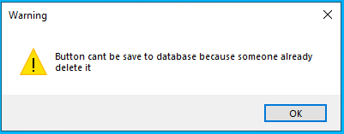

* If this warning shows up that means someone already delete the screen you are trying to edit.

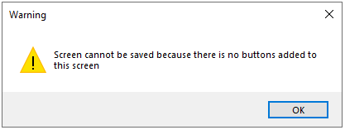

TSD-User manual

Created by: Moayad Raddad