Department of Computing
COURSE: WEB APPLICATION DEVELOPMENT | MARKS:  /100
COURSE CODE: BCS2203 | MARKS:  /100
SEMESTER: 1 2018-19 | MARKS:  /100
TOPIC/OBJECTIVE : | MARKS:  /100
TYPE OF ASSESSMENT: Assignment | MARKS:  /100
ASSESSMENT NO: Assignment 1 | MARKS:  /100
TIME / DEADLINE: 22-11-2018 | MARKS:  /100
STUDENT NAME: SIGNATURE:

STUDENT ID: SECTION:
FEEDBACK (If Any):

LECTURER NAME: T.SHEEBA SIGNATURE:

INSTRUCTIONS TO CANDIDATE

- Accomplish the questions individually.
- Full mark for this assignment is 100 marks.
- The program must be running properly.

- Any plagiarism will be given zero mark.

Softcopy submission:
- Submit all the files (Assignment.aspx and Assignment.aspx.cs)
- Submit Assignment.doc (Screen shot of output)

Hardcopy submission:
- Copies paste all the codes (HOT1.aspx and HOT1.aspx.cs) and screen shot of output in one Assignment.doc file.

Case Study:

The Sultanate of Oman has announced a new loan scheme for young Omanis to apply for their studies related educational loan. This scheme is open for Omanis only whose age is between 15-30 years old. Only unmarried students are eligible to apply and the total of their parent income must not exceed RO 10,000.

The applicant must also an account holder of any local bank in Oman and they must attach the supporting files required for their application. Failure to meet all these conditions will result in ineligibility of the application.

Question:

Create a webpage for this online application form. On the header region, a suitable title and image are needed which represent this scheme. For ‘Applicant Name’, if the student enters the name with small letter, the name should be automatically converted to uppercase (see Figure 1). To calculate the total parent income, minimum one function is needed. For ‘Age’, the web control used must be able to display a message box (see Figure 2). If the student is not an account holder, a link which will be redirected to a new page named ‘Register.aspx’ for the student to register. Finally, the student will also be informed about another new loan scheme that will be launched soon (popped up a new page, see Figure 3 for example).

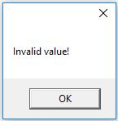
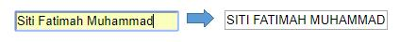

Figure 1: Lowercase to Uppercase Figure 2: Example of message box

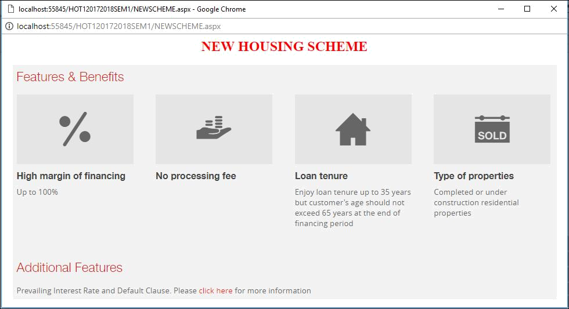

Figure 3: Example of Popped Up A New Page

The example of output is shown in Figure 4 and Figure 5

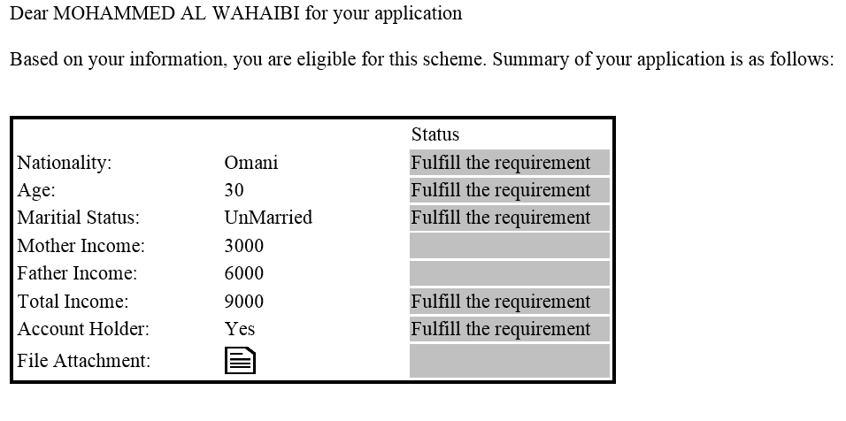
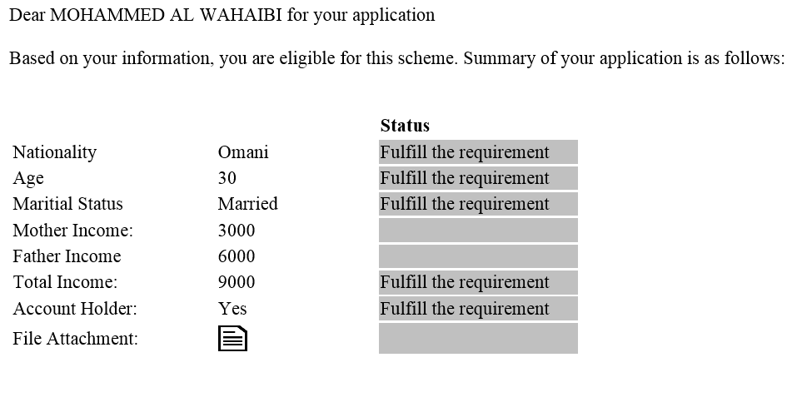
Figure 4: Example of output1
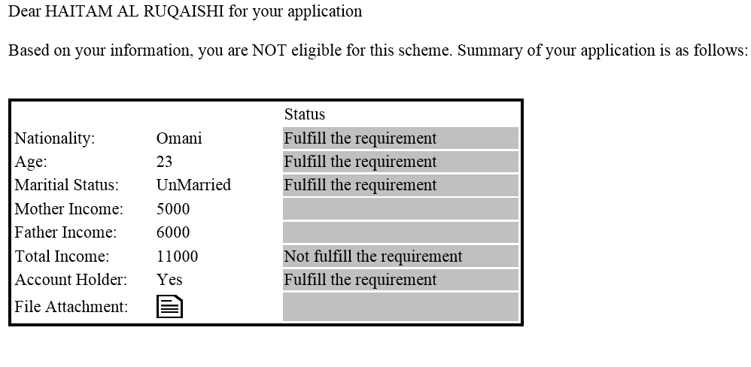

Figure 5: Example of output 2

