Detecting Toxic Comments in Online Discussions:
A Literature Review and Dataset Survey
Moaz Allam, Kareem Elhenawy
Department of Computer Science and Engineering, The American University in Cairo
Moaz_Allam@aucegypt.edu, karimelhenawy@aucegypt.edu

ABSTRACT
Comment sections receive far more posts than a moderation team can read, so platforms have been looking at machine learning to help triage them. This report reviews the work already done on automatic toxic comment detection and surveys five public datasets available for it. The review covers three generations of approach: bag-of-words classifiers, the recurrent-network ensembles that won the 2017-18 Jigsaw Kaggle challenge, and fine-tuned transformer models. The project itself will use Civil Comments, a corpus of 1,999,514 comments in which every toxicity attribute is scored as the share of annotators who agreed with it rather than as a yes or no. We report our own statistics for it, because two of its properties decide the design: the classes are extremely imbalanced, with severe_toxicity clearing a 0.5 threshold on 13 comments out of 1,804,874, and the number of positive examples depends heavily on where that threshold is put.
KEYWORDS toxic comment classification, multi-label classification, content moderation, class imbalance, unintended bias, BERT
1 INTRODUCTION
Most large sites that let people comment have the same problem. The number of comments is far past what a moderation team can read, but a small share of them are abusive enough that leaving them up pushes other people out of the conversation. Jigsaw, the Google research group behind the datasets used here, puts it plainly: platforms struggle to keep conversations going, and many communities end up limiting or shutting down comments entirely [4].
The task we take on is the one defined by the Civil Comments corpus [3, 9]. Given the text of a comment, predict seven attributes: an overall toxicity score, plus severe_toxicity, obscene, threat, insult, identity_attack and sexual_explicit. Each one is a number between 0 and 1, the share of annotators who said the attribute applied, rather than a yes or a no. That makes this a multi-label problem, since a comment can be an insult and an identity attack at the same time, and it adds a decision that binary datasets do not have: at what score does a comment count as positive?
That decision is not a detail. Figure 2 shows what happens to the toxicity attribute alone as the threshold moves. In the training split, 201,476 comments score 0.4 or above, 144,334 score 0.5 or above, and only 96,410 score 0.6 or above. Shifting the line by one tenth changes the size of the positive class by a factor of about two. The Kaggle competition built on this data used 0.5 [3], and so will we, but a number that moves the answer that much has to be stated and justified rather than assumed.
The second problem is imbalance, and it is worse here than in the Jigsaw corpus that most of the literature uses. At a 0.5 threshold, toxicity applies to 7.997% of the 1,804,874 training comments and insult to 5.903%, but threat applies to 0.237%, sexual_explicit to 0.260%, and severe_toxicity to 13 comments in the entire split, which is 0.0007%. A classifier that simply answers "no" to every question is 97.76% accurate on average across the seven attributes, and 99.9993% accurate on severe_toxicity, while being worth nothing at all. Any evaluation that leads with accuracy will look excellent and measure nothing.
The third problem is that toxicity is often not in the words. Van Aken et al. [16] went through the errors of the leading systems by hand and found that half of the false negatives they sampled were toxic without containing a swear word. Sarcasm, metaphor and deliberately misspelled slurs all get past a keyword filter. The fourth is unintended bias: a model trained on comments that attack a group can end up learning the name of the group rather than the attack, which is the problem Civil Comments was released to measure [2].
2 RELATED WORK
2.1 Bag-of-words classifiers
The first wave treated this as ordinary text classification. Davidson et al. [6] collected tweets containing terms from a crowd-sourced hate-speech lexicon and had three or more annotators label each one as hate speech, offensive language, or neither. Their classifier was logistic regression over TF-IDF word n-grams and part-of-speech n-grams, and it reached an overall precision of 0.91, recall of 0.90 and F1 of 0.90.
The overall numbers hide the interesting result. On the hate speech class alone, precision was 0.44 and recall 0.61. The model was good at telling offensive from inoffensive and bad at telling hate speech from ordinary offensiveness, because the two share a vocabulary. We expect the same difficulty between severe_toxicity and toxicity, and it is a good reason to report per-class numbers from the start rather than an average that hides them. Two surveys from the same period, by Schmidt and Wiegand [13] and Fortuna and Nunes [8], catalogue the features people tried before deep learning took over.
2.2 The Jigsaw Kaggle challenge
The 2017-18 competition on the older, binary-labelled Jigsaw corpus drew 4,539 teams and scored submissions on the mean column-wise ROC AUC [4]. The winning solution is worth reading for what it does not contain: there is no new architecture in it. The model was two bidirectional GRU layers feeding two dense layers, and the team says directly that most of a model's complexity sits in the embedding layer, so that is where they spent their effort, on the highest-dimensional FastText and GloVe embeddings they could find [15]. Their public score moved from 0.9877 to 0.9890 in four steps, none of them architectural: diverse embeddings, translating comments into other languages and back to augment the data, labelling the test set with their own model and training on it, and stacking [15]. The lesson is that diversity of embeddings and training data mattered more than network design, which argues for starting from a pre-trained model rather than trying to out-engineer that effort.
Van Aken et al. [16] did the analysis that is most useful for planning. They compared twelve approaches on 223,549 Wikipedia comments, built an ensemble that beat all of them (AUC 0.983), then read the remaining errors by hand and sorted them into categories. Half of the false negatives they sampled were toxic without using a swear word, and 53% of the false positives were cases where they disagreed with the label itself. That second figure is the one worth remembering: on a majority of the sampled false positives the label was doubtful, which puts a ceiling on what any model trained on such labels can score.
2.3 Transformer models
Duchene et al. [7] benchmarked a wide set of models on Civil Comments specifically, which makes their results directly relevant here. Two findings matter for our plan: all the BERT variants performed about the same regardless of size, and DistilBERT combined a good AUROC with a low inference time. They also found that every model they tested was affected by identity association bias, and that RoBERTa trained with focal loss gave the best results on both bias and AUROC.
On the older Jigsaw data, Adhikari et al. [1] fine-tuned BERT-base-uncased and report a micro-averaged F1 of 0.7354, against 0.4651 for an SVM, 0.3864 for logistic regression, 0.3790 for random forest and 0.3085 for naive Bayes on the same task. The size of that gap is why our plan includes both a classical baseline and a transformer rather than only the transformer.
2.4 Measuring unintended bias
Civil Comments exists because of this problem. Borkan et al. [2] released the identity-annotated test set alongside a set of threshold-agnostic metrics for unintended bias, arguing that a single aggregate score hides systematic differences between demographic groups, and used those metrics to find bias in public models that ordinary accuracy measures had missed. The Kaggle competition built on that release scored entries on a bias-weighted metric rather than on raw AUC [3]. HateXplain [11] attacks the same problem from the annotation side: every post is marked with the specific words the annotator based the decision on, and models trained on those rationales showed less bias toward the targeted communities.
3 WHAT WE PLAN TO DO
We will train a multi-label classifier on Civil Comments in three stages, so that each stage has something to be compared against.
Before any of that, we have to fix the threshold. We will binarise at 0.5 to stay comparable with the competition and with Duchene et al. [7], and we will repeat the headline evaluation at 0.4 and 0.6 to show how much of the result depends on that choice. Given Figure 2, reporting a single number at a single unstated threshold would not be honest.
Stage 1 is a classical baseline: TF-IDF features over word n-grams, then one classifier per attribute with scikit-learn. We will compare logistic regression, a linear SVM, k-nearest neighbours and a decision tree on the same features, partly because those are the models the course covers and partly because running four of them over one representation shows what the features themselves can and cannot support. On 1.8 million comments, k-nearest neighbours will likely be too slow to use at full scale, which is itself a result worth reporting.
Stage 2 is neural: first a small network in TensorFlow/Keras, then a fine-tuned DistilBERT. DistilBERT rather than BERT-base because Duchene et al. [7] found little accuracy difference between BERT sizes but a large speed difference, and because we have limited compute and two million comments to get through. The output layer is seven sigmoid units rather than a softmax. A softmax makes the outputs compete and sum to one, which is the wrong shape here, since a comment really can be an insult and an identity attack at once. The loss is binary cross-entropy per attribute; given that severe_toxicity has 13 positive examples at our threshold, we expect to drop it from the modelling and say so, and for the other rare attributes we will try focal loss, which puts more weight on the rare and difficult cases [7].
Stage 3 is evaluation: precision, recall and F1 for each attribute separately, macro-F1 and micro-F1 across them, and per-attribute ROC AUC. We will not report plain accuracy as a headline number, for the reason given in Section 1.
We also intend a bias audit, which is the main reason for choosing this corpus. The identity annotations needed for it are in the Kaggle release rather than in the Parquet version we start from [3], so the audit uses that file: for each identity subgroup we compare the model's score distribution on comments mentioning it against the rest, following the subgroup metrics of Borkan et al. [2]. If the model flags neutral comments that merely mention a group, that result goes in the report either way.
The intended application is a moderation aid, not an automatic ban system: a queue ordered by predicted toxicity with the predicted attribute attached, so a human moderator reads the worst first. That also sets the operating point, since recall matters more than precision when a person reviews everything the model flags.
4 EXISTING DATASETS
4.1 Civil Comments (the dataset will be used)
The Civil Comments platform shut down at the end of 2017 and released its archive of public comments so that researchers could keep using it; Jigsaw paid for the toxicity annotation [3]. The version Google publishes on Hugging Face [9] holds 1,999,514 comments in 422 MB of Parquet, split into 1,804,874 training, 97,320 validation and 97,320 test rows.
Each row has the comment text and the seven scores listed in Section 1. Every comment was shown to up to 10 annotators, some to far more [3]. Comment length in the training split runs from 1 to 1,906 characters, median 202, mean 297.
The counts below were derived, not copied. The dataset server publishes per-column histograms over the whole training split with bin edges at 0, 0.1 and so on, so the number of comments at or above any tenth is a sum of bins. We checked that reading rather than assuming it: an independent row-count query for toxicity at or above 0.5 returns 144,334, exactly what the last five toxicity bins sum to, and each of the seven histograms sums to 1,804,874. The script that records the raw responses is submitted with this report.
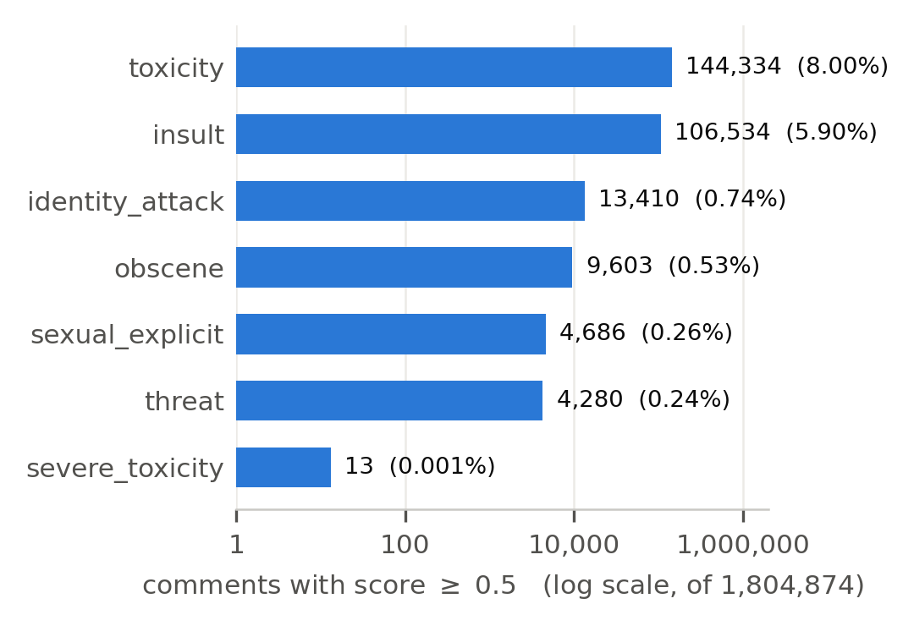
Figure 1: Comments scoring 0.5 or above on each attribute, out of 1,804,874 training comments. The axis is logarithmic because the counts span four orders of magnitude; every bar is labelled with its true count.
Figure 1 gives the label counts at a 0.5 threshold: toxicity 144,334 (8.00%), insult 106,534 (5.90%), identity_attack 13,410 (0.74%), obscene 9,603 (0.53%), sexual_explicit 4,686 (0.26%), threat 4,280 (0.24%) and severe_toxicity 13 (0.0007%). The last of those is not a typo. At this threshold severe_toxicity is not a class a model can be trained on at all, and any report that presents seven per-class F1 scores without mentioning it is hiding something.
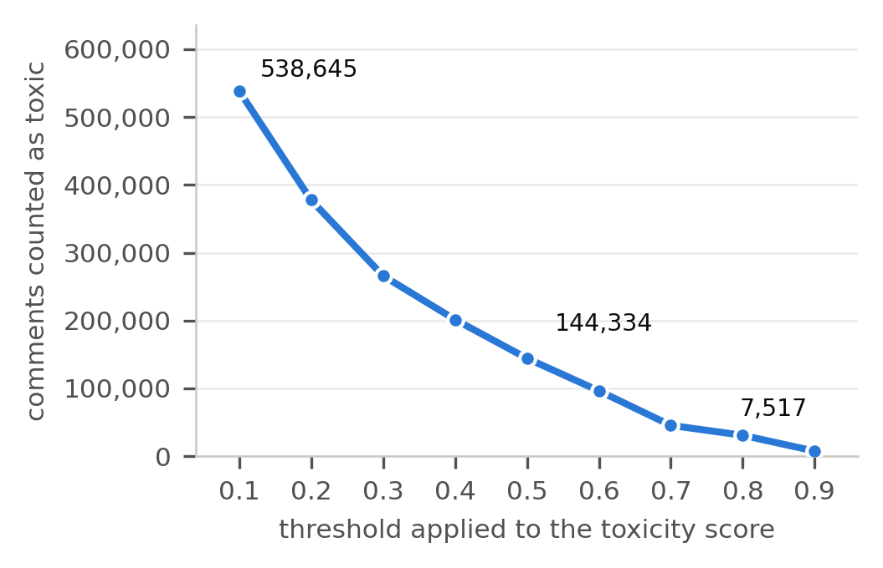
Figure 2: How many training comments count as toxic as the threshold on the toxicity score changes. The conventional 0.5 cut sits in the steepest part of the curve.
Figure 2 is the threshold argument from Section 1 drawn out. Between 0.1 and 0.9 the positive class shrinks from 538,645 comments to 7,517, and the region around the conventional 0.5 cut is where the curve is steepest, so small changes there have the largest effect on the training set.
The corpus is released under CC0 [9]. Two limitations matter for us. The Parquet release does not include the identity columns, which live in the Kaggle release [3] and in the CivilCommentsIdentities configuration of TensorFlow Datasets, which holds 448,000 examples [14]; a bias audit needs one of those. And the fractional labels are only as good as the annotation, with most comments seen by 10 raters, so a score of 0.3 means three raters disagreed with seven rather than that the comment is thirty percent toxic.
4.2 Jigsaw Toxic Comment Classification Challenge
English comments from Wikipedia talk page edits, labelled by human raters [4]. We downloaded train.csv, test.csv and test_labels.csv and counted them: 159,571 training rows with an id, the comment text and six binary columns, no duplicate ids and no empty comments. toxic appears on 15,294 comments (9.58%), obscene on 8,449 (5.29%), insult on 7,877 (4.94%), severe_toxic on 1,595 (1.00%), identity_hate on 1,405 (0.88%) and threat on 478 (0.30%); 16,225 comments (10.17%) carry at least one label.
The test file holds 153,164 comments but only 63,978 (41.77%) were ever scored, the rest being marked -1 to deter hand labelling [4]. As a check on our counting, van Aken et al. [16] describe their Wikipedia corpus as 223,549 comments, and 159,571 + 63,978 = 223,549 exactly. Released under CC0, with the text under Wikipedia's CC-SA-3.0 [4].
Most of the reviewed literature uses this set, so it is the natural place to check our pipeline before pointing it at the larger corpus. Its limitations are why it is not the main dataset: binary labels with no confidence attached, a single platform, and no identity annotations.
4.3 HateXplain
20,148 posts, 9,055 from Twitter and 11,093 from Gab [11]. We downloaded the released dataset.json and confirmed the total, and that every post has exactly three annotators. Each post gets a three-class label by majority vote, plus the target community and word-level rationale spans. Taking the majority of the three annotators reproduces the paper's counts exactly: 5,935 hateful, 5,480 offensive, 7,814 normal and 919 where no majority was reached. Agreement is Krippendorff's alpha of 0.46 [11], and the repository is MIT licensed [10]. Limitations: far smaller than Civil Comments, one three-class label rather than seven scores, and 919 posts with no majority label.
4.4 Davidson hate speech and offensive language
24,783 tweets, sampled from users whose tweets contained terms from the Hatebase lexicon [6]. We downloaded labeled_data.csv and counted the classes: 1,430 hate speech (5.77%), 19,190 offensive language (77.43%) and 4,163 neither (16.80%). MIT licensed [5]. The paper describes 24,802 labelled tweets while the released file has 24,783 rows; we use the file's count, since that is what a download gives you today. Limitations: heavily skewed toward offensive, one label per tweet, and a hate class small enough that the authors' own model reached only 0.44 precision on it.
4.5 OLID (OffensEval 2019)
14,100 English tweets, split 13,240 for training and 860 for test, collected for SemEval-2019 Task 6 [17]. The annotation is hierarchical: level A marks offensive (4,640) against not offensive (9,460); level B splits the offensive posts into targeted and untargeted; level C identifies the target. The task page distributes OLID through a Google Drive link and states no licence at all, asking only that users cite the paper [12], which is different from the CC0 and MIT terms on the other datasets. Limitations: small, one label per level, and a hierarchy that does not line up with the Civil Comments attributes.

Table 1: The five candidate datasets. Instance counts for Civil Comments come from the dataset server; those for the Jigsaw, HateXplain and Davidson sets were obtained by downloading the files and counting rows.
Dataset | Instances | Source | Labels | Availability
Civil Comments (ours) | 1,804,874 train / 97,320 validation / 97,320 test | Civil Comments platform | 7 scores from 0 to 1: toxicity, severe_toxicity, obscene, threat, insult, identity_attack, sexual_explicit | Hugging Face, 422 MB Parquet, and Kaggle. CC0
Jigsaw Toxic Comment | 159,571 train / 153,164 test (63,978 scored) | Wikipedia talk pages | 6 binary, non-exclusive: toxic, severe_toxic, obscene, threat, insult, identity_hate | Kaggle, after accepting rules. CC0; text under CC-SA-3.0
HateXplain | 20,148 | Twitter (9,055), Gab (11,093) | 3-class (hateful / offensive / normal) by majority of 3, plus target community and word-level rationales | GitHub and Hugging Face. MIT
Davidson et al. | 24,783 | Twitter | 1 of 3 classes: hate speech (5.77%), offensive (77.43%), neither (16.80%) | GitHub. MIT
OLID (OffensEval 2019) | 14,100 (13,240 train / 860 test) | Twitter | 3 hierarchical levels: offensive or not; targeted or not; target type | Google Drive link on the task page. No licence stated

4.6 Why Civil Comments
Civil Comments is the dataset for this project for three reasons. It is relatively large dataset with around 2m training data rows. Its fractional labels carry information a binary flag throws away: a comment that eight of ten raters called toxic is a different training example from one that five of ten did, and a model can be trained on the score rather than on the flag. And its Kaggle release carries the identity annotations that the bias audit in Section 3 needs, which no other dataset here provides at this scale.
The cost is the threshold decision and a file large enough to need care. HateXplain, Davidson and OLID work as out-of-domain tests but not as the main corpus: their label schemes are coarser, they are single-label, and they are between seventy and a hundred and thirty times smaller.
5 CONCLUSION
Toxic comment detection has moved from n-gram classifiers to recurrent ensembles to fine-tuned transformers, and the reported gains are real: a fine-tuned BERT reaches 0.7354 micro-F1 on the Jigsaw labels against 0.4651 for an SVM on the same task [1]. But the same literature shows that most of the remaining difficulty is not about model capacity. It is about rare classes, about labels that careful readers disagree with, and about models that learn an identity term instead of an attack. Our counts say the same thing from the data side: one attribute has 13 positive examples in 1.8 million comments, and the toxic class halves if the threshold moves by two tenths. That is why the plan puts as much weight on the threshold decision and on per-class evaluation as on the choice of model.
AI USAGE DISCLOSURE
This report was completed with assistance from Claude (Anthropic). The AI was used to retrieve and derive dataset statistics, to check bibliographic details and reported results against publisher pages, to identify factual errors in an earlier draft, and to help draft and edit the text. The scripts that produce every statistic and figure are submitted alongside this report, all sources were checked, and the authors are accountable for the accuracy of the content.
REFERENCES
[1] Binita Adhikari, Pratistha Sapkota, and Rajad Shakya. 2026. Multi-Label Toxic Comment Detection Using BERT-Based NLP and Machine Learning. International Journal on Engineering Technology and Infrastructure Development 2, 2 (June 2026), 37-45.
[2] Daniel Borkan, Lucas Dixon, Jeffrey Sorensen, Nithum Thain, and Lucy Vasserman. 2019. Nuanced Metrics for Measuring Unintended Bias with Real Data for Text Classification. In Companion Proceedings of The 2019 World Wide Web Conference. arXiv:1903.04561
[3] cjadams, Daniel Borkan, inversion, Jeffrey Sorensen, Lucas Dixon, Lucy Vasserman, and nithum. 2019. Jigsaw Unintended Bias in Toxicity Classification. Kaggle. kaggle.com/c/jigsaw-unintended-bias-in-toxicity-classification
[4] cjadams, Jeffrey Sorensen, Julia Elliott, Lucas Dixon, Mark McDonald, nithum, and Will Cukierski. 2017. Toxic Comment Classification Challenge. Kaggle. kaggle.com/c/jigsaw-toxic-comment-classification-challenge
[5] Thomas Davidson. 2017. hate-speech-and-offensive-language. GitHub, MIT License. github.com/t-davidson/hate-speech-and-offensive-language
[6] Thomas Davidson, Dana Warmsley, Michael Macy, and Ingmar Weber. 2017. Automated Hate Speech Detection and the Problem of Offensive Language. In Proceedings of ICWSM 2017, Vol. 11. 512-515.
[7] Corentin Duchene, Henri Jamet, Pierre Guillaume, and Reda Dehak. 2023. A benchmark for toxic comment classification on Civil Comments dataset. In Extraction et Gestion des Connaissances (EGC 2023), RNTI-E-39. 19-30. arXiv:2301.11125
[8] Paula Fortuna and Sergio Nunes. 2018. A Survey on Automatic Detection of Hate Speech in Text. ACM Computing Surveys 51, 4, Article 85 (July 2018), 30 pages.
[9] Google. civil_comments. Hugging Face Datasets, CC0-1.0. huggingface.co/datasets/google/civil_comments
[10] hate-alert. 2021. HateXplain dataset. GitHub, MIT License. github.com/hate-alert/HateXplain
[11] Binny Mathew, Punyajoy Saha, Seid Muhie Yimam, Chris Biemann, Pawan Goyal, and Animesh Mukherjee. 2021. HateXplain: A Benchmark Dataset for Explainable Hate Speech Detection. In Proceedings of the AAAI Conference on Artificial Intelligence, Vol. 35. 14867-14875.
[12] OffensEval 2019. OLID v1.0 download page. SemEval-2019 Task 6. sites.google.com/site/offensevalsharedtask/olid
[13] Anna Schmidt and Michael Wiegand. 2017. A Survey on Hate Speech Detection using Natural Language Processing. In Proceedings of the Fifth International Workshop on NLP for Social Media. ACL, 1-10.
[14] TensorFlow Datasets. civil_comments dataset catalog entry. tensorflow.org/datasets/catalog/civil_comments
[15] To Train Them Is My Cause and Chun Ming Lee. 2018. 1st place solution overview. Kaggle solution write-up, Toxic Comment Classification Challenge.
[16] Betty van Aken, Julian Risch, Ralf Krestel, and Alexander Loeser. 2018. Challenges for Toxic Comment Classification: An In-Depth Error Analysis. In Proceedings of the 2nd Workshop on Abusive Language Online (ALW2). ACL, 33-42.
[17] Marcos Zampieri, Shervin Malmasi, Preslav Nakov, Sara Rosenthal, Noura Farra, and Ritesh Kumar. 2019. Predicting the Type and Target of Offensive Posts in Social Media. In Proceedings of NAACL-HLT 2019. ACL, 1415-1420.

