**Moaz Maalik 17L-4164**

**Course:** Artificial Intelligence

**Section:** F

**Introduction**

The assignment uses Genetic Algorithm to make a timetable having minimum clashes and to reduce the number of students who have consecutive papers.

**Methodology**

The overall structure of the Algorithm is same as of GA with the following detail:

**Chromosome:**

The chromosome is represented by a 1d array of size equal that of number of courses.

The index of the array represents the course ID and the value on the index represents the time slot. This value is and integer between 0-20 as there are 21 slots in total 3 days(7 per day).

**Crossover and Mutation Operator:**

Crossover is performed by taking two chromosomes and generating a random point of division and performing crossover over that point to generate two new chromosomes .

Mutation is performed by generating a random point and a random slot and place that slot on that point on the chromosome . Probability of mutation is set to 0.5.

**Fitness Function**

Fitness function computers three values

1. total_slots_with_overflow
2. number_students_having_two_exams_in_one_given_slot
3. number_of_students_having_exams_on_two_consecutive_slots

In the it sums all 3 values and returns the score .

Fitness function uses many helper functions each of which are well commented in the code.

**Generation of chromosome population**

Initially a population of 10 chromosomes are generated on which random slots are assigned.

**Repeatedly creating the next generation from existing generation**

The next generation is created by taking the top5 chromosomes according to their fitness score and performing crossover of the top 1 with the rest four.Furthermore mutation is also performed on these new offspringes according to its probability .This generates 10 new chromosomes and hence the new population.

**Termination condition**

Termination con

1. Not even a single student can have more than two exams in one slot.

2. Not even a single student can have more than two exams in consecutive slot.

3. Not even a single student can have more than three exams in one given day.dition is when the fitness of the best chromosome in a generation is zero.which means

**Results**

After running the algorithm on the provided files . It took almost 3 minutes to reduce an initial score of 3000 to 1500

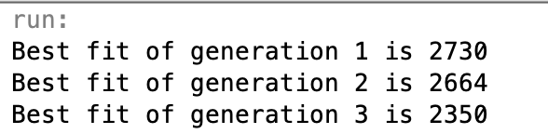



Judging by this speed the algo will take approximately 15minutes to provide a solution which is very very effective .