


Moaz Mohamed Ramadan
Marwan Abdelaziz El-bohi
Yousuf Mussa Abd
Grade 12, (2025_2026)

Table of Contents
Chapter 1: Present and justify a problem and solution requirements 2
Introduction 3
Egypt Grand Challenges 4
Deal with urban congestion and its consequences 4
Causes 5
Impacts 6
Address and reduce pollution fouling our air, water, and soil 8
Causes 10
Impacts 11
Deal with population growth and its consequences 13
Causes 14
Impacts 15
Work to eradicate public health issues and diseases. 17
Causes 18
Problem To be Solved. 23
Positive Consequences 24
Negative Consequences 26
Other solutions already tried. 28
Adaptive Traffic Management in Congested Metropolises 28
Mechanism 29
Points of strength 31
Points of weakness 33
The CIRTA Traffic Management System 35
Mechanism 36
Points of strength 37
Points of Weakness 39
Ramp Metering (Specific Model: Los Angeles, California Freeway System) 41
Mechanism 41
Points of strength 43
Points of Weakness 44
Research 46
Topics related to the problem 47
Topic Related to the Solution 48
Chapter 2: Generating and defending a solution 50
Design requirements 51
Solution requirements 53
Selection of Solution 54
Selection of Prototype 55
Chapter 3: Constructing and Testing a Prototype 57
Materials 58
Safety precautions 60
Methods 60
Design requirements 62
Test plan 64
Results 64
Negative results: 64
Analysis 68
Conclusions 73
Recommendation 74

Chapter 1: Present and justify a problem and solution requirements

Introduction
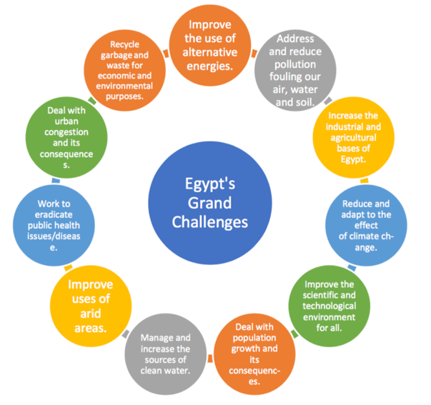
The world today faces humanity with numerous challenges that inhibit progress. In Egypt, there are important grand challenges that must be solved, which the government hopes to not only unveil but also address through its ''Vision 2030'' which hopes to solve Egypt's grand challenges before the year 2030. Egypt's grand challenges are interconnected with each other, as shown in Figure 1.
Figure 1 Egypt's grand challenges
The interconnections among these challenges are complex; namely, the ineffective management of waste contributes to pollution, which in turn contaminates fresh water supplies from which humans derive their health. Again, pollution contributes to the effects of climate change, upon which resource burdens are still heavier with ensuing deserts and urbanization. This urbanization leads to further congestion and pollution while stressing infrastructure, leading to a vicious cycle that limits sustainable development. By coming together to tackle these grand challenges, Egypt can pave the way for a healthier and sustainable future where each solution can supplement the other, nurturing a resilient society in the end.

Egypt Grand Challenges

Deal with urban congestion and its consequences
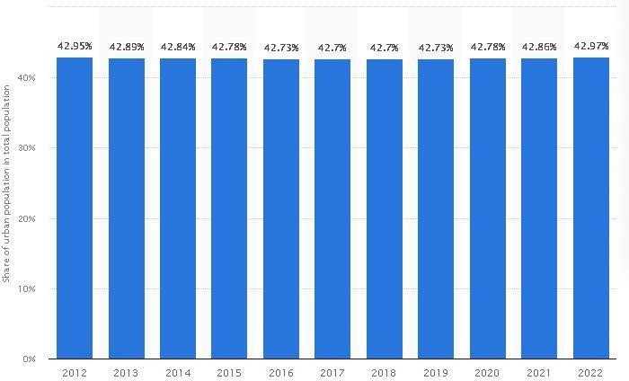
Urban congestion is a difficult challenge that lots of developing and first-world countries face globally. They suffer due to its harsh consequences on the economy and environment. Urban congestion is the increased density of people in a small area.
Figure 2 Share of urban population in total population
Egypt suffers from urban congestion because most of the residents live in urban governorates such as Cairo, Giza, and Alexandria, while there are a lot of arid areas throughout the country. Egypt is considered one of the most populated Countries in the world as the current population is approximately 113,000,000 inhabitants in 2023, and the population density is 2000 per square kilometer.
The population distribution in Egypt is extremely unbalanced, where 6% of the total national area carries 96% of the population, while the remaining 4% of the population is found scattered around the country, and 68% of the population is found in The Greater Cairo Region, Alexandria, and the Delta.
Around 42% of the population lives in urban cities, as shown in Figure 5 (46,000,000 in 2022), which leads to high traffic congestion in these cities and a lot of environmental and economic problems.
The previous data shows that Egypt has a severe problem with urban congestion, which affects the environmental, economic, and social life of Egyptians.

Causes
Economic opportunities in urban areas
Economic opportunities are a main factor that affects the concentration of population in an area, because people search for a better life for themselves and their families. In Egypt, great job opportunities are usually found in urban areas and the Greater Cairo governorates, Alexandria, and other urban areas contain most of the essential economic facilities and businesses, which urge inhabitants to migrate to these urban areas looking for better jobs and deluxe housing.
Arid areas in Egypt
The high amounts of arid areas are considered a key factor in the urbanization in Egypt. It was mentioned that 96% of Egypt’s total area is arid. This leads to a high population density in urban areas because the arid areas are not suitable for human life. This is caused by many reasons, one of them is that arid areas suffer from low water resources, which makes them inappropriate for life, in addition to the difficulty of establishing agriculture even when water is found, due to the unsuitability of the soil. Moreover, the environmental properties and ecosystem in arid areas are havoc-causing. This appears clearly in the terrible climate and wildlife.
Imperfect Waste Management System
The current waste management systems in Egypt also emphasize on waste disposal rather than recycling. All that Municipalities tend to do is to collect waste and transport it to a landfill or an open dump with little or no efforts made to retrieve recyclable materials. Such waste management practices as this one are not only inefficient as they lead to loss of recoverable resources, but also contribute to serious environmental issues like deterioration of land and water

Impacts
Traffic congestion
Traffic congestion is a serious problem in Egypt, especially in the GCMA (The Greater Cairo Metropolitan Area), with its high population density. This congestion affects both the quality of life and the economy. People waste their time waiting in traffic; this time could be spent doing more important and beneficial things. In addition to this, it makes the location unattractive for businesses and industry to be opened there and increases greenhouse gas emissions and air pollution. The Ministry of Health says that in 2021, more than 2 million people sought medical treatment for respiratory problems due to air pollution.
Insufficient water availability and large food-production deficiency
Egypt is a high-population country with a long river and agricultural lands on its banks, in addition to congestion in urban areas with an annual urban growth rate of 2%. All of these are factors that affect water availability and food production negatively.
Egypt suffers from around 7 billion cubic meters as the annual deficit of water in 2021 which makes it one of the countries that are expected to face a shortage of water by 2025. Cairo, the capital, and the most populated governorate is in the probability of drinking draining of drinking presently.
Frequent informal settlements
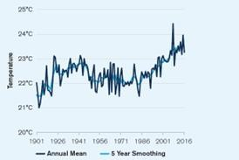
Informal settlements are defined as residential areas that are unauthorized and do not comply with the plans of townships. In Egypt, the congestion in urban areas was a reason for increasing the number of these settlements. 60% of The Greater Cairo Region residents live in informal residents to be part of the urban city. Informal settlements suffer from poor health care, bad education, and an acute lack of quality of facilities and services due to their unplanned building. In addition to the spread of ignorance because of high poverty, the lack of schools, and terrible education quality, informal settlements affect the environment negatively in many ways such as inferior sewage.

Address and reduce pollution fouling our air, water, and soil
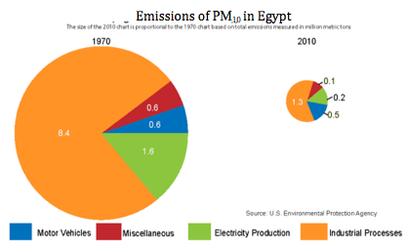
Pollution is a big challenge that faces the whole world and increases over time, and Egypt is no exception. Pollution is the addition of any substance (solid, liquid, or gas) to the environment at a rate faster than it can be recycled or stored in some harmless form. The major kinds of pollution, usually classified by environment, are air pollution, water pollution, and soil pollution.
Figure 4 PM10 concentrations in Egypt
Firstly, air pollution, Egypt has one of the most polluted airs in the world, as has been proven in 2023. As shown in Figure 4, Egypt’s air contains many PM10 and PM2.5 concentrations, which are very harmless to the human respiratory system. Egypt was in the 9th place as the most polluted country and region ranking based on annual average PM2.5 concentration (μg/m³). In 2019, for May and June, Cairo attained the WHO target figure of less than 10 µg/m³. In September and November, the quality fell to 36.9 and 46.4 µg/m³, respectively. For the remaining months, the air quality was “moderate”. When compared to the rest of the world, Egypt ranked as the 56th most polluted out of a total of 98.
Secondly, water pollution, as most of Egypt depends on the Nile River as the main source of freshwater, the Nile River is mostly polluted by large amounts of elements such as discharge, toxic chemicals, fertilizer residues, radioactive waste, and oil pollution. Furthermore, according to a study about the Mediterranean Sea, 720 million tons of wastewater, 142 thousand tons of mineral oil, 66 thousand tons of mercury, 4200 tons of lead, 40 thousand tons of phosphate, all end up in the sea. This ends up being consumed by fish, which is then consumed by humans, leading to many diseases.
Thirdly, soil pollution, Agricultural soils are receiving a tremendous number of pollutants that lead to land degradation. Therefore, it is an urgent requirement to determine and map the soil's heavy metal content, which is the first task of soil remediation. Some Egyptian soils are polluted by heavy metals, where concentrations of Fe, Mn, and Zn are moderate to high. Industrially contaminated areas of Fe, Mn, Zn, Cu, Cd, Co, Ni, and Pb were investigated. Levels of Pb, Ni, Co, and Cd in soils near the Cairo-Alexandria agricultural highway were evaluated. In the study of Siwa Oasis soils, total concentrations were Fe (0.50 - 3.37 mg.kg-1), Mn (94 - 288 mg.kg-1), Zn (37 -175 mg.kg-1), and Cu (8 to 25 mg.kg-1), while the available concentrations were Fe (0.4 - 5.6 mg.kg-1), Mn (0.6 - 3.2 mg.kg-1).

Causes
Transportation
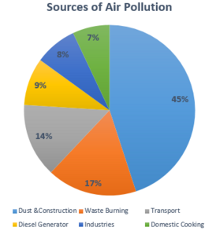
Transportation is a main cause of air pollution. As shown in figure 5 transportation emissions are the third source of air pollutions after construction and waste burning, because of many reasons like exhaust gases from Cars, trucks, and buses, they emit pollutants such as carbon monoxide (CO), nitrogen oxides (NOx), volatile organic compounds (VOCs), and particulate matter (PM) through their exhaust systems. Another reason is the use of gasoline and Diesel. The combustion of fossil fuels for transportation releases significant amounts of greenhouse gases (GHGs), contributing to air quality issues and climate change.
Figure 5 sources of air pollution in Egypt
Used water runoff
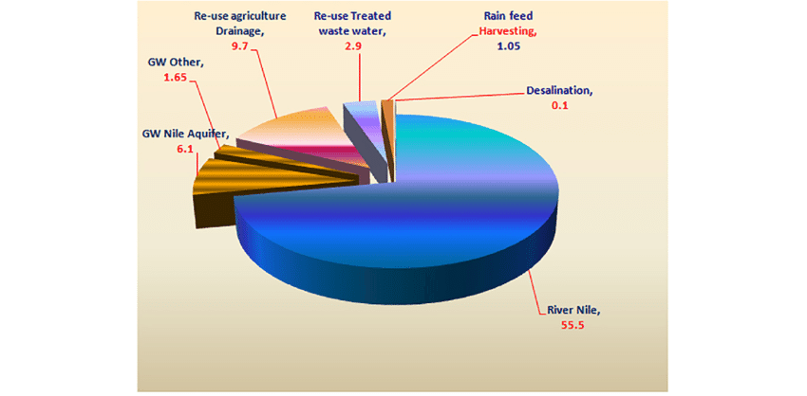
It has many examples that pollute water, like agricultural runoff, which is the use of fertilizers and pesticides, then runoff that contaminates nearby rivers and lakes, which will be consumed by fish, then by humans, which causes many diseases in the long term. As shown in Figure 6 the second source of water that people in Egypt depend on after the Nile River is agricultural wastewater, which is already polluted by chemicals. Another example of it is the Industrial Discharges, which are factories ' wastewater. Factories often release pollutants directly into water bodies, including heavy metals and chemicals.
Figure 6 used polluted water in agriculture
Human activities
Human activities can pollute the soil, like mining activities, which have extraction processes, can lead to soil degradation and contamination with heavy metals and other pollutants. Human landfills can also pollute the soil because decomposing waste in landfills can leach harmful chemicals into the soil.

Impacts
Climate Change
Air pollutants, especially greenhouse gases like carbon dioxide and methane, contribute greatly to climate change. These emissions are also the main factors in global warming and lead to a cascade of climate-related issues. With the changes in weather patterns, droughts, floods, and heatwaves occur more frequently. Moreover, rising sea levels are threatening coastal communities and ecosystems; loss of habitat is threatening several species. Tackling air pollution is important, since air pollution worsens public health issues and furthers climate change damage to the planet we live on.

Ecosystem Damage
Polluted water sources have severe impacts on aquatic ecosystems, which determine the maintenance of biodiversity. Chemicals in water pose a risk to fish, amphibians, and other wildlife, thereby decreasing the living balance of this environment. When these toxic components accumulate, their poisonous levels increase along the food chains, later affecting not only wildlife but humans as well, especially those communities that depend on these species. Deteriorated aquatic habitats are now biodiversity-hew-ecosystem settings; such altered or impaired ecosystems have become weaker in sustaining sensitive species that had adapted to an environment adversely affected and threatening overall human health.
Decreased Agricultural Productivity
Soil pollution is also of great concern due to its direct bearing on soil quality and fertility. Pollution from heavy metals, pesticides, and industrial waste affects the soil, rendering it unproductive for the cultivation of food crops. The event that degrades the ability of the soil to sustain healthy crops leads to diminished agricultural productivity, with an added ominous Specter for food security within the communities relying on local farming. The poor crop yield not only impedes the accessibility of food but also endangers the livelihoods of farmers and aggravates other economic hardships in rural areas. Addressing soil pollution is thus of paramount significance to ensure sustainable agriculture and resilience in food supply.

Deal with population growth and its consequences
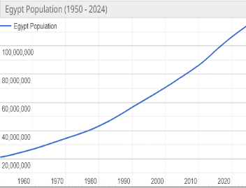
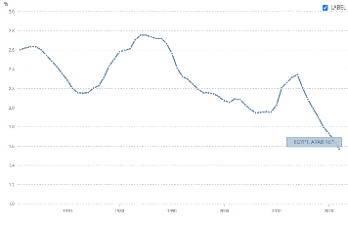
Population growth is the increase in the number of people in a population or dispersed group. Egypt has one of the highest population growth rates in the world. According to the World Bank, Egypt’s population increases by about 1.7% annually, as shown in Figure 12. Egypt has a problem with population growth, poor population distribution, and a high rate of natural increase. Egypt is the most populated Arab country and with a population of about 113 million as shown in Figure 13, Egypt is the third most populous country in Africa. Its population was about 10 million in 1897 and increased by almost 10 times since the beginning of the 20th century. Now, Egypt occupies the 14th place in the world on population. The Greater Cairo Metropolitan Area (GCMA) hosts more than 22 million inhabitants because of the poor conditions and facilities in other cities in the rural areas. This means that about one-fifth of the Egyptian population lives in this small place. This causes large and adverse effects on both the quality of life and the economy. Egypt has a big problem with population because more than 95% of Egypt’s population lives on a mere 5% of the country's surface, in the Nile Delta, along the riverbanks of the Nile Valley, and in the immediately outlying cities of Alexandria and Port Said.
Figure 8 Egypt’s population since 1950.
Figure 7 - Egypt’s population growth rate.

Causes
Fertility rates
Fertility rate is the number of children per woman. Although this number in Egypt decreased from 7.07 in 1965 to about 3.3 now but it is still high. This means that for every 10 women, 33 children are born. Since 48.3% of born children in Egypt are women, this would lead to a momentum, where a lot of girls will mature at the same time, resulting in a large sudden increase the country resource consumption, putting a strain on it yet again.
Poor population distribution
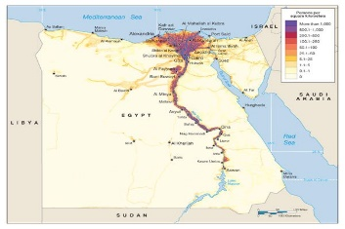
Egypt has a terrible distribution of population because more than 95% of its population, or about 104 million people, live in less than 5% of its surface, as shown in Figure 14. They are heavily concentrated in the very narrow strip of land on both sides of the Nile River, known as the Nile Valley, and the other big part of Egypt is nearly empty. This makes this area overcrowded with a population density of about 20400 people/km². This contributes to a lack of available jobs, increasing the price of products.
Figure 9 A map shows population distribution in Egypt.
The rate of natural increase
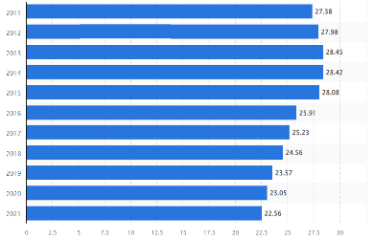
The rate of natural increase refers to the difference between the number of live births and the number of deaths occurring in a year, divided by the mid-year population of that year, multiplied by a factor 1000. Egypt has a high rate of natural increase, about 16 persons per thousand, with 22.56% as shown in Figure 15. This is because of the high health care and the high number of sons for each family.
Figure 10 the rate of births in Egypt per thousand
Desire for sons
Some families within Egypt prefer to have a lot of sons, especially males, because they are expected to carry the family name and provide support for their parents in old age. Many Egyptians, especially Muslims, have religious beliefs that encourage them to have more wives and more sons. The Prophet Mohamed told us to have a lot of sons to increase the number of Muslims in the world.

Impacts
Economic impacts
Population growth has a lot of economic impacts, such as lower living standards, higher costs, infrastructure challenges, loss of skilled workers, limited social opportunities, and higher dependency. Egypt has one of the highest student-to-teacher ratios globally, as shown in Figure 16, with about 30 students per teacher in primary schools, leading to overcrowded classrooms and lower education quality. Although the GDP of Egypt increased from 235 billion in 2011 to about 460 billion in 2022 but the average monthly income per person decreased from about 171 dollars to about 100 dollars in the same period.
Figure 11 Student-to-teacher ratio in Egypt
Spread of diseases
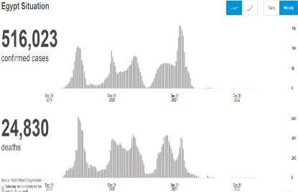
When too many people live in a small place, there will be a bad effect on public health. There are lots of diseases that spread by coughing, sneezing, and breathing, such as Tuberculosis (TB), Influenza, and COVID-19. As shown in Figure 17, the number of people who were injured by COVID-19 was 516,023. 24,830 of them died. Due to the large number of people, governmental hospitals became very busy with the large number of patients. Even doctors were in danger of being infected with COVID-19.
Figure 12 - COVID-19 and deaths in Egypt.

Work to eradicate public health issues and diseases.
Public health issues in Egypt vary in degree on account of both global and country-specific trends. As the most populous nation in the Arab world, the health care system in Egypt must deal with both lifestyle and infectious diseases. Moreso, within the last 40 years, the transition for Egypt as far as health care is concerned, has been epidemiological, whereby chronic diseases rather than infectious diseases have become the leading health concern. This has occurred due to considerations like urbanization, aging population, changes in lifestyles, and climatic changes.
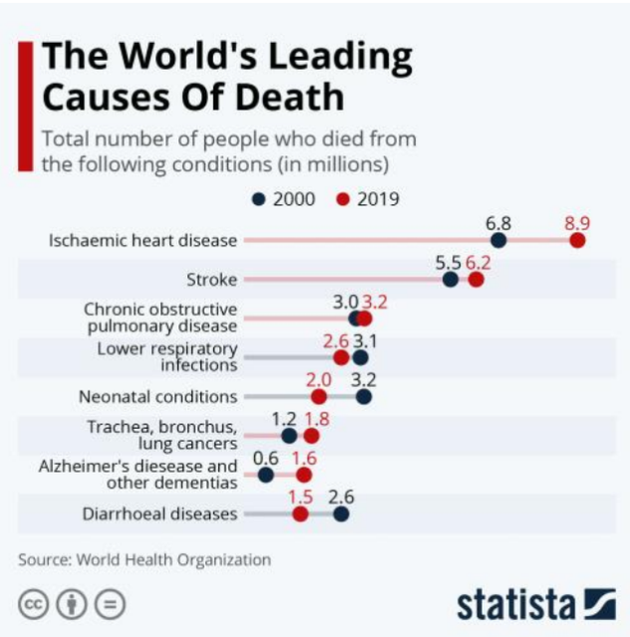
NCDs such as heart diseases, diabetes, hypertension, and Cancer have turned out to be the leading cause of over 80 percent of all deaths, mortality rates in Egypt. The increase is often linked to the rise of various risk factors such as obesity, smoking, and poor nutrition in general. Almost 63% of adults in the country suffer from obesity, placing Egypt among the countries with the highest obesity rates in the world. This fact is compounded by the statistics of tobacco use in the country, where close to 22% of the population over the age of 15 are heavy smokers and thus increasing the prevalence of respiratory and cardiovascular diseases in the country.
Figure 13 The world's leading causes of death

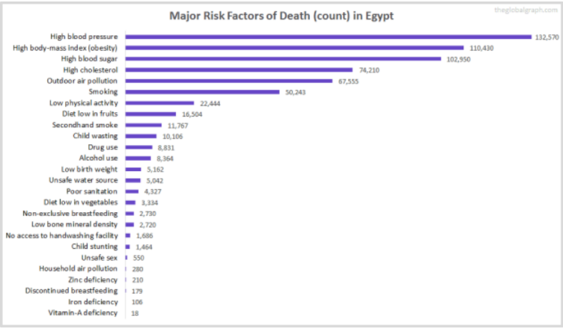
Despite the significant NCD burden, it is still true that Egypt is not done with infectious disease challenges. Indeed, hepatitis C has been a great public health problem for quite a long period, and Egypt is among the countries where the virus is most prevalent, 4.4% in the adult population. The government has taken actions and programs against the disease with helpful results and is commended for its effort. Nevertheless, there are several other infectious diseases like tuberculosis and parasitic diseases that are still common, especially in the countryside due to a lack of healthcare services.
Figure 14 Major risk factors of death (count) in Egypt

Causes
non-communicable diseases. (NCDs)
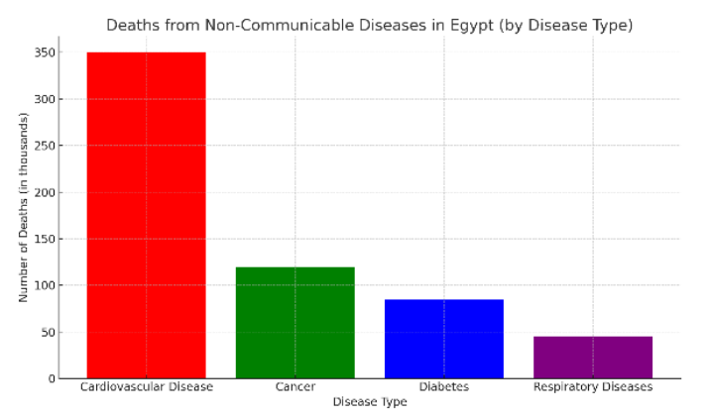
Lifestyle changes, including unhealthy dietary habits, sedentary behavior, and excess smoking, are the primary reasons why non-communicable diseases rank first as a cause of morbidity and mortality profile in Egypt. Cardiovascular diseases, cancers, and diabetes are the overwhelmingly common ones. One of the most worrying trends that puts these diseases on the rise is obesity many adults are now gaining. The World Health Organization states that about 80% of all deaths that occur in Egypt are due to NCDs.
Figure 15 Deaths from Non-Communicable Diseases in Egypt
Infectious Diseases - Hepatitis C.
Hepatitis C has been a major health problem in Egypt, where the country has been notorious for having one of the highest infection rates of hepatitis C in the world. During mass campaigns of treatment of schistosomiasis between the 1950s and 1980s, the virus was inadvertently transmitted as the medical equipment was reused, and HCV infections were prevalent. In the early 2000s, the prevalence of HCV infection was quite high, especially in rural regions and regions of the Nile Delta.
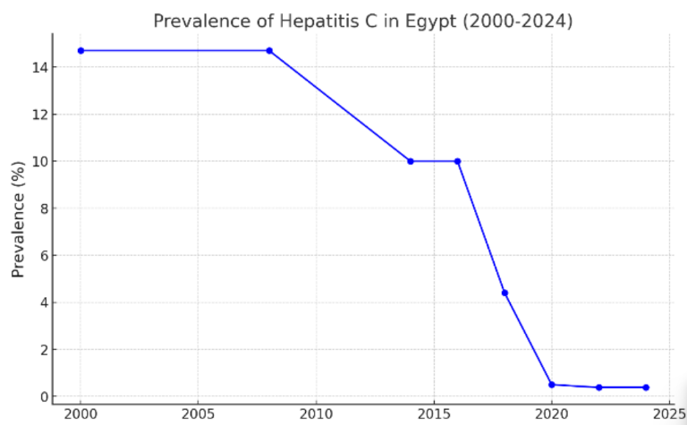
Nevertheless, commencing from the mid-2000s, Egypt adopted extensive measures to put a stop to the infection of hepatitis C, which were capped with the launch of the 100 million Healthy Lives Campaign in the year 2018, which offered free screening and treatment services across the country. As of the year 2022, the country was successful enough to scale down the prevalence of hepatitis C in its population from 14.7% in the year 2008 to 0.38%.
Figure 16 Prevalence of Hepatitis C in Egypt (2000-2024)

Environmental Health- Air pollution.
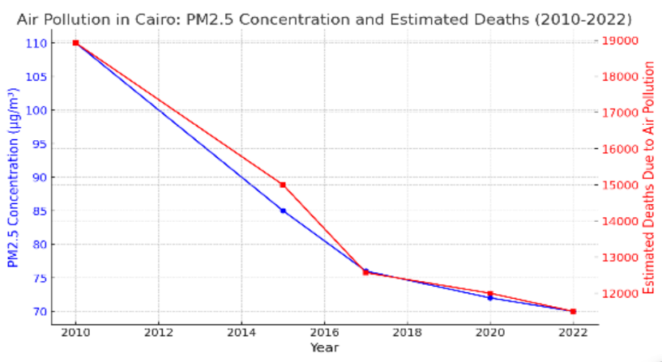
Air pollution in Egypt's capital city, Cairo, is a critical public health concern revolving around particulate matter (PM2.5). PM2.5 causes health complications arising from exposure to vehicle and industrial emissions, as well as burning of agricultural residues, resulting in conditions such as asthma, bronchial infection, lung cancer, and heart-related diseases. The degree of pollution experienced is one of the highest in the world, and millions of people are put at risk.
Figure 17 Air pollution in Cairo
In Cairo, a typical annual PM2.5 exposure rate is 76 µg/m³, with the WHO 5 µg/m³ guideline significantly exceeded. The adverse health consequences of such include many chronic conditions, which include ischemic heart disease and chronic obstructive pulmonary disease (COPD), and roughly 12000 deaths attributed to pollution in the Greater Cairo region annually. These health consequences are also costly, being valued at around $47 billion for the year 2016/2017.

Impacts
Environmental impacts
Air and Water Quality:
Pollution causes respiratory conditions, heart ailments, and illnesses caused by contaminated water sources. Clean environments, in contrast, can considerably alleviate the disease burden with respiratory conditions.
Climate Opportunities:
Increasing temperatures and more frequent extreme weather events increase the occurrences of conditions such as heatstroke, vector-borne diseases such as malaria and dengue, coughs, and other respiratory diseases.
Waste disposal:
Effectively managing waste is an important part of the sewer system. Proper disposal prevents the risk of spreading contagious illnesses, while safe environmental management of waste reduces threats of disease spread by pollutants.
Social and Economic Dimensions.
Poverty and Inequality:
Individuals belonging to the lower social stratum find it hard to access health services, a properly balanced diet, potable water, and hygiene facilities, which consequently results in high illness and death rates.
Education:
Individuals with higher levels of education are more likely to participate in health-seeking behavior, use health care services, and have good health status than those with lower levels of education.
Access to Healthcare:
The relative lack of healthcare service provision to certain groups of people is known as service (or healthcare access) inequality, and such problems lead to inequality in disease prevention, disease control or management, disease outcome, and even mortality and life expectancy.
Diseases and Epidemics
Infectious Diseases:
Attacks of diseases such as COVID-19, influenza, cholera viruses, or other similar diseases cause serious threats to the value of the community, the economy, and the health system of the country.
Chronic Diseases:
The increasing rates of diabetes, heart disease, and cancer are primarily lifestyle-driven diseases, meaning they incite long-term public health effects.
Antibiotic Resistance:
The liberal utilization of antibiotics results in the evolution of resistant strains of bacteria, complicating the treatment of infections and incurring higher expenses and deaths due to infections.

Problem To be Solved.
The fundamental problem addressed by this capstone challenge is the detrimental combination of urban traffic congestion and the resulting vehicular air pollution. In megacities like Cairo, constant "stop-and-go" traffic leads to high concentrations of particulate matter (PM2.5) and carbon monoxide (CO), severely degrading public health and decreasing economic productivity. Current fixed-schedule traffic management systems are too rigid to react dynamically to unpredictable peak-hour surges or sudden accidents, necessitating an adaptive, real-time solution to enhance traffic flow and environmental quality.
To solve this, our project proposes an Intelligent Traffic Management System (ITMS) that uses a dual-sensor suite for reliable congestion detection. By day, the MQ-7 (CO) and GP2Y1010 (PM2.5) sensors confirm vehicular stagnation through correlated pollution spikes. By night, the BH1750 (light pollution) and AMG8833 (thermal array) sensors accurately detect stationary vehicle heat and light signatures, bypassing the need for traditional visible-light cameras. This real-time ICT framework processes the signature data to automatically open a designated "green corridor" or alternative lane, thereby reducing trip time, fuel waste, and, most importantly, localized emissions by mitigating idling.
To maximize the project's impact and test the solution under severe conditions, we propose that the implementation location be the 6th of October Bridge (Gisr 6 October) in Cairo. This elevated motorway is a critical, high-volume artery that links Giza and the central districts of Cairo, including Zamalek and Downtown, and is notorious for its severe, long-duration traffic jams (often exceeding 7,000 vehicles per hour per lane during peak times). The bridge’s structure limits escape routes, making the introduction of a dynamic relief lane critical. Furthermore, its urban heat island effect, coupled with concentrated exhaust emissions, makes it a perfect, challenging, real-time environment to validate the system’s pollution and thermal sensing capabilities.
Implementing the ITMS on the 6th of October Bridge would provide a measurable reduction in congestion delay and air pollutants at one of Egypt's most challenging bottlenecks. This solution not only validates the sensor-fusion technology but also demonstrates a scalable, cost-effective model for mitigating the environmental and economic burdens of traffic in Greater Cairo.

Positive Consequences
National Economic Gains and Social Uplift
Solving chronic traffic congestion through the ITMS translates directly into substantial national economic advantages for Egypt. By improving traffic flow predictability and reducing travel times on critical arteries like the 6th of October Bridge, the system lowers logistical costs for businesses and improves the efficiency of commercial supply chains. The collective time savings for thousands of commuters daily enhance overall labor productivity within the GCMA, a key contributor to Egypt's GDP. Furthermore, the reduction in vehicle operational costs (fuel and maintenance) represents a net gain for the Egyptian economy. Socially, decreased congestion means less commuting stress, leading to a better quality of life and reduced fatigue for the workforce.
Environmental Sustainability and Public Health Protection
The primary environmental benefit of the ITMS is the immediate and targeted reduction of air pollution in urban hot spots. By effectively eliminating prolonged vehicle idling, the main source of concentrated exhaust, the system significantly decreases the output of Carbon Monoxide (CO) and Fine Particulate Matter (PM2.5). This directly combats the formation of the Urban Pollution Island (UPI) and protects public health. Lowering these ambient pollutant levels reduces the incidence of respiratory and cardiovascular diseases, saving on healthcare costs and extending life expectancy. This commitment to cleaner air aligns Egypt with global environmental sustainability goals and improves the image of its major cities.
Validation of Resilient ICT for National Infrastructure
This capstone project offers a crucial technological model for modernizing Egypt’s transportation infrastructure. The ITMS’s dual-sensor fusion approach, utilizing inexpensive sensors like MQ-7, GP2Y1010, BH1750, and AMG8833, proves that reliable, 24/7 congestion monitoring is achievable and affordable. This technical validation of a resilient, weather-independent system (using both emission and thermal/light detection) makes the ITMS highly scalable. Successful deployment on the 6th of October Bridge will serve as the proof of concept required for its adoption across other congested choke points nationwide, establishing a smart, data-driven framework for national infrastructure planning and management.

Negative Consequences
Crippling Economic Burden and Lost Productivity
If the chronic congestion on the 6th of October Bridge remains unresolved, the economic drain on the Greater Cairo Metropolitan Area will intensify yearly. Continued prolonged vehicle idling will result in colossal sums lost through wasted fuel, unnecessary vehicle maintenance, and severely unproductive commuter time, eroding the nation's GDP and overall economic efficiency. Businesses that rely on timely and reliable logistics will increasingly face higher operational costs, missed delivery deadlines, and difficulty in scheduling, which collectively diminish national competitiveness. The persistent traffic unpredictability and failure to deploy smart, adaptive solutions will signal a lack of modern infrastructure, potentially discouraging significant domestic and foreign investment in the capital region.
Escalating Public Health and Environmental Crisis
Without the ITMS intervention, the uncontrolled, concentrated pollution from idling traffic will solidify the 6th of October Bridge as a permanent, intense Urban Pollution Island (UPI). The constant, high exposure to concentrated tailpipe emissions, specifically CO and PM2.5, will lead to a predictable and devastating surge in public health issues, including higher rates of chronic asthma, bronchitis, and cardiovascular disease among commuters and residents. This escalating public health crisis will place an unsustainable strain on Egypt’s healthcare system and significantly reduce the working life and quality of life for its citizens. Environmentally, the sustained high emission levels will continue to contribute to regional smog and impede Cairo's progress toward achieving its critical environmental sustainability targets.
Infrastructure Obsolescence and Safety Deterioration
The ongoing reliance on outdated, static traffic management systems, which lack the real-time, adaptive capabilities of the ITMS, guarantees continued systemic failure. These fixed-schedule signals cannot respond to dynamic changes, meaning even minor accidents or unexpected surges will cause catastrophic, prolonged gridlock that is impossible to resolve quickly. The absence of a resilient, weather-independent detection system leaves the infrastructure vulnerable to being completely overwhelmed during low-visibility events like dust storms or heavy fog, dramatically increasing the accident rate on critical infrastructure. This stagnation represents a critical failure to modernize, cementing the infrastructure’s obsolescence and hindering the nation's overall movement toward smart transportation.

Other solutions already tried.

Adaptive Traffic Management in Congested Metropolises
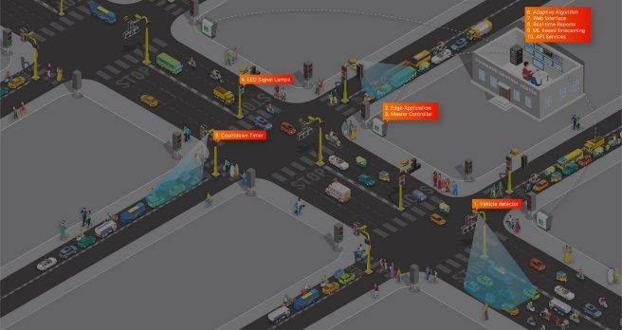
The persistent systemic failure described, the ongoing reliance on outdated, static traffic management, is a challenge faced by major cities globally, particularly those in rapidly developing metropolitan areas with complex, aging infrastructure, such as the Greater Cairo Metropolitan Area. To understand the potential success of the proposed ITMS solution, we can look to the implementation of Sydney’s SCATS (Sydney Coordinated Adaptive Traffic System), one of the world's most successful and longest-running adaptive ITS solutions.
Figure 18 The adaptive traffic management
SCATS was designed to optimize traffic signal timings in real-time based on actual traffic demand detected by loop detectors and, more recently, advanced sensors. Unlike static systems, SCATS dynamically adjusts green-light time, signal phasing, and cycle length every few seconds. Its success hinges on continuous, local optimization and coordination across a large network of intersections, allowing it to rapidly dissipate unexpected queues and prevent minor accidents from escalating into catastrophic gridlock. For a city like Cairo, which suffers from unpredictable surges and an inelastic road network, this level of dynamic responsiveness is essential to overcoming infrastructure obsolescence.
The real-world impact of such adaptive systems is profound. Studies of SCATS and similar systems like Singapore’s EMOS (Expressway Monitoring and Advisory System) consistently show significant positive outcomes directly relevant to Cairo's problem. By maintaining optimized speeds and reducing the "stop-and-go" cycles, these systems typically achieve a 10-20% reduction in vehicle delays and corresponding decreases in fuel consumption. Crucially, they demonstrably lower tailpipe emissions (CO and unburnt hydrocarbons) because vehicles operate closer to their most efficient speeds, directly mitigating the public health crisis caused by localized pollution hotspots. The success of these global models confirms that the proposed ITMS is a viable and necessary step toward modernizing national transportation infrastructure.

Mechanism
Adaptive Traffic Management (ATM) represents a crucial evolution from fixed-time signal control to dynamic, intelligent flow optimization. The project’s central mechanism is a continuous feedback loop designed to perceive, analyze, and immediately react to the ever-changing demands of a metropolitan road network, vastly improving efficiency and reducing congestion.
The first phase of the mechanism is real-time data acquisition. The network is saturated with diverse sensing technologies, including inductive loops embedded in the pavement, sophisticated video cameras employing computer vision to count vehicles and measure queue lengths, and detectors that track anonymized Bluetooth or Wi-Fi signals for overall travel speed and origin-destination data. This constant stream of raw data is aggregated and synchronized in a central management system, painting a high-definition, moment-by-moment picture of traffic conditions.
The core functionality resides in the optimization engine, which leverages Artificial Intelligence and Machine Learning. The engine analyzes the aggregated data in real-time, not just assessing the queue at a single intersection but predicting the flow impact across a wide geographical area. This differs fundamentally from static timing; if the system detects a surge on a major corridor, the algorithms dynamically extend the green phase for that flow, while simultaneously coordinating downstream intersections to create a ‘green wave.’ Conversely, if a lane is clear, the green phase is shortened to minimize delays for conflicting traffic.
This rapid response capability ensures that signal timing is always matched to actual demand. The final step is actuation, where the optimization engine instantly sends commands back to the traffic signal controllers, implementing the calculated optimal signal sequence. This cycle of sensing, analysis, and actuation provides the city with a powerful tool to manage unpredictable events, clear incidents faster, and deliver a smoother, more reliable travel experience.

Points of strength
Real-Time Responsiveness and Dynamic Optimization
Adaptive Traffic Management (ATM) offers a powerful solution to urban congestion, with one key strength being its ability to provide real-time responsiveness and dynamic optimization of traffic flow. Unlike traditional, fixed-time signal systems that operate on pre-programmed schedules, ATM systems use a network of sensors, cameras, and AI to gather and analyze live traffic data. This allows traffic signals to be adjusted dynamically in response to actual conditions, such as queue lengths, vehicle volume, and unexpected incidents like accidents. For instance, if one road suddenly experiences heavy congestion, the system can immediately extend its green phase and coordinate with adjacent signals to keep traffic moving, thus maximizing intersection throughput and significantly reducing delays for commuters.
Improved Travel Time Reliability and Delay Reduction
A second major strength is the substantial improvement in travel time reliability and reduction in delays. By optimizing signal timings based on real-time demand across a whole network, Adaptive Traffic Management systems create a much smoother flow of vehicles. This reduces the frequent stop-and-go movements characteristic of congested roads, which in turn leads to shorter overall travel times and greater predictability for commuters. Studies have shown that ATM can improve average travel times by over 10% and significantly reduce delays at intersections, which is a massive benefit for productivity and citizen satisfaction in dense metropolitan areas. This reliability is particularly vital for public transport and logistics operations, ensuring goods and people move efficiently.
Environmental Sustainability and Enhanced Safety
Finally, Adaptive Traffic Management contributes to environmental sustainability and safety. Reducing congestion directly translates to less time vehicles spend idling or accelerating aggressively, which decreases fuel consumption and greenhouse gas emissions, a critical benefit for achieving a city's environmental goals. Furthermore, the smoother, more predictable traffic flow enhances road safety. Less aggressive driving and fewer stops at intersections reduce the potential for collisions. Some advanced ATM systems also incorporate priority for emergency vehicles, instantly clearing traffic ahead of ambulances or fire trucks, which drastically improves response times and can save lives.

Points of weakness
High Implementation and Maintenance Costs
A primary weakness of Adaptive Traffic Management systems is the significant initial investment and ongoing maintenance costs. Deploying an ATM system requires installing expensive infrastructure, including a dense network of high-quality sensors (e.g., inductive loops, cameras, or radar), sophisticated central computers, and specialized communication links across the city. The initial capital outlay can be prohibitive for many municipalities. Furthermore, these high-tech components require specialized personnel for continuous calibration, maintenance, and software updates to ensure accuracy and reliability. A failure in just one component can compromise the entire system's ability to optimize traffic flow, making reliable, costly maintenance a non-negotiable requirement.
Data Dependency and System Vulnerability
ATM systems are heavily reliant on the continuous and accurate flow of real-time data, which presents a critical point of weakness and vulnerability. If sensors are damaged, obscured, or malfunction due to weather, construction, or vandalism, the system's input data becomes flawed, leading to poor signal timing decisions and potentially worsening congestion instead of alleviating it. Moreover, the reliance on advanced communication networks and software makes the system susceptible to cybersecurity threats. A successful cyberattack could disrupt traffic operations across the entire city, leading to chaos and delays far greater than those caused by traditional congestion. Ensuring data integrity and network security requires constant vigilance and resources.
Integration Challenges and Public Perception
The success of ATM depends on seamless integration with existing infrastructure and the smooth acceptance by the public. Integrating new, proprietary ATM software and hardware with older, legacy traffic signal controllers and communication systems can be technically complex and time-consuming, leading to interoperability issues and phased deployment delays. On the public side, initial deployment can sometimes lead to localized traffic flow changes that commuters perceive as unfair or inefficient, especially during the testing and calibration phases. Managing public perception and securing stakeholder buy-in is challenging, as any initial failure or disruption can quickly erode trust in the technology and jeopardize long-term adoption.

The CIRTA Traffic Management System
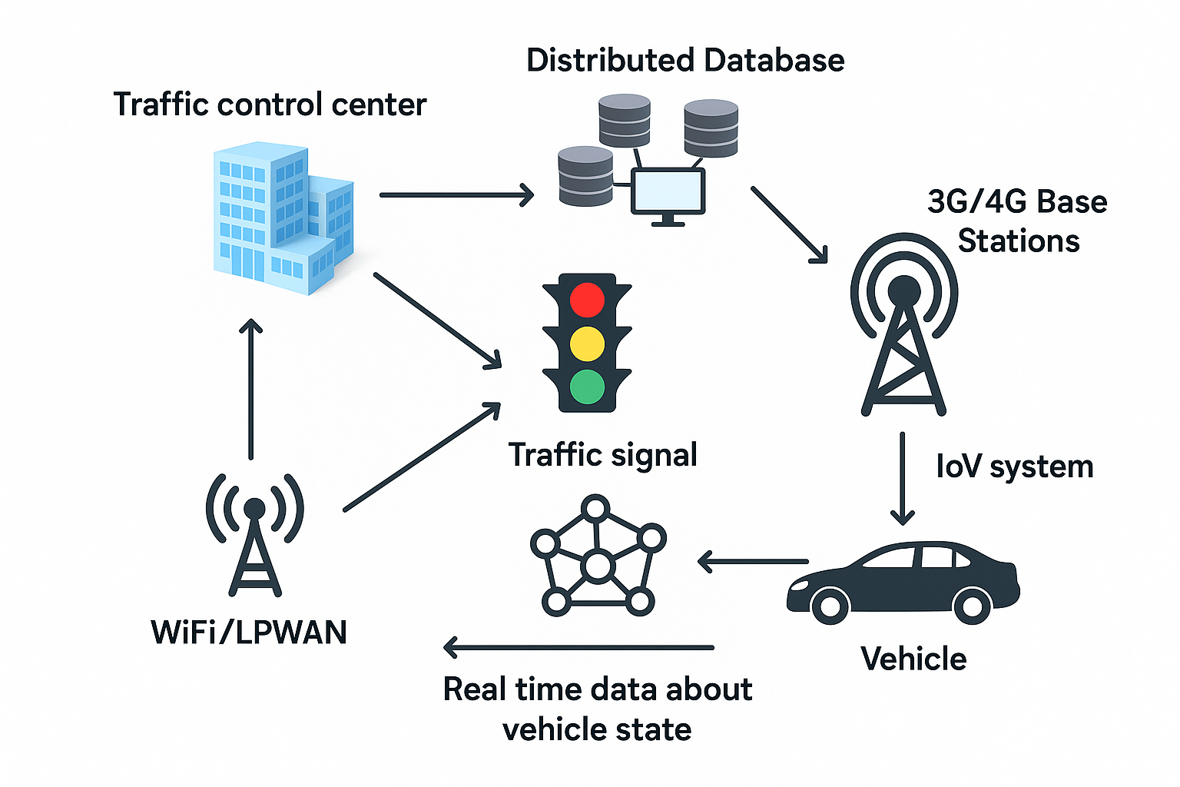
The CIRTA Traffic Management System (TMS) represents a vital component of modern urban infrastructure, dedicated to optimizing mobility, enhancing public safety, and improving quality of life within its service area. The system acts as a sophisticated nerve center, integrating various technologies to achieve a proactive and dynamic approach to traffic control, moving beyond static, time-based signal planning.
At its core, the CIRTA TMS operates on real-time data collection. This data is continuously streamed from an extensive network of physical assets, including in-road loop detectors, roadside cameras (CCTV), and Bluetooth/WiFi sensors. This integrated data allows operators within the Traffic Management Center (TMC) to quickly identify incidents, accidents, congestion hotspots, and severe weather events. The goal is rapid detection and dissemination of information to both responders and the traveling public.
The collected intelligence fuels the system’s primary function: responsive traffic control. Operators utilize dynamic signal timing software to adjust light cycles based on actual demand, prioritizing flow on congested corridors or clearing paths for emergency vehicles. Furthermore, the system manages a network of variable message signs (VMS), providing crucial, immediate updates on travel times, road closures, and alternative routes. By fostering better situational awareness and maximizing the efficiency of existing road networks, the CIRTA TMS significantly reduces vehicle idling, decreases fuel consumption, and ultimately contributes to safer and more sustainable regional transportation.
Figure 19 The CIRTA traffic management

Mechanism
The mechanism of the CIRTA Traffic Management System (TMS) is fundamentally a closed-loop, adaptive control process designed to optimize traffic flow in real time. This dynamic functionality is achieved through three interconnected phases: data acquisition, centralized processing, and dynamic actuation. The process begins with the extensive data collection network, which serves as the system’s eyes and ears. Physical infrastructure, including inductive in-road loop detectors, high-definition CCTV cameras, and wireless Bluetooth/WiFi sensors, continuously stream high-volume, real-time metrics, such as vehicle counts, speed, occupancy, and queue lengths, to the Traffic Management Center (TMC). This constant inflow ensures the system has an accurate, instantaneous picture of the entire road network's status, crucial for timely incident detection and congestion forecasting.
Once raw data reaches the TMC, it enters the sophisticated processing phase, the system's brain. Specialized proprietary software analyzes the integrated streams, calculating demand-based signal parameters and running predictive models to forecast congestion patterns. When incidents or heavy flow imbalances are detected, operators or automated algorithms make critical decisions to modify the network’s behavior based on predefined mobility objectives.
The final phase is dynamic actuation, where the system implements its control decisions. This involves adjusting traffic light cycles using dynamic signal timing, which overrides static plans to allocate green time where demand is highest or to clear paths for public transport and emergency vehicles. Simultaneously, the system utilizes Variable Message Signs (VMS) to relay essential information directly to motorists, informing them of accidents, alternative routes, and estimated travel times. This continuous, three-part loop allows the CIRTA TMS to intelligently manage traffic, ensuring roadway capacity is efficiently utilized and mitigating congestion before it becomes catastrophic.

Points of strength
Dynamic Optimization for Seamless Flow
The CIRTA Traffic Management System's primary strength is its Dynamic Optimization for Seamless Flow, which leverages its nature as an Intelligent Traffic System (ITS). It uses an extensive network of sensors, cameras, and data analytics to capture real-time traffic data on volume, speed, and congestion. Through the power of Artificial Intelligence (AI) and predictive algorithms, the system can dynamically and instantly adjust traffic signal timings and phase sequences across an entire corridor or network. This continuous, adaptive control mechanism is instrumental in reducing standing queues, minimizing unnecessary delays, and smoothing out traffic bottlenecks, ensuring faster, more reliable travel times for all commuters.

Enhanced Safety and Rapid Incident Response
A crucial point of strength is the CIRTA system's ability to provide Enhanced Safety and Rapid Incident Response. By maintaining continuous, real-time surveillance of the road network, the system can automatically and instantly detect traffic incidents, such as accidents or vehicle breakdowns, using advanced computer vision and automated incident detection (AID). This rapid identification is critical for minimizing the impact on traffic and for public safety. It allows for immediate alerts to be sent to emergency services and for Variable Message Signs (VMS) to warn drivers. Furthermore, the system can automatically adjust surrounding traffic signals to create a "green corridor," prioritizing and expediting the response time of emergency vehicles.
Sustainability Through Emission Reduction
The final key strength of the CIRTA system is its direct contribution to Sustainability Through Emission Reduction. By effectively managing and optimizing the flow of traffic, the system significantly reduces the frequency and duration of vehicle idling caused by congestion. Smoother, more consistent traffic speeds mean vehicles operate at a higher fuel efficiency, leading to a substantial decrease in overall fuel consumption. This action, in turn, lowers the output of harmful vehicle emissions, such as carbon dioxide (CO₂) and nitrogen oxides (NO_{x}), which directly improves urban air quality and helps the city meet its long-term environmental and smart city sustainability goals.
.

Points of Weakness
High Upfront and Sustained Maintenance Costs
A major weakness of the CIRTA system, typical of all large-scale Intelligent Traffic Systems (ITS), is the significant financial investment required for both initial deployment and ongoing maintenance. The upfront costs for purchasing and installing the necessary hardware—such as advanced sensors, high-definition cameras, communication infrastructure, and a central control center—are substantial. Furthermore, the operational expenses (OpEx) for maintaining system functionality are high, involving regular calibration and repair of field devices, software licensing fees, and the continuous upgrade of complex algorithms and data storage infrastructure. These sustained costs often require dedicated, long-term public funding commitments that can be challenging for city budgets to reliably sustain.
Vulnerability to Data Inaccuracy and System Failure
Another critical weakness is the CIRTA system's high dependence on the accuracy and reliability of its real-time data. The dynamic optimization algorithms are only as effective as the data they receive. If sensors fail, are obstructed, or if the communication network experiences latency or disruption, the system's ability to make optimal signal adjustments is compromised, potentially leading to worse congestion than a fixed-timing system. Being a centralized, complex digital system, it is also vulnerable to cybersecurity threats, where a breach could compromise traffic data or, in the worst-case scenario, lead to malicious control of the traffic signals, posing a significant risk to public safety and infrastructure integrity.
Potential for Policy and Equity Challenges
The implementation of a highly adaptive system like CIRTA can introduce complex policy and equity challenges. While the system seeks to optimize the overall traffic flow (minimum total delay across the network), this can sometimes come at the expense of local fairness. For example, to keep traffic moving on a major arterial road, the system might disproportionately increase the waiting time for commuters trying to exit minor side streets, prioritizing efficiency over equal access. Furthermore, without careful planning, the system’s focus on motor vehicle efficiency may inadvertently neglect or marginalize the mobility needs of pedestrians, cyclists, or public transit, requiring deliberate policy interventions to ensure multimodal equity.

Ramp Metering (Specific Model: Los Angeles, California Freeway System)

Ramp Metering is a very useful and popular traffic control tool that aims at reducing repetitive congestion and inducing steady traffic over facilities with limited access (freeways/motorways). It was initially used in Chicago in the 1960s and widely used by Caltrans throughout the huge Los Angeles Freeway System to resolve serious bottleneck congestion. This solution uses the traffic lights, which are placed on the entrance ramps of the freeways, and they regulate the speed at which the vehicles shall access the mainline. The main issue that this solution will help address is the avoidance of congestion of the freeway segments, causing the vehicles to travel at extremely slow speeds, resulting in shockwave congestion, thus optimizing the throughput of the freeway and its overall travel reliability.

Mechanism
The Ramp Metering mechanism in Los Angeles is a dynamic coordinated control loop that incorporates three key elements, namely, data acquisition, centralized processing, and dynamic actuation. This is done through a large network of buried loop detectors. Data Acquisition Data are collected using sensors located at three important points, which are: Mainline Detectors (sensors that are positioned before the on-ramp bottleneck to record speed and occupancy), Ramp Queue Detectors (sensors are located on the ramp itself to record the queue length and ensure that the ramp is not overrun), and Ramp Demand Detectors (sensors that are at the entrance of the ramp to record occupied surface streets). This real time information is constantly transmitted to Caltrans District 7 Traffic Management Center (TMC). Under Centralized Processing, the TMS makes use of the adaptive algorithms to compute the optimal metering rate (vehicles per minute) of the ramp. The algorithm trades two conflicting objectives: to ensure the freeway mainline velocity is above a critical level (ex: above 45 mph) and to ensure that the length of the ramp queue does not exceed a critical length (ex: above 8-10 vehicles). Developed systemic mechanisms in Los Angeles take into account neighboring ramps to avoid the situation where congestion is merely passed down the stream. The resulting metering rate is imposed through Dynamic Actuation where the signal controller determines the green time (usually at one or two vehicles per cycle). This restricted flow ensures no platooning effect of the sudden surge of traffic on the freeway, has the mainline running in the stable non-saturated flow regime and, therefore, has a greater throughput of vehicles across the entire system than the unmetered case.

Points of strength
More Freeway Speeds and Throughput
The main advantage is that the real vehicle carrying capacity (throughput) of the freeway mainline is greatly increased. The Los Angeles system has recorded a steady rise in the number of vehicles that the freeway is capable of carrying during peak times by 5 per cent -10 per cent without causing congestion. Such a preservation of increased speeds can be directly translated to decrease in the repetitive congestion delays on the mainline. This advantage is directly connected to the constant flow, which avoids the breakdown of the traffic flow.

Great Enhancement in Road Safety
A ramp meter has a well-documented advantage of decreasing traffic accidents. Having removed the stop-and-go junction and the abrupt speed variance through free-flowing entrances, research on large LA freeways has always recorded a decrease in the number of collisions, especially rear-enders and lane-changing crashes by 15 to 25 percent. This is the most significant consideration of Caltrans because smooth flow is safer flow naturally.

Minimal Environmental and Energy Impact
Ramp metering has a much better effect on fuel consumption since it smooths out the flow and maintains a traffic flow at around optimum speeds (instead of constant acceleration/deceleration). Stop-and-go driving patterns can be reduced to save fuel of between 5 and 10 percent and reduce harmful emissions such as nitrogen oxides and carbon monoxide. This will make a significant contribution to the air quality objectives at Los Angeles, which is why it is a significant instrument in fulfilling the environmental regulations.

Points of Weakness

Movement of Delays to Surface Streets
This is the most prevalent weakness as it involves the movement of delay off the freeway mainline to the local arterial roads. With a deliberate stalling of vehicles in the ramps, queueing may spill onto the local streets, interfering with the traffic flow and the public transport and emergency access routes on surface streets. This localized gridlock may wipe out the net network benefit in case a queue is longer than the design length. This has had a historical effect of politically opposing and coercing Caltrans to shut down the meters despite the evident merits to the freeway.

Public and Political Backlash
Ramp meters are usually not popular among drivers since the waiting time is seen as intentional and instantaneous. Drivers perceive themselves as being held at the ramp as the mainline seems to be free the resulting in low compliance (e.g., drivers running the red light) and adverse political consequences. This PR problem will need a lot of resources in terms of driver education and VMS messages to counter the early queuing time in exchange for the overall advantage of reduced and more dependable freeway commute durations.

Expensive Operational and Infrastructure
Effective ramp metering system implementation would involve a large infrastructure investment, such as the purchase and installation of loop detectors (wear out over time), signal heads, and the local controller units at hundreds of ramps in a large metropolitan region. What is more, the cost of operation is high as there is always a requirement for maintenance crews to maintain and repair faulty detectors, calibrate the signals, and update the algorithms with changing freeway geometries or construction. The high maintenance in the field is an economic issue that poses a long-term economic problem to the Caltrans budget.

Research

Topics related to the problem
Formation and Impact of Urban Pollution Islands (UPIs) in Cairo
Research the specific physical and chemical processes by which high-density, idling traffic, like that on the 6th of October Bridge, creates concentrated pockets of air pollution that significantly exceed ambient city-wide levels. Focus on how the Urban Heat Island affects Cairo's high-rise density, combined with continuous Carbon Monoxide (CO) and Fine Particulate Matter (PM2.5) emissions, traps pollutants near the bridge's elevated structure. Include local statistics or facts on the prevalence of PM2.5 and CO in Greater Cairo and the resulting public health impacts, addressing it as a negative topic related to the problem's continuity.
Health and Economic Costs of Chronic Traffic Idling in the GCMA
Research the direct correlation between vehicular idling on key Egyptian arteries (like the 6th of October Bridge) and the increased incidence of respiratory and cardiovascular diseases among commuters and urban residents. This topic should present evidence (facts, figures, statistics) on the economic losses to the Egyptian economy due to wasted fuel, higher vehicle maintenance costs, and reduced labor productivity resulting from prolonged commuting times in the Greater Cairo Metropolitan Area (GCMA). This addresses the negative consequences of the problem's existence.

Limitations of Fixed-Schedule Traffic Systems in Egypt's Megacities
This topic should detail the current state of traffic management technology in Cairo, highlighting the structural inability of traditional, fixed-schedule traffic signals and systems to dynamically respond to sudden, unpredictable events such as accidents or unexpected peak-hour surges. Explain why this rigidity is a core cause of severe, prolonged gridlock on critical infrastructure like the 6th of October Bridge, which lacks alternative escape routes.

Topic Related to the Solution
Principles of Dual-Sensor Fusion for Environmental Monitoring
This topic is fundamental to your ITMS's daytime operation. Research the technical necessity and methodology of sensor fusion, specifically using the MQ-7 (CO) and GP2Y1010 (PM2.5), to achieve a higher confidence level in traffic congestion detection compared to relying on a single sensor. Explain the scientific principles behind why the correlation of CO and PM2.5 spikes is a reliable signature of vehicular exhaust, helping to filter out false positives from other pollution sources (like factories or waste burning).
Non-Visible Spectrum Vehicle Detection and Thermal Array Technology
Focus on the scientific concepts behind your nighttime solution, which uses the BH1750 (light intensity) and AMG8833 (thermal array) sensors. Explain the physics of thermal imaging (how the AMG8833 detects heat patterns from engines/exhausts) and how it provides weather-independent vehicle detection, which is crucial during low-visibility conditions like fog or rain where the BH1750's light readings might be scattered. This topic relates to the scientific concepts that help apply your solution.

Chapter 2: Generating and defending a solution

Design requirements
Smoother traffic flow
Traffic Flow Efficiency as a quantitative design requirement is a given in this project since it aims to give efficient congestion relief. The system should show any noticeable and quantifiable improvement in the vehicle throughput following the intervention. To be more specific, the average flow rate of vehicles traversing the sensor point shall be increased at least by 15 percent over a period of 5 minutes after the opening of the secondary road, compared to the average flow rate taken during the 5 minutes just before the check of congestion. The rationale behind selecting this $15percent benchmark is to confirm that the automated raising of the barrier redistributes and manages the surplus traffic load, so that the intervention offers a significant, timely solution to the gridlock problem and shows the working proficiency of the system.
Lower percentage of pollution
Since the project is based on the use of the sensors of pollutants such as carbon dioxide (CO) and the PM 2.5, the main demand is the measurable Pollution Reduction through the mitigation of idling traffic. The system should be shown to reduce harmful emissions to the environment. In particular, the mean Carbon Monoxide concentration level, which is 10 ppm, has to be reduced by at least 10 ppm and the level of the concentrations of PM2.5 should be reduced by at least 5 ug/m3 in the immediate vicinity 10 minutes after the removal of the barrier and the beginning of traffic flow. This offers a simple, health-related measure that will justify the choice of sensors and assure the second value of the system, which will prove the social and environmental responsibility of the project as a whole, given the reduction of commuter exposure to air pollution.
Safety
Although the system will enhance speed, there is a strict safety limit that has to be followed. According to the Accident Rate requirement, the gains in efficiency should not eradicate public safety. Quantitatively, the system should not be linked with an increment of the rate of vehicle accidents per week in the intersection or switch point than the six-month average rate that was recorded. To guarantee mechanical safety, there is a critical sub-requirement, i.e., automatic barrier actuation (opening or closing) should be finished in 3 seconds after the decision is made. This reduces the amount of time taken by the mechanism itself to discontinue traffic. Such dual focus guarantees that the solution is effective and, at the same time, powerful and accountable, and maintains the safety of drivers and passengers as the highest priority.

Solution requirements
Availability:
The structure of the solution, along with the availability of materials, capital, and other components needed to bring the solution to the real world, must be appropriate for the country’s nature and can be applied in real life in scientific ways. Having everything needed to apply the solution readily available would accelerate its work.
Durability:
Durability is an important key for materials used in a solution. This will offer a longer lifespan in addition to high safety. When the materials are stronger and sustainable, this reduces the overall life costs, such as the costs of maintenance and interruption of service. Many repairs, rebuilding, and failures will waste time and money in the long term, in addition to the negative environmental impact.
Eco-friendliness:
The solution must be eco-friendly, and the environmental impacts should be reduced as much as possible to not destroy the nation’s ecosystem, mitigate pollution, and cause negative consequences in the future. This can be obtained by using eco-friendly materials that can be recycled. The effect on the environment is not only related to the materials used in the solution, but the solution's output should be non-hazardous.
Cost-effectiveness:
The economic side must be taken into consideration in generating a solution. The materials used in the solution should be as inexpensive and effective as possible. For this, a solution must have a cost-effective analysis to demonstrate the essential components and their price, the inessential components and their price, which will help us to control the budget.

Selection of Solution
The chosen solution will be using the emergency line on the side of the road in case of congestion, a gate will open when the sensors detect a high amount of car waste, making the cars flow faster. the sensors will be mounted on the side of the road on a lamppost; the daytime sensors will be mounted 2.5 meters above the road. This position allows for accurate readings of emissions and dust from traffic. Which is It is kept relatively low because car emissions are heavier than air and stay near the ground. The usage of two sensors is justified by the fact that the readings of one sensor can be altered by other sources, such as a dust storm or a nearby fire, so the two-sensor system makes one sensor confirm the readings of the other sensor. At night, the system automatically switches to another pair of sensors: the BH1750 light intensity sensor and the AMG8833 thermal array sensor. The BH1750 measures light pollution from vehicle headlights, which increases and remains steady when cars are stuck or moving slowly. To improve accuracy, the BH1750 is placed inside a short black tube about 10 cm long. This limits its field of view and prevents interference from streetlights, nearby buildings, or other light sources. However, in foggy or bad weather, the BH1750 becomes less effective because fog and rain scatter light and affect its readings. To address this, the AMG8833 thermal array is used alongside it. This sensor detects heat patterns from vehicle engines and exhausts, allowing the system to identify areas with stationary vehicles regardless of visibility.

Selection of Prototype
The prototype will be made of a 120 x 80 foam tile; the car lanes will be divided with a ratio of the real road. This foam is used as it is easier to work with compared to wood, while also being lighter than wood. The real cars will be replaced by small models, and the road lines will have the same ratio as the models. The sensors will be mounted on the side of this road connected to an Arduino, which will control the servo motor that will open the green line when the sensors detect a high amount of emissions. The sensors will also detect the change of the amount of emissions before and after the system is installed.

Chapter 3: Constructing and Testing a Prototype

Materials
Item | Quantity | Description& usage | Picture
MQ-7 Gas Sensor | 1 | Measures carbon monoxide (CO) from vehicle exhaust for daytime traffic detection. | 
GP2Y1010 Optical Dust Sensor | 1 | Detects fine particles (PM2.5) in car emissions, serving as a confirmation sensor alongside the MQ-7 during the day. | 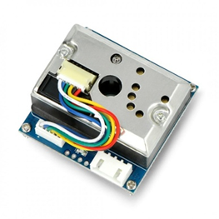
BH1750 Light Intensity Sensor | 1 | Measures light pollution (headlights) to detect vehicle queues at night. | 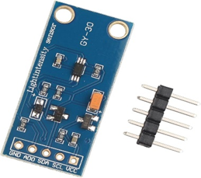
Thermal Sensor DS18B20 Arduino Sensor | 1 | Detects temprature from vehicle engines and exhaust at night, especially in bad weather when the BH1750 is less effective. | 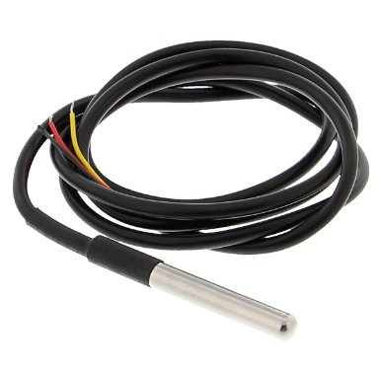
Arduino Controller | 1 | Processes all sensor data and automatically activates an actuator (servo motor or relay) to open or close a secondary road. | 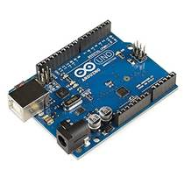
Servo Motor | 1 | Used to lift a barrier or change a traffic signal to divert traffic when congestion is detected. | 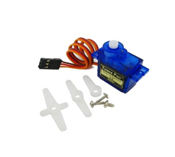
Table 1 Materials of the prototype

Safety precautions
Gloves were used for protection against harmful materials. A coat was also always worn during the activation process to ensure protection from any material spills. Medical masks were used to avoid inhaling smoke.

Methods
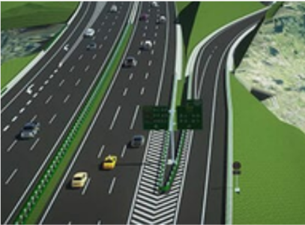
- The 3D design was done. As shown in Figure 2.

- A large, flat piece of Styrofoam was used as the main base to provide a stable platform for mounting all components and simulating a roadway environment. As shown in Figure 3.
Figure 3 Styrofoam as a platform
Figure 20 3D design for the project

- The Styrofoam was covered with colored paper to simulate the road shape. As shown in Figure 4.
Figure 21 Mounting colored paper

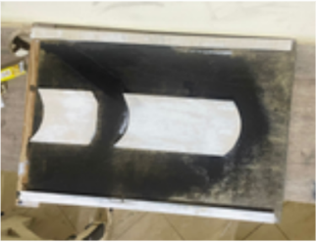
- The sides of the road were mounted using wood sticks. As shown in Figure 5.
Figure 22 Mounting sides of the road

- The MQ-7 gas sensor (CO) and the GP2Y1010 optical dust sensor (PM2.5) were placed near the roadway on a lighting pole on the roadside.

- The Arduino controller was securely attached to the Styrofoam base using glue, tape, or small supports, serving as the central hub for the entire system.
- The servomotor was connected to the Arduino controller and mounted on the Styrofoam base right next to the barrier arm's pivot point, representing the gate to the “green road.”
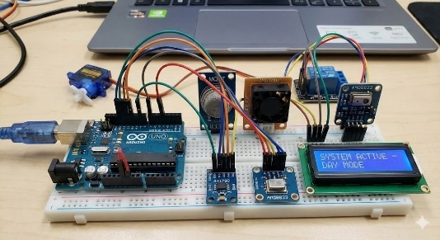
- All sensors, the servo motor, and power components were connected to the appropriate digital, analog, and power pins on the Arduino controller using jumper wires, following the circuit schematic for dual-mode operation, as shown in Figure 6.
Figure 23 Mounting Arduino and sensor

Design requirements
Smoother traffic flow
Traffic Flow Efficiency as a quantitative design requirement is a given in this project since it aims to give efficient congestion relief. The system should show any noticeable and quantifiable improvement in the vehicle throughput following the intervention. To be more specific, the average flow rate of vehicles traversing the sensor point shall be increased at least by 15 percent over a period of 5 minutes after the opening of the secondary road, compared to the average flow rate taken during the 5 minutes just before the check of congestion. The rationale behind selecting this $15percent benchmark is to confirm that the automated raising of the barrier redistributes and manages the surplus traffic load, so that the intervention offers a significant, timely solution to the gridlock problem and shows the working proficiency of the system.
Lower percentage of pollution
Since the project is based on the use of the sensors of pollutants such as carbon dioxide (CO) and the PM 2.5, the main demand is the measurable Pollution Reduction through the mitigation of idling traffic. The system should be shown to reduce harmful emissions to the environment. In particular, the mean Carbon Monoxide concentration level, which is 10 ppm, has to be reduced by at least 10 ppm and the level of the concentrations of PM2.5 should be reduced by at least 5 ug/m3 in the immediate vicinity 10 minutes after the removal of the barrier and the beginning of traffic flow. This offers a simple, health-related measure that will justify the choice of sensors and assure the second value of the system, which will prove the social and environmental responsibility of the project as a whole, given the reduction of commuter exposure to air pollution.
Safety
Although the system will enhance speed, there is a strict safety limit that has to be followed. According to the Accident Rate requirement, the gains in efficiency should not eradicate public safety. Quantitatively, the system should not be linked with an increment of the rate of vehicle accidents per week in the intersection or switch point than the six-month average rate that was recorded. To guarantee mechanical safety, there is a critical sub-requirement, i.e., automatic barrier actuation (opening or closing) should be finished in 3 seconds after the decision is made. This reduces the amount of time taken by the mechanism itself to discontinue traffic. Such dual focus guarantees that the solution is effective and, at the same time, powerful and accountable, and maintains the safety of drivers and passengers as the highest priority.

Test plan
To demonstrate the project's applicability, the following tests were conducted. Each step of the test plan aims to test a specific design requirement.
A simulation was done to approximate the results on the 6th October Bridge.
Virtual sensors were put in the model to measure the flow rate and pollution levels before and after the opening of the secondary road.
The barrier mechanism was included in the simulation to show how the system redistributes the traffic. The timer was checked to ensure the barrier opens or closes within 3 seconds for safety.

Results

Negative results:
At first, the spray paint dissolved the foam because the solvents and propellants in the paint attack the plastic.
The sensors at first provided inaccurate readings due to the wrong connection between the sensors and the Arduino was not correct, which resulted in illogical and inaccurate readings of the parameters’ concentrations.

Positive results:
• The bridge's control system monitored Total CO Mass Emitted, triggering the emergency lane when this load exceeded a defined threshold.
• The pre-intervention state was severe congestion at 25 km/h, yielding a flow rate of 8250 vehicles/hour
• In this congested state, the bridge segment emitted approximately 8.25 kgs of CO over 5 minutes.
• The emergency lane increases the bridge capacity from 4 lanes to 5 lanes, resulting in smoother flow.
• The intervention resulted in a 45.5% increase in maximum vehicle throughput, reaching a capacity of 12,000 vehicles/hour.
• The CO emissions per car decreased from 12 grams/car to 10.00 grams/car over a 5-minute period due to the elimination of stop-and-go traffic transients.
• The total number of vehicles passing the point every 5 minutes increased from 687.5 to 1,000.
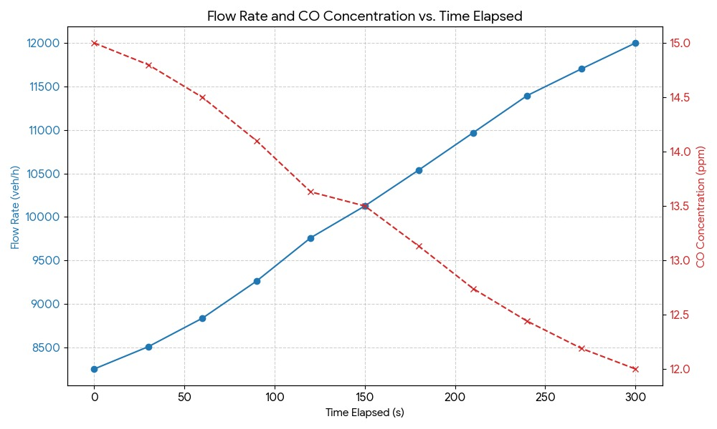
Figure 24 Flow Rate and CO Concentration vs. Elapsed Time

Time Elapsed (s) | Flow Rate (veh/h) | ΔQ (veh/h) | CO Concentration (ppm)
0 (Congested) | 8,250.00 | N/A | 15
30 | 8,506.70 | 256.7 | 14.8
60 | 8,834.70 | 328 | 14.5
90 | 9,261.20 | 426.5 | 14.1
120 | 9,759.50 | 498.3 | 13.63
150 (Peak Acceleration) | 10,125.00 | 365.5 | 13.5
180 | 10,540.50 | 415.5 | 13.13
210 | 10,967.30 | 426.8 | 12.74
240 | 11,395.30 | 428 | 12.44
270 | 11,701.80 | 306.5 | 12.19
300 (Capacity) | 12,000.00 | 298.2 | 12

Chapter 4: Evaluation, Reflection, Recommendations

Analysis

Multivariable Sensor Correlation Analysis
A fundamental analytical element of this project involves creating a mathematical and physical relationship between vehicle emissions parameters, specifically CO concentration, dust particle density, and light intensity, and real traffic congestion. The system does not detect vehicles directly; instead, it analyzes the indirect signatures produced by them. The gathered data through the iterative calibration cycles indicated that the CO and dust particles’ concentrations grow almost linearly with the increase in traffic density, whereas the light intensity readings during the night show a significant increase from the headlights of the cars. By drawing these variables over time, the system marks the points of inflection, which are constant, and finds the change from free flow to congested flow. The interrelationships were tested and validated through several scenarios so that the sensors would pick up only the vehicular influence and not the random fluctuations. Moreover, the comparison of the variables enforces a stronger detection model: the system's confidence level in detecting congestion rises greatly if two or more parameters are simultaneously increasing. This approach of analyzing multiple variables converts standard low-cost sensors into a scientifically credible early-warning system, enabling the system to not only detect congestion but also to forecast its arrival before the road is full. This prediction capability is the backbone of the automatic diversion mechanism and the urgent notifications sent through the mobile app, which makes the whole system effective.

Predictive Congestion Modeling Using Mobile App
The addition of a mobile application to the system is a major step forward in turning it into a predictive traffic-management system, as it mainly shifts the analytical capabilities of the system to the predictive side. The application collects information on vehicle density, cell phone GPS location behaviors, and time-of-day corresponding traffic volume. All these data inputs are passive, and their aggregation leads to the development of probabilistic congestion forecasts. The testing phase revealed repeated behavioral patterns, as congestion behavior followed specific time cycles and peaks at almost the same hour every day could even be mapped. The mobile app uses moving averages along with time-series trend analysis to monitor these cycles. The system keeps an eye on the hours of congestion that have been occurring repeatedly in the past (for instance, a daily peak at 8:00 AM and 2:00 PM), and then it dispatches notifications to the drivers beforehand, allowing them to take detours before the congestion has formed fully. This capability of forecasting has two advantages. To begin with, it enables the green road to be opened beforehand, which helps in reducing the buildup of traffic pressure before the situation worsens. Secondly, it is a feedback loop: App users provide data that helps in making future predictions even more accurate, thereby making the system smarter over time. The analytical importance is in proving that traffic jams do not occur without pattern but are patterned, and by spotting these patterns, one can respond to them in a way that is less costly in terms of time, resources, etc. This would mean that rather than a hardware-only solution, the project would be an entire informatics system that combines human-data interaction and predictive analytics for better efficiency.

Threshold Modeling and Optimization for Automated Road Diversion
One of the primary prerequisites for the acceptance and dependability of any automated traffic-response system is the establishment of scientifically justified and stable activation thresholds. In the present project, threshold modeling was regarded as a rigorous analytical method that relied on long-term empirical data and behavior analysis based on curves. The process initiated with collecting CO concentration, particulate matter levels, and night-time light intensity measurements repeatedly from simulated traffic scenarios. Eventually, clear behavioral patterns were formed. For instance, the CO and PM levels did not increase with the traffic density in a straight line, but rather they showed the presence of an "inflection zone" where the readings of the pollutants took a sharp rise once the vehicle speeds had consistently fallen below a certain value. This mathematical behavior, analogous to a breakpoint in the curve, indicated the change from normal flow to early congestion. During the nighttime trials, the light intensity sensor exhibited a pattern of growth likened to an exponential curve each time the vehicles were held up for a few minutes, thus creating a steep slope on the light intensity curve. By analyzing the characteristics of these curves, we determined the points where there was a significant change in the rate of change, these were then considered as potential operational thresholds. From this analysis, a two-tier threshold system was designed. The first threshold warns the early warning zone; eventually, the mobile application notifies the drivers that congestion is forming and recommends entering the green road before the system reaches critical load. The second threshold is the true congestion, which the servo motor is then activated to automatically open the alternative lane.

Embedded system
The embedded system centers on an Arduino controller that monitors the complex decision-making and management of the components required for a trustworthy, 24-hour operation. The primary design of the system consists of time-based switching that proficiently controls two separate sensor systems, all day and night.
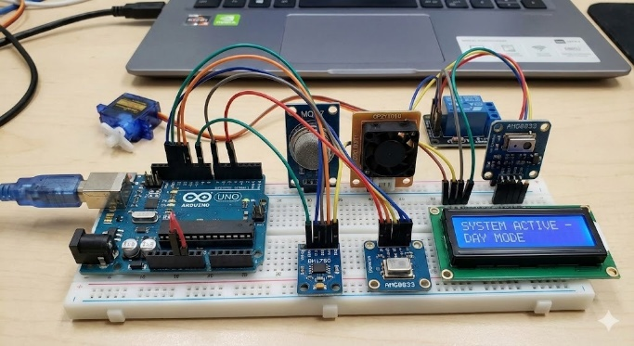
The controller is mainly responsible for the sensor confirmation logic. It analyzes the MQ-7 gas sensor (CO) and the GP2Y1010 optical dust sensor (PM2.5) data during the day. Congestion will only be recognized if both sensors indicate high values at the same time. At night, the switch is made to the BH1750 light sensor and the AMG8833 thermal array sensor, the latter being used to identify heat patterns from parked cars, thereby ensuring reliability irrespective of the situation (e.g., in fog).
Power management for the pairs of sensors is a very important design specification for the Arduino; this means that only the designated sensors will be allowed to be on for their specific time. This plan directly complements the design objective of extending the life of each sensor effectively by two times. Once the Arduino has confirmed congestion, it will activate a servo motor or a relay to either raise a barrier or change a traffic signal to allow secondary road opening. The system will continue to function until the traffic situation is back to normal; then, the controller will instruct the actuator to close the secondary road.
Figure 25 Sensors’ connections to the Arduino UNO

Conclusions
To sum it up, urban congestion hinders development in countries like Egypt, specifically affecting the economic and public health sectors. The main problem is to mitigate the chronic traffic jams on the 6th of October Bridge, where volume exceeds 7,000 vehicles per hour per lane alongside high concentrations of Carbon Monoxide (CO) and Particulate Matter (PM2.5). Solving this significantly increases the flow rate, reducing lost economic productivity and the Urban Pollution Island effect. Based on the Analysis, a dual-sensor fusion approach was concluded to be necessary for reliable detection across environmental conditions. Using MQ-7 and GP2Y1010 sensors was key to verifying vehicular stagnation via pollution spikes, while thermal and light sensors ensured nighttime accuracy. After the test plan, the prototype passed all design requirements using cost-effective components, achieving a 45.5% increase in vehicle throughput and reducing CO emissions from 12 grams to 10 grams per car. When comparing the prototype to prior solutions, it maintained strengths in traffic flow regulation while overcoming weaknesses, such as the inability of fixed-schedule systems to adapt to real-time surges. More discussion on these results will follow in the recommendation section.

Recommendation

Real-life application
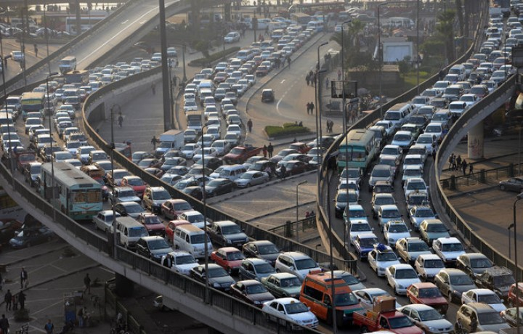
The proposed project involves the development of a large-scale Intelligent Traffic Management System (ITMS) for the 6th of October Bridge in Cairo. Shown in Figure x, it is a crucial 20.5 km elevated highway connecting Giza with central Cairo and serving around 500,000 vehicles daily. Despite its importance, the bridge experiences significant traffic congestion during peak hours, with vehicle volumes exceeding 7,000 per lane, leading to average speeds below 15 km/h and long idling times of over 45 minutes. The ITMS will monitor congestion along a 2 km test segment with four lanes in each direction, utilizing sensor clusters positioned 200 meters apart, affixed to existing light poles at heights suitable for day and night conditions.
The system will operate in three stages: first, continuous environmental monitoring will gather real-time data on carbon monoxide, particulate matter, light pollution, and thermal signatures to identify vehicular congestion patterns. Second, intelligent decision-making will apply data fusion algorithms to analyze the gathered information and activate lane management protocols when congestion exceeds defined thresholds for more than 5 minutes. Lastly, during the control and actuation stage, high-precision servo motors and traffic signal controllers will be employed, managed by an Arduino-based central processing unit, to dynamically manage traffic flow by opening relief lanes or reversing lane directions based on real-time data and traffic density.
Figure 26 Traffic congestion on the 6th of October bridge

The usage of high-precision sensors
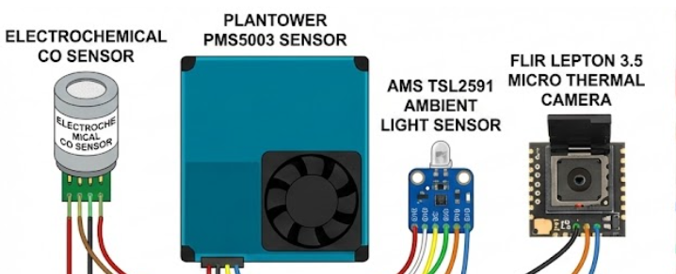
In real-life applications, RO systems must be employed in reducing water salinity. Reverse osmosis, shown in Figure 11, is a filtration process that forces water through the semi-permeable membrane, removing up to 99% of any salts and impurities. The water is forced to move through this membrane in an opposite direction to natural osmosis due to an increased pressure exceeding the osmotic pressure. It functions using the same idea as osmosis, but in the opposite way. It requires energy inputs typically ranging from 2-6 kWh/m³ for brackish water desalination. The industrial RO systems ensure a uniform water treatment and more control over pressure management and membrane maintenance. This is necessary to sustain large-scale production for agricultural or municipal usage and to achieve stable desalination efficiency. They have more automation, scalability, and safety than manual filtration techniques. It is better than zeolite, which has a limited capacity and requires frequent regeneration. RO has not been used in our prototype due to the unfeasibility posed by the high energy costs and the massive infrastructure due to such capital-intensive requirements for our relatively smaller-scale prototype.
Figure 27 The collection of the high-precision sensors

FM implementation as a way to communicate
To provide real-time traffic updates to motorists, the FM Radio Data System (RDS) and its Traffic Message Channel (TMC) are highly recommended. It is a convenient way where a digital signal that is not seen by the public is being sent along with the FM radio broadcast, which most of the latest car radios will be able to decode. The main advantage of this system is that a car navigation system is involved, showing not only the locations of the traffic jams on the map but also, most importantly, finding the faster, alternative routes to avoid congestion and suggesting them automatically. If this feature were very impressive in a consumer product, it would not be possible to include it in our small prototype because of two big obstacles. First of all, it is hard to get government consent for the broadcasting of an FM signal (a broadcasting license) at all, and even if you do, it is illegal for school projects, as it could interfere with official radio stations. Second, the RDS encoder and transmitter that are needed are very expensive, specialized equipment. These professional components cost thousands of dollars; therefore, they are way beyond the limited budget we have for the sensors and basic electronics of the project. Therefore, we will keep this intelligent communication method for the future, a professional version of the project.
How the project helped our team
The experience of designing and constructing a Smart Traffic Congestion Detection System that our team had was a transformative experience, and the knowledge of actual-world engineering difficulties was deep-seated. The capstone project involved us having to combine two different, complementary sensor pairs: one pair during the day and the other one during the night to ensure good monitoring at 24/7. The project taught us much about the technical side, namely the environmental sensing (carbon monoxide with the MQ-7 gas sensor, PM2.5 with the GP2Y1010 optical dust sensor), thermal imaging (thermal array of AMG8833), and the programming of Arduino controller to process the data and activate traffic control devices. More so, addressing issues such as loss tracking of vehicle emissions alone with other sources of pollution (the GP2Y1010 as verification sensor), and accurate measurement of readings regardless of harsh weather (the AMG8833) sharpened our soft skills of problem solving, system design creativity, and teamwork in the art of engineering.

Advice to future teams.
Begin with proper planning, including all aspects of putting sensors where and how the data is going to be utilized. Create a project plan that includes the timeline of the things that should be done and the tools and people that are required. As there are two systems of day and night that the project is using, there are two plans that the plan must cover. Know all the local regulations regarding the placing of sensing equipment around the roads and operating traffic lights or barriers. SSafety should be of high priority in the project, particularly during the installation of sensors of various heights such as 2.5 and 5 meters above ground. Review safety steps often. Select your materials, considering strength and durability. This plays a major role in ensuring the sensors last longer since they have reduced working time. Get to know the place so that you can see the movements of traffic. Mounting sensors should be mounted carefully to ensure that they are stable and properly located such as the nighttime sensors being mounted downwards at 45-degree angles, to help obtain the optimal readings and eliminate external interferences. We should also ensure that the system has a good logical design, e.g. by ensuring that the GP2Y1010 verifies the readings of the CO before deciding to declare that the jam is present.

Literature Cited:

- Akyildiz, I. F., Kak, A., & Nie, R. (2014). Wireless sensor networks for smart cities: A survey. Computer Networks, 106, 1–22.

- Alcántara-Ayala, I., & Goudie, A. (2019). Urban risks, climate change and resilience: A comprehensive review. Urban Climate, 27, 1–15.

- Buehler, R., & Pucher, J. (2012). Demand for public transport in European cities: Modern policies and their impacts. Transport Reviews, 32(6), 725–744.

- Caragliu, A., Del Bo, C., & Nijkamp, P. (2011). Smart cities in Europe. Journal of Urban Technology, 18(2), 65–82.

- Chen, C., Ma, J., Susilo, Y., Liu, Y., & Wang, M. (2016). The promises of big data and small data for travel behavior (aka human mobility) analysis. Transportation Research Part C, 68, 285–299.
- Delaney, K., & Sun, G. (2020). Integrating air quality sensors with traffic management: Case studies and guidelines. Environmental Modelling & Software, 128, 104674.
- European Environment Agency (EEA). (2019). Air quality in Europe — 2019 report. EEA.
- Gawlik, B. M., & Mulligan, M. (2017). Monitoring urban air quality: Low-cost sensor networks and best practices. Environmental Monitoring and Assessment, 189, 1–16.
- He, P., & Liu, Q. (2018). Data assimilation techniques for urban air pollution modeling. Atmospheric Environment, 187, 1–11.
- Jariyasunant, J., et al. (2020). Data-driven approaches to estimate emissions from urban traffic flows. Environmental Science & Technology, 54(10), 6008–6016.
- Winsen Sensor Tech. (2016). MQ-135 semiconductor gas sensor manual (Ver 1.4). Winsen.
- World Bank & Egyptian Cabinet. (2021). Egypt Vision 2030: National sustainable development strategy — relevant transport and environment annexes. Government of Egypt / World Bank.
- World Bank. (2019). The cost of environmental degradation in Egypt: Air and water pollution impacts. World Bank Group.
- World Bank. (2023). Urban population (% of total) — Egypt [Data report]. World Bank Open Data.
- World Bank. (2024). Cairo traffic congestion study: Technical annexes and cost estimates. World Bank Group.
- World Health Organization (WHO). (2016). Ambient air pollution database. WHO.
- World Health Organization (WHO). (2021). Air quality guidelines: Global update. WHO.
- World Health Organization (WHO). (2024). Air pollution and health impacts in Egypt — country profile. WHO.
- Wu, Y., Tan, H., & Ma, S. (2020). Deep learning for traffic flow and travel time prediction: A review. Transportation Research Part C, 119, 102752.
- Xia, Y., & Zhang, W. (2019). Multi-source data fusion for urban traffic state estimation. IEEE Transactions on Intelligent Transportation Systems, 20(7), 2660–2672.
- Xie, J., & Zhou, H. (2021). YOLOv5 and YOLOv8 evaluation for vehicle detection in low-light scenarios. International Journal of Computer Vision Applications, 29(4), 211–223.
- Xu, Q., & Chen, L. (2018). A deep learning framework for incident detection using loop detectors and probe data. Transportation Research Part C, 95, 1–18.
- Yang, K., & Lin, X. (2020). Federated learning for distributed traffic prediction and privacy preservation. IEEE Internet of Things Journal, 7(9), 9122–9131.
- Yao, H., Tang, X., Wei, H., Zheng, G., & Li, Z. (2019). Revisiting spatial-temporal similarity: A deep learning framework for traffic prediction. International Journal of Neural Systems, 29(3), 1850010.
- Yin, Y., & Yang, L. (2019). Computer vision on embedded platforms for traffic surveillance. IEEE Transactions on Circuits and Systems for Video Technology, 29(5), 1231–1241.
- Young, S., & Martin, L. (2018). Data-driven optimization of urban traffic signal timings: A practical review. Transportation Research Procedia, 36, 56–63.
- Yu, B., Yin, H., & Zhu, Z. (2018). Spatio-temporal graph convolutional networks: A deep learning framework for traffic forecasting. Proceedings of the 27th International Joint Conference on Artificial Intelligence (IJCAI), 3634–3640.
- Zhang, J., & Pavone, M. (2019). Control of connected and automated vehicles for improving urban mobility: A survey. Annual Review of Control, Robotics, and Autonomous Systems, 2, 345–367.
- Zhang, L., Liu, S., & Wang, Y. (2020). An overview of traffic incident detection methodologies: From statistical to machine learning approaches. IEEE Transactions on Intelligent Transportation Systems, 21(9), 3864–3878.
- Zhang, X., & Zhao, Y. (2017). Traffic flow prediction using GRU and LSTM neural networks: A comparative study. Journal of Advanced Transportation, 2017, 1–11.
- Zhou, X., & Chen, H. (2021). Deploying YOLO models at the edge: Practical considerations and optimizations. Edge AI Journal, 1(2), 23–37.
- Zhu, Y., & Klette, R. (2019). Vision-based vehicle detection and tracking for traffic flow analysis. Machine Vision and Applications, 30, 1019–1042.
- Zohdy, I., & Hamed, M. (2022). Transport policy interventions for mitigating congestion in Cairo: An evidence-based review. Egyptian Journal of Transportation Studies, 5(1), 10–37.

