
Resource of Innovative and Lively Learning Skills
Stimulation - Creation – Innovation

Subject: Amazing World | Level 3

Worksheet 1
Fill in the blanks.
- _____________ has more than two thirds of the world’s plant species.
- ______________ have an excellent sense of smell.
- They hatch from eggs of frogs and have tails _____________.
- The position of ______________ in the sky affects the length, direction and shape.
- The shadow of an object is always the ______________ shape.

Worksheet 2
Choose the correct option.
- __________ have fixed volume.
- Solid
- Liquid
- Gas
- __________ are important sources of energy.
- Coal and oil
- Solar energy
- Heat and light
- A __________ is used to make electrical energy.
- Wood
- Wind turbine
- Natural gas
- Important natural resource for life.
- Sunlight
- Money
- Paper
- __________ get energy from fuel like petrol or diesel.
- Microwaves
- Vehicles
- Clothes

Worksheet 3
Identify solid, liquid and gas and write some properties.
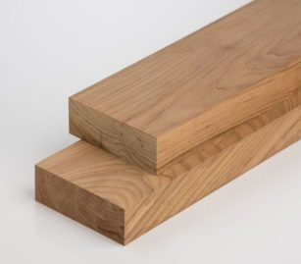__________________________________________________________________________________________________________________________________________________________________________________________________
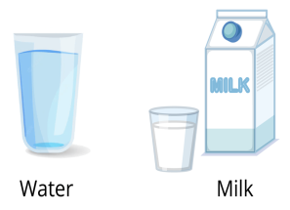
__________________________________________________________________________________________________________________________________________________________________________________________________

__________________________________________________________________________________________________________________________________________________________________________________________________

Worksheet 4
Complete the given diagram.

Natural resources

Worksheet 5
- Identify the pictures and mention some uses.

________________________________________________________________________________________________________________________________________________________________________________________________________________________

________________________________________________________________________________________________________________________________________________________________________________________________________________________

________________________________________________________________________________________________________________________________________________________________________________________________________________________

Worksheet 6
Answer the following questions.
- Why is earth a unique planet?
_________________________________________________________________________________________________________________________________________________________________________________________________________________________________________
- Name five natural resources of energy?
_________________________________________________________________________________________________________________________________________________________________________________________________________________________________________
- Define matter.
____________________________________________________________________________________________________________________________________________________________________________________________________
- Define habitat and its types.
__________________________________________________________________________________________________________________________________________________________________________________________________

Worksheet 7
Activity
Draw and label life cycle of frog.

Worksheet 8
Activity
- Find out the picture of endangered and extinct animals.

Worksheet 9
Write about human and capital resources.

Worksheet 10

