Final Year Project
Web Based FYP Portal

By
Moaz Javed
Supervised by
Mrs. Memoona Afsheen
Department of Computer Science
Quaid-I-Azam University, Islamabad, Pakistan
Session (2019-2023)

In the name of Allah, the Most Gracious, the Most Merciful

Table of Contents
1. Software Project Management Plan 6
1.1 Introduction 6
1.2 Problem Definition 6
1.2.1 Proposed Solution 6
1.3 Scope 7
1.4 Objectives 7
1.5 Project Organization 8
1.5.1 Software Process Model 8
1.5.2 Roles and Responsibilities 8
1.6 Project Management Plan 8
1.6.1 Project Description and understanding 8
1.6.2 Software Project Management Plan 9
2 Requirements gathering and analysis 10
2.1 Specific Requirement 10
2.2 Functional Requirements 10
2.2 Use Cases 11
2.3.1 Use Case Diagram 12
2.3.2 Use Case Description 13
2.4 System Sequence Diagram 32
2.4.1 SSD1: Login 32
2.4.2 SSD2: Upload Projects 33
6.4.3 SSD3: Update Projects 34
6.4.4 SSD4: Signup 35
2.4.5 SSD5: Login 36
2.4.6 SSD6: Select Project 37
2.4.7 SSD7: View Project 38
2.4.8 SSD8: View Request 39
2.4.10 SSD10: Login 41
2.4.11 SSD11: View Request 42
2.4.12 SSD12: Request Update 43
2.4.13 SSD13: Approve Request 44
2.6 Domain Model 45
3. Software design description 46
3.1 Introduction 46
3.2 Design Overview 46
3.3 ERD Diagram 46
3.3 Activity Diagram 47
3.3.2 Upload project 49
3.3.3 Update Project 50
3.3.4 View Request 51
3.3.4 Signup Student 53
3.3.5 Login Student 54
3.3.6 Select Project 55
3.3.7 View Project 56
3.3.8 Assign Project 57
3.4 Sequence Diagram 58
3.4.1 Login Teacher 58
3.4.2 Upload Project 59
3.4.3 Update Project 60
3.4.4 Signup Student 61
3.4.5 Login Student 62
3.4.6 Select Project 63
3.4.7 View Project 64
3.4.8 Login Coordinator 65
3.4.9 View Request 66
3.4.10 Request Update 67
3.4.11 Approve Project 68
3.5 Design Class Diagram 69
4. System Implementation 70
4.1 Introduction 70
4.2 Languages/Technologies Selection 70
4.3 Tools Selection 70
4.4 User Interface Design 70
4.4.1 Teacher Login 71
4.4.2 Teacher Upload Project 72
4.4.3 Teacher Update Project 73
4.4.4 Student Signup 73
4.4.5 Login Student 74
4.4.6 Select Project 75
4.4.7 Assign Project 75
4.4.7 View Project 76

1. Software Project Management Plan

1.1 Introduction
The final year project (FYP) supervision management system is a web-based application that designed to streamline the process of assigning final year project assignment to the final year students in various categories. With the help of this system, teachers can upload projects under different categories such as mobile-based, web-based, artificial intelligence, Iot-based, and more. Students can then select projects based on their interest and project coordinator can approve and disapprove these selections.

1.2 Problem Definition
1.2.1.1 Existing System
The current system for assigning projects involves teacher’s project descriptions, which are then approved or disapproved. A coordinator checks whether the project has already been assigned or not, then projects uploaded to the intranet platform. Students select a project and arrange a meeting with the teacher to discuss and agree upon the project. However, there is no proper system in place to provide information about which project have been assigned, causing confusion and inefficiencies in the project assignment process.
Disadvantage:
- It is difficult to provide information about projects which have already been assigned.
- It may also lead the duplication of projects and possible conflict occur between students.
- It is difficult for user to manage the projects.

1.2.1 Proposed Solution
A web based FYP portal can address the problem of the lack of a proper information system that track the status of projects. The portal can be designed to provide a foremost platform where teacher can upload projects and students can view and select the projects, they are interested in. The portal can have a database that trace projects, including their status (e.g., assigned, or unassigned) to the students. This will provide transparency and clarity about the project’s assignment process, and teachers, coordinator and students can easily view the project status and progress.

Advantages
- The web-based portal will provide a proper system for teachers to upload projects and for students to select the project.
- The portal will maintain a database of all the projects including its existing state.
- The portal will help to reduce the chances of duplication of projects by providing information of already assigned projects.
- The web-based portal is convenient for teachers, students, and coordinators to manage projects from anywhere.

1.3 Scope
This will be a Web-based Portal. This system will provide a platform to teachers to manage FYP for final year students. Following points lie under scope.
- Teachers can manage the final year projects.
- Student can View the projects and select the project.
- Coordinator will approve the selection of the project from the students.

1.4 Objectives
The primary objective of this system is to offer a centralized platform for teachers, students and coordinator to interact with each other for the smooth allocation of projects to the final year students.
The objectives of the system are following:
- Students will view the projects.
- Students will select the project.
- Students will view the teacher’s profile.
- Teachers will upload, update, view and delete the projects.
- Teachers will approve or disapprove the selection of his project by student.
- Teachers will forward the request of selection of projects to the coordinator.
- Coordinator will view the requests of selection of projects.
- Coordinator will approve or disapprove the selection of projects.
- Coordinator will view the projects as well.
- The System will provide a feature to check whether a project has already been assigned to a student in the past. If a teacher attempts to upload the same project, the system alerts the teacher that this project was already in the past.
- When the selected project is approved by the coordinator, the student is notified.

1.5 Project Organization
Project organization consists of the software process model, roles and responsibilities and tools and techniques.

1.5.1 Software Process Model
I will be using the Incremental Software Development Model because of the following reasons.
- Entire software development is divided in parts, and we can easily check and analyze each part.
Small prototypes are made individually and merged, and a complete prototype is achieved.
- I will be adding more functionality to the software little by little until the final product is achieved.

1.5.2 Roles and Responsibilities

Roles
I am going to develop this system and my supervisor will help me in understanding the requirements of the system.

Responsibilities
- Correctly understand the system.
- Gather the requirements and resources.
- Understand the workflow of the system.
- Develop a working web-based system.

1.6 Project Management Plan

1.6.1 Project Description and understanding
This is the first and basic task in which I have to understand the project and make an overall description.

1.6.2 Software Project Management Plan

Description
The initial step in the development of project is the identification of requirements.
The requirements include both functional and non-functional requirements.

Deliverables and Milestones
- Understanding the system.
- Defining the scope of the system.
- Requirements gathering.
- Creating UML Diagrams for the system.
- Writing use case text.
- Implementation.
- Testing

Dependencies
System is dependent on the project description. Therefore, project developers must understand the system and the requirements of the system clearly.

Risk and Contingencies
Incomplete understanding about the system and unclear requirements of the system are the risks at this level. If these are not clear, then the system developed may not meet user requirements.
1.7 Timeline chart

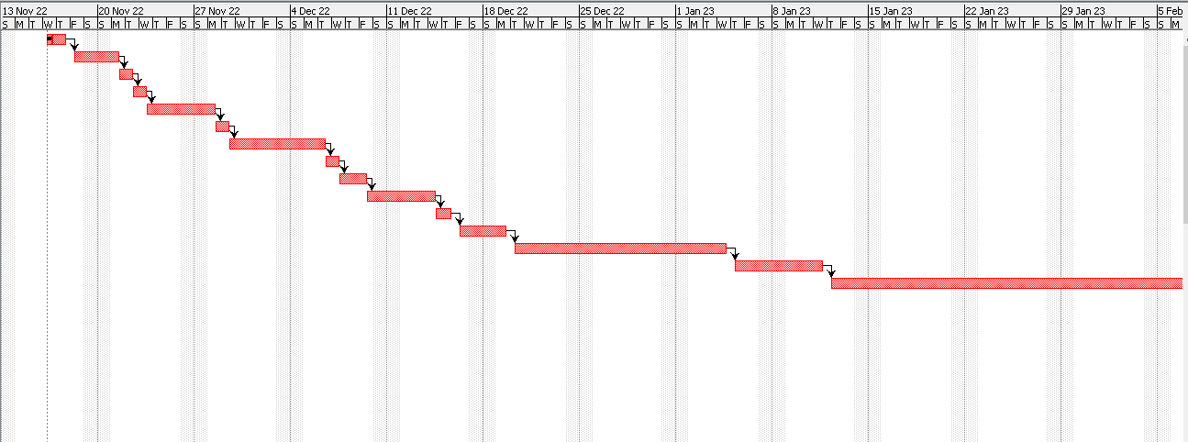

1- | Introduction
2- | Problem Definition & Solution
3- | Scope & Objective
4- | Project Organization
5- | Requirements Gathering
6- | Functional Requirements
7 | Use Case Diagram & Description
8- | System Sequence Diagram
9- | Domain Model
10- | Software Design Description
11- | System Implementation
12- | Tools Selection
13- | User Interface Design

2 Requirements gathering and analysis

Specific Requirement
It contains the functional requirements of the system. It gives a detailed description of the system and its features like what is the boundary of this project, and the analysis phase provides the base understanding of the project.
System Users:
- Project Coordinator
- Teacher
- Student

2.2 Functional Requirements
- Students will register on the system.
- Student will login to the system.
- Students will view the projects uploaded by the teachers.
- Students will select the project uploaded by the teachers.
- Students will view the status of the project selection approval.
- Teachers will login the system.
- Teachers will upload, update, and view the projects.
- Teachers will view the project selection requests by students.
- Teachers will forward the project selection request to the coordinator or decline.
- Coordinator will login on the system.
- Coordinator will view the projects uploaded by teachers.
- Coordinator will approve the request of the project selection forwarded by the teacher or disapprove it.
- System will check if the project uploaded by the teacher had already been done in the past.
- System will not allow the teacher to upload a project if already done in the past.
- System will keep an archive of the projects.

Use Cases
Use case diagram is a graphical representation of a user’s interaction with the system and depicts the specifications of the use case. A use case diagram depicts the actors, use cases and the relationship among them. The Use case description includes primary actors, stakeholders, pre- conditions, post-condition, success scenario, alternative scenarios, special requirements, technologies, and frequency of occurrence.

2.3.1 Use Case Diagram
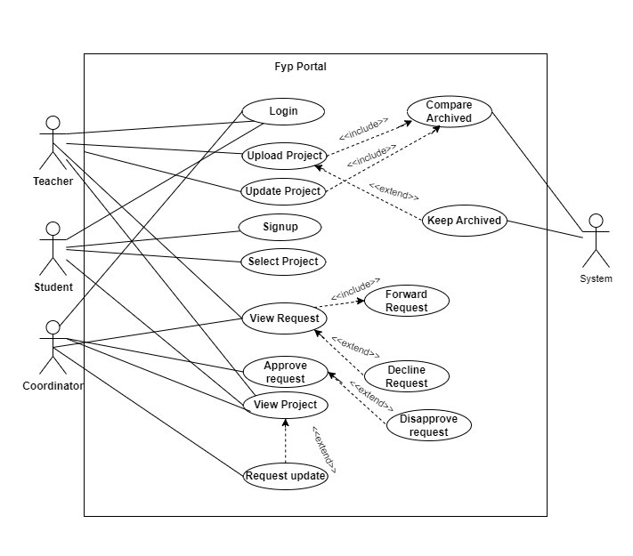

2.3.2 Use Case Description

UC-1: Login

Table 1: Login
UC-1 | Login
Primary actor | Teacher
Pre-condition | Teacher has registered his account.  Account is active.
Post-condition | Account will be opened.
Main Success Scenario | 1) Teacher opens the login form.  2) Teachers enters the required information  3) Teachers enters login button.  4) Data will be validated from database.  5) Account is opened.
Alternative Scenario | - In case of internet issue, account will not open.  - System will restart and account will be open.  - In case of database issue, data is not validated properly
Special Requirements | None
Technology | Internet Connection  PC/Laptop
Frequency of occurrence | Many times, a day.

UC-2: Upload Project

Table 1: Upload Project
UC-2 | Upload Project
Primary actor | Teacher
Pre-condition | Teacher must login his account.
Post-condition | Teachers upload the projects.
Main Success Scenario | 1) Teachers opens the account.  2) Teachers click the upload button.  - System displays the option to a select a file.  - System displays the detail form.  3)Teachers enters the project title and its description.  4) Teachers upload the project.  - System shows the successful notification.  UC-14 starts:
Alternative Scenario | - In case of internet issue, project will not upload.  - Restart the system and upload the project.  - In case of same projects, project will not upload.  - Update and upload the project again.
Special Requirements | None
Technology | Internet connection  PC/Laptop
Frequency of occurrence | Many times, a day

UC-3: Update Project

Table 1: Update Project
UC-3 | Update Project
Primary actor | Teachers
Pre-condition | Teacher must login his account.  Coordinator request to teacher to edit the project.
Post-condition | Teachers update the projects.
Main Success Scenario | 1) Teachers opens the account.  2) Teachers view the request given by coordinator.  3) Teachers click on update button.  4) System shows an editable form in which teacher can change the title or description.  5) Teachers update the project description and title.  6) Teachers submits the form.  UC-14 starts:  If the comparison is TRUE, System shows a successful updating message.
Alternative Scenario | - In case of no edit request given by coordinator, teacher could not update the project.  - Coordinator must request to teacher to edit the project.  - In case of same project, changes will not be made.  - Change the description of the project and update the project.
Special Requirements | None
Technology | Internet Connection  PC/Laptop
Frequency of occurrence | Many times, a day.

UC-4: View Request
Table 1: View Request
UC-4 | View Request
Primary actor | Teacher
Pre-condition | Students request for the project selection.  Teachers is logged in to FYP portal.
Post-condition | Teachers views the request of students for project selection.
Main Success Scenario | 1) Teacher opens his account.  2) System displays the projects of teacher.  3) Teachers click the project request.  4) System displays the request of students for project.  5) Teachers views the requests of students.  UC-5 starts:
Alternative Scenario | - In case of students does not select the project, teachers couldn’t view the project requests.  - Student must select the project.  - The teacher view request may experience technical difficulties such slow performance, issues with existing system leading to project disruption.  - Teachers should restart the system.
Special Requirements | None
Technology | Internet Connection  PC/Laptop
Frequency of occurrence | Many times, a day.

UC-5: Forward Request
Table 1: Forward Request
UC-5 | Forward Request
Primary actor | Teacher
Pre-condition | Students request for the project selection.  Teachers reviewed the project request and approved it.
Post-condition | Teachers forward the project request of students to coordinator.
Main Success Scenario | 1) Teacher opens his account.  2) System displays the projects of teacher.  3) Teachers click the project request.  4) System displays the request of students for project.  5) Teachers approve the requests of students.  6) System approve and forward the requests.
Alternative Scenario | - In case of no project selection request, teachers couldn’t forward the project requests.  - Student must select the project.  - In case of teachers do not view the project request, teachers will not forward the project requests.  - Teachers must view the project selection request of students.
Special Requirements | None
Technology | Internet Connection  PC/Laptop
Frequency of occurrence | Many times, a day.

UC-6: Decline Request
Table 1: Decline Request
UC-6 | Decline Request
Primary actor | Teacher
Pre-condition | Students request for the project selection.  Teachers has reviewed the project selection request.
Post-condition | Teachers decline the project requests of students.  Student is notified of the declined request and reason provided by the teacher.
Main Success Scenario | 1) Teacher accesses the web based-FYP portal and navigates to the section for project selection requests.  2) System displays the projects requests of students to teachers.  3) Teachers click the project request.  4) System displays the request of students for project.  5) Teachers decline the requests of students and notifies it.  - System declines the requests and notifies to student that project selection request does not meet the requirement or pre-requisites for the project.  - System declines the requests and notifies to student that this project is already assigned.
Alternative Scenario | In case of teachers do not review the project selection request, teachers couldn’t decline the project requests.  - Teachers must view the project requests.
Special Requirements | None
Technology | Internet Connection  PC/Laptop
Frequency of occurrence | Many times, a day.

UC-7: Signup

Table 1: Signup
UC-7 | Signup
Primary actor | Student
Pre-condition | System is in working condition and stable internet connection.
Post-condition | Accounts of students have been created and details of account have been stored.
Main Success Scenario | - Students click the signup button from the navigation bar.  - System displays the signup page that allow student to input the details.  - Students add the details and enter the submit button.  - System shoes the successful signup message.
Alternative Scenario | - Students did not enter the right details for register.  - System prompts to enter the correct details.  - Server might be down.  - Restart the system.
Special Requirements | None
Technology | Internet Connection  PC/Laptop
Frequency of occurrence | Many times, a day

UC-8: Login

Table 1: Login
UC-8 | Login
Primary actor | Student
Pre-condition | Student must register his account.
Post-condition | Account will be opened.
Main Success Scenario | 1) Students open the login form.  2) Students enters the required information  3) Students enters login button.  4) Data will be validated from database.  5) Account is opened.
Alternative Scenario | 1) In case of internet issue, account will not open.  2) In case of database issue, data is not validated properly.
Special Requirements | None
Technology | Internet Connection  PC/Laptop
Frequency of occurrence | Many times, a day

UC-9: Select Project
UC-9 | Select Project
Primary actor | Student
Pre-condition | Student must login from account.
Post-condition | Students select the project.
Main Success Scenario | - Students open his account.  - System displays the list of teachers.  - Students select the teacher.  - System displays the list of projects of teacher.  - Students view list of unassigned projects.  - Students select the project.  - System forwards the selection of project to particular teacher.  - Students is notified.
Alternative Scenario | - In case of internet issue. Students did not select the project.  - Restart the system and select the project again.  - System prompts the project have already assigned.  - Select the project again.
Special Requirements | None
Technology | Internet Connection  PC/Laptop
Frequency of occurrence | Many times, a day

Table 1: Select Project

UC-10: View Project
Table 1: View project
UC-10 | View Project
Primary actor | Student, Teacher, Coordinator
Pre-condition | User is logged in to FYP portal.  Projects exist in the system.
Post-condition | The user has viewed the details of FYP projects on the FYP portal.
Main Success Scenario | 1) Users select the teacher for view the project.  2) System shows the list of project upload by teacher.  3) Users views the project.
Alternative Scenario | - In case of teacher does not upload the project, users couldn’t view the project.  - Teacher must upload the project.  - The users view project may experience technical difficulties such as system crashes, slow performance, issues with existing system leading to project disruption.  - Users should restart the system.
Special Requirements | None
Technology | Internet Connection  PC/Laptop
Frequency of occurrence | Many times, a day.

UC-11: Login

Table 1: Login
UC-11 | Login
Primary actor | Coordinator
Pre-condition | Coordinator has registered his account.  Account is active.
Post-condition | Account will be opened.
Main Success Scenario | 1) Coordinator opens the login form.  2) Coordinator enters the required information.  3) Coordinator enters login button.  4) Data will be validated from database.  5) Account is opened.
Alternative Scenario | - In case of internet issue, account will not open.  - System will restart and account will be open.  - In case of database issue, data is not validated properly.
Special Requirements | None
Technology | Internet Connection  PC/Laptop
Frequency of occurrence | Many times, a day.

UC-12: Approve Request

Table 1: Approve Request
UC-12 | Approve Request
Primary actor | Coordinator
Pre-condition | Teacher must upload the project.  Student must select the project.  Teacher forwards the project requests.
Post-condition | Coordinators approve the project requests.
Main Success Scenario | - Coordinators open his account.  - Coordinator accessed the web based-FYP portal and navigates to the section for reviewing project selection requests.  - Coordinators click the project request option.  - System displays the project requests.  - Coordinators select the option to approve the project selection request.  - System displays the message project is approved successfully.  - System notifies to students that your project request is approved successfully. .
Alternative Scenario | - In case of internet issue, notification will not get.  - Restart the system and will get notifications.  - In case of teacher does not forward the students project selection request, coordinator could not approve the requests.  - Teacher must forward the request of students.
Special Requirements | None
Technology | Internet Connection  PC/Laptop
Frequency of occurrence | Many times, a day.

UC-13: Disapprove Request

Table 1: Disapprove Request
UC-13 | Disapprove Request
Primary actor | Coordinator
Pre-condition | Teacher must upload the project.  Student must select the project.  Teacher forwards the project request.
Post-condition | Coordinators disapprove the project requests.
Main Success Scenario | - Coordinators open his account.  - Coordinator accessed the web based-FYP portal and navigates to the section for reviewing project selection requests.  - Coordinators click the project request option.  - System displays the project requests.  - Coordinators select the option to disapprove the project selection request and notifies it.  - System notifies to students that project is already approved. .
Alternative Scenario | - In case of internet issue, notification will not get.  - Restart the system and will get notifications.  - In case of teacher does not forward the students project selection request, coordinator could not approve the requests.  - Teacher must forward the request of students
Special Requirements | None
Technology | Internet Connection  PC/Laptop
Frequency of occurrence | Many times, a day.

UC-14: Request Update

Table 1: Request Update
UC-13 | Request Update
Primary actor | Coordinator
Pre-condition | Teachers must upload the project.  Coordinator is logged in.  Coordinator views the uploaded projects.
Post-condition | Coordinator request teachers to update project.
Main Success Scenario | - Coordinator navigates to the project page and select the option to request an update.  - System displays a form where coordinator can provide details of the requested update.  - Coordinator fills out the form and submit the request.  - The system notifies the teacher of the update request in the FYP portal.
Alternative Scenario | - In case of coordinator does not view the projects, coordinator could not request to teacher for updating.  - Coordinator must view the uploaded project.
Special Requirements | None
Technology | Internet Connection  PC/Laptop
Frequency of occurrence | Many times, a day.

UC-15: Compare Archived

Table 1: Compare Archived
UC-14 | Compare Archived
Secondary actor | System
Pre-condition | Teachers has already uploaded the projects in FYP portal.
Post-condition | Teachers is able to compare archived version of the projects.  System verifies that the project has been previously uploaded.
Main Success Scenario | - Teacher logs in to FYP portal.  - System shows the screen.  - Teacher clicks the select project file button.  - System asks to select a file.  - Teacher selects project file and add title and description of project.  - System verifies the title and description and display error that project has been previously uploaded.
Alternative Scenario | - In case there is no project in the system, system could not compare projects.  - There must be projects in FYP portal.
Special Requirements | None
Technology | Internet Connection  PC/Laptop
Frequency of occurrence | Many times, a day.

UC-16: Keep Archived

Table 1: Keep Archived
UC-15 | Keep Archived
Secondary actor | System
Pre-condition | Teachers has uploaded project in the system.
Post-condition | System has stored separate the new version of project as a separate archive.
Main Success Scenario | - System receives uploaded project from teacher.  - System checks the archive database to determine if a previous version of the project exist.  - System will stored separate the new version of projects as a separate archive.
Alternative Scenario | - If the archived database is full, system will not upload projects anymore.  - Teachers must delete older archives to make room for new one.
Special Requirements | None
Technology | Internet Connection  PC/Laptop
Frequency of occurrence | Many times, a day.

2.4 System Sequence Diagram
A system sequence diagram illustrates input and output events related to our system. System is treated as black box and the emphasis of the diagram are the events which are generated by the system for the particular scenario of use-cases.

2.4.1 SSD1: Login

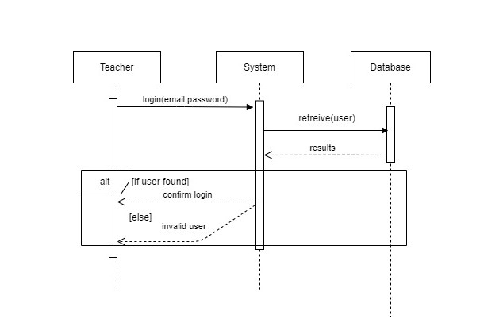

2.4.2 SSD2: Upload Projects

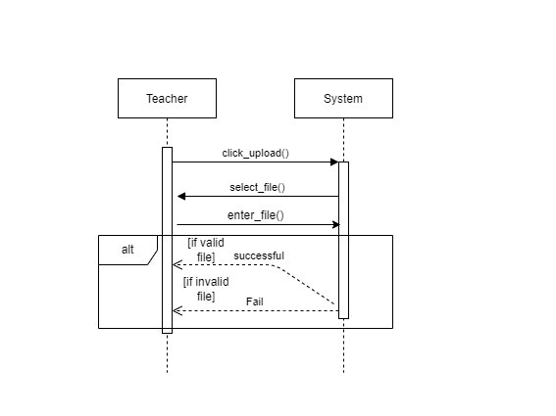

SSD3: Update Projects
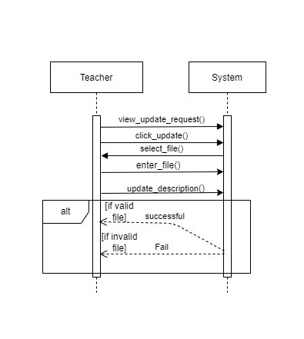

SSD4: Signup

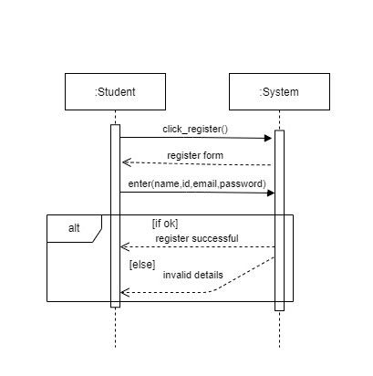

2.4.5 SSD5: Login

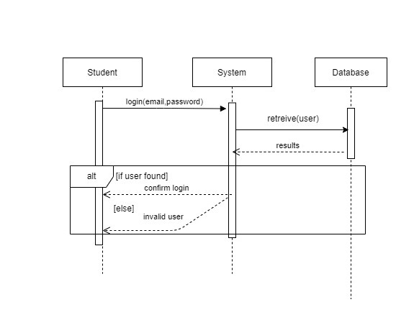

2.4.6 SSD6: Select Project

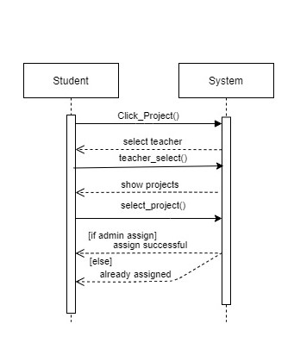

2.4.7 SSD7: View Project

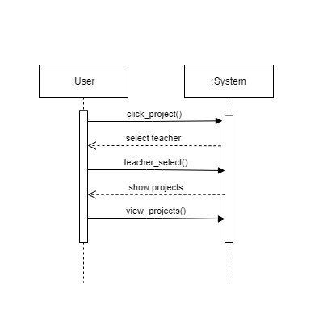

2.4.8 SSD8: View Request

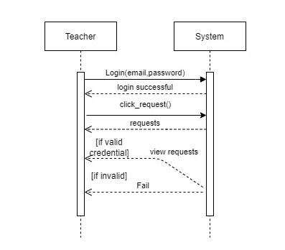

2.4.9 SSD9: Forward Request

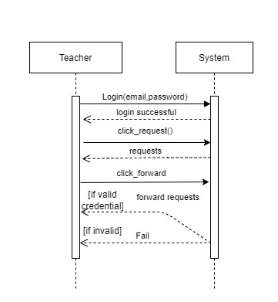

2.4.10 SSD10: Login

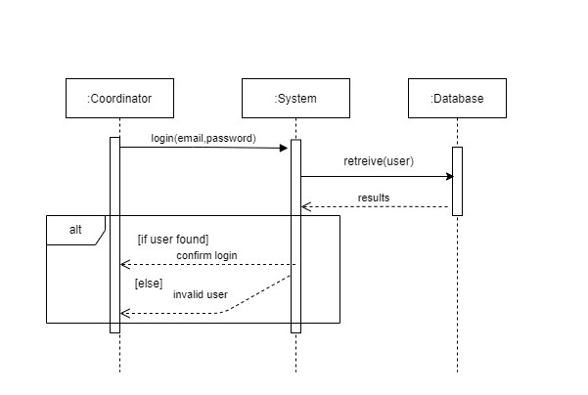

2.4.11 SSD11: View Request

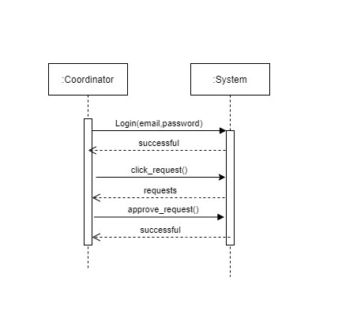

2.4.12 SSD12: Request Update

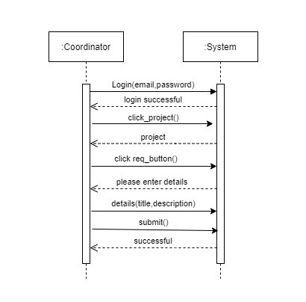

2.4.13 SSD13: Approve Request



2.6 Domain Model
Domain model is an object model of a problem domain. It is based on real world classes/concepts and their relationships. It is used to identify the relationships among all the entities within the scope of the problem domain.

Entities include:

- Coordinator
- Student
- Teacher
- System
- Project
- Project list
- Request
- Archive

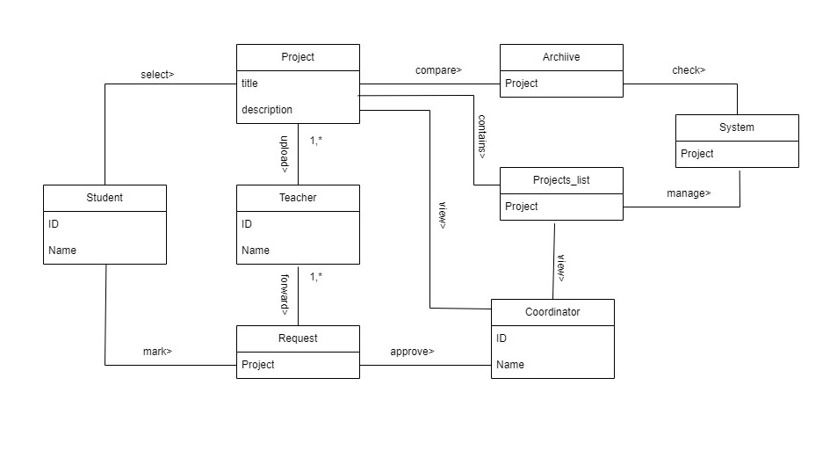

Figure: Domain Model

3. Software design description

3.1 Introduction
The software design document provides the design detail of Event Detection System and tracks the necessary information required to effectively define architecture and system design Product Overview. This document will help the developer to understand the inner workings of the Event Detection System.

3.2 Design Overview
The software design document provides design details of the Event Detection System. It includes the following diagrams which will explain the design overview of the system.
- ERD Diagram
- Activity Diagram
- Sequence Diagram
- Class Diagram

ERD Diagram
Entity Relationship Diagram, also known as ERD, ER Diagram or ER model, is a type of
structural diagram for use in database design. An entity-relationship (ER) diagram is a
graphical representation of entities and their relationships. Entities are the things we need to
store data about.

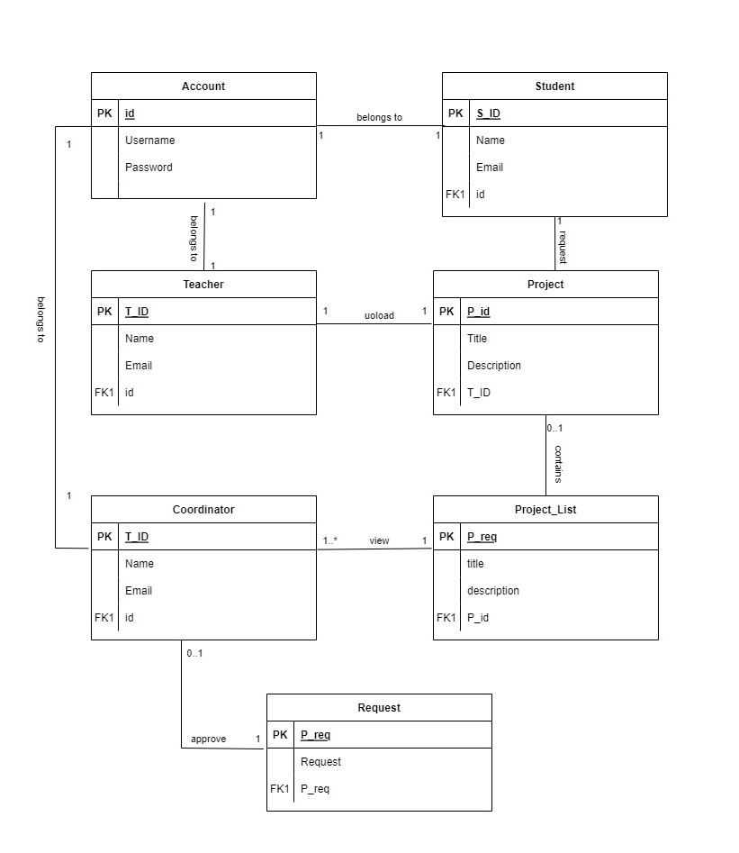

3.3 Activity Diagram
Activity diagram is another important diagram in UML to describe the dynamic aspects of the system. Activity diagram is basically a flowchart to represent the flow from one activity to another activity. The activity can be described as an operation of the system. The control flow is drawn from one operation to another.
3.3.1 Teacher Login
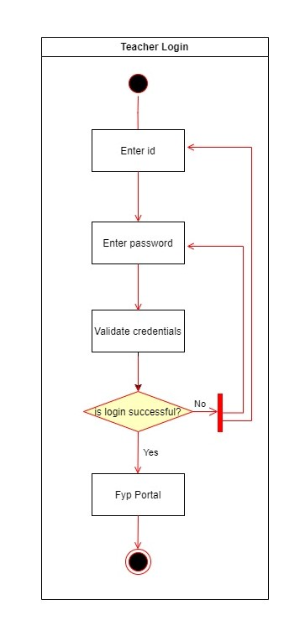

3.3.2 Upload project
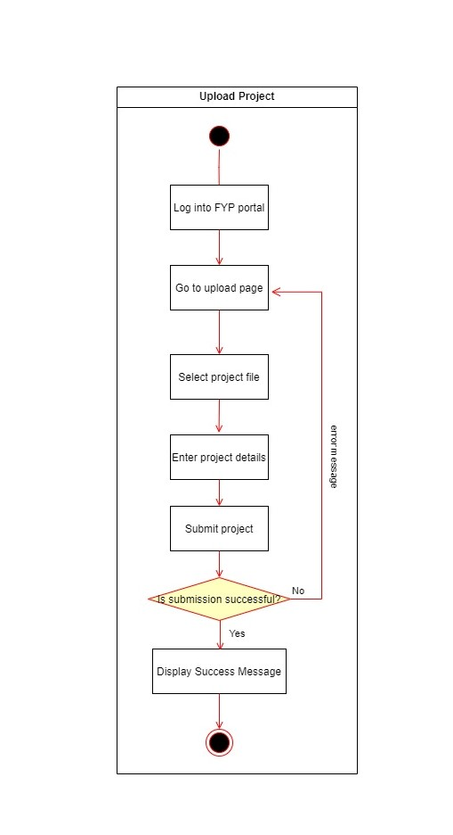

3.3.3 Update Project

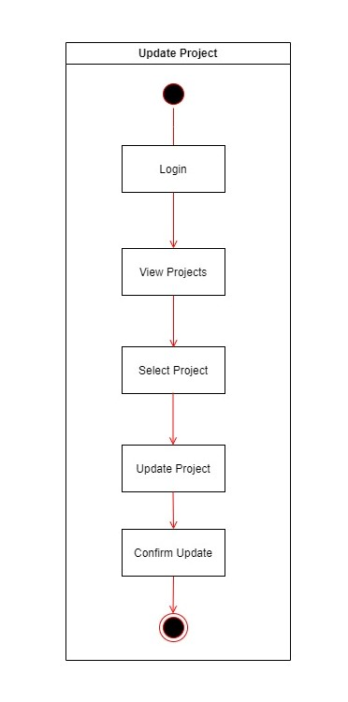

View Request

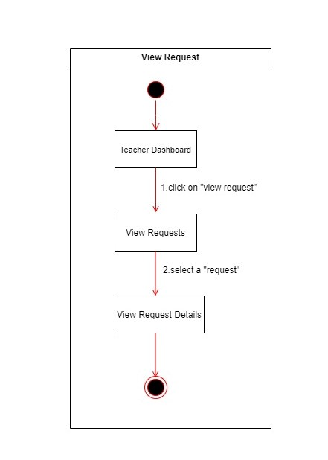

3.3.5 Forward Request

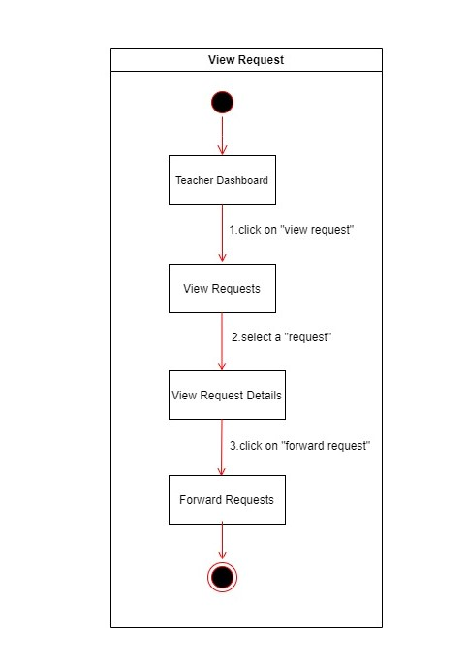

3.3.4 Signup Student
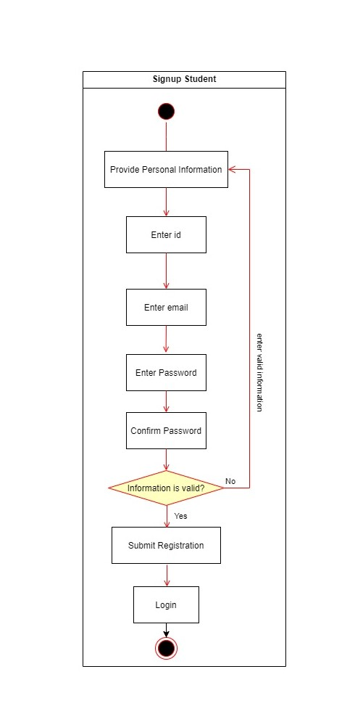

3.3.5 Login Student
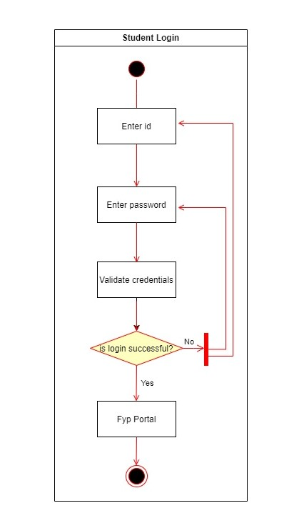

3.3.6 Select Project

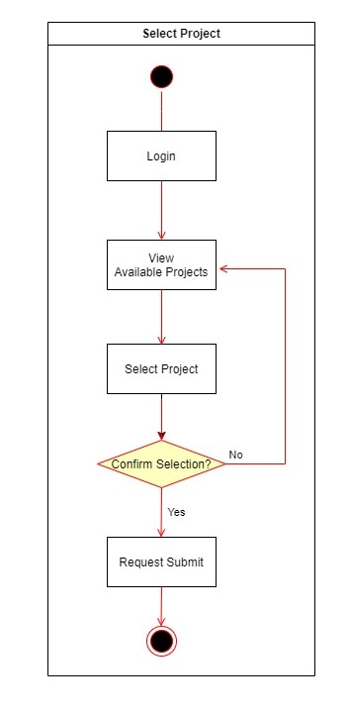

3.3.7 View Project
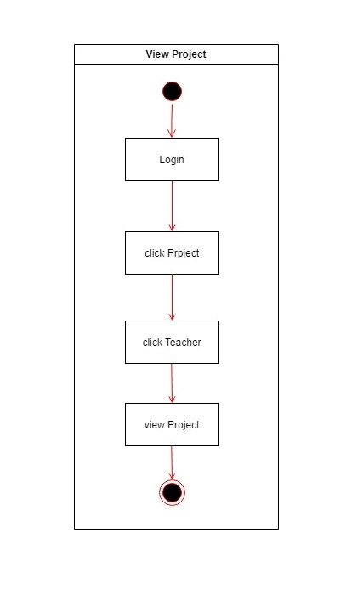

Assign Project
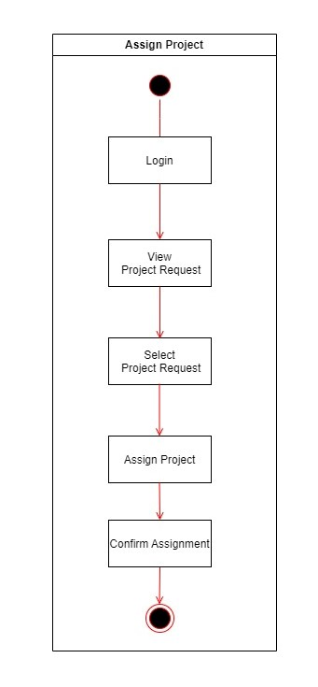

3.4 Sequence Diagram
A sequence diagram is an interaction diagram that shows how objects operate with one another and in what order. It is a construct of a message sequence chart. A sequence diagram shows object interactions arranged in time sequence.

3.4.1 Login Teacher
Teacher can login from the account who have been already register.
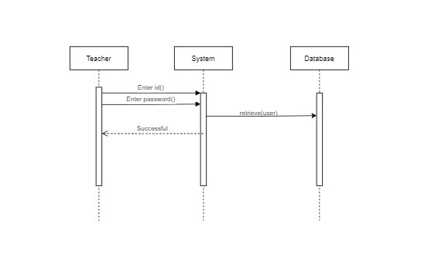

3.4.2 Upload Project

- Teacher will upload the projects.
- He will click on upload, select file and enter details about the project and upload the Project.

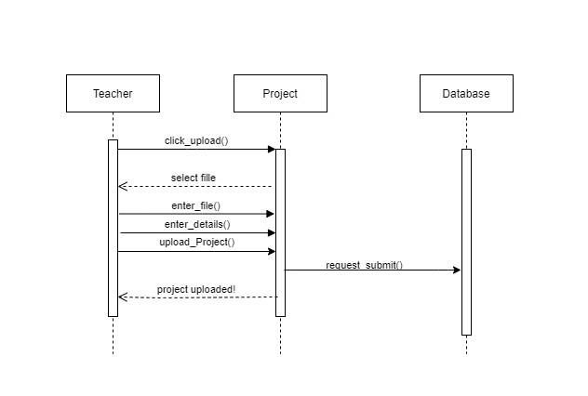

3.4.3 Update Project
- Teacher will view the update requests.
- Teacher will update the projects.
- He will click the update button and then edit the details of the project.
- Changes will be made in database.

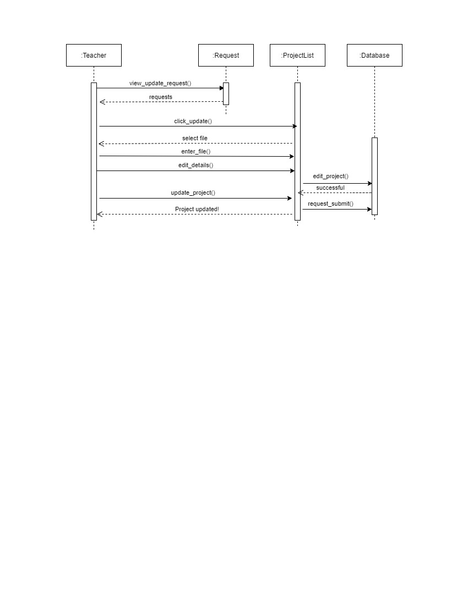

3.4.4 Signup Student

- Student will click on register.
- Student will enter details.
- If details are valid student register successful.

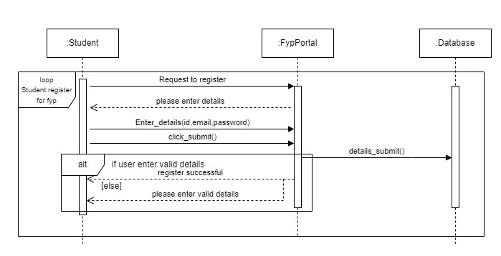

3.4.5 Login Student

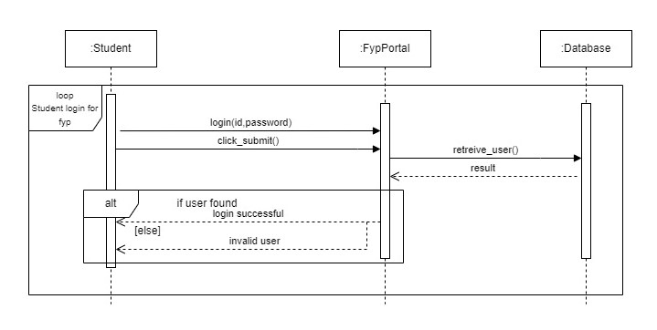

3.4.6 Select Project
- Student will click on the projects.
- Student will select the project.
- Student request will be submitted to coordinator.

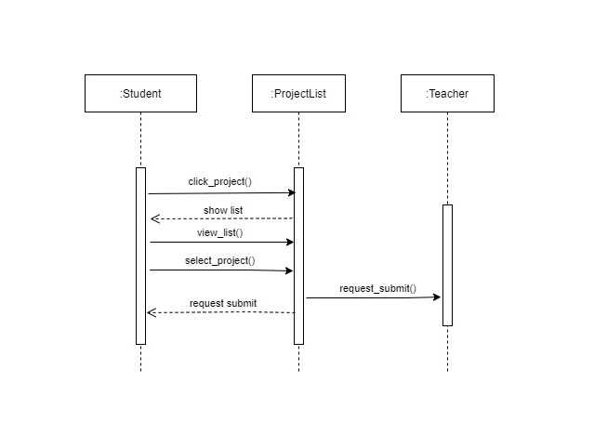

3.4.7 View Project
- User will click on projects.
- Project list will be shown.
- User will view the projects.
.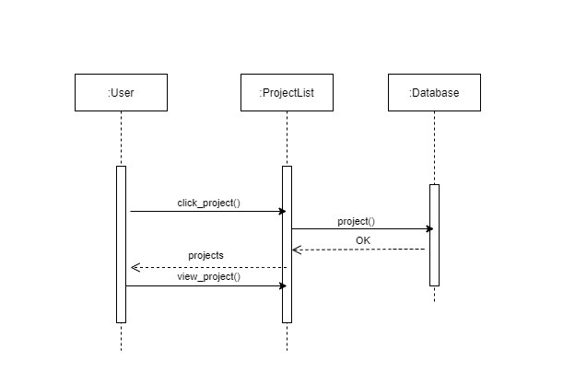

3.4.8 Login Coordinator

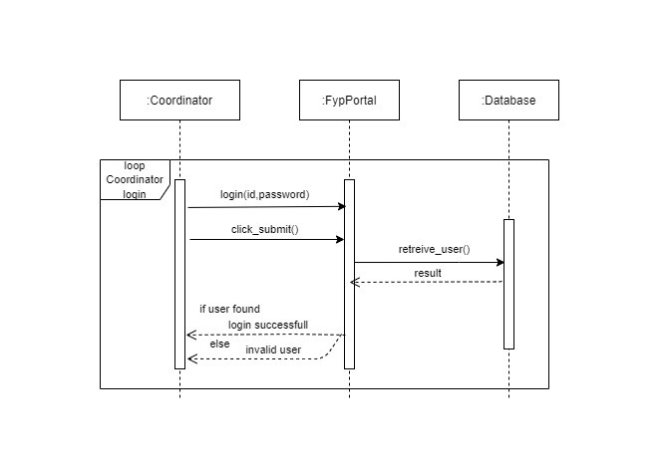

3.4.9 View Request

- Coordinator will click on projects.
- Coordinator will view the requests forwarded by teacher.

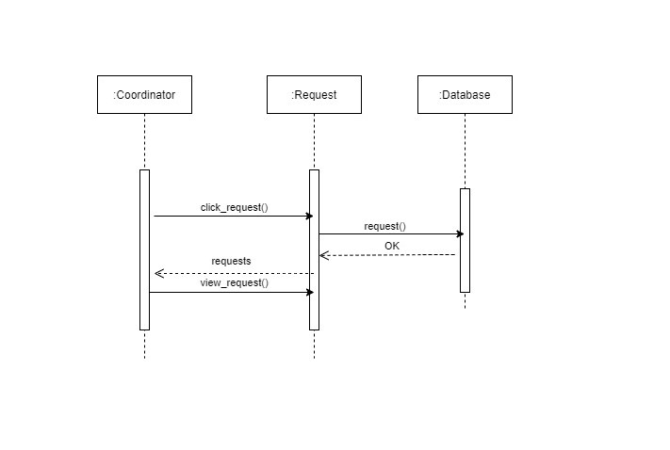

3.4.10 Request Update
- Coordinator will view the projects in portal.
- Coordinator send the update request for project to teacher.

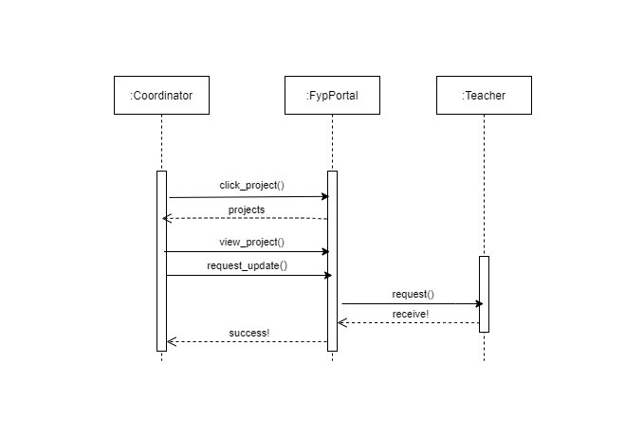

3.4.11 Approve Project
- Coordinator will assign project to student.
- He can check all the request of student who apply for selection of project, and then coordinator assigned the project to student.
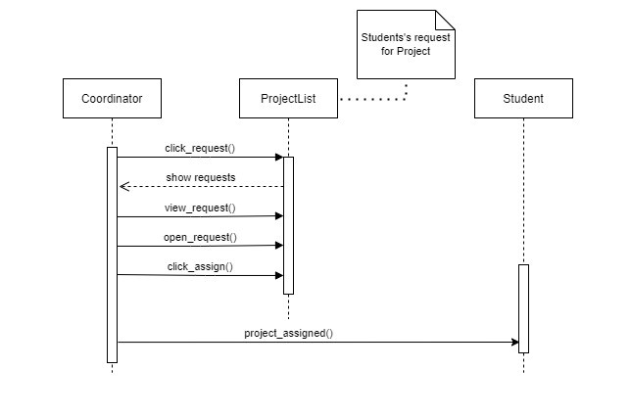

3.5 Design Class Diagram
A class diagram in the Unified Modelling Language (UML) is a type of static structure diagram that describes the structure of a system by showing the system's classes, their attributes, operations (or methods), and the relationships among objects.
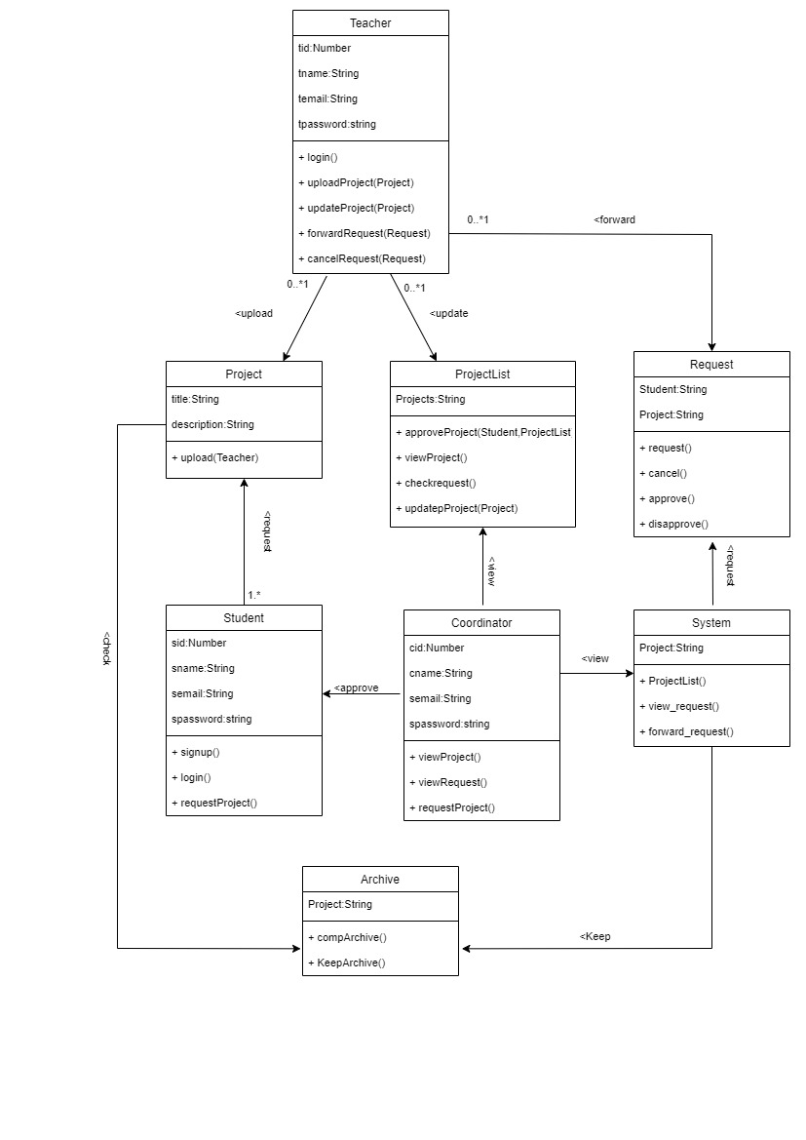

4. System Implementation

4.1 Introduction
This document describes the project implementation and user manual for developing and use of the Web base FYP Portal. The project implements are in Mern.

4.2 Languages/Technologies Selection
The project is implemented in the following languages:
1. ReactJs

4.3 Tools Selection
- Visual Studio Code

4.4 User Interface Design
User interface design shows how an end user will interact with the system through screens to perform different tasks.
A user interface is the means in which a user controls a software program or hardware device. User interfaces are designed in such a way that task requires minimum possible steps. Following are some screens of this system through which users can communicate to the system.

4.4.1 Teacher Login
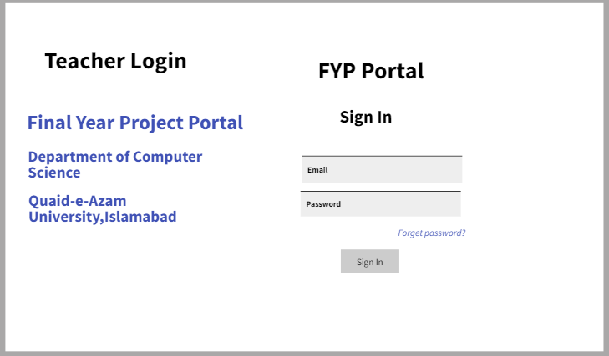

4.4.2 Teacher Upload Project
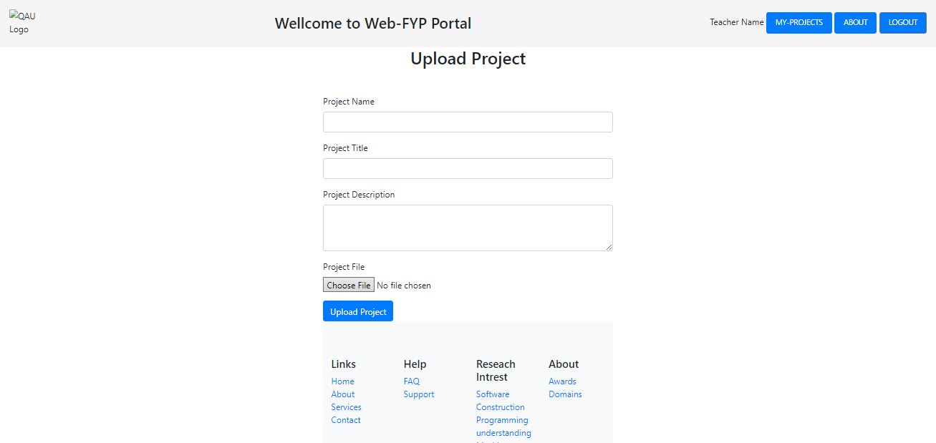
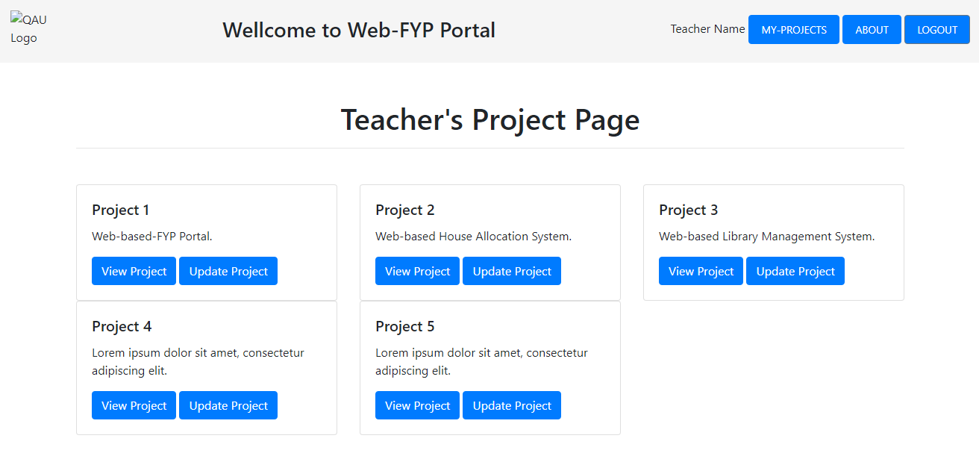

4.4.3 Teacher Update Project
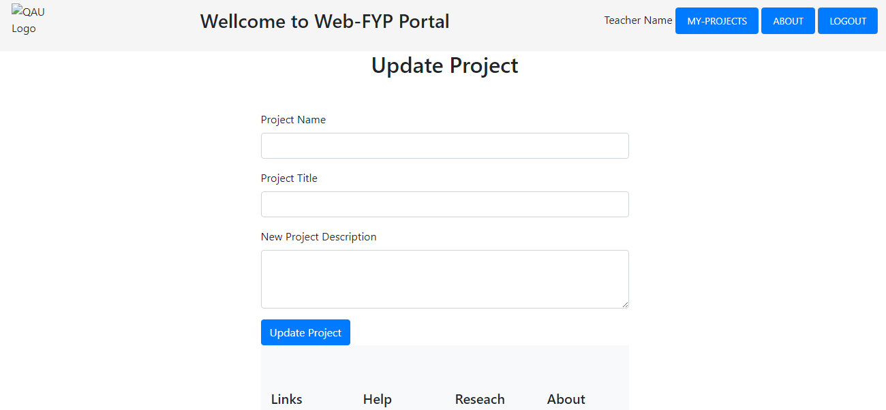

4.4.4 Student Signup
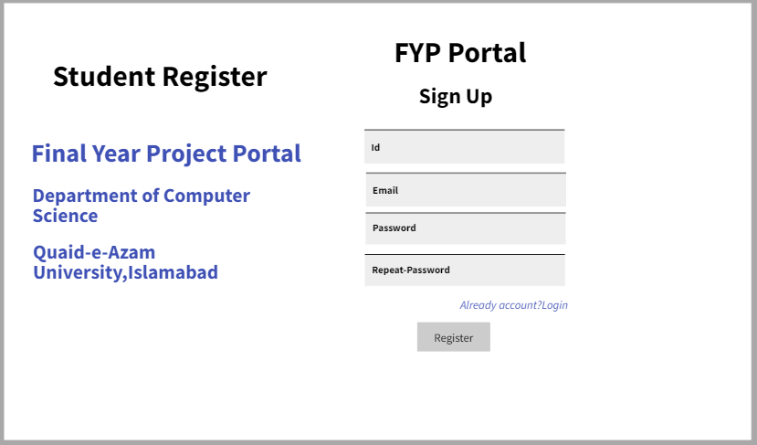

4.4.5 Login Student
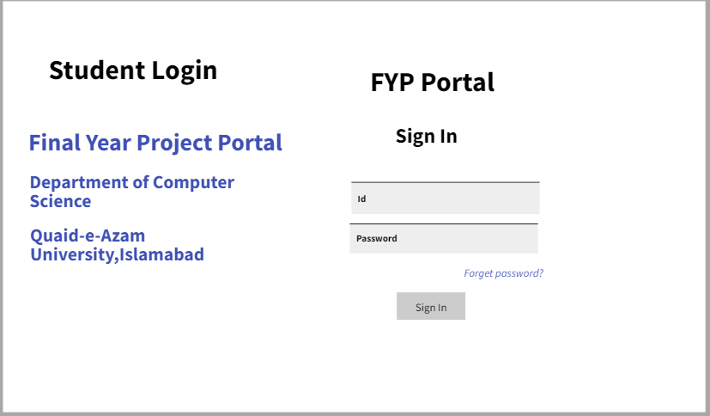
Teacher who offering the projects.
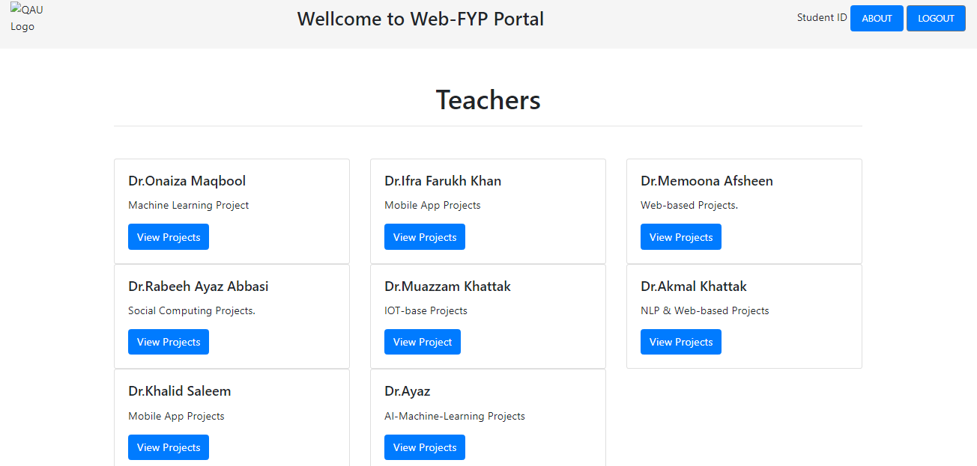

4.4.6 Select Project
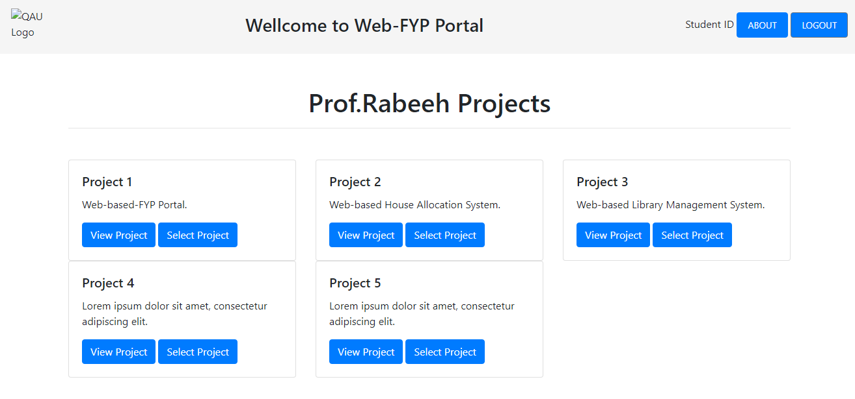

4.4.7 Assign Project
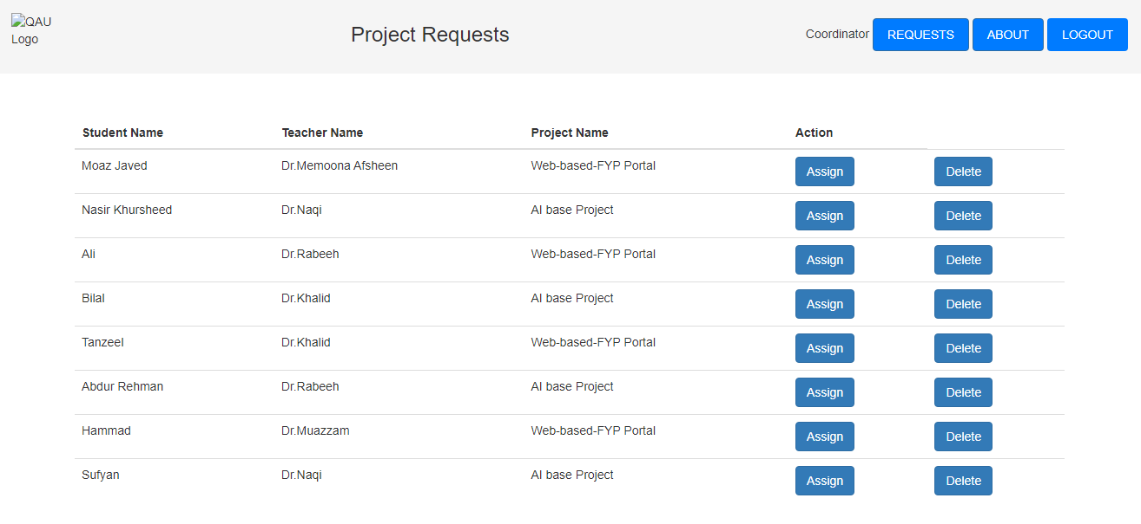

4.4.7 View Project
