**Resource of Innovative and Lively Learning Skills**

**Stimulation - Creation – Innovation**

|  |  |
| --- | --- |
| **Subject: Amazing World** | **Level 3** |

**Worksheet 1**

**Fill in the blanks.**

|  |
| --- |
| 1. _____________ has more than two thirds of the world’s plant species. |
| 1. ______________ have an excellent sense of smell. |
| 1. They hatch from eggs of frogs and have tails _____________. |
| 1. The position of ______________ in the sky affects the length, direction and shape. |
| 1. The shadow of an object is always the ______________ shape. |

**Worksheet 2**

**Choose the correct option.**

1. **__________ have fixed volume.**
2. Solid
3. Liquid
4. Gas
5. **__________ are important sources of energy.**
6. Coal and oil
7. Solar energy
8. Heat and light
9. **A __________ is used to make electrical energy.**
10. Wood
11. Wind turbine
12. Natural gas
13. **Important natural resource for life.**
14. Sunlight
15. Money
16. Paper
17. **__________ get energy from fuel like petrol or diesel.**
18. Microwaves
19. Vehicles
20. Clothes

**Worksheet 3**

**Identify solid, liquid and gas and write some properties.**

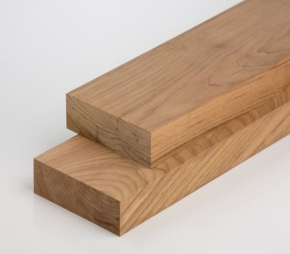**__________________________________________________________________________________________________________________________________________________________________________________________________**

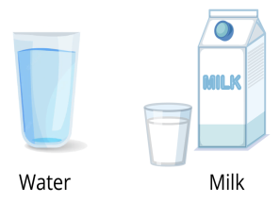

**__________________________________________________________________________________________________________________________________________________________________________________________________**



**__________________________________________________________________________________________________________________________________________________________________________________________________**

**Worksheet 4**

**Complete the given diagram.**

**Worksheet 5**

* **Identify the pictures and mention some uses.**

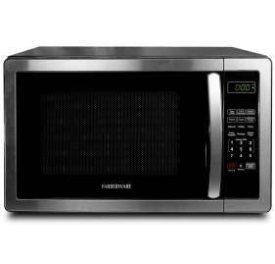

**________________________________________________________________________________________________________________________________________________________________________________________________________________________**

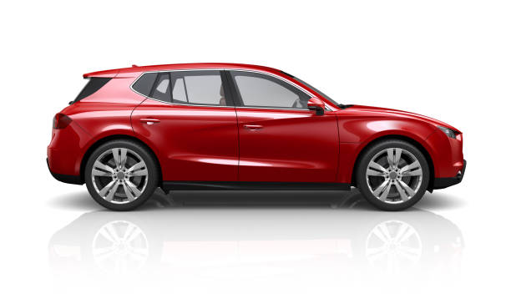

**________________________________________________________________________________________________________________________________________________________________________________________________________________________**

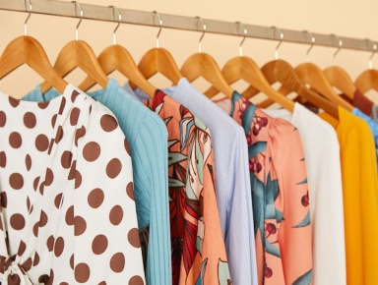

**________________________________________________________________________________________________________________________________________________________________________________________________________________________**

**Worksheet 6**

**Answer the following questions.**

1. Why is earth a unique planet?

_________________________________________________________________________________________________________________________________________________________________________________________________________________________________________

1. Name five natural resources of energy?

_________________________________________________________________________________________________________________________________________________________________________________________________________________________________________

1. Define matter.

____________________________________________________________________________________________________________________________________________________________________________________________________

1. Define habitat and its types.

__________________________________________________________________________________________________________________________________________________________________________________________________

**Worksheet 7**

**Activity**

**Draw and label life cycle of frog.**

**Worksheet 8**

**Activity**

* **Find out the picture of endangered and extinct animals.**

**Worksheet 9**

**Write about human and capital resources.**

|  |  |
| --- | --- |
|  |  |
|  |  |
|  |  |
|  |  |
|  |  |
|  |  |
|  |  |

**Worksheet 10**