***Shoe Dumpsters:***

*This website is used for thrift shoes reselling, customers can simply place order in the contact section and check details of each shoes by clicking on them.*

***Tools Used:***

*HTML CSS JAVASCRIPT MONGODB*

***Visual Representation of App:***

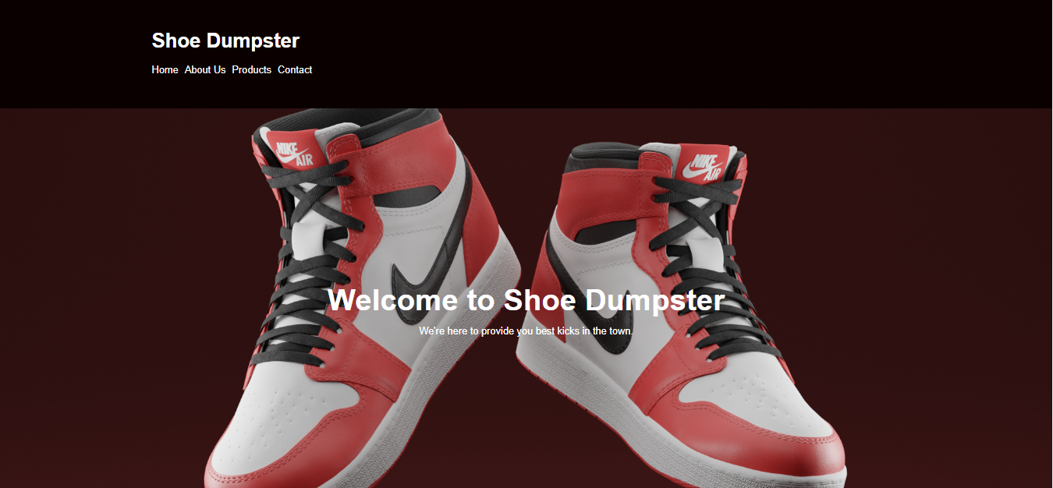

***Product Area:***

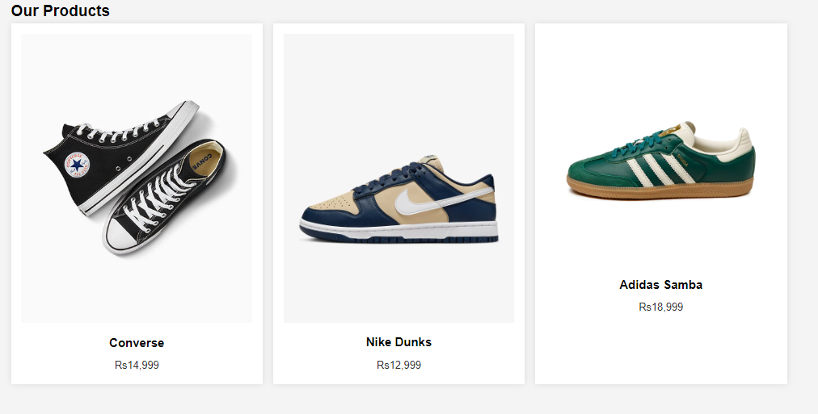

***Contact Section:***

