1. **Step 2: (step2_2.html)**

When there is no record been found, please hide the following area; and show the text of “*No Suggested Goods or Services been found. Please re-enter the description of those Products or services that you are selling or trying to sell, so that we can recommend you the relevant Goods & Services*”.

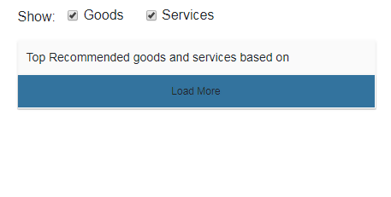

1. **Also on the step 2 (step2_2.html), please have the key enter/up (& textbox lost focus) to trigger “Go” button;**

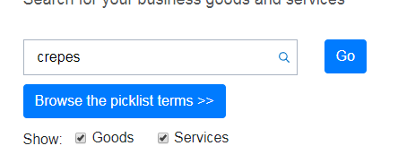

1. After “Step 3 – Search”, when people click on “Continue” button, they will see the following form:

In default, the selected answer is “NO”. But if people click on “YES”, they will have to fill in the following questions:

1. **“Step 4” (step4.thml)** – Choose ownership type & fill in ownership info. Please ask the following question (it is because U.S. ask for more ownership information than Australia does). Please validate the required fields for those fields that marked with * signs.

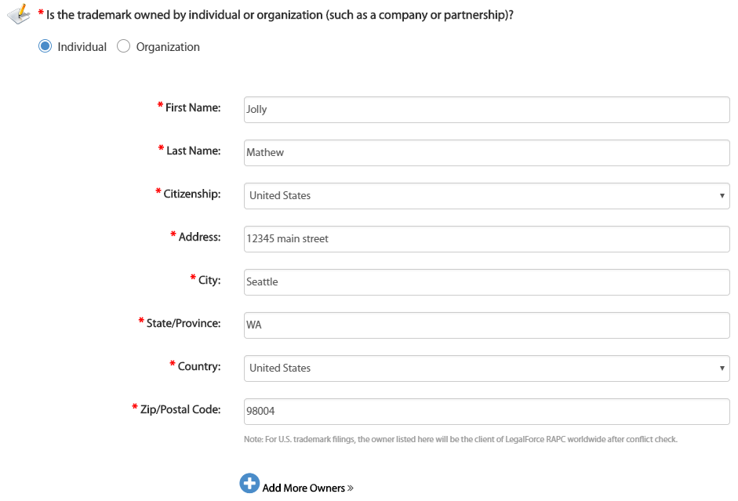

* When people choose “Individual” type, we will **have a button to “Add More Owners”;** because it is possible for multiple owners owning the same trademark.
* When people choose “Organization” type, please show the following question (please validate the mandatory fields before “Continue”):

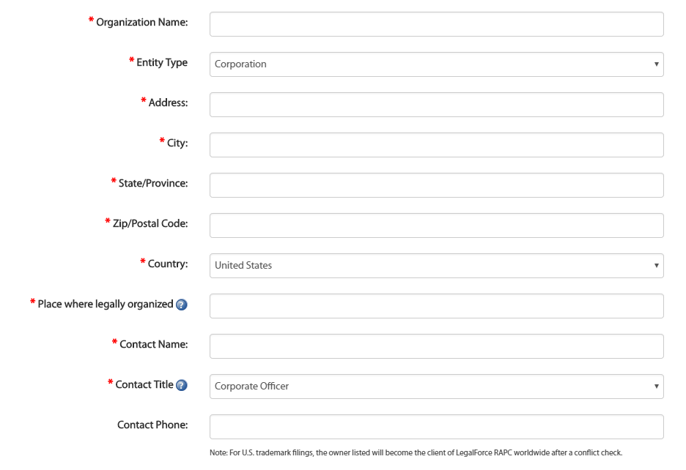

I will create two APIs to return **the list of “Country” & the list of “Citizenship” drop-down data.**

For the “Organization” -> “Entity Type” option list, please see the following pre-populated option list:

<option selected="selected" value="2">Corporation</option>

<option value="3">LLC (Limited Liability Company)</option>

<option value="4">Partnership</option>

<option value="5">LP (Limited Partnership)</option>

<option value="9">LLP (Limited Liability Partnership)</option>

<option value="10">Ltd. (Limited Company)</option>

<option value="11">LTDA (Limitada)</option>

<option value="6">Joint Ventures</option>

<option value="1">Proprietorship</option>

<option value="7">Trust</option>

<option value="12">S.A. </option>

<option value="13">S.A. de C.V.</option>

<option value="14">GmbH</option>

<option value="15">mbH</option>

<option value="16">N.V. </option>

<option value="8">Other</option>

**If people choose the “Corporation” or “LLC (Limited Liability Company)”** (value = 2 or 3), they will go to “**Step 5 -> OPTIONAL: Protect in Multiple Countries**” step.

**If people choose other options (other than values of 2, 3),** we will show the following form.

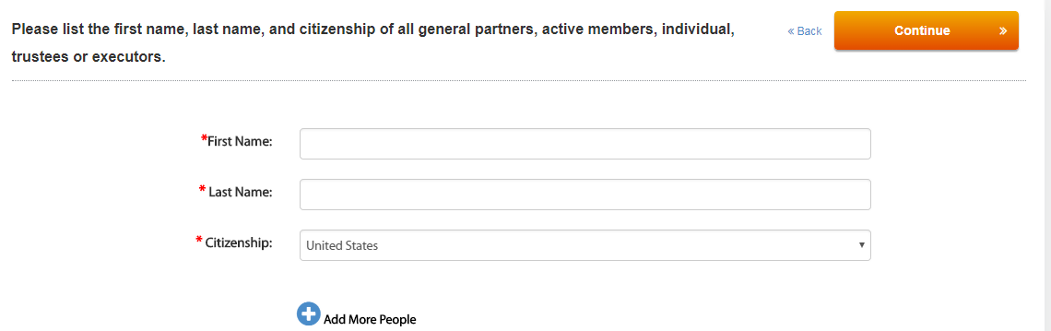

Then, the next step is “**Step 5 -> OPTIONAL: Protect in Multiple Countries**” with the following form:

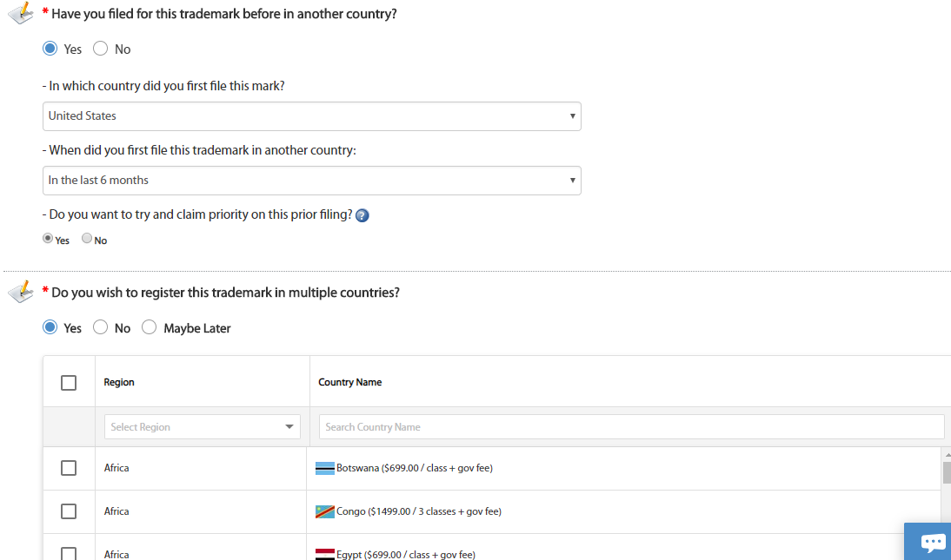

For the question of "Do you wish to register this trademark in multiple countries"?

I will create an API to return all available countries' list & their services fees.

============================================================

Then the last step **– “Step 6” - will be an “Summary” Page** to show all the collected answers from all previous steps, plus the following optional up-sell checkboxes:

