Troubleshooting Realsense:

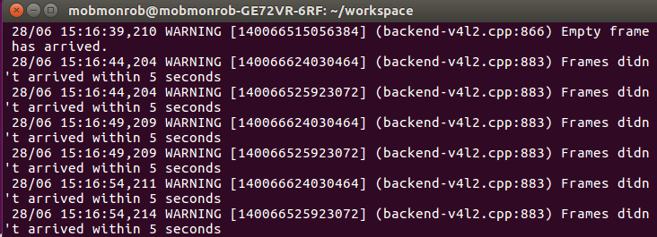
When launch files are executed the second time the following warning occurs.
This error can be ressolved by unplugging and plugging in again the camera.

Command: rs-enumerate-devices (information about connected devices)
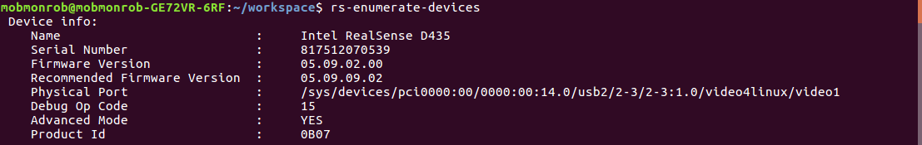

Available Topics (List can be obtained with: rostopic list; message type of topic can be inspected with: rostopic type <topic>)
/camera/aligned_depth_to_color/camera_info
/camera/aligned_depth_to_color/image_raw
/camera/aligned_depth_to_color/image_raw/compressed
/camera/aligned_depth_to_color/image_raw/compressed/parameter_descriptions
/camera/aligned_depth_to_color/image_raw/compressed/parameter_updates
/camera/aligned_depth_to_color/image_raw/compressedDepth
/camera/aligned_depth_to_color/image_raw/compressedDepth/parameter_descriptions
/camera/aligned_depth_to_color/image_raw/compressedDepth/parameter_updates
/camera/aligned_depth_to_color/image_raw/theora
/camera/aligned_depth_to_color/image_raw/theora/parameter_descriptions
/camera/aligned_depth_to_color/image_raw/theora/parameter_updates
/camera/aligned_depth_to_infra1/camera_info
/camera/aligned_depth_to_infra1/image_raw
/camera/aligned_depth_to_infra1/image_raw/compressed
/camera/aligned_depth_to_infra1/image_raw/compressed/parameter_descriptions
/camera/aligned_depth_to_infra1/image_raw/compressed/parameter_updates
/camera/aligned_depth_to_infra1/image_raw/compressedDepth
/camera/aligned_depth_to_infra1/image_raw/compressedDepth/parameter_descriptions
/camera/aligned_depth_to_infra1/image_raw/compressedDepth/parameter_updates
/camera/aligned_depth_to_infra1/image_raw/theora
/camera/aligned_depth_to_infra1/image_raw/theora/parameter_descriptions
/camera/aligned_depth_to_infra1/image_raw/theora/parameter_updates
/camera/aligned_depth_to_infra2/camera_info
/camera/aligned_depth_to_infra2/image_raw
/camera/aligned_depth_to_infra2/image_raw/compressed
/camera/aligned_depth_to_infra2/image_raw/compressed/parameter_descriptions
/camera/aligned_depth_to_infra2/image_raw/compressed/parameter_updates
/camera/aligned_depth_to_infra2/image_raw/compressedDepth
/camera/aligned_depth_to_infra2/image_raw/compressedDepth/parameter_descriptions
/camera/aligned_depth_to_infra2/image_raw/compressedDepth/parameter_updates
/camera/aligned_depth_to_infra2/image_raw/theora
/camera/aligned_depth_to_infra2/image_raw/theora/parameter_descriptions
/camera/aligned_depth_to_infra2/image_raw/theora/parameter_updates
/camera/color/camera_info
/camera/color/image_raw
/camera/color/image_raw/compressed
/camera/color/image_raw/compressed/parameter_descriptions
/camera/color/image_raw/compressed/parameter_updates
/camera/color/image_raw/compressedDepth
/camera/color/image_raw/compressedDepth/parameter_descriptions
/camera/color/image_raw/compressedDepth/parameter_updates
/camera/color/image_raw/theora
/camera/color/image_raw/theora/parameter_descriptions
/camera/color/image_raw/theora/parameter_updates
/camera/depth/camera_info
/camera/depth/color/points
/camera/depth/image_rect_raw
/camera/depth/image_rect_raw/compressed
/camera/depth/image_rect_raw/compressed/parameter_descriptions
/camera/depth/image_rect_raw/compressed/parameter_updates
/camera/depth/image_rect_raw/compressedDepth
/camera/depth/image_rect_raw/compressedDepth/parameter_descriptions
/camera/depth/image_rect_raw/compressedDepth/parameter_updates
/camera/depth/image_rect_raw/theora
/camera/depth/image_rect_raw/theora/parameter_descriptions
/camera/depth/image_rect_raw/theora/parameter_updates
/camera/extrinsics/depth_to_color
/camera/extrinsics/depth_to_infra1
/camera/extrinsics/depth_to_infra2
/camera/infra1/camera_info
/camera/infra1/image_rect_raw
/camera/infra1/image_rect_raw/compressed
/camera/infra1/image_rect_raw/compressed/parameter_descriptions
/camera/infra1/image_rect_raw/compressed/parameter_updates
/camera/infra1/image_rect_raw/compressedDepth
/camera/infra1/image_rect_raw/compressedDepth/parameter_descriptions
/camera/infra1/image_rect_raw/compressedDepth/parameter_updates
/camera/infra1/image_rect_raw/theora
/camera/infra1/image_rect_raw/theora/parameter_descriptions
/camera/infra1/image_rect_raw/theora/parameter_updates
/camera/infra2/camera_info
/camera/infra2/image_rect_raw
/camera/infra2/image_rect_raw/compressed
/camera/infra2/image_rect_raw/compressed/parameter_descriptions
/camera/infra2/image_rect_raw/compressed/parameter_updates
/camera/infra2/image_rect_raw/compressedDepth
/camera/infra2/image_rect_raw/compressedDepth/parameter_descriptions
/camera/infra2/image_rect_raw/compressedDepth/parameter_updates
/camera/infra2/image_rect_raw/theora
/camera/infra2/image_rect_raw/theora/parameter_descriptions
/camera/infra2/image_rect_raw/theora/parameter_updates
/camera/realsense2_camera_manager/bond
/camera/realsense2_camera_manager/parameter_descriptions
/camera/realsense2_camera_manager/parameter_updates
/diagnostics
/rosout
/rosout_agg
/tf_static

Start RealsenseViewer by typing
realsense-viewer
to the terminal

Invalid Value in rs2_get_option(options:0x7f08780053f0, option:Enable Auto Exposure):
get_xu(id=11) failed! Last Error: Input/output error

