Parts of cluster

node: Have container runtime, Kubelet to make sure that everything is running that should be running, kubeproxy to handling networking

Running on master node- API server (This is the entry point to K8s cluster) (UI, API,CLI can talk to API Server),Controller manager, Scheduler and etcd. Request in master node must be in json or yaml format.

Controller Manager (Keeps track of whats happening in the cluster)

Scheduler (Ensures Pods placement) (Decides on which node new Pod should be scheduled) In Kubernetes, a Pod is the smallest deployable unit and the basic building block used to run containers. It represents a single instance of a running process in a cluster. A Pod can contain one or more tightly coupled containers that share the same network namespace and have access to the same storage volumes. Pods are designed to be ephemeral, meaning they can be created, scheduled, and destroyed as needed. When a Pod is created, Kubernetes schedules it to run on a specific Node (worker machine) within the cluster. The containers within the Pod share the same IP address and port space and can communicate with each other using localhost. This facilitates easy communication between containers within the same Pod.

etcd (Kubernetes backing store) Holds the current state of kubernetes cluster

Virtual network: (create one unified machine) (merge all the nodes inside a cluster into a powerful unified machine)

Worker nodes: Higher workload, much bigger and more resources

pod: Smallest unit in kubernetes. Abstraction over container. Usually 1 application per pod. Each pod gets its own IP address. For running the containers. New IP address on re-creation.

Service and Ingress: Permanent IP address. Lifecycle of Pod and service not connected. External service to access through browser. Internal service for the things that can’t be public like DB etc. Load balancer. Abstraction of container.
Ingress to map ip address to named URL and route traffic into cluster
There are few kinds of service:

NodePort: In Kubernetes, a NodePort Service is a type of service that exposes a set of Pods to the outside world, or within the cluster, using a static port on each node. It allows external traffic to reach the Pods running inside your cluster. NodePort Services are often used when you need to make your application accessible from outside the cluster or when you want to expose your application on a specific port across all nodes in the cluster.

Here's how a NodePort Service works and what you need to know about it:

1. **Port Allocation**: When you create a NodePort Service, Kubernetes automatically allocates a port in the range of 30000-32767 (by default) on each node in the cluster. This allocated port will be used as the entry point for accessing the Service.

2. **Target Pods**: The NodePort Service forwards traffic to a set of target Pods that you specify when creating the service. These target Pods are usually part of a Deployment, StatefulSet, or another type of workload controller.

3. **Node IP**: On each node in the cluster, the allocated port is mapped to the Service's port. This means that when you access any node's IP address on the allocated port, Kubernetes will route the traffic to the appropriate Pods associated with the Service.

4. **External Access**: This type of Service allows you to access your application from outside the cluster using any node's IP and the allocated port. For example, if you have a NodePort Service with the allocated port 31000, you can access it from your browser using `http://<node-ip>:31000`.

5. **Cluster Internal Access**: NodePort Services can also be accessed internally from within the cluster. If other applications or services within the same cluster need to communicate with your Service, they can do so using the Service's allocated port on any node's IP.

6. **Limitations**: While NodePort Services provide external access, they might not be the most suitable choice for production scenarios where you need to expose services over standard ports (like HTTP on port 80 or HTTPS on port 443). In these cases, you'd typically use an Ingress Controller, which provides more advanced routing capabilities.

To create a NodePort Service, you define it in a YAML manifest similar to the following:

```yaml
apiVersion: v1
kind: Service
metadata:
name: my-nodeport-service
spec:
selector:
app: my-app-label
type: NodePort
ports:
- protocol: TCP
port: 80
targetPort: 8080
```

In this example, the NodePort Service named `my-nodeport-service` forwards traffic to Pods with the label `app: my-app-label` on port 8080. The allocated NodePort will be in the default range, and you can access the Service using any node's IP and the allocated port.

Remember that the use of NodePort Services might not be ideal for all situations, especially when you need more advanced routing, SSL termination, or are working with a large number of services. In those cases, you might consider using other service types like LoadBalancer or Ingress.

ClusterIP: In Kubernetes, a ClusterIP Service is a type of service that exposes a set of Pods to other resources within the same cluster. It provides a stable virtual IP address that represents a set of backend Pods. ClusterIP Services are used for internal communication between different parts of your application within the same Kubernetes cluster.

Here's a more detailed explanation of the ClusterIP Service and how it works:

1. **Internal Communication**: ClusterIP Services are primarily used for enabling communication between different components of your application running within the same Kubernetes cluster. This is typically done over the cluster's internal network.

2. **Virtual IP**: When you create a ClusterIP Service, Kubernetes assigns a virtual IP address to the service. This IP is reachable only from within the cluster and isn't exposed externally. It's not accessible from outside the cluster or from other networks.

3. **Service Discovery**: Other resources, such as Pods or other Services, can communicate with the backend Pods of the ClusterIP Service using its virtual IP and the defined port.

4. **Load Balancing**: If multiple Pods are part of the backend for the ClusterIP Service, Kubernetes performs load balancing by distributing incoming requests among those Pods. This ensures even distribution of traffic and optimal resource utilization.

5. **Name Resolution**: Kubernetes automatically creates DNS records for ClusterIP Services. This allows other Pods and Services within the cluster to discover and connect to the Service using its DNS name.

6. **Single Port Exposure**: Unlike NodePort and LoadBalancer Services, ClusterIP Services do not expose your application to external networks. They are meant for internal communication within the cluster.

To create a ClusterIP Service, you define it in a YAML manifest similar to the following:

```yaml
apiVersion: v1
kind: Service
metadata:
name: my-clusterip-service
spec:
selector:
app: my-app-label
ports:
- protocol: TCP
port: 80
targetPort: 8080
```

In this example:

- `apiVersion` and `kind`: Specify the resource type and API version.

- `metadata`: Metadata about the Service, including its name.

- `spec`: Defines the specifications for the Service:

- `selector`: Specifies the labels that the Service uses to select the Pods it should forward traffic to.

- `ports`: Specifies the ports that the Service should listen on and forward traffic to:

- `protocol`: Specifies the protocol (TCP in this example).

- `port`: Specifies the port on which the Service will listen.

- `targetPort`: Specifies the port on the Pods that the Service should forward traffic to.

After applying this YAML manifest using `kubectl apply -f filename.yaml`, Kubernetes will create a ClusterIP Service named `my-clusterip-service` that represents the backend Pods with the label `app: my-app-label`. This Service will have an internal virtual IP address that other resources within the cluster can use to communicate with the backend Pods.

Headless Service: In Kubernetes, a Headless Service is a type of service that is used when you want to access individual Pods directly using their IP addresses, without the typical load balancing or service discovery that regular services provide. Unlike ClusterIP Services, which abstract a set of Pods behind a single IP address, Headless Services allow each Pod to be addressable individually.

Here are the key characteristics and use cases for Headless Services:

1. **DNS-Based Service Discovery**: When you create a Headless Service, Kubernetes sets up DNS records for each Pod associated with the service. This enables you to discover and access each Pod directly using its DNS name, which is typically in the form `<pod-name>.<service-name>.<namespace>.svc.cluster.local`.

2. **No Load Balancing**: Unlike other service types (such as ClusterIP, NodePort, or LoadBalancer), Headless Services do not perform load balancing or distribute traffic among the Pods. Instead, they return a list of IP addresses for the backend Pods.

3. **Custom Service Discovery**: Headless Services are useful in scenarios where you want to implement your own custom service discovery or load balancing logic. You might want to do this when deploying databases, stateful applications, or distributed systems where direct interaction with individual Pods is necessary.

4. **StatefulSets**: Headless Services are commonly used in conjunction with StatefulSets. When you create a StatefulSet, Kubernetes assigns unique and stable network identities to each Pod. Headless Services provide a way to discover and connect to these Pods by their unique identities.

To create a Headless Service, you define it in a YAML manifest similar to the following:

```yaml
apiVersion: v1
kind: Service
metadata:
name: my-headless-service
spec:
clusterIP: None
selector:
app: my-app-label
ports:
- protocol: TCP
port: 80
targetPort: 8080
```

In this example:

- `apiVersion` and `kind`: Specify the resource type and API version.

- `metadata`: Metadata about the Service, including its name.

- `spec`: Defines the specifications for the Service:

- `clusterIP`: Set to `None` to indicate that this is a Headless Service.

- `selector`: Specifies the labels that the Service uses to select the Pods it should forward traffic to.

- `ports`: Specifies the ports that the Service should listen on and forward traffic to:

- `protocol`: Specifies the protocol (TCP in this example).

- `port`: Specifies the port on which the Service will listen.

- `targetPort`: Specifies the port on the Pods that the Service should forward traffic to.

After applying this YAML manifest using `kubectl apply -f filename.yaml`, Kubernetes will create a Headless Service named `my-headless-service`. DNS records will be set up for each Pod associated with the service, allowing you to directly access and interact with the Pods using their individual IP addresses and DNS names.

ExternalName Service: In Kubernetes, an ExternalName Service is a special type of service that provides a way to create a DNS entry for a Service that points to an external domain name. This is useful when you want to give an easy-to-remember name to an external resource without exposing details about the resource's location or underlying IP addresses.

Here's a more detailed explanation of the ExternalName Service and its purpose:

1. **DNS Alias**: An ExternalName Service acts as an alias for an external resource, effectively creating a DNS CNAME record that maps a Kubernetes Service name to an external domain name.

2. **Decoupling**: ExternalName Services decouple your application from the actual location of the external resource. This is helpful when you want to change the external resource's location or replace it without changing your application's configuration.

3. **No Load Balancing**: Unlike other service types (like ClusterIP, NodePort, or LoadBalancer), ExternalName Services don't perform load balancing or forward traffic to any Pods. They are simply DNS aliases.

4. **Example Use Case**: Suppose you have an external database hosted outside your Kubernetes cluster and you want to refer to it with a more convenient name within your cluster. You can create an ExternalName Service that maps a Kubernetes Service name to the external database's domain name.

To create an ExternalName Service, you define it in a YAML manifest similar to the following:

```yaml
apiVersion: v1
kind: Service
metadata:
name: my-external-service
spec:
type: ExternalName
externalName: example.com
```

In this example:

- `apiVersion` and `kind`: Specify the resource type and API version.

- `metadata`: Metadata about the Service, including its name.

- `spec`: Defines the specifications for the Service:

- `type`: Set to `ExternalName` to indicate that this is an ExternalName Service.

- `externalName`: Specifies the external domain name that the Service should point to.

After applying this YAML manifest using `kubectl apply -f filename.yaml`, Kubernetes will create an ExternalName Service named `my-external-service` that maps the Kubernetes Service name to the external domain `example.com`. Any DNS queries to `my-external-service` will resolve to the configured external domain, allowing you to use the Kubernetes Service name in your application code to refer to the external resource.

Remember that ExternalName Services don't perform load balancing, nor do they route traffic to Pods. They serve as convenient DNS aliases for external resources.

LoadBalancer Service: In Kubernetes, a LoadBalancer Service is a type of service that exposes a set of Pods to the external world, typically by provisioning a cloud provider's load balancer. It distributes incoming network traffic across multiple backend Pods, providing high availability, scalability, and fault tolerance for your application.

Here's a more detailed explanation of the LoadBalancer Service and how it works:

1. **External Accessibility**: LoadBalancer Services are primarily used to make your application accessible from outside the Kubernetes cluster, typically over the internet. They are often used for web applications or APIs that need to serve external user traffic.

2. **Provisioned Load Balancer**: When you create a LoadBalancer Service, Kubernetes interacts with the underlying cloud provider's infrastructure to provision a load balancer. This load balancer forwards traffic to the backend Pods associated with the Service.

3. **NodePort and ClusterIP**: Behind the scenes, Kubernetes also creates a ClusterIP Service and a NodePort Service. The ClusterIP Service makes the Pods accessible within the cluster, while the NodePort Service exposes the Service on a specific port across all nodes. The external load balancer then routes traffic to the NodePort.

4. **Dynamic IP and DNS**: The external load balancer gets assigned an IP address and a DNS name (if supported by the cloud provider). This IP address is what external users will use to access your application.

5. **Load Balancing Algorithms**: The external load balancer uses load balancing algorithms to distribute incoming traffic across the backend Pods. This ensures even distribution and optimal resource utilization.

6. **High Availability**: LoadBalancer Services provide high availability by automatically adjusting the load balancing as the number of available backend Pods changes due to scaling or failures.

7. **Health Checks**: LoadBalancer Services often include health checks that monitor the health of backend Pods. If a Pod becomes unresponsive, the load balancer can temporarily remove it from the list of available targets.

To create a LoadBalancer Service, you define it in a YAML manifest similar to the following:

```yaml
apiVersion: v1
kind: Service
metadata:
name: my-loadbalancer-service
spec:
selector:
app: my-app-label
type: LoadBalancer
ports:
- protocol: TCP
port: 80
targetPort: 8080
```

In this example:

- `apiVersion` and `kind`: Specify the resource type and API version.

- `metadata`: Metadata about the Service, including its name.

- `spec`: Defines the specifications for the Service:

- `selector`: Specifies the labels that the Service uses to select the Pods it should forward traffic to.

- `type`: Set to `LoadBalancer` to indicate that this is a LoadBalancer Service.

- `ports`: Specifies the ports that the Service should listen on and forward traffic to:

- `protocol`: Specifies the protocol (TCP in this example).

- `port`: Specifies the port on which the Service will listen.

- `targetPort`: Specifies the port on the Pods that the Service should forward traffic to.

After applying this YAML manifest using `kubectl apply -f filename.yaml`, Kubernetes will create a LoadBalancer Service named `my-loadbalancer-service` that distributes incoming traffic across the backend Pods with the label `app: my-app-label`. The cloud provider's load balancer will be provisioned to route external traffic to the NodePort Service on all nodes, and the NodePort Service will further route traffic to the Pods.

Deployment: Blueprint of Pods. Abstraction of Pods. For stateless apps.

Statefulset: For stateful apps like DB where state matters. DB are often hosted outside of Kubernetes cluster because it is hard to create statefulset.

Configuration file in kubernetes: First part- Metadata
Second part-configuration
Status-(This will be auto generated by kubermetes)

Kubectl CLI: For configuring the Minikube cluster
Minikube CLI: For start up/deleting cluster
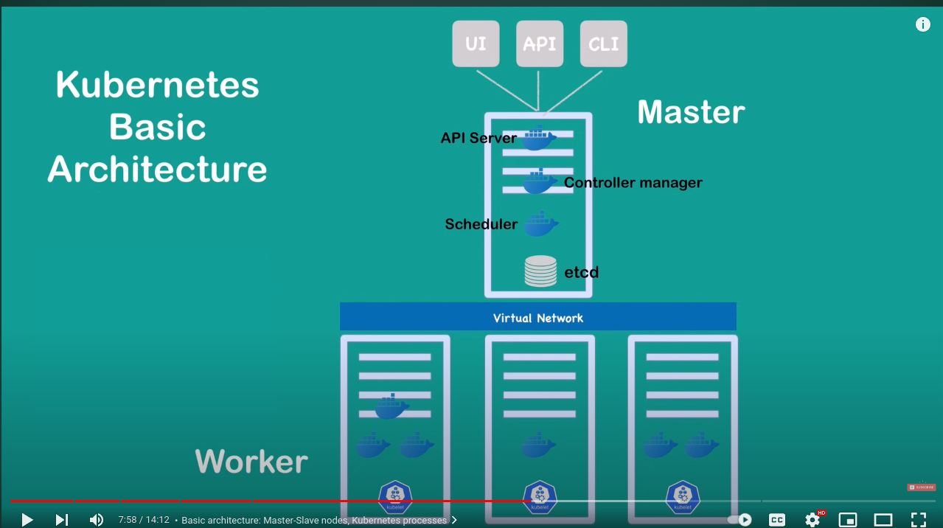
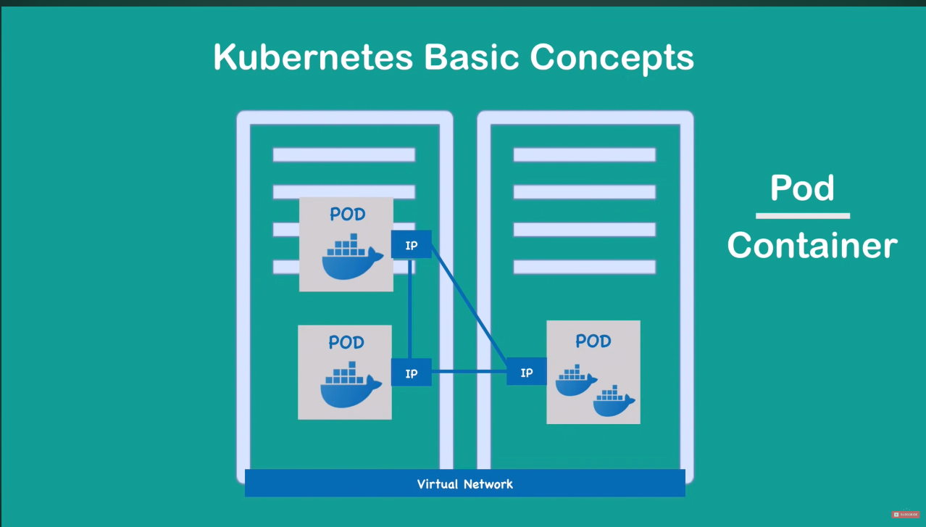

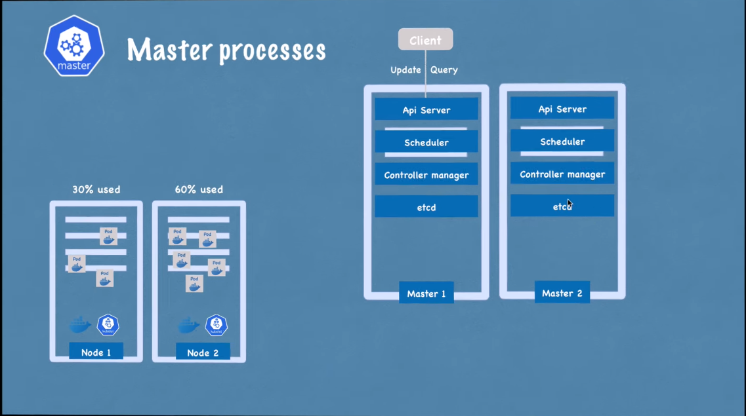

Kubectl commands:
The most basic command for viewing Kubernetes objects via kubectl is get. If you
run kubectl get <resource-name>, you will get a listing of all resources in the
current namespace. If you want to get a specific resource, you can use kubectl get
<resource-name> <obj-name>.
this command
will extract and print the IP address of the specified Pod:
$ kubectl get pods my-pod -o jsonpath –template={.status.podIP}

$kubectl apply -f <yaml_file>
$kubectl delete -f <yaml_file>
$kubectl get <resource_name> // Can be pod,service etc
$kubectl get <resource_name> <object_name> // To get specific object
$kubectl describe <resource_name> // Can be pod,service etc
$kubectl describe <resource_name> <object_name>
$kubectl get deployment nginx-deployment -o yaml // To get yaml file with status
$kubectl exec -it <pod_name> -c <container_name> -- /bin/sh #This is to interact with a container running inside a pod

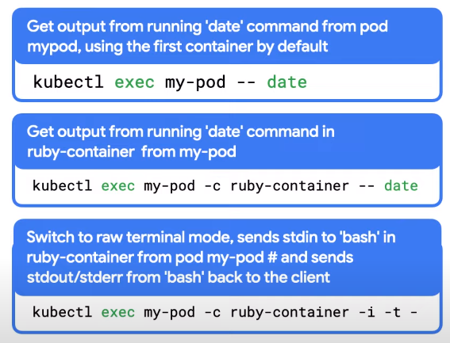
Kubernetes config file: 3 parts
1. Metadata
2. Spec
Template is blueprint for pods
3. Status (This will be auto created and handled by kubernetes)

apiVersion: apps/v1
kind: Deployment
metadata:
name: nginx-deployment
labels:
app: nginx
spec:
replicas: 2
selector:
matchLabels:
app: nginx
template:
metadata:
labels:
app: nginx
spec:
containers:
- name: nginx
image: nginx:1.16
ports:
- containerPort: 8080

The YAML manifest you provided is a Kubernetes Deployment definition for creating a Deployment named "nginx-deployment" running two replicas of an Nginx container with the image version "nginx:1.16". Let's break down the components of this Deployment:

```yaml
apiVersion: apps/v1
kind: Deployment
metadata:
name: nginx-deployment
labels:
app: nginx
```

- `apiVersion`: Specifies the API version to use for this resource. In this case, it's `apps/v1`, indicating the "apps" API group and version 1.
- `kind`: Specifies the type of Kubernetes resource, which is "Deployment" in this case.
- `metadata`: Contains metadata information about the Deployment, including its name and labels.
- `name`: The name of the Deployment, set to "nginx-deployment".
- `labels`: Labels are key-value pairs that can be used to identify and organize resources. In this case, the label "app" is set to "nginx".

```yaml
spec:
replicas: 2
selector:
matchLabels:
app: nginx
template:
metadata:
labels:
app: nginx
spec:
containers:
- name: nginx
image: nginx:1.16
ports:
- containerPort: 8080
```

- `spec`: The "spec" section defines the desired state of the Deployment.
- `replicas`: Specifies the number of replicas (instances) of the Pod that should be running. In this case, it's set to 2, so the Deployment will maintain two replicas of the Nginx container.
- `selector`: Defines the label selector used to identify the Pods controlled by this Deployment. The "matchLabels" field is set to match pods with the label "app: nginx".
- `template`: The "template" section specifies the Pod template used to create new Pods when scaling up or during updates.
- `metadata`: The metadata section in the template contains labels for the Pod. In this case, the "app" label is set to "nginx".
- `spec`: The spec section in the template defines the container specification.
- `containers`: Contains the container definition for the Pod.
- `name`: Specifies the name of the container, which is set to "nginx".
- `image`: Specifies the container image to use for the Nginx container, which is "nginx:1.16".
- `ports`: Specifies the container port that should be exposed and can be accessed from outside the Pod. In this case, it exposes port 8080.

When this Deployment is applied to a Kubernetes cluster, it will create and manage two replicas of the Nginx container, ensuring they are always available and that the desired state is maintained.
apiVersion: v1
kind: Service
metadata:
name: nginx-service
spec:
selector:
app: nginx
ports:
- protocol: TCP
port: 80
targetPort: 8080

The YAML manifest you provided is a Kubernetes Service definition named "nginx-service." A Service in Kubernetes is used to expose a set of pods to the network and allow them to be accessed by other applications within the cluster or from outside the cluster.

Let's break down the components of this Service definition:

```yaml
apiVersion: v1
kind: Service
metadata:
name: nginx-service
```

- `apiVersion`: Specifies the API version to use for this resource. In this case, it's `v1`, indicating the core "v1" API group.
- `kind`: Specifies the type of Kubernetes resource, which is "Service" in this case.
- `metadata`: Contains metadata information about the Service, including its name.

```yaml
spec:
selector:
app: nginx
ports:
- protocol: TCP
port: 80
targetPort: 8080
```

- `spec`: The "spec" section defines the specifications for the Service.

- `selector`: The "selector" field is used to determine which pods should be part of this service. In this case, the Service will include all pods with the label "app: nginx."

- `ports`: The "ports" field specifies the ports that the Service should listen on and forward traffic to the pods.

- `protocol`: Specifies the protocol used for the service. In this case, it's set to "TCP."
- `port`: The port number that the Service should listen on. For incoming traffic to the Service, it will listen on port 80.
- `targetPort`: The port number on the pods to which the traffic should be forwarded. In this case, it's set to 8080, meaning the Service will forward incoming traffic to port 8080 on the pods that match the selector.

When this Service is created, it will act as a load balancer, forwarding incoming traffic on port 80 to the pods that have the label "app: nginx" and are running Nginx containers on port 8080. This allows the Nginx service to be accessible from other pods within the cluster or from outside the cluster, depending on the type of Service (e.g., ClusterIP, NodePort, LoadBalancer).

NodePort: must be between 30000-32767

Namespace: By default when a cluster is created 3 namespaces are created.
Kube-system:controller-manager,kubeproxy,kubeapi etc all are in kube-system namespace.
Default: When the namespace is not mentioned created object are created in default namesapce.
Configmap and secret can’t be shared across namespace each namespace must define their own configmap and secret. But services can be shared across namespaces.
Kube-public: Public resources and congifs

DaemonSet: Usually when we need to run a pod in every node or subset of node in a cluster then we use daemonset. Pods created by daemonSet are usually ignored by kubernetrs scheduler.

Job: For a task to complete one time. After successfully completion of one time the job will be in completed state. The job will not be automatically deleted and cant be seen with kubectl get job to see all the job. One time job is normal job and CronJob is scheduled job.

Selector and matchselector: Only Selector is used in replication controller and service and replicaset, deployment, daemonset, job use matchselector along with selector.

Deployment: In deployment we can upgrade and rollback which is not possible in replicaset or replication controller.

Statefulset: Here creation and deletion of pods order matters. Here one pod will be master pod where we can read and write both but rather than the master pod all the pods are slave pod where we can read only. All the pods have different storage.

RBAC: To get cluster role- kubectl get clusterroles
To get ClusterRole binding- kubectl tet clusterrolebindings
To see if a specific user can perform a specific operation- kubectl auth can-i create pods

