FOUNDER OS
An AI-Augmented Operations Intelligence Platform for Multi-Startup Portfolio Management
A Project Report submitted in partial fulfilment of the requirements for the award of the degree of
«Bachelor of Technology»
«Computer Science and Engineering»
Submitted by
«MOBASHIR ALAM»
Roll No.: «23038004508»
Under the guidance of
«MR. NARENDER»
« Professor, Dept. of CSE»
«Department of Computer Science and Engineering»
«J.C. Bose University of Science and Technology»
«JUNE 2026»

BONAFIDE CERTIFICATE
This is to certify that the project report entitled “FOUNDER OS: An AI-Augmented Operations Intelligence Platform for Multi-Startup Portfolio Management” is a bonafide record of the work carried out by «MOBASHIR ALAM» (Roll No. «23038004508») in partial fulfilment of the requirements for the award of the degree of «Bachelor of Technology» in «Computer Science and Engineering» of «J.C. Bose University of Science and Technology ». The work presented in this report is original and has not been submitted, in part or in full, to any other institute or university for the award of any degree or diploma.

« MR. NARENDER » | « PROF. (DR.) S.K. GUPTA »
Project Guide  «Professor, Dept. of CSE» | Head of Department  «Department of Computer Science and Engineering»

Submitted for the project viva-voce examination held on ____________________.

Internal Examiner External Examiner

ACKNOWLEDGEMENTS
I would like to express my sincere gratitude to everyone who supported me through the course of this project.
First and foremost, I thank my project guide, MR. NARENDER , Professor, Dept. of CSE, for the continuous guidance, technical insight, and encouragement that shaped this work. Their feedback at every review helped me convert a broad idea into a concrete, working system.
I am grateful to HEAD OF DEPARTMENT NAME, Head of the Department of Computer Science and Engineering, and to all the faculty members of the department, for providing the academic environment, infrastructure, and motivation that made this project possible.
I would also like to thank Nasheedio, the organisation whose real operational needs inspired and grounded this platform, for the opportunity to work on a genuine, production-style problem and for access to the systems that the connectors integrate with.
MOBASHIR ALAM
Roll No.: 23038004508

ABSTRACT
Founders and operators who run several early-stage ventures simultaneously face a persistent information problem: the data they need to make decisions is fragmented across many disconnected Software-as-a-Service (SaaS) tools. Engineering activity lives in GitHub, team communication and attendance in Slack, content performance in YouTube Studio, and finance, hiring, and project status in yet more spreadsheets and dashboards. Each tool answers only its own narrow question, none of them are aware of organisational roles, and synthesising a portfolio-wide picture is a manual, error-prone, and time-consuming exercise.
This project presents Founder OS, a unified, role-aware operations-intelligence platform that consolidates these scattered signals into a single web application and makes them legible to the right person at the right altitude — from an individual team member up to the founder. The system is built as a single-page application using React, TypeScript, and Vite on the front end, and Supabase (managed PostgreSQL with Row-Level Security, plus Deno-based serverless edge functions) on the back end. A fine-grained role-based access-control model is enforced not only in the user interface through route guards but, more importantly, inside the database through Row-Level Security policies, so authorization cannot be bypassed by a malicious client.
The technical core of the platform is a generic connector framework that ingests data from third-party services through serverless functions, normalises it into a common schema, and exposes it through purpose-built analytics dashboards. Three connectors are implemented end to end: a YouTube connector using the OAuth 2.0 authorization-code flow to pull channel, video, audience, and retention analytics; a Slack accountability connector that reconstructs a configurable "work-day" (with a boundary hour so night shifts are not split at midnight) to track attendance and work updates across an entire team; and a GitHub engineering connector that synchronises commits and pull requests across multiple organisations, maps anonymous handles to employees, and surfaces contribution load and key-person ("bus-factor") risk. Layered on top of every connector is KAI, a natural-language assistant that constructs a grounded JSON snapshot of the synced data and queries a large-language-model gateway, allowing both engineering leads and the chief executive to ask plain-English questions and receive answers cited strictly from the organisation's own data.
The platform additionally implements email one-time-password multi-factor authentication, a transactional-email queue, and dashboards for project management, human resources, and finance. The result is a working, security-conscious, extensible system that demonstrably reduces the effort required to obtain a cross-functional, cross-startup operational view. This report documents the motivation, a review of related work, the system design and methodology, the implementation of each major subsystem, the results obtained, and directions for future enhancement.
Keywords: operations intelligence, role-based access control, Row-Level Security, OAuth 2.0, serverless functions, data connectors, large language models, retrieval-augmented question answering, engineering analytics.

NOMENCLATURE
This section lists the abbreviations, acronyms, and key terms used throughout the report.
Abbreviations and acronyms
Term | Expansion / Meaning
API | Application Programming Interface
BaaS | Backend-as-a-Service
CRUD | Create, Read, Update, Delete
CSS | Cascading Style Sheets
ERD | Entity-Relationship Diagram
HTTP(S) | Hypertext Transfer Protocol (Secure)
IST | India Standard Time (Asia/Kolkata, UTC+05:30)
JSON | JavaScript Object Notation
JWT | JSON Web Token
KAI | The platform's AI assistant ("Knowledgeable AI")
KPI | Key Performance Indicator
LLM | Large Language Model
MFA | Multi-Factor Authentication
OAuth | Open Authorization (delegated-access protocol)
OTP | One-Time Password
PAT | Personal Access Token
PR | Pull Request
RAG | Retrieval-Augmented Generation
RBAC | Role-Based Access Control
RLS | Row-Level Security (PostgreSQL)
SaaS | Software-as-a-Service
SPA | Single-Page Application
SQL | Structured Query Language
UI / UX | User Interface / User Experience
UTC | Coordinated Universal Time

Domain-specific terms
Term | Meaning in this project
Connector | A subsystem that ingests data from one external service (GitHub, Slack, YouTube)
Work-day | A logical day for attendance, shifted by a boundary hour so night shifts stay whole
Backfill credit | Crediting a batched, late work update against the days it covers
Bus-factor risk | A repository whose contributions are concentrated in one person (key-person risk)
Snapshot | The grounded JSON summary of synced data passed to the LLM by a KAI function
Edge function | A serverless Deno function executed on Supabase infrastructure
Executive mode | An optional bold UI theme for connector dashboards (CEO-facing view)

TABLE OF CONTENTS
ACKNOWLEDGEMENTS iii
ABSTRACT iv
NOMENCLATURE vi
TABLE OF CONTENTS viii
LIST OF FIGURES xi
LIST OF TABLES xii
CHAPTER 1: INTRODUCTION 1
1.1 Background and Motivation 1
1.2 Problem Statement 1
1.3 Objectives 2
1.4 Scope of the Project 2
1.5 Limitations 3
1.6 Organisation of the Report 3
CHAPTER 2: LITERATURE REVIEW 3
2.1 Business-Intelligence Dashboards and Operational Analytics 4
2.2 Engineering-Productivity and Team Analytics 4
2.3 Access Control and Database-Level Security 5
2.4 Third-Party Integration and Delegated Authorization 5
2.5 Large-Language-Model Assistants over Private Data 5
2.6 Gap Analysis 6
CHAPTER 3: SYSTEM DESIGN AND METHODOLOGY 7
3.1 Architectural Overview 7
3.2 Technology Stack 8
3.3 Access-Control Design (RBAC + Row-Level Security) 8
3.4 Data Model 11
3.5 The Connector Framework 12
3.6 The KAI AI Subsystem (Design) 12
3.7 Development Methodology 13
CHAPTER 4: IMPLEMENTATION 13
4.1 Module Catalogue 13
4.2 The Connector Framework in Code 14
4.3 YouTube Connector 15
4.4 Slack Accountability Connector 16
4.5 GitHub Engineering Connector 19
4.6 KAI — Grounded Natural-Language Assistant 21
4.7 Authentication and Multi-Factor Security 22
4.8 User-Experience Highlight: Executive Mode 23
4.9 A Note on Diagrams 23
CHAPTER 5: RESULTS AND DISCUSSION 24
5.1 Overview of the Delivered System 24
5.2 Module-by-Module Results 24
5.3 Operational Observations 25
5.4 Evaluation against Existing Systems 26
5.5 Limitations 27
CHAPTER 6: CONCLUSION AND FUTURE SCOPE 27
6.1 Conclusion 27
6.2 Key Achievements 28
6.3 Future Scope 28
REFERENCES 29
APPENDIX 30
Appendix A: Selected Schema — Connector Framework 30
Appendix B: Selected Row-Level Security Policy 31
Appendix C: Deployment and Configuration Notes 31
Appendix D: How to Rebuild This Report 32

LIST OF FIGURES
Figure 1: High-level system architecture of Founder OS, showing the browser SPA, the Supabase backend, the external APIs, and the AI gateway. 7
Figure 2: Two-layer access control: UI route guards for usability and PostgreSQL Row-Level Security policies for authoritative enforcement. 10
Figure 3: Entity-relationship diagram of the core domain entities and the generic connector framework. 11
Figure 4: The generic connector ingestion pipeline shared by all connectors: load credential, fetch, normalise, idempotent upsert, roll up, and serve. 12
Figure 5: YouTube connector: OAuth 2.0 authorization-code flow followed by analytics synchronisation. 16
Figure 6: Slack work-day bucketing: a configurable boundary hour keeps night shifts whole, then each message is classified as check-in, work update, or activity. 19
Figure 7: GitHub multi-organisation engineering sync, with identity mapping, daily roll-ups, a repository registry, and graceful early stop on rate-limit or time-budget exhaustion. 21
Figure 8: KAI grounded question-answering: the edge function reads synced data, builds a deterministic snapshot, and queries the AI gateway with strict grounding rules. 22
Figure 9: Authentication with email one-time-password multi-factor verification. 23
Figure 10: Screenshot: the Founder Command Center showing the portfolio-wide overview. 24
Figure 11: Screenshot: the GitHub engineering dashboard with contribution and risk views. 25
Figure 12: Screenshot: the Slack "Today" accountability board. 25
Figure 13: Screenshot: the YouTube analytics overview. 25
Figure 14: Screenshot: KAI answering a natural-language question grounded in the data. 25
Figure 15: Screenshot: a connector dashboard in Executive ("CEO View") mode. 25

LIST OF TABLES
Table 1: Comparison of Founder OS with representative existing systems 6
Table 2: Technology stack of Founder OS 8
Table 3: Representative page-level dashboards and their primary audience 13
Table 4: Edge functions grouped by purpose 14
Table 5: Objectives versus delivered outcomes 26

CHAPTER 1: INTRODUCTION

1.1 Background and Motivation
The modern early-stage company is assembled from cloud software. Source code and engineering activity live in GitHub; day-to-day communication, stand-ups, and attendance happen in Slack; audience growth and content performance are measured in YouTube Studio; and finance, hiring, payroll, and project status are spread across spreadsheets and a long tail of additional SaaS dashboards. Each of these tools is excellent at its own job, but each is also a silo. They do not talk to one another, they have no shared notion of who a person is across systems, and none of them understands the organisational hierarchy of the company that uses them.
This fragmentation becomes acute for a founder or operator who runs several ventures at once. To answer a simple cross-cutting question — "Is the engineering team shipping this week, is everyone putting up their attendance, and how is our content doing across the portfolio?" — that person must log in to three or four different products, mentally translate between their different vocabularies, manually reconcile usernames and time zones, and stitch the fragments into a story. The exercise is repetitive, slow, and easy to get wrong, and it scales badly: every new startup and every new tool multiplies the work.
The motivation for this project is the observation that the raw data already exists — it is simply trapped behind many separate interfaces. If that data can be ingested into one place, normalised to a common shape, made aware of organisational roles, and presented at the altitude appropriate to each viewer, then the manual synthesis disappears and decisions can be made from a single, trustworthy surface. Founder OS is the realisation of that idea: an internal operations-intelligence platform that unifies these signals and adds a natural-language layer so that questions can be asked of the data directly.

1.2 Problem Statement
To design and implement a secure, role-aware web platform that consolidates operational data from multiple third-party services (GitHub, Slack, YouTube) and internal modules (projects, human resources, finance) into a unified, multi-startup dashboard, and to augment it with an AI assistant that answers natural-language questions grounded strictly in the organisation's own synced data.
The core challenges embedded in this statement are: (i) integrating heterogeneous external APIs with different authentication models (OAuth tokens, bot tokens, personal access tokens) reliably and idempotently; (ii) enforcing access control that cannot be circumvented from the client; (iii) reconciling identities and time semantics across systems; and (iv) grounding a large-language-model assistant so that it never fabricates figures.

1.3 Objectives
The objectives of the project are as follows:
- To build a single-page web application that presents a unified, multi-startup operational view tailored to the viewer's organisational role.
- To design a generic connector framework — credential storage, ingestion functions, normalised tables, and rollups — that makes adding a new data source repeatable rather than bespoke.
- To implement three production-grade connectors end to end: YouTube (OAuth 2.0 analytics), Slack (team attendance and work-update accountability), and GitHub (multi-organisation engineering analytics).
- To enforce role-based access control both in the user interface (route guards) and, authoritatively, in the database (Row-Level Security policies).
- To provide an AI assistant ("KAI") that answers plain-English questions using a grounded snapshot of the synced data, serving both engineering-lead and chief-executive perspectives.
- To secure the platform with multi-factor authentication and to support operational concerns such as transactional email and notifications.

1.4 Scope of the Project
The project delivers a working, deployed web application covering: authentication with email one-time-password MFA; a role-based navigation and permission model; dashboards for the founder, project managers, functional heads, human resources, and finance; the connector framework and the three connectors named above with their dedicated analytics dashboards; and the KAI natural-language assistant for each connector. The platform is built on a managed cloud backend (Supabase) and deployed through the Lovable platform.

1.5 Limitations
The following boundaries apply to the present version of the system:
- The analytical depth of each connector is bounded by how far back data has been synced; historical depth equals sync depth.
- The KAI assistant is routed through a hosted AI gateway using a general-purpose model; it is grounded on a JSON snapshot rather than a vector database, which is appropriate for the data volumes involved but is not a full retrieval-augmented-generation pipeline.
- The deployment is configured for a single organisation's portfolio (single-tenant) and seeded accordingly, although the schema is multi-startup by design.

1.6 Organisation of the Report
The remainder of this report is organised as follows. Chapter 2 reviews related work in business-intelligence dashboards, access control, third-party integration, and language-model assistants, and positions Founder OS against it. Chapter 3 presents the system architecture, technology stack, data model, the access-control design, and the development methodology. Chapter 4 describes the implementation in detail, with deep-dives into each connector, the KAI subsystem, and the security mechanisms, including pseudo-code for the most significant algorithms. Chapter 5 discusses the results, what each dashboard delivers, and an evaluation against the surveyed alternatives. Chapter 6 concludes the report and outlines future scope, followed by the references and appendices.

CHAPTER 2: LITERATURE REVIEW
This chapter surveys the bodies of work and the existing systems that are relevant to Founder OS, organised by theme, and concludes with a gap analysis that positions the project against the state of the art.

2.1 Business-Intelligence Dashboards and Operational Analytics
The discipline of presenting operational data for decision-making is well established. Few [1], in his foundational treatment of information-dashboard design, defines a dashboard as a visual display of the most important information needed to achieve objectives, consolidated on a single screen so it can be monitored at a glance, and catalogues the common design failures that reduce a dashboard's effectiveness. These principles — single-surface consolidation, appropriate visual encoding, and minimisation of non-data ink — directly inform the dashboard layouts used throughout this project.
Commercial business-intelligence (BI) platforms such as Tableau, Microsoft Power BI, and Looker generalise this idea: they connect to data sources, model the data, and let analysts compose interactive visualisations. They are powerful but general-purpose; they assume a data team to model the sources and build the reports, they are priced for enterprises, and they are not opinionated about a specific operational domain or organisational role structure. Founder OS takes the opposite stance — it is purpose-built and role-aware, trading generality for an out-of-the-box, domain-specific experience that a non-analyst founder can use immediately.

2.2 Engineering-Productivity and Team Analytics
Measuring software-delivery performance is an active area. Forsgren, Humble, and Kim [2], in Accelerate, present the research behind the now-widely-adopted DORA metrics (deployment frequency, lead time for changes, change-failure rate, and time to restore service) and argue, with statistical backing, that delivery performance predicts organisational performance. A recurring caution in this literature is that naive activity counts — lines of code, raw commit counts — are poor proxies for productivity and can incentivise the wrong behaviour. Commercial tools such as LinearB, Swarmia, and GitHub's own Insights operationalise these ideas for engineering managers.
The GitHub connector in this project is informed by these lessons: it surfaces contribution distribution and key-person ("bus-factor") risk rather than ranking individuals by raw output, and it explicitly annotates that commit counts reflect default-branch activity and should not be over-read — a nuance also passed to the AI assistant as a grounding rule.

2.3 Access Control and Database-Level Security
Role-Based Access Control (RBAC) is the canonical model for managing authorization in multi-user systems. Sandhu, Coyne, Feinstein, and Youman [3] formalised the family of RBAC reference models, in which permissions are associated with roles and users acquire permissions by being assigned to roles, greatly simplifying administration compared with per-user access lists. Founder OS adopts RBAC with five application roles.
A common weakness in web applications is enforcing authorization only in application code, where it can be bypassed if the client talks to the data layer directly. PostgreSQL's Row-Level Security (RLS) [4] addresses this by attaching security policies to tables, so that the database itself restricts which rows a given user may read or modify, regardless of the query's origin. The Supabase platform [5] builds its access model on exactly this primitive, exposing the authenticated user's identity to policies. This project therefore enforces RBAC authoritatively inside the database through RLS policies backed by SECURITY DEFINER helper functions, with the user interface guards acting only as a usability layer.

2.4 Third-Party Integration and Delegated Authorization
Aggregating data from external services requires a secure way to act on a user's behalf. The OAuth 2.0 Authorization Framework [6] is the industry standard for delegated authorization; its authorization-code grant lets an application obtain a scoped access token (and a refresh token for long-lived access) without ever handling the user's credentials. The YouTube connector implements this grant directly. For services where a long-lived secret is appropriate, the project uses bot tokens (Slack) and personal access tokens (GitHub), each stored server-side and never exposed to the browser — a separation enabled by running all ingestion inside serverless edge functions rather than in the client.

2.5 Large-Language-Model Assistants over Private Data
The transformer architecture introduced by Vaswani et al. [7] underpins modern large language models (LLMs), which can answer questions and summarise text fluently. Their central weakness for analytics use is hallucination — confidently stating facts that are not true. Lewis et al. [8] proposed Retrieval-Augmented Generation (RAG), in which a model is conditioned on documents retrieved from an external knowledge source at inference time, substantially improving factual accuracy on knowledge-intensive tasks. The general principle — ground the model in authoritative source data and instruct it to cite only that data — is what makes an LLM trustworthy for operational reporting.
The KAI subsystem applies this principle in a form suited to its data scale: rather than a vector store, each KAI function deterministically constructs a compact, complete JSON snapshot of the relevant synced data and supplies it to the model along with strict instructions to use only the numbers present in the snapshot. This is a lightweight, auditable variant of grounded generation appropriate for structured operational data.

2.6 Gap Analysis
The reviewed work establishes the building blocks — dashboards, delivery metrics, RBAC, RLS, OAuth, and grounded LLMs — but each addresses only one facet. General BI tools are unaware of roles and require modelling effort; engineering-analytics tools cover only engineering; communication and content analytics live in their own products; and LLM assistants are typically bolted onto a single source. Table 1 summarises the comparison.
Table 1: Comparison of Founder OS with representative existing systems
Capability | General BI (Tableau / Power BI) | Eng-analytics (LinearB / GH Insights) | Native tool dashboards (Slack / YT) | Founder OS
Cross-tool consolidation | Yes (with modelling) | No | No | Yes
Role-aware presentation | No | Partial | No | Yes (5 roles, RLS-enforced)
Database-level authorization | N/A | N/A | N/A | Yes (PostgreSQL RLS)
Multi-startup portfolio view | Possible | No | No | Yes (native)
Built-in grounded AI Q&A | Limited / add-on | Emerging | No | Yes (per connector)
Out-of-the-box, no data team | No | Yes | Yes | Yes
Extensible connector framework | Via connectors | No | No | Yes

The gap Founder OS fills is the combination of all of these in a single, role-aware, multi-startup platform that a non-specialist can operate, with grounded AI assistance layered over every data source. The remaining chapters detail how this combination is designed and implemented.

CHAPTER 3: SYSTEM DESIGN AND METHODOLOGY

3.1 Architectural Overview
Founder OS follows a modern three-tier, serverless architecture. The presentation tier is a single-page application (SPA) that runs entirely in the browser; the logic and data tier is provided by Supabase, a managed backend-as-a-service that bundles a PostgreSQL database, an authentication service, file storage, a realtime engine, and a serverless function runtime; and the integration tier consists of the external service APIs (GitHub, Slack, YouTube, and an email provider) together with a hosted AI gateway. Figure 1 shows the overall arrangement and the principal data flows between these tiers.
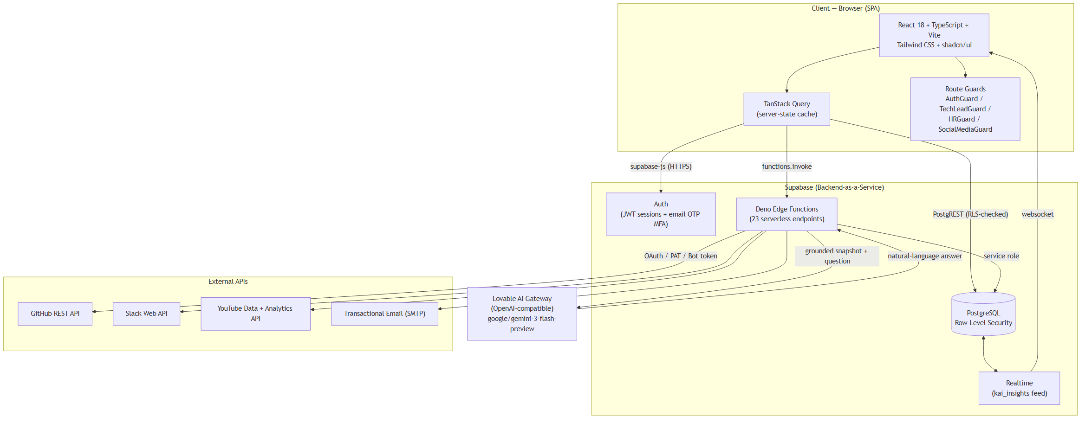
Figure 1: High-level system architecture of Founder OS, showing the browser SPA, the Supabase backend, the external APIs, and the AI gateway.
Two design decisions in this architecture are worth highlighting. First, all third-party communication and all privileged database writes happen inside edge functions, never in the browser. This keeps secrets (OAuth refresh tokens, bot tokens, personal access tokens, the AI gateway key) on the server and gives a single, auditable choke point for ingestion. Second, the browser reads data through Supabase's auto-generated REST interface, but every such read is filtered by Row-Level Security in the database, so the client is never trusted to enforce who may see what.

3.2 Technology Stack
The platform is implemented with the technologies listed in Table 2. The choices favour a fast, type-safe developer experience and a managed backend that minimises operational burden while still exposing low-level control (raw SQL migrations, serverless functions) where the project needs it.
Table 2: Technology stack of Founder OS
Layer | Technology | Role in the project
Language | TypeScript | Type-safe application code across UI and edge functions
UI framework | React 18 | Component-based single-page application
Build tool | Vite | Fast dev server and production bundling
Styling | Tailwind CSS + shadcn/ui (Radix) | Utility-first styling and accessible component primitives
Server state | TanStack Query | Caching, invalidation, and synchronisation of server data
Routing | React Router | Client-side routing and route guards
Charts | Recharts | Data visualisation in dashboards
Forms | React Hook Form + Zod | Form state and schema validation
Backend | Supabase (PostgreSQL) | Database, auth, storage, realtime
Serverless | Deno edge functions | Ingestion, OAuth, AI, email, MFA (23 functions)
AI | Lovable AI Gateway (Gemini 3 Flash) | OpenAI-compatible LLM access for KAI
Testing | Vitest + Testing Library | Unit and component testing
Deployment | Lovable | Build, hosting, and function deployment

3.3 Access-Control Design (RBAC + Row-Level Security)
Authorization is modelled with Role-Based Access Control. Every user has an application role stored on their profile, drawn from five values: founder, mfo (multi-function operator), functional_head (further qualified by a department such as tech, social_media, or hr), project_manager, and team_member. Roles determine both what a user sees and what a user may change.
Crucially, this model is enforced at two layers, as shown in Figure 2. In the browser, lightweight route guards (AuthGuard, TechLeadGuard, HRGuard, SocialMediaGuard) prevent unauthorised navigation and hide controls that the user may not use — this is a usability and defence-in-depth measure. The authoritative enforcement, however, lives in the database: every sensitive table has Row-Level Security policies whose USING and WITH CHECK clauses call SECURITY DEFINER helper functions such as is_founder(), is_founder(uuid), is_social_media_lead(), and has_role(uuid, app_role). Because these policies are evaluated by PostgreSQL itself against the authenticated user's identity (auth.uid()), an attacker who bypasses the UI and calls the data API directly still cannot read or write rows they are not entitled to.
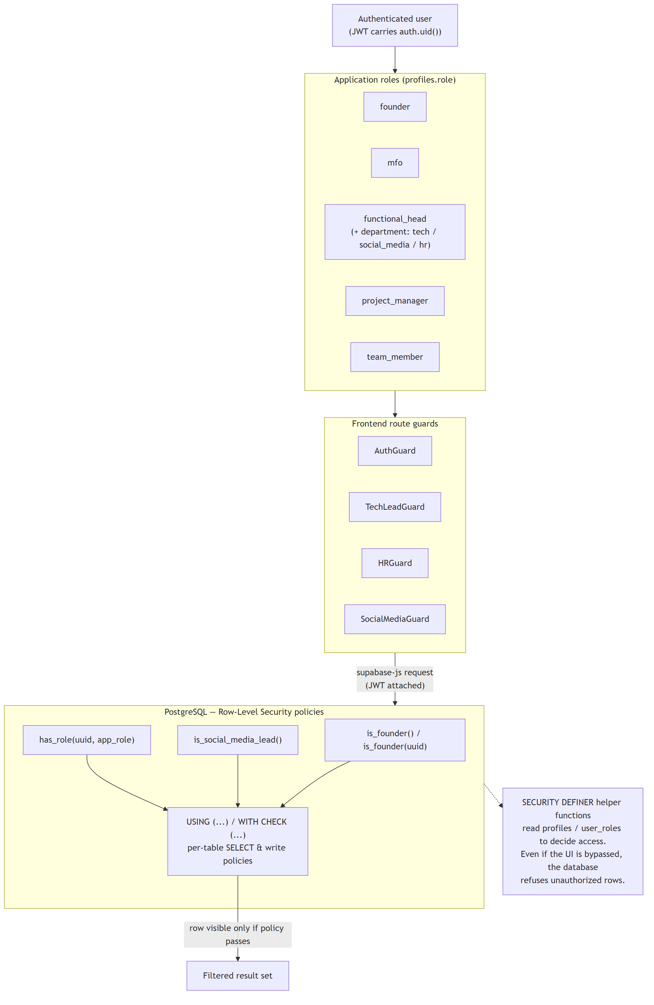
Figure 2: Two-layer access control: UI route guards for usability and PostgreSQL Row-Level Security policies for authoritative enforcement.
This separation is a deliberate security posture: the front end is treated as untrusted, and correctness of authorization does not depend on it.

3.4 Data Model
The database schema is broad, reflecting the platform's many modules, but it is anchored by a small set of core entities and a uniform connector framework. The central entities are startups (the portfolio companies), profiles (users, carrying role, department, and cross-system identity fields such as github_username), and user_roles. Around these sit domain tables for projects, tasks, bugs, documents, departments, and the human-resources and finance modules.
The connector framework contributes a consistent set of tables — connector_credentials (one encrypted credential row per connector per startup), the raw data tables (connector_data_github, connector_data_slack, and the YouTube equivalents), a normalised metrics table, and an AI kai_insights feed. Figure 3 presents an entity-relationship view of the core domain together with the connector framework.
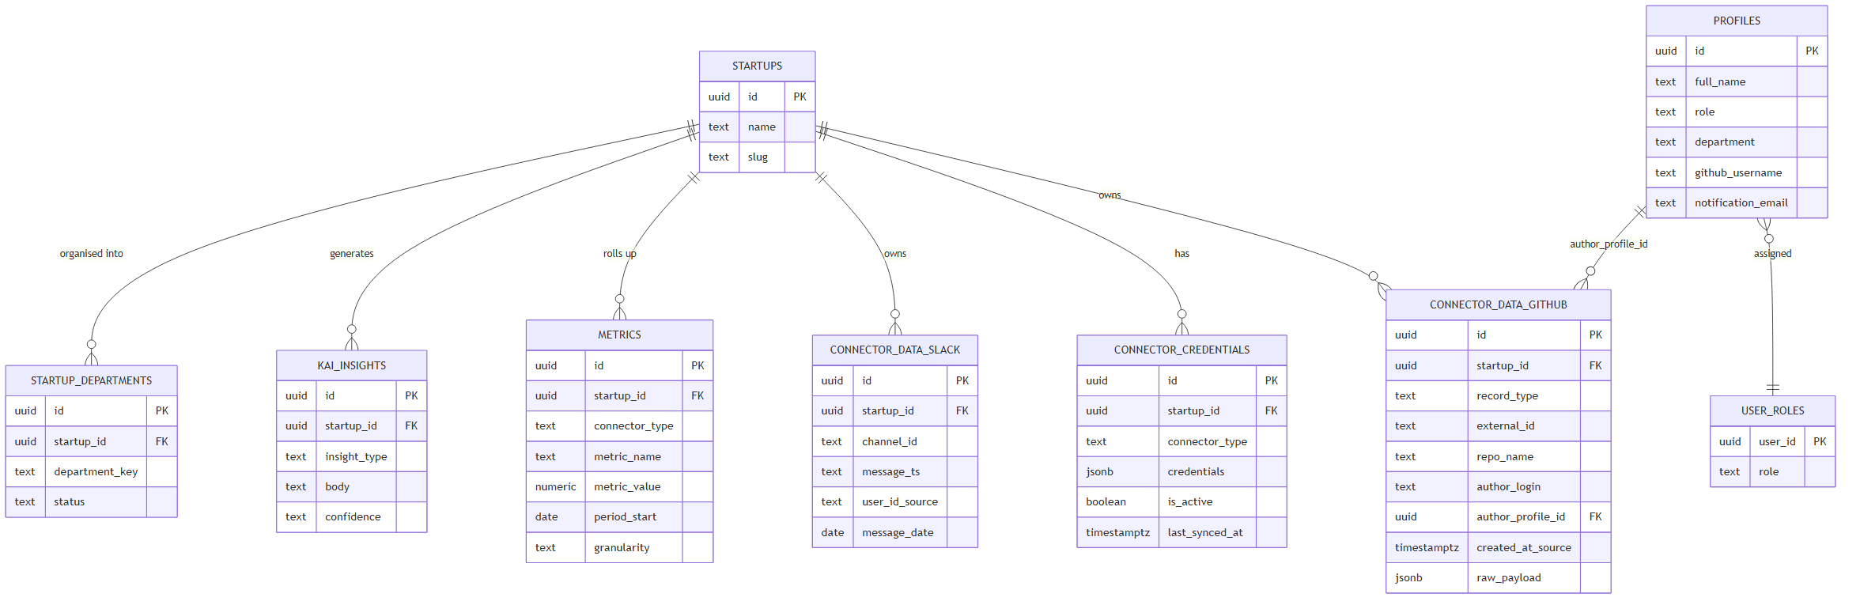
Figure 3: Entity-relationship diagram of the core domain entities and the generic connector framework.
A few schema conventions recur throughout: every connector-owned table is keyed by startup_id (so the data is partitioned per company), raw payloads from external APIs are retained in a jsonb column for traceability and reprocessing, and uniqueness constraints (for example UNIQUE (startup_id, record_type, external_id)) make ingestion idempotent — re-running a sync updates existing rows rather than duplicating them.

3.5 The Connector Framework
Rather than implement each integration as a one-off, Founder OS defines a repeatable pipeline that every connector follows, illustrated in Figure 4. A sync is triggered (manually from a dashboard, by invoking the connector's edge function); the function loads the active credential for that startup and connector from connector_credentials; it calls the external API with appropriate pagination and rate-limit awareness; it normalises the response into uniform row shapes; it performs an idempotent upsert into the connector's raw table; it computes daily roll-up aggregates into a *_daily table for fast dashboard queries; and finally it records last_synced_at. Dashboards then read the normalised tables through Row-Level-Security-checked queries, and the KAI assistant reads the very same tables to build its snapshot.
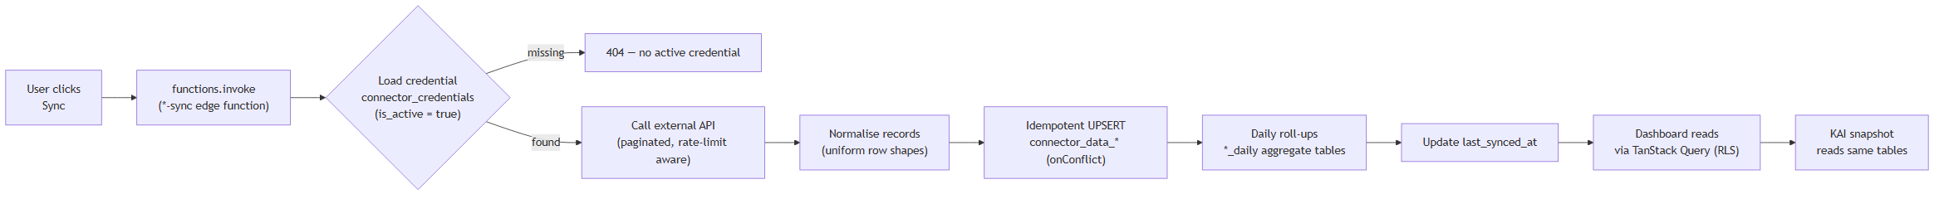
Figure 4: The generic connector ingestion pipeline shared by all connectors: load credential, fetch, normalise, idempotent upsert, roll up, and serve.
This uniformity is what makes the framework extensible: adding a new source (for example, Instagram) means writing one new sync function and a dashboard, while reusing the credential storage, the table conventions, the rollup pattern, and the KAI design.

3.6 The KAI AI Subsystem (Design)
Each connector is paired with a KAI question-answering function (github-kai-ask, slack-kai-ask, youtube-kai-ask) and there are platform-level functions (kai-ask, kai-predict) for broader insight generation. The design goal is grounded answering: the assistant must never invent numbers. Each function therefore (i) reads the full relevant synced history from the database, (ii) deterministically aggregates it into a compact JSON snapshot (per-person and per-repository/channel breakdowns, totals, and momentum deltas), and (iii) sends that snapshot, together with a system prompt containing strict grounding rules, to the Lovable AI gateway. The model's answer is thus constrained to the organisation's own data. The detailed request flow is given in Chapter 4 (Figure 8).

3.7 Development Methodology
The project was developed iteratively using the Lovable platform in conjunction with Supabase. Schema changes are expressed as versioned SQL migrations (the repository contains roughly seventy-five migration files), giving a reproducible, auditable history of the database. Server behaviour is encapsulated in independently deployable edge functions. Each feature was built in a vertical slice — migration, edge function, data-access hook, and UI — and validated end to end against real connected accounts before moving on. Type safety (TypeScript end to end, generated database types) and component tests (Vitest) provide a baseline of correctness, while the iterative loop kept the system continuously demonstrable. This methodology suited a solo developer building a broad platform: it favoured working software at every step over big-design-up-front, while the migration history and RLS policies kept the foundations disciplined.

CHAPTER 4: IMPLEMENTATION
This chapter describes how the system was built. It begins with an overview of the modules, then presents the connector framework in code, followed by detailed treatments of the three connectors and the KAI assistant, the security mechanisms, and a user-experience highlight. Representative pseudo-code is given for the most significant algorithms.

4.1 Module Catalogue
The application is organised into page-level dashboards, each guarded by the access-control model of Section 3.3, and a set of serverless edge functions that perform all privileged work. The application comprises twenty-seven page-level routes; Table 3 lists a representative selection grouped by audience, and Table 4 catalogues the twenty-three edge functions by purpose.
Table 3: Representative page-level dashboards and their primary audience
Module / Route | Primary audience | Purpose
Founder Command Center | Founder | Portfolio-wide health and priorities at a glance
Portfolio / Startup Detail | Founder, MFO | Per-startup deep view (finance, team, documents)
Project Board / Project Detail | Project managers | Projects, tasks, bugs, discussion
Functional Head / Department | Functional heads | Department status and updates
HR Dashboard | HR lead, founder | Attendance, leave, payroll, reviews, hiring
Finance (CFO) Dashboard | Founder, finance | Financial entries and funding
Social Media (YouTube) | Social-media lead, founder | YouTube analytics connector dashboard
Slack — Team Ops | Social-media lead, founder | Attendance and work-update accountability
Engineering — GitHub | Tech lead, founder | Commits, PRs, focus, and key-person risk
Profile / Inbox / Login / Verify 2FA | All users | Identity, notifications, authentication

Table 4: Edge functions grouped by purpose
Group | Functions | Responsibility
Connector sync | connector-sync, github-sync, slack-sync, youtube-sync, youtube-analytics-sync | Ingest and normalise external data
Connector discovery | github-discovery, youtube-discovery | Read-only scans (orgs/repos, channels) for setup
OAuth | youtube-oauth-start, youtube-oauth-callback | OAuth 2.0 authorization-code flow
Presence | slack-presence | Live "who is online" lookup
AI (KAI) | kai-ask, kai-predict, github-kai-ask, slack-kai-ask, youtube-kai-ask | Grounded Q&A and insight generation
Authentication | send-mfa-code, verify-mfa-code | Email one-time-password MFA
Email | send-transactional-email, process-email-queue, preview-transactional-email, handle-email-suppression, handle-email-unsubscribe | Transactional email pipeline
Reporting | weekly-tech-digest | Scheduled engineering digest

4.2 The Connector Framework in Code
Credentials for every integration are stored in a single table, connector_credentials, with a jsonb credentials column that holds whatever each connector needs (an OAuth refresh token, a Slack bot token, or a GitHub personal access token plus a list of organisations). The table is protected so that only a founder may write credentials, while the sync functions read them using the service role. Ingestion is made idempotent by upserting against a natural key, so repeated syncs converge rather than duplicate. The pattern, common to every connector, is:
function syncConnector(startup_id, connector_type):
cred = SELECT credentials FROM connector_credentials
WHERE startup_id = $1 AND connector_type = $2 AND is_active
if not cred: return 404 "no active credential"
records = []
for page in fetchExternalAPI(cred, window, rateLimitAware = true):
records += normalise(page) # uniform row shape
UPSERT INTO connector_data_<type> (records)
ON CONFLICT (startup_id, <natural key>) DO UPDATE
rollUpDaily(startup_id) # aggregate into *_daily
UPDATE connector_credentials SET last_synced_at = now()
return counts
An important practical detail is that PostgREST's bulk upsert requires every row in a batch to have the same set of keys; mixed-shape records (for example, commits without a merged_at field alongside pull requests that have one) must be padded to a uniform shape, a lesson applied throughout the GitHub connector.

4.3 YouTube Connector
The YouTube connector is the most authentication-rich of the three because it acts on a user's Google account through the OAuth 2.0 authorization-code grant. Figure 5 traces the full flow. The user starts the connection from the Social-Media dashboard; youtube-oauth-start returns a Google consent URL carrying the requested scopes and an anti-forgery state value; after the user grants access, Google redirects to youtube-oauth-callback, which exchanges the authorization code for an access token and a long-lived refresh token and stores them in connector_credentials. Thereafter, youtube-sync and youtube-analytics-sync use the refresh token to obtain fresh access tokens and query the YouTube Data and Analytics APIs.
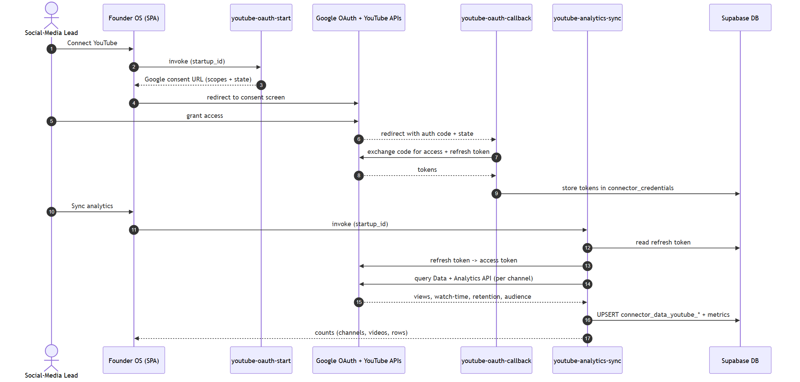
Figure 5: YouTube connector: OAuth 2.0 authorization-code flow followed by analytics synchronisation.
Data is ingested in tiers: a data tier (channels and their videos), an analytics tier (views, watch-time, and engagement over time), and a tier-2 layer (audience geography and demographics, and per-video retention curves). The dashboard presents these through tabs — overview, audience, retention, content lab, and an "Ask KAI" tab — with KPI tiles and Recharts visualisations. Channel-level filtering and pagination keep the views responsive when a startup owns several channels.

4.4 Slack Accountability Connector
The Slack connector was deliberately reframed from a generic message-analytics tool into a team-accountability system answering three operational questions: who is at work now, who has not posted attendance, and who has not given a work update. Two design problems made this non-trivial.
Problem 1 — night shifts must not split at midnight. Different team members work different hours, some overnight. A naive calendar-day bucket would split a single night shift across two days. The connector therefore computes a logical work-day by converting each message's timestamp to the configured local time zone (Asia/Kolkata) and shifting by a configurable boundary hour: any activity before the boundary rolls into the previous calendar day. Figure 6 shows the bucketing and classification logic, and the algorithm is:
function localWorkDate(ts_seconds, timeZone, boundaryHour):
(y, m, d, hour) = localParts(ts_seconds, timeZone) # via Intl.DateTimeFormat
base = UTC_date(y, m, d)
if hour < boundaryHour:
base = base - 1 day # before boundary -> previous work-day
return base as YYYY-MM-DD
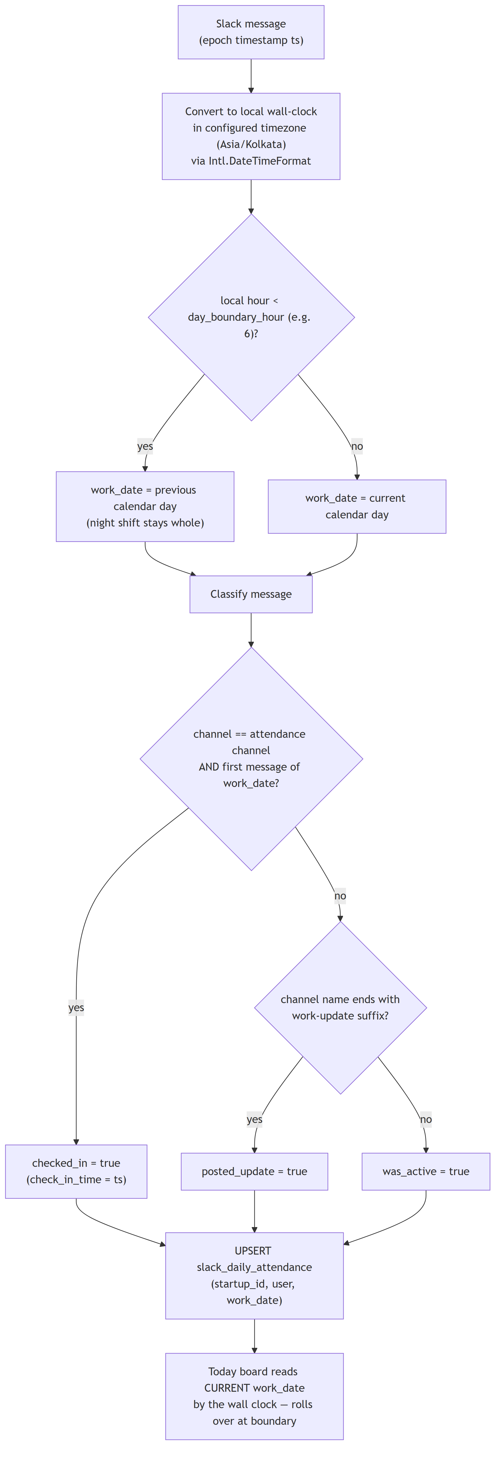
Figure 6: Slack work-day bucketing: a configurable boundary hour keeps night shifts whole, then each message is classified as check-in, work update, or activity.
A message is classified by channel: the first message of a work-day in the designated attendance channel marks a check-in; a message in any channel whose name ends with the configured work-update suffix marks a work update; any other message marks generic activity. Results are upserted into slack_daily_attendance, keyed by (startup_id, user, work_date). The "Today" board reads the current work-day computed from the wall clock, so the board rolls over automatically at the boundary hour rather than waiting for new data.
Problem 2 — batched and self-reported updates. People often post several days of updates at once, or write attendance for past days in a single message. The connector handles batched updates with backfill credit (a late update is credited against the days it covers, up to a configurable cap, shown in an amber "caught up" state) and parses free-text bulk check-ins with the AI assistant, flagging them distinctly as self-reported so they are not confused with live check-ins. A monthly attendance sheet aggregates the per-day records across the team.

4.5 GitHub Engineering Connector
The GitHub connector gives engineering leadership and the founder a clear picture of who is working on what, how much, and where the risk is. It synchronises across multiple organisations using a personal access token, as shown in Figure 7. For each organisation it lists repositories most-recently-pushed first, skips archived or inactive ones, and for each active repository fetches commits within the window and open and merged pull requests, paginating defensively.
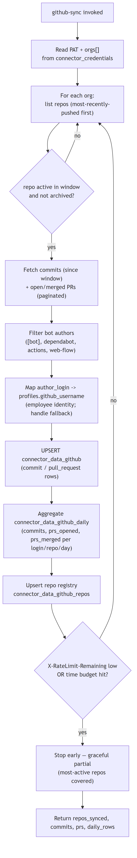
Figure 7: GitHub multi-organisation engineering sync, with identity mapping, daily roll-ups, a repository registry, and graceful early stop on rate-limit or time-budget exhaustion.
Three engineering concerns shaped the implementation. Identity — raw GitHub handles are mapped to employees via profiles.github_username, with the raw handle shown as a fallback and a mapping dialog provided to link the rest. Bot noise — automated authors ([bot], dependabot, github-actions, web-flow) are filtered so they do not pollute per-person statistics. Resource limits — the GitHub API permits 5,000 requests per hour per token, so the function watches X-RateLimit-Remaining and enforces an internal time budget, stopping gracefully with the most-active repositories already covered and reporting whether the run was partial. Commits and pull requests are upserted into connector_data_github, aggregated into connector_data_github_daily, and the full repository inventory (including dormant and archived repositories) is recorded in connector_data_github_repos. The dashboard then surfaces overview KPIs, a per-person view, a per-repository view with a bus-factor risk flag (a repository whose commits are dominated by a single contributor), a "focus / right now" view of in-flight pull requests, and a filterable commits panel.

4.6 KAI — Grounded Natural-Language Assistant
KAI lets any authorised user ask plain-English questions of a connector's data and receive an answer cited only from that data. Figure 8 shows the request flow for the GitHub assistant (github-kai-ask); the Slack and YouTube assistants follow the same pattern over their respective tables.
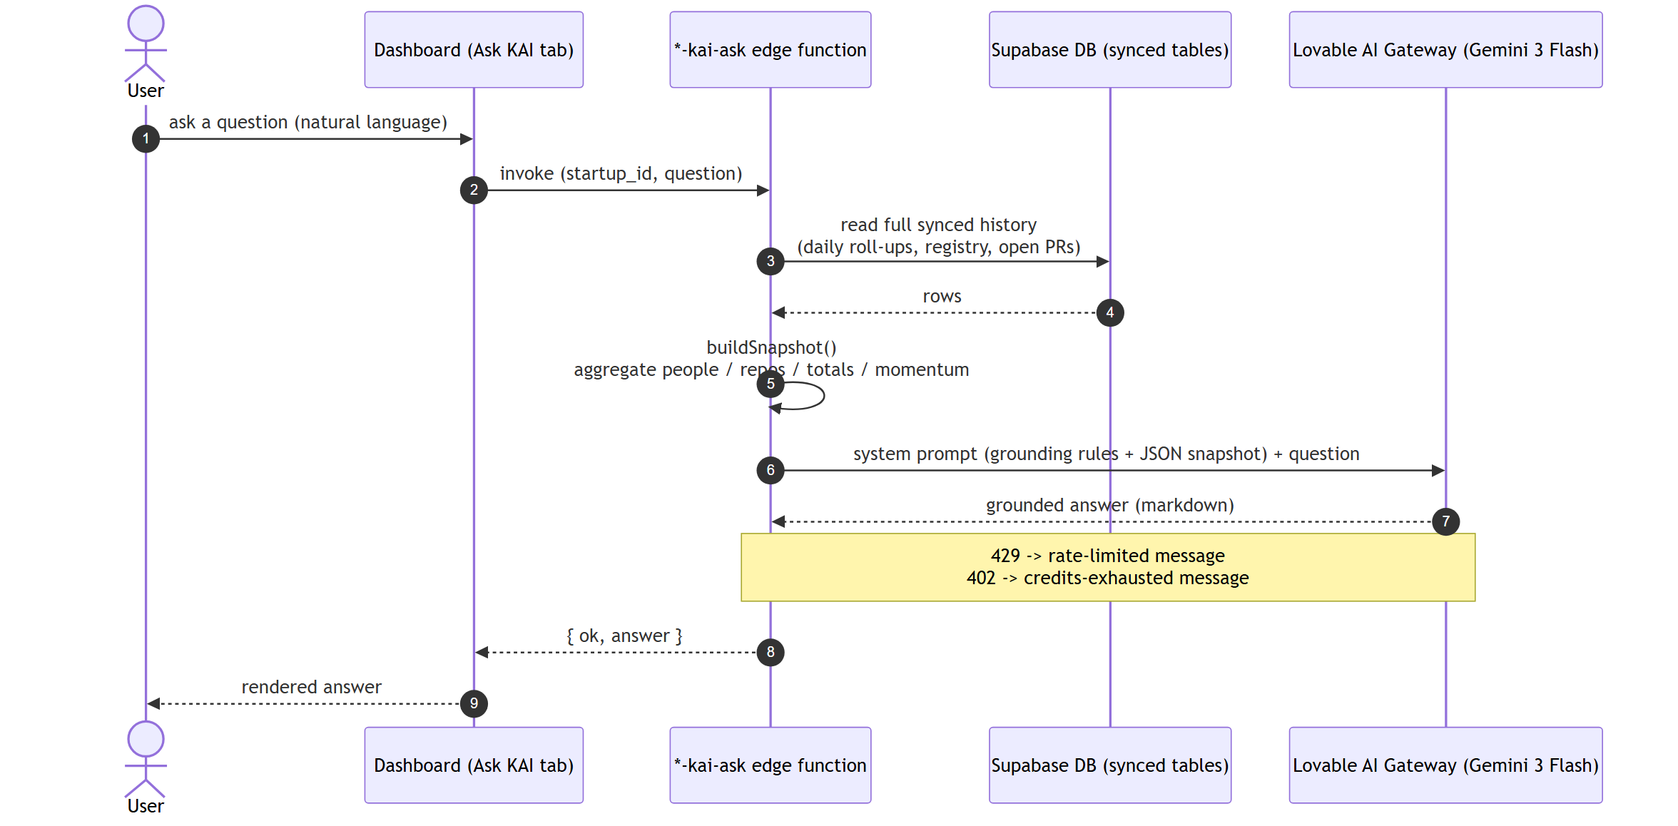
Figure 8: KAI grounded question-answering: the edge function reads synced data, builds a deterministic snapshot, and queries the AI gateway with strict grounding rules.
When invoked with a startup_id and a question, the function reads the full synced history (for GitHub, 180 days of daily roll-ups plus the repository registry and all open pull requests), then deterministically builds a compact JSON snapshot: per-person totals (commits, pull requests opened and merged, repositories touched, last-active date), per-repository contributor breakdowns with a bus-factor flag, full-window and last-seven-day totals, and seven-day-versus-prior-seven-day momentum deltas. The snapshot and a system prompt of grounding rules are sent to the Lovable AI gateway (an OpenAI-compatible endpoint proxying google/gemini-3-flash-preview). The grounding rules are explicit, for example:
- Only cite numbers present in the snapshot. Never invent data.
- Answer for two audiences: an engineering lead (load balance,
who is blocked, stuck PRs) and the CEO (are we shipping, is
everyone contributing, risk).
- Flag risk concretely: stale open PRs, bus_factor_risk repos,
contributors with little recent activity, sharp momentum drops.
- Commits reflect default-branch activity; do not over-read raw
counts as productivity.
The function maps rate-limit (HTTP 429) and credit-exhaustion (HTTP 402) responses to friendly messages and returns the model's markdown answer. Because the model only ever sees the organisation's own aggregated data and is instructed to cite nothing else, the assistant is suitable for operational reporting. This is a lightweight, auditable application of the retrieval-augmented-generation principle discussed in Section 2.5: retrieval is a deterministic database query, and the "documents" are a structured snapshot.

4.7 Authentication and Multi-Factor Security
Authentication is built on Supabase Auth (email and password, issuing JWT sessions) and hardened with email one-time-password multi-factor authentication. Figure 9 shows the flow: after a successful password sign-in, send-mfa-code generates a time-limited six-digit code, stores it (hashed, with an expiry and attempt counter), and emails it to the user; the Verify2FA page collects the code and verify-mfa-code validates it before access is granted. Combined with the Row-Level Security model of Section 3.3, this gives the platform layered protection: something the user knows (password), something the user receives (OTP), and database-enforced authorization on every row.
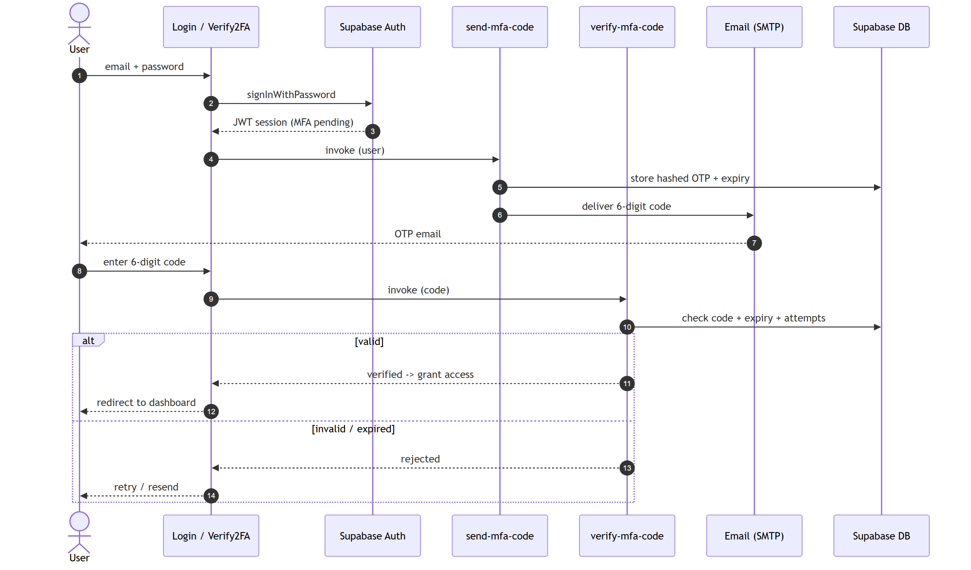
Figure 9: Authentication with email one-time-password multi-factor verification.

4.8 User-Experience Highlight: Executive Mode
A distinguishing UX feature is Executive ("CEO View") mode, a one-click bold re-skin of the three connector dashboards intended for executive presentation. It is implemented elegantly as a token-swap: a React context flips a persisted flag, and a scoped CSS class redefines the design-system colour tokens (a red/gold/black palette) together with an animated backdrop and entrance animations. Because every component is built on these CSS variables, the entire dashboard re-skins automatically without touching component code. A global rescue rule remaps the handful of components that hardcode light colours so they remain legible on the dark canvas. The feature demonstrates the value of a disciplined, token-driven design system.

4.9 A Note on Diagrams
As Founder OS is a software system, this report contains data-flow diagrams, sequence diagrams, an entity-relationship diagram, and architectural block diagrams in place of the hardware schematics or circuit diagrams that a hardware project would include; there is no hardware component in this project. The pseudo-code listings above capture the algorithmic core of the most significant routines, and selected source-level excerpts are reproduced in the Appendix.

CHAPTER 5: RESULTS AND DISCUSSION

5.1 Overview of the Delivered System
The project delivers a working, deployed web platform that meets the objectives set out in Section 1.3. A user signs in, passes email one-time-password verification, and is presented with navigation and dashboards appropriate to their role. The three connectors ingest live data from GitHub, Slack, and YouTube into the unified schema, the dashboards render that data with key-performance-indicator tiles and charts, and the KAI assistant answers natural-language questions grounded in the synced data. This section discusses what each part delivers, summarises operational observations, and evaluates the system against the alternatives surveyed in Chapter 2. Figures 10 to 15 are screenshots of the running application.
Note: the screenshots referenced below are to be captured from the running application and placed in the `report/figures/` directory using the file names shown; until then the build inserts a labelled placeholder for each.

5.2 Module-by-Module Results
Founder Command Center. The landing surface for the founder consolidates portfolio-wide signals and priorities, giving the cross-startup view that previously required visiting several tools (Figure 10).
[ Figure not yet rendered — run render_figures.ps1 to produce screenshot_founder.png from figures/screenshot_founder.mmd ]
Figure 10: Screenshot: the Founder Command Center showing the portfolio-wide overview.
Engineering — GitHub. The engineering dashboard answers, in one place, who is working on which repository, how many commits and pull requests they have produced, and where key-person risk lies. It provides overview KPIs, per-person and per-repository breakdowns, an in-flight pull-request view, a filterable commits panel, and identity mapping (Figure 11).
[ Figure not yet rendered — run render_figures.ps1 to produce screenshot_github.png from figures/screenshot_github.mmd ]
Figure 11: Screenshot: the GitHub engineering dashboard with contribution and risk views.
Slack — Team Ops. The accountability board shows, for the current work-day, who has checked in, who is active but has not checked in, who is absent, and who has not posted a work update, along with a monthly attendance sheet. The work-day boundary logic correctly keeps overnight shifts intact (Figure 12).
[ Figure not yet rendered — run render_figures.ps1 to produce screenshot_slack.png from figures/screenshot_slack.mmd ]
Figure 12: Screenshot: the Slack "Today" accountability board.
Social Media — YouTube. The content dashboard presents channel and video performance, audience geography and demographics, and retention curves across the connected channels (Figure 13).
[ Figure not yet rendered — run render_figures.ps1 to produce screenshot_youtube.png from figures/screenshot_youtube.mmd ]
Figure 13: Screenshot: the YouTube analytics overview.
KAI assistant. Each connector's "Ask KAI" tab answers free-text questions — for example, "who shipped the most this week?" or "which pull requests are stuck?" — citing figures only from the synced snapshot (Figure 14).
[ Figure not yet rendered — run render_figures.ps1 to produce screenshot_kai.png from figures/screenshot_kai.mmd ]
Figure 14: Screenshot: KAI answering a natural-language question grounded in the data.
Executive mode. The optional executive re-skin renders the same dashboards in a bold, presentation-oriented theme for chief-executive review (Figure 15).
[ Figure not yet rendered — run render_figures.ps1 to produce screenshot_exec.png from figures/screenshot_exec.mmd ]
Figure 15: Screenshot: a connector dashboard in Executive ("CEO View") mode.

5.3 Operational Observations
Several qualitative results emerged from running the connectors against real accounts:
- Idempotency holds. Repeated syncs converge on the same data rather than duplicating it, owing to the natural-key upserts; this makes the manual "Sync" button safe to press at any time.
- Graceful degradation under limits. The GitHub connector's rate-limit and time-budget handling allows large multi-organisation accounts (tens of repositories across two organisations) to be synced incrementally, covering the most active repositories first and reporting partial runs honestly.
- Correct temporal semantics. The Slack work-day boundary resolves the night-shift problem: a shift that crosses midnight is recorded against a single work-day, and the "Today" board rolls over at the configured boundary hour by the wall clock rather than waiting for new messages.
- Grounded answers. Because KAI is constrained to a deterministic snapshot, its answers track the dashboard figures; the principal constraint on answer quality is sync depth, not the model.
Table 5 maps the project objectives to their delivered outcomes.
Table 5: Objectives versus delivered outcomes
Objective (Section 1.3) | Outcome
Unified, role-aware multi-startup dashboard | Delivered — 27 routes, five roles, role-based navigation
Generic connector framework | Delivered — shared credentials, tables, rollups, and pattern
Three end-to-end connectors | Delivered — YouTube (OAuth), Slack (attendance), GitHub (eng)
RBAC enforced in UI and database | Delivered — route guards + PostgreSQL RLS policies
Grounded AI assistant | Delivered — per-connector KAI over a snapshot
MFA and operational concerns | Delivered — email OTP MFA, email queue, notifications

5.4 Evaluation against Existing Systems
Measured against the comparison in Table 1, Founder OS occupies a position that none of the surveyed categories occupy alone. Unlike general business-intelligence tools, it is role-aware and requires no data-modelling effort before it is useful; unlike single-domain analytics products, it spans engineering, communication, and content in one surface; unlike the native dashboards of the source tools, it offers a cross-startup portfolio view and database-level authorization; and unlike a bolt-on chatbot, its AI assistant is grounded per-connector in the organisation's own data. The trade-off for this integration is breadth over depth: a dedicated tool will always offer more specialised analysis within its niche, whereas Founder OS optimises for a unified, decision-ready overview.

5.5 Limitations
The honest limitations of the current system are: analytical depth is bounded by sync depth; KAI uses a general-purpose hosted model over a JSON snapshot rather than a vector-database retrieval pipeline, which is adequate at the present data scale but would need revisiting at much larger volumes; per-message enrichment in Slack (for example, reaction counts) depends on the granted API scopes; and the deployment is currently single-tenant even though the schema is multi-startup. These are addressed as future work in Chapter 6.

CHAPTER 6: CONCLUSION AND FUTURE SCOPE

6.1 Conclusion
This project set out to solve a concrete and common problem: the operational data a founder needs is scattered across many disconnected SaaS tools, none of which understands the organisation's roles or offers a portfolio-wide view. Founder OS addresses this by consolidating those signals into a single, role-aware web platform and adding a grounded natural-language assistant on top.
The work delivers a complete, deployed system rather than a prototype. It contributes a generic connector framework that turns each new integration into a repeatable pattern, and it implements three connectors end to end — a YouTube analytics connector built on the OAuth 2.0 authorization-code flow, a Slack accountability connector with a carefully designed work-day model that respects night shifts, and a multi-organisation GitHub engineering connector that surfaces contribution load and key-person risk. Security is treated as a first-class concern: authorization is enforced authoritatively in the database through PostgreSQL Row-Level Security rather than trusted to the client, and access is protected by email one-time-password multi-factor authentication. Finally, the KAI assistant demonstrates a disciplined, auditable way to apply large language models to operational data — grounding every answer in a deterministic snapshot of the organisation's own figures.
In meeting all six stated objectives, the project shows that a single developer, using a managed serverless backend and a token-driven front end, can build a broad yet secure operations-intelligence platform that measurably reduces the manual effort of obtaining a cross-functional, cross-startup view.

6.2 Key Achievements
- A unified, role-aware platform spanning twenty-seven dashboards and twenty-three serverless functions.
- A reusable connector framework with idempotent ingestion and daily roll-ups.
- Three production-grade connectors (YouTube, Slack, GitHub), each with a dedicated analytics dashboard.
- Two-layer access control: UI route guards plus database-enforced Row-Level Security.
- Email one-time-password multi-factor authentication and a transactional-email pipeline.
- A grounded, per-connector AI assistant (KAI) for natural-language reporting.

6.3 Future Scope
Several enhancements would extend the platform's value:
- Additional connectors. An Instagram/Meta connector and a Google-Sheets/finance connector would broaden coverage, reusing the existing framework with minimal new code.
- Scheduled and realtime synchronisation. Replacing manual sync with scheduled background jobs (and, where supported, webhooks) would keep dashboards continuously fresh without user action.
- A dedicated, configurable AI backend. Routing KAI through a dedicated model API with selectable models, and evolving the grounding from a JSON snapshot toward a true vector-store retrieval-augmented-generation pipeline, would improve answer quality at larger data volumes.
- Deeper engineering analytics. Incorporating the DORA delivery metrics (lead time, deployment frequency, change-failure rate, time to restore) and pull-request review-health metrics would add industry-standard rigour to the GitHub connector.
- Full multi-tenancy. Generalising the single-tenant deployment into a multi-organisation SaaS offering, with per-tenant isolation enforced by the existing RLS foundation.
- Mobile experience. A responsive or native mobile client for on-the-go executive review, building on the same APIs.
Together these directions would evolve Founder OS from an internal operations platform into a general, extensible product for multi-venture operators.

REFERENCES
[1] S. Few, Information Dashboard Design: The Effective Visual Communication of Data. Sebastopol, CA, USA: O'Reilly Media, 2006.
[2] N. Forsgren, J. Humble, and G. Kim, Accelerate: The Science of Lean Software and DevOps — Building and Scaling High Performing Technology Organizations. Portland, OR, USA: IT Revolution Press, 2018.
[3] R. S. Sandhu, E. J. Coyne, H. L. Feinstein, and C. E. Youman, "Role-based access control models," Computer, vol. 29, no. 2, pp. 38–47, Feb. 1996, doi: 10.1109/2.485845.
[4] The PostgreSQL Global Development Group, "Row Security Policies," PostgreSQL Documentation. [Online]. Available: https://www.postgresql.org/docs/current/ddl-rowsecurity.html. [Accessed: Jun. 2026].
[5] Supabase, "Row Level Security," Supabase Documentation. [Online]. Available: https://supabase.com/docs/guides/database/postgres/row-level-security. [Accessed: Jun. 2026].
[6] D. Hardt, Ed., "The OAuth 2.0 Authorization Framework," Internet Engineering Task Force (IETF), RFC 6749, Oct. 2012. [Online]. Available: https://www.rfc-editor.org/rfc/rfc6749.
[7] A. Vaswani, N. Shazeer, N. Parmar, J. Uszkoreit, L. Jones, A. N. Gomez, Ł. Kaiser, and I. Polosukhin, "Attention is all you need," in Advances in Neural Information Processing Systems (NeurIPS), vol. 30, 2017, pp. 5998–6008.
[8] P. Lewis, E. Perez, A. Piktus, F. Petroni, V. Karpukhin, N. Goyal, H. Küttler, M. Lewis, W. Yih, T. Rocktäschel, S. Riedel, and D. Kiela, "Retrieval-augmented generation for knowledge-intensive NLP tasks," in Advances in Neural Information Processing Systems (NeurIPS), vol. 33, 2020, pp. 9459–9474.
[9] Meta Open Source, "React — The library for web and native user interfaces," React Documentation. [Online]. Available: https://react.dev. [Accessed: Jun. 2026].
[10] TanStack, "TanStack Query — Powerful asynchronous state management," TanStack Documentation. [Online]. Available: https://tanstack.com/query. [Accessed: Jun. 2026].
[11] GitHub, "GitHub REST API documentation," GitHub Docs. [Online]. Available: https://docs.github.com/en/rest. [Accessed: Jun. 2026].
[12] Slack Technologies, "Slack Web API," Slack API Documentation. [Online]. Available: https://api.slack.com/web. [Accessed: Jun. 2026].
[13] Google, "YouTube Analytics and Reporting APIs," Google for Developers. [Online]. Available: https://developers.google.com/youtube/analytics. [Accessed: Jun. 2026].
[14] Tailwind Labs, "Tailwind CSS — Rapidly build modern websites," Tailwind CSS Documentation. [Online]. Available: https://tailwindcss.com/docs. [Accessed: Jun. 2026].

APPENDIX

Appendix A: Selected Schema — Connector Framework
The connector framework is anchored by the connector_credentials table, which stores one credential per connector per startup and is writable only by a founder. The raw GitHub data table is keyed for idempotent ingestion.
CREATE TABLE public.connector_credentials (
id uuid PRIMARY KEY DEFAULT gen_random_uuid(),
startup_id uuid NOT NULL REFERENCES public.startups(id) ON DELETE CASCADE,
connector_type text NOT NULL
CHECK (connector_type IN
('github','slack','youtube','google_sheets','spotify','drive')),
credentials jsonb NOT NULL DEFAULT '{}'::jsonb,
is_active boolean NOT NULL DEFAULT true,
last_synced_at timestamptz,
last_sync_error text,
UNIQUE (startup_id, connector_type)
);
CREATE TABLE public.connector_data_github (
id uuid PRIMARY KEY DEFAULT gen_random_uuid(),
startup_id uuid NOT NULL REFERENCES public.startups(id) ON DELETE CASCADE,
record_type text NOT NULL CHECK (record_type IN ('pull_request','issue','commit')),
external_id text NOT NULL,
repo_name text NOT NULL,
author_login text,
author_profile_id uuid REFERENCES auth.users(id) ON DELETE SET NULL,
created_at_source timestamptz,
raw_payload jsonb NOT NULL DEFAULT '{}'::jsonb,
UNIQUE (startup_id, record_type, external_id) -- makes sync idempotent
);

Appendix B: Selected Row-Level Security Policy
Authorization is enforced in the database. A SECURITY DEFINER helper resolves the caller's role, and policies reference it. The example below restricts writes to founders while allowing authenticated reads.
-- Helper: is the current user a founder?
CREATE OR REPLACE FUNCTION public.is_founder(_user_id uuid)
RETURNS boolean
LANGUAGE sql STABLE SECURITY DEFINER SET search_path = public
AS $$
SELECT EXISTS (
SELECT 1 FROM public.profiles
WHERE id = _user_id AND role = 'founder'
)
$$;
-- Policy: only a founder may write credentials; any authenticated user may read.
ALTER TABLE public.connector_credentials ENABLE ROW LEVEL SECURITY;
CREATE POLICY "connector_credentials_select" ON public.connector_credentials
FOR SELECT USING (auth.uid() IS NOT NULL);
CREATE POLICY "connector_credentials_write" ON public.connector_credentials
FOR ALL USING (public.is_founder(auth.uid()));

Appendix C: Deployment and Configuration Notes
The application is configured through server-side secrets held by the Supabase project (never exposed to the browser):
- SUPABASE_URL, SUPABASE_SERVICE_ROLE_KEY — used by edge functions for privileged database access.
- LOVABLE_API_KEY — authenticates calls from the KAI functions to the AI gateway.
- Per-connector credentials (OAuth client ID/secret and refresh token for YouTube; bot token for Slack; personal access token plus organisation list for GitHub) — stored as rows in connector_credentials.
Edge functions are declared in the Supabase configuration with JWT verification disabled where they are invoked server-to-server, and schema changes are applied as versioned SQL migrations. The front end is built with Vite and deployed through the Lovable platform.

