**Back-End:**

After Activating the Plugin, It‘ll create two pages:

-MEMBER REGISTRATION:

A Registration Form for registering new user.

-MEMBER HOME

Home page for all members after successful log in.

**Registration Form:**

We can also include the Registration form at any page by using the **[tm_mbr_registration]** shortcode.

**Log In Form:**

We can include the log in form at any page by including the **[team_member_login]** shortcode.

**ADD New Department:**

**Step-1:** To add a new department, Click “DEPARTMENT” Tab Under “TEAM MEMBER”. 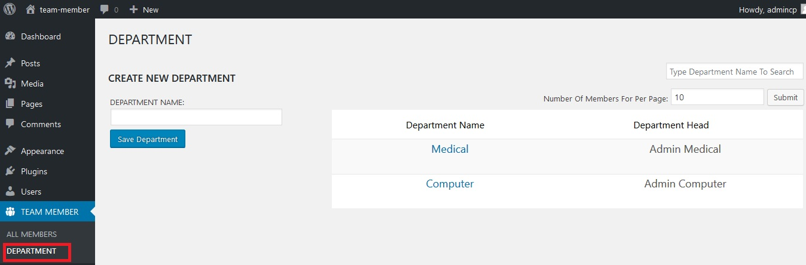

**Step-2:** Then Type your desired Department name into the department field and Click “Save Department” Button.

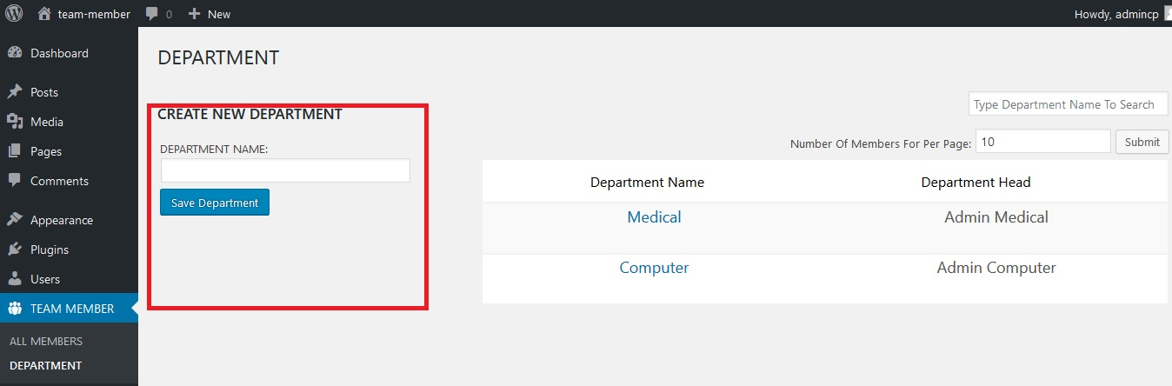

If your department name match with any existing department then it’ll append a number at the last of your department name.

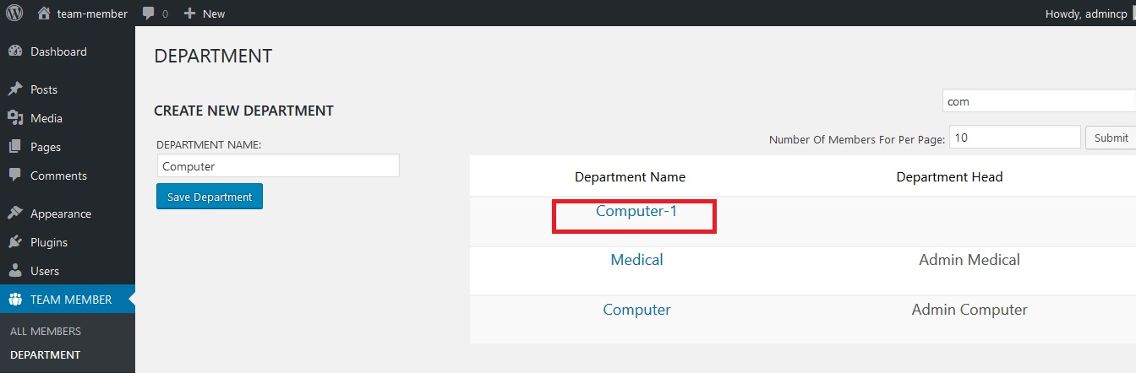

**ADD New Member:**

**Step-1:** To Add New Member From wordpress admin panel Click On the “TEAM MEMBER” Menu Option.

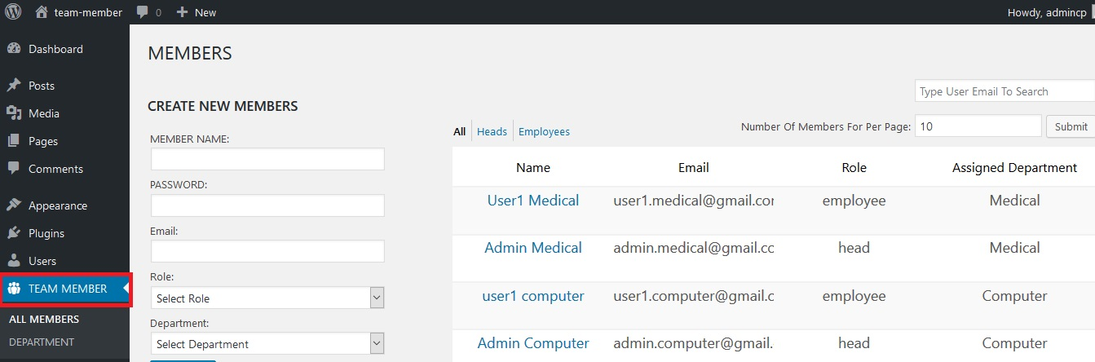

**Step-2:** Fill the user information and click “Add User” Button.

**Update Department:**

To update a department, just hover over the department name and click on “Edit”. Then Fill up your desired fields and click update.

You can also delete a department by click on the delete button.

**Update Member:**

To update a member, hover over the member name and click on “Edit”. Then Fill up your desired fields and click update.

You can also delete a member by click on the delete button.

**Front-End:**

At first, you have need to log in with a valid user account.

If you login with an employee account, then you’ll see details of your account in the home page.

If you login with a department head account, then you’ll see details of your account in the home page. Additionally, you can also find a list of your department employees under your account details.

You can upload your profile picture from the home page. You can also edit your account details from here.