SustainWear Testing Table
Test ID | Test Type | Test Case | Description | Expected Result | Actual Result | Status
1 | Unit Test | Login function validation | Test login with correct and incorrect credentials | Valid credentials log in, invalid credentials show error | Works as expected | Passed
2 | Unit Test | Create donation API | Ensures donation is saved correctly to the database | Donation item stored with correct fields into correct table | Item stored successfully | Passed
3 | Acceptance Test | Donor adds a donation | Donor logs in, uploads a clothing item with details | Donation appears in their history and charity dashboard | Completed successfully | Passed
4 | Acceptance Test | Charity Staff approves/declines donation | Charity staff reviews incoming donation and updates status | Donation status updates and is reflected across system | Worked correctly | Passed
5 | Acceptance Test | Admin views analytics | Admin logs in and accesses metrics (C02 Report) dashboard | Analytics load correctly with no errors | Displayed successfully | Passed
6 | Usability Test | Dashboard navigation | Test whether users can easily navigate between pages | Users can locate features without confusion | Minor improvements made like improving font size | Improved
7 | Usability Test | Donation form clarity | Checks if user/s understand how to submit donations | Users complete form without confusion | Needed clearer labels; fixed | Passed after revision
8 | Accessibility Test | Mobile responsiveness | Check UI on mobile screens | Layout adjusts correctly on all screen sizes | Minor layout fix needed after checking with google lighthouse | Updated
9 | Security Test | Role-based access control | Ensure donor cannot access admin/charity pages | Unauthorized users blocked and sends them to login page | Access correctly blocked after adding middleware | Passed after revision
10 | Security Test | Password storage | Verify passwords stored securely (hashed) | Hashed passwords only | Confirmed hashed storage by using bcrypt | Passed
11 | Security Test | Unauthorized API access | Attempt to access API without authentication using cookie session token | Request denied and will send you to login | Access denied as expected | Passed

Image proof:
Test ID 1:
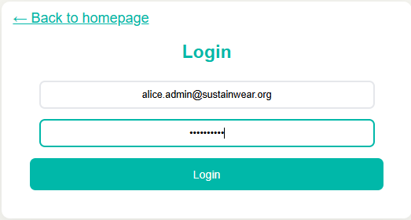
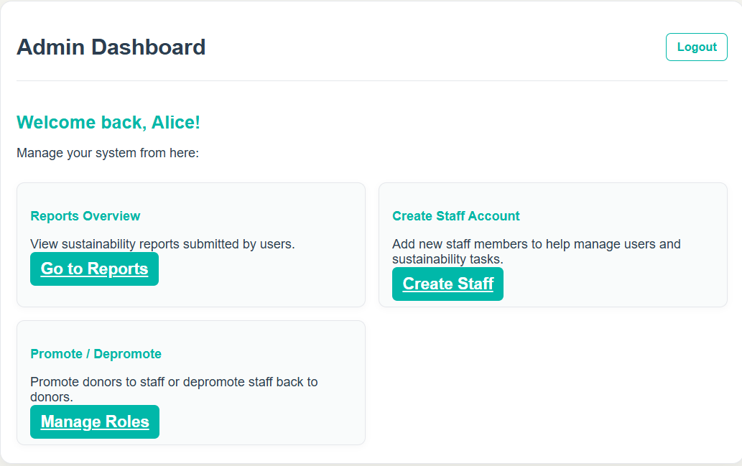
Test ID 2:
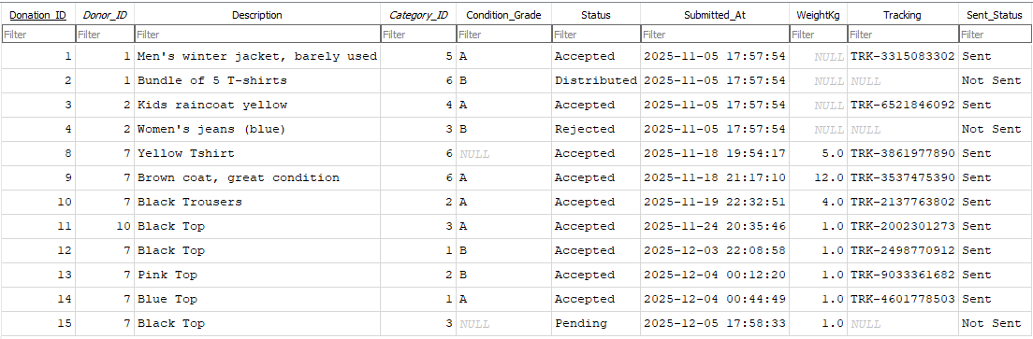
Test ID 3:
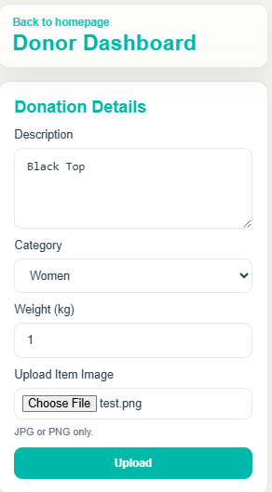

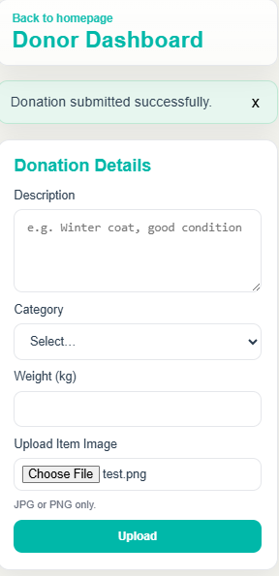
Test ID 4:
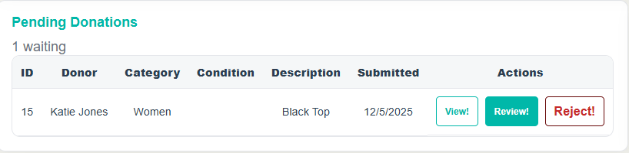
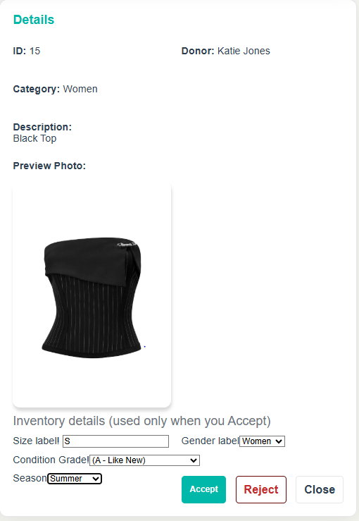
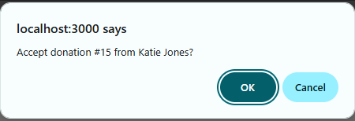
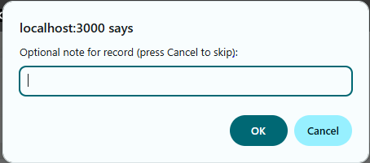
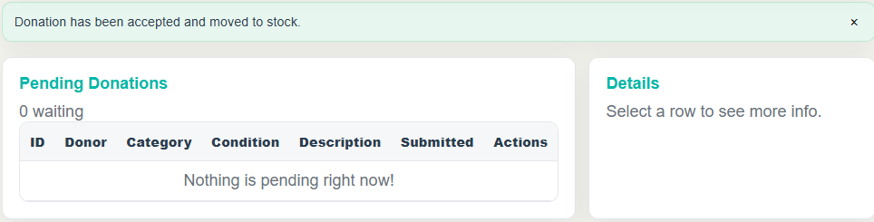
Test ID 5:
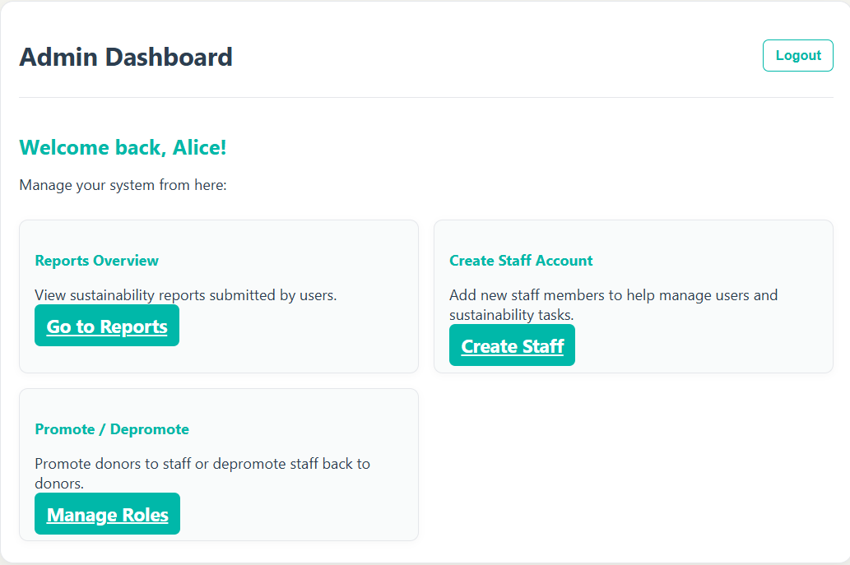
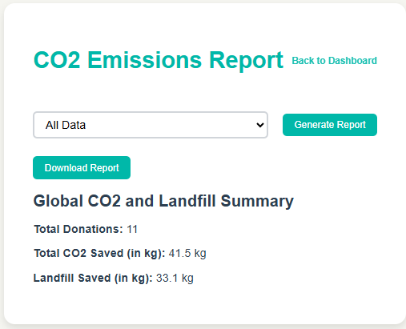
Test ID 6:
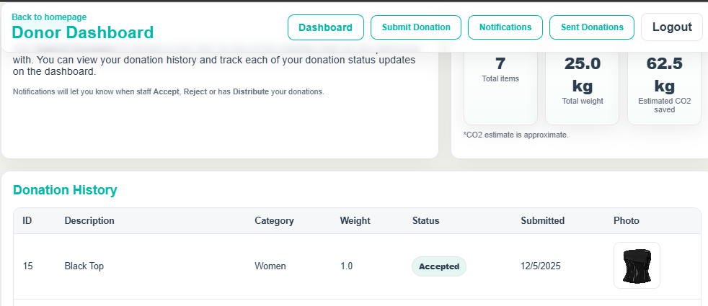
Test ID 7:

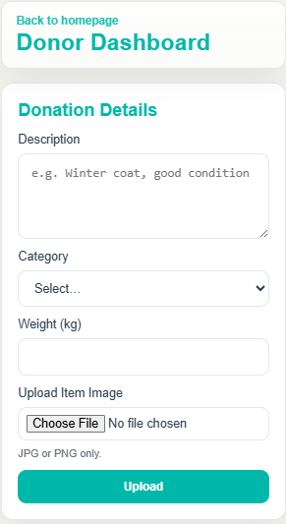
Test ID 8:
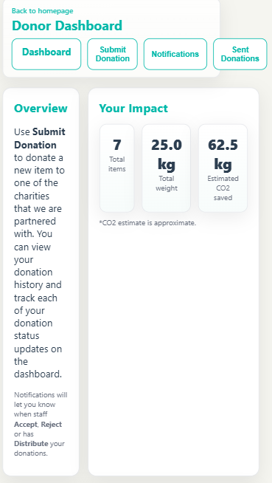
Test ID 9:
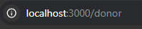
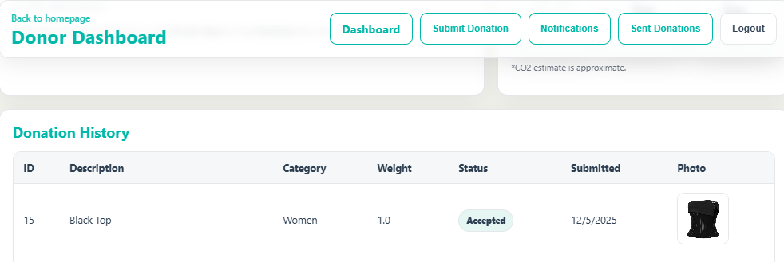

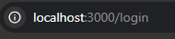
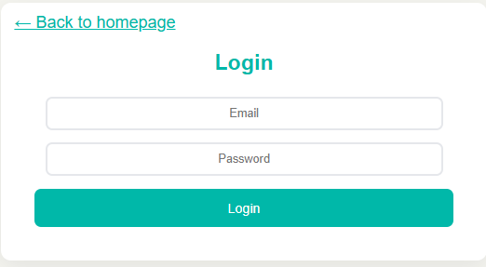
Test ID 10:
Test ID 11:

