Student Name: Mobeen Zar
DS & AI 13

AI-Powered Resume Screening & Semantic Job Matching Platform
Project Overview
This project focuses on building an AI-powered system that automates resume screening and matches resumes with job descriptions using Natural Language Processing (NLP) and Machine Learning. The system extracts meaningful information from resumes and ranks candidates based on relevance.
The system will:
- Accept resumes (PDF/DOCX) and job descriptions as input
- Extract and preprocess text using NLP techniques
- Identify key skills, experience, education, and keywords
- Compute a matching score between resumes and job descriptions
- Rank candidates based on relevance

Key Features
- Resume parsing (PDF/DOCX)
- NLP-based skill extraction
- Semantic job–resume matching
- Hybrid similarity scoring
- Interactive results dashboard
Rationale & Market Relevance
Manual resume screening is time-consuming and inconsistent. This project addresses the problem by introducing AI-driven semantic matching, reducing bias and improving efficiency. Unlike traditional keyword-based systems, this solution understands contextual meaning.
Workflow & Methodology
The system uses a hybrid NLP approach combining TF-IDF and sentence embeddings. Text data is cleaned, vectorized, and compared using cosine similarity to generate ranked results.
Technologies Used
- Python
- spaCy, NLTK
- Sentence-Transformers (MiniLM)
- Scikit-learn
- Streamlit
- Dockerization

Matching Methodology
The final matching score is calculated using a weighted hybrid model:
TF-IDF Similarity (40%), Semantic Embedding Similarity (50%), and Skill Overlap (10%). This balances keyword relevance with contextual understanding.

Entity Relationship Diagram (ERD)
Embeddings
Job Description
Skills
Resume
Match Results
User

Systems Workflow
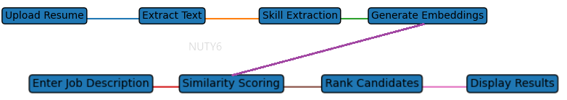

Conclusion
This project demonstrates an application of AI and NLP in recruitment. It showcases real-world application and strong technical foundations suitable for academic evaluation.

