“Bank Account Management System”

Submitted By: 

NOREEN BIBI 3457

NARMEEN ASIM 34

MUNAHIL YAQOOB 3450

Submitted To:

Mam Asma Khatoon

Department of Computer Science

DaTE:9,Nov,2017

**Bank Management System**

2

 

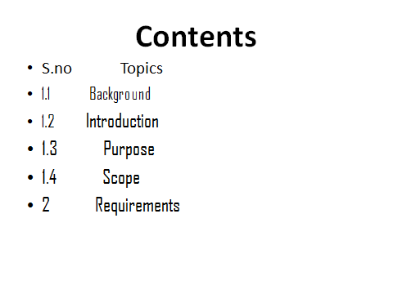

***1.1Background:***

**The previous bank management system registration of person is done by just writing the person name, age, gender and amount. Whenever the person comes up his information is stored freshly .It is destroyed after some time period to decrease the paper load in the bank .All the work is done manually by the receptionist and other staff and lot of papers are needed to be handle and taken care of. Manager have to remember various records of people**.

***1.2Introduction:***

**Banks are the essential part of our lives, providing the best bank facilities to people. It is necessary for the banks to keep the track of its day to day activities and record of people. By keeping track of all the activities on paper is very cumbersome and error prone, unreliable and inefficient. It is also not economically and technical feasible to maintain these record on paper .Bank MANAGEMENT SYSTEM also provide low cost reliable automation of the existing system. The system also provide excellent security of data and every level of user-system interaction.**

**The project “Bank Management System” includes 7 options.**

**1. New account**

**2. Deposit**

**3. Withdraw**

**4. Balance enquiry**

**5. Complete account holder’s list**

**6. Close an account**

**7. Modify an account**

***1.3Purpose:***

**The purpose of this system is reduce time and cost. And this system provide more accuracy. This system is more applicable.**

**2.Requirements:**

**FUNCTIONAL REQUIREMENTS:**

**2.1.1 login:**

A simple user can access their account and can deposit/withdraw money from their account. User can also transfer money from their account to any other bank account. ¬ User login, use PIN system .  
**2.1.2Customer’s data:**

**It is necessary condition to with draw amount from bank is that customer must have an account no, and name otherwise the program doesn’t execute.**

**2.1.3Appearing of main screen:**

**Main screen must appear so that user know that how to execute the program. If it doesn’t appear then it is a serious issue.**

**2.1.4Account option:**

**Different options appear. It is necessary to fill the form correctly. If it is not fill properly program doesn’t execute.**

**2.1.5Exit option:**

**It is necessary option. After the account is successfully created then it is user desire that he/she wants to exit or select any other option.**

**3Non functional requirements:**

**3.1.1ERRORS**

**Input errors will be result in blinking of screen.**

**Uml diagram:**

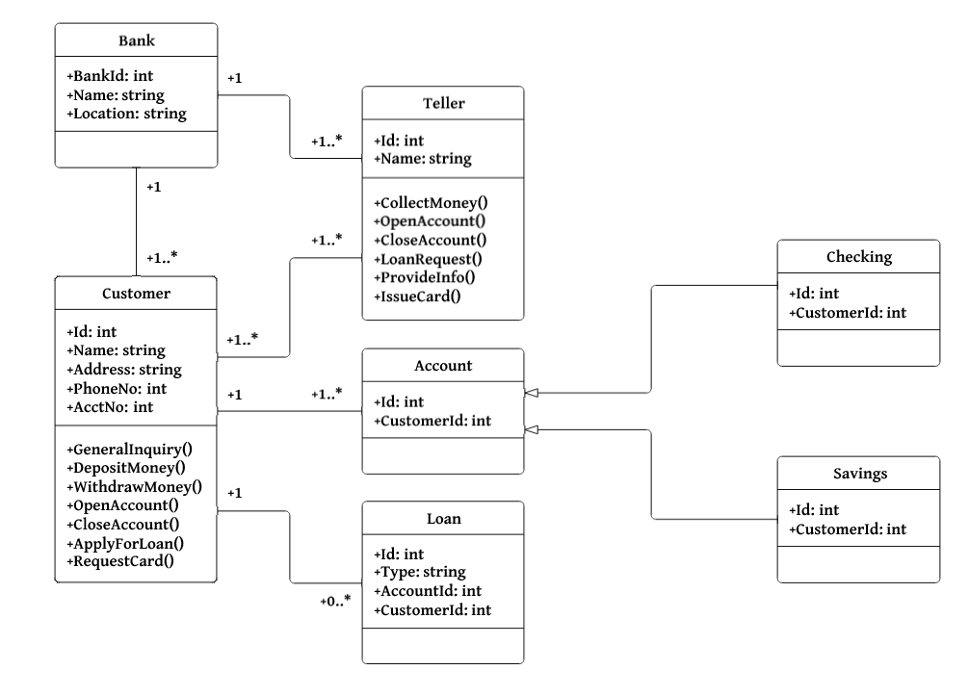

Activity diagram:

