# Tutorial: Development of a low cost open-source ultrasonic device for plant height measurements

This tutorial gives details about the realization of the low cost ultrasonic device presented in the study “Development of a low cost open-source ultrasonic device for plant height measurements”.

The tutorial is divided in four parts: the construction of the electronic system, the upload of the code, the model and printing of the protection cases, and the final assembly of the device.

## Construction of electronic part

### Needed hardware:

* [A soldering iron](https://fr.aliexpress.com/item/1005001713299071.html?spm=a2g0o.productlist.0.0.3ea3362ftxVK2C&algo_pvid=fba5d2a5-d620-47f9-945c-295fc2b706d3&algo_expid=fba5d2a5-d620-47f9-945c-295fc2b706d3-1&btsid=0b0a119a16208304127478646ed2e6&ws_ab_test=searchweb0_0,searchweb201602_,searchweb201603_) with [Tin wire](https://fr.aliexpress.com/item/4000111884901.html?spm=a2g0o.productlist.0.0.20cc7b0dU7bocB&algo_pvid=0f306380-8d90-40c0-89e3-496b70e216bc&algo_expid=0f306380-8d90-40c0-89e3-496b70e216bc-0&btsid=0b0a119a16208303886728545ed2e6&ws_ab_test=searchweb0_0,searchweb201602_,searchweb201603_)
* [9V battery](https://www.amazon.fr/VARTA-alcaline-Longlife-Bloc-6LR61/dp/B000EGSGQK/ref=sr_1_12?__mk_fr_FR=%C3%85M%C3%85%C5%BD%C3%95%C3%91&dchild=1&keywords=9v+battery&qid=1620831711&sr=8-12https://fr.aliexpress.com/item/4000124925942.html?spm=a2g0o.productlist.0.0.4bcc2986F7bXlO&algo_pvid=cfc6d67f-6f2f-4484-bf33-67ecb8de4c56&algo_expid=cfc6d67f-6f2f-4484-bf33-67ecb8de4c56-4&btsid=0b0a119a16208303540408112ed2e6&ws_ab_test=searchweb0_0,searchweb201602_,searchweb201603_) and a [9V DC battery power cable](https://www.amazon.fr/Sourcingmap-bo%C3%AEtiers-plastique-Type-connecteur/dp/B00H8T5EU2/ref=sr_1_5?__mk_fr_FR=%C3%85M%C3%85%C5%BD%C3%95%C3%91&crid=21LHZDBTBQMT1&dchild=1&keywords=9v+battery+connector&qid=1620831742&sprefix=9v+battery+%2Caps%2C399&sr=8-5)
* An Arduino Uno ([or clone)](https://www.amazon.fr/Elegoo-ATmega328P-ATMEGA16U2-Controller-Microcontr%C3%B4leur/dp/B01N91PVIS/ref=sr_1_5?__mk_fr_FR=%C3%85M%C3%85%C5%BD%C3%95%C3%91&dchild=1&keywords=arduino+uno&qid=1620831676&sr=8-5) with USB cable
* A sensor [HC-SR04](https://www.amazon.fr/HC-SR04-capteur-distance-ultrasons-Arduino/dp/B00KKKT7YK/ref=sr_1_6?__mk_fr_FR=%C3%85M%C3%85%C5%BD%C3%95%C3%91&crid=VWL8W29UAK6J&dchild=1&keywords=hc+sr04&qid=1620831314&sprefix=HC+S%2Caps%2C229&sr=8-6)
* A [LCD keypad shield](https://www.amazon.fr/HALJIA%C2%AE-Display-Keyboard-Arduino-MEGA2560/dp/B06XDNY7FY)
* A [SD card reader](https://www.amazon.fr/AZDelivery-Reader-M%C3%A9moire-Memory-Arduino/dp/B06X1DX5WS/ref=sr_1_7?__mk_fr_FR=%C3%85M%C3%85%C5%BD%C3%95%C3%91&dchild=1&keywords=sd+card+arduino&qid=1620831058&s=computers&sr=1-7) for Arduino and a [SD card](https://www.amazon.fr/SanDisk-SDSQUAR-016G-GN6MA-M%C3%A9moire-MicroSDHC-Nouvelle/dp/B073K14CVB/ref=sr_1_5?__mk_fr_FR=%C3%85M%C3%85%C5%BD%C3%95%C3%91&dchild=1&keywords=sd+card+8go&qid=1620831290&sr=8-5)
* [Jumper wire](https://www.amazon.fr/KeeYees-Femelle-Pin-t%C3%AAte-Arduino-Raspberry/dp/B07KCD7GS7/ref=sr_1_8?__mk_fr_FR=%C3%85M%C3%85%C5%BD%C3%95%C3%91&dchild=1&keywords=arduino+wire&qid=1620831475&sr=8-8) for Arduino, Male-Female and Male-Male

Links are indicative, users can purchase similar products from any other distributor.

### Hardware assembly:

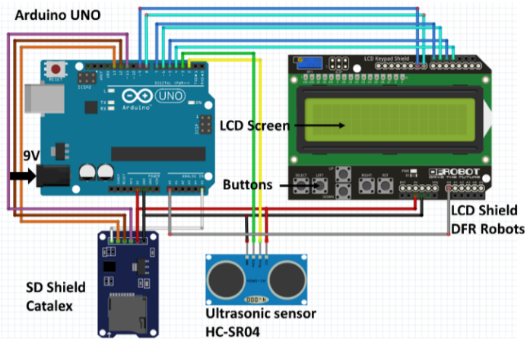

*Figure 1: Electronic Schematic of the device*

The first step consists in plugging the LCD shield on the Arduino UNO. As it is a shield, all the connections (blue, blue-green, red, black and grey wires on Figure 1) are directly made by plugging it in. [This video](https://www.youtube.com/watch?v=naSSiS_9rEw) gives an example of what it should look like.

The second step consists in soldering the SD shield. As displayed in the following figure, the LCD shields include small connectors made for soldering other components. [This video](https://www.youtube.com/watch?v=sS_oW81NweI) shows how to plug it. However, the LCD shield prevent access to the Arduino pin. It is not a problem as every pin is also available on the LCD shield, as seen in the following picture.



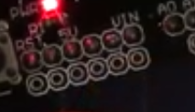

*Figure 2: Picture of the pads to sold on the LCD shield*

It is then easy to solder the pins from the SD shield on the Arduino pins through the LCD shield. Figure 1 shows how to connect it.

Finally, the HC-SR04 ultrasonic sensor must be sold in the same way as the SD shield, using wires as displayed in Figure 1. It is important to use wires of approx. 12cm height, as the sensor will be out of the box.

## Preparation of the software part

* 1. **Sending the Arduino code**

You will need to download the [Arduino software](https://www.arduino.cc/en/software) in order to send the code to the Arduino.

Using [this video](https://www.youtube.com/watch?v=aECi1xoAjio) it is possible to easily connect the Arduino to the PC, and to send code. [This video](https://www.youtube.com/watch?v=PcusGFga46U) is optional but gives more information about the basics of Arduino

You can then paste the code ‘Arduino\_ultrasonic\_sensor.ino’ from [the deposit](https://zenodo.org/record/4117797#.YJpOLaGxVOQ) on the Arduino IDE, and upload it to the Arduino. After the upload, the device should work and the LCD screen should display information.

* 1. **Modify the Arduino code to the needs of the user : Reference file with measurement identifiers**

The user must modify two parameters to make the code compatible with his own use. First, the variable « lg\_id » in the « Parameters » section, which corresponds to the number of characters used to encode measurements identifiers in the reference file. For example, if measurement identifiers are GENOTYPE001, GENOTYPE002, … GENOTYPE100, lg\_id must be set to 11. Second, the variable « dist\_cali » in the « Parameters » section which corresponds to distance used for calibration when the device is first turned on. This value depends on the height of the sensor on the stick as well as on the height of the plastic plate on the stick during calibration. For example, in the current version, the sensor must be placed 1.5 m above the soil, and the plate 10 cm above the soil for calibration.

The user must also upload a .csv file named “height.csv” on the SD card. This file must contain a single column with measurement identifiers in chronological order of measurement. All measurement identifiers must have the same number of characters.

## Printing the case of the device with 3D printer

The model has been made using the OpenSCAD software, available [here](https://openscad.org/downloads.html). This software transforms an easy code into a 3D model. The code ‘3DShells\_ultrasonic\_sensor.scad’ is available from the deposit.

It is then necessary to export the file as an STL file. [This video](https://youtu.be/Jl8LtwKYe2o?t=198) at 3:10 shows how to do it in OpenScad.

This STL file then needs to be sliced for the 3D printer. Using the software [CURA](https://ultimaker.com/fr/software/ultimaker-cura), it is very easy to adapt it to the 3D printer, following [this video](https://www.youtube.com/watch?v=NsGOoi3677M). It is important to not change the size of the STL object in CURA, as it fits to the electronics elements of the sensor.

If you do not have access to a 3D printer in your lab, you can check for the closest [Fab Lab](https://fabfoundation.org/global-community/).

## Final assembly of the device

|  |  |
| --- | --- |
| Once the 3D printing part is done, it is possible to put the electronic parts in the principal case |  |
| The buttons and cover of the case can be the mounted and screwed to the case : |  |
| The ultrasonic device has a special 3D case. The wires are connected following the figure 1. |  |
| The ultrasonic device is then packed in a protection case. |  |
| We chose to screw both cases on an iron holder. This holder has an empty section which is a few millimeters larger than the section of the aluminum stick, so that it can be threaded onto it, and maintained with a hand-manipulated screw. | D:\Users\moinards\Downloads\Photos capteur\20210512_103740.jpg |
| The general device can be then mounted on the aluminium stick |  |
| The reflective plate is moving through the aluminium stick in order to adjust it to the height of the wheat to measure. This plate was constructed with a bicycle brake and a cd jacket. |  |
| The reflective plate can be easily mounted on the aluminium stick |  |
| The final device with the electronic part mounted in the 3D case on the top of the aluminium plate, and the reflective plate moving through the aluminium stick, and blocked by the brake |  |

: