BSc in Web Technologies & Programming

Cross Platform Mobile Application Development

*Chearch*

*10011177*

*Pierce Jordan*

Contents

Introduction 3

Device Functionality 3

Usage 3

# Introduction

*This application detects the users location and then searches Church's in the area and shows the user the closest Church.*

***Example:***

*This application is a Church searching Application. It detects the users current location and shows them the closest church to them. It also allows the user to add new Church's and delete existing Church's down to a minimum of 10.*

*There are 3 screens in the app:*

*One screen shows the closest church*

*Another screen allows users to add a new Church.*

*Another screen allows the user to delete the Church*

*In addition there are two side menus.*

*Left menu allows user to cycle throw the three screens.*

*Right menu is a settings menu that allows the user to put app into selection mode and select a desired Church.*

# Device Functionality

*A link to any device functionality provided by ngCordova should be included here.*

***Example:***

*Camera -* [*http://ngcordova.com/docs/plugins/camera/*](http://ngcordova.com/docs/plugins/camera/)

*Gallery -* [*http://ngcordova.com/docs/plugins/camera/*](http://ngcordova.com/docs/plugins/camera/)

*Geolocation -* [*http://ngcordova.com/docs/plugins/geolocation/*](http://ngcordova.com/docs/plugins/geolocation/)

# Usage

*This section should include screen shots of each screen and its purpose, as well as a small description of how to use each screen,*

*Home Screen*

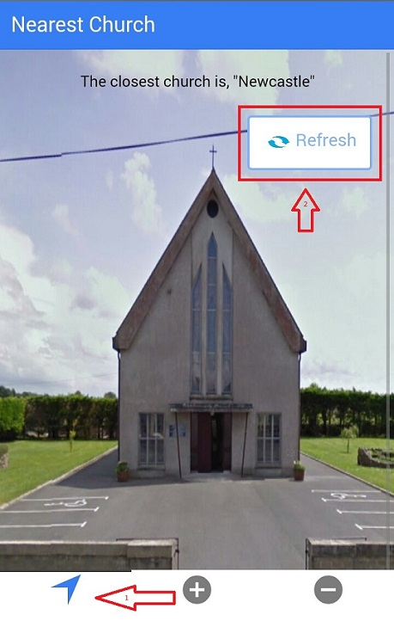 *This is the first screen that opens after the splash screen in the application.*

*To access this screen from other areas click on the tab short cut indicated by arrow 1, or from left menu.*

*to refresh the church should the user move location then click “Refresh” indicated by arrow 2.*

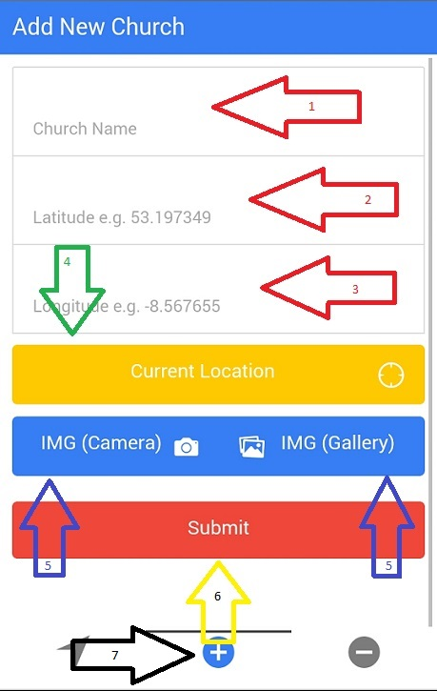*Add New Church screen*

*To access this screen click on the “+” tab short cut indicated by arrow 7. Or from the left menu*

*Enter new Church's name at arrow 1*

*Latitude of the church (arrow 2)*

*longitude of church (arrow 3)*

*If the user does not know the longitude or latitude of church they can alternatively click the current location (arrow 4) button which will automatically pinpoint the users current location and populates the relevant fields.*

*Clicking the buttons (arrow 5) allows the user to input an image of the church either from the Gallery or by taking a photo. This field is optional as the application will populate this parameter with a default image.*

*User then selects submit (arrow 6) which will alert the user of their choices and a new Church is created.*

*Delete Church screen*

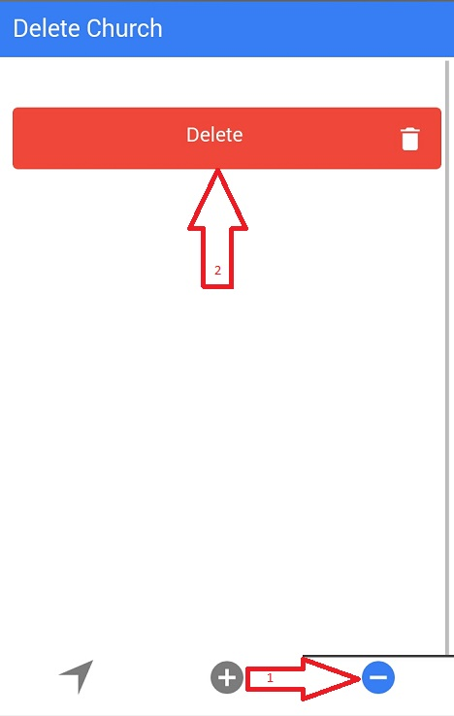 *This screen can be accessed by clicking the “-” symbol (arrow 1)*

*Delete button allows the user to delete the currently selected church. In this instance there is no church selected so user will be instructed to select a church from the right menu.*

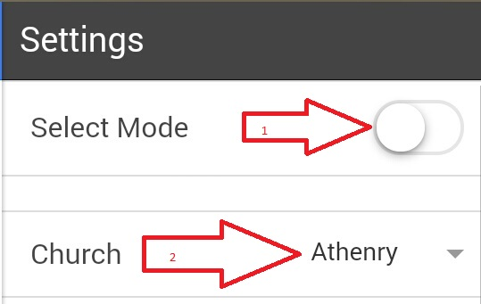*Right Menu*

*Toggle “Select Mode” on/off (arrow 1)*

*Select Church.*

*Note church cannot be selected until toggle is on.*

*Selected church will be displayed in Delete Church screen (see below)*

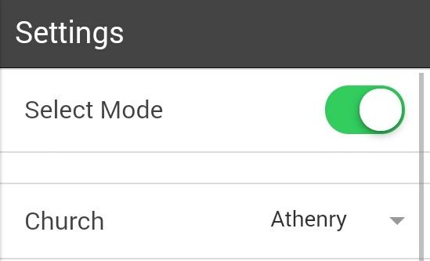

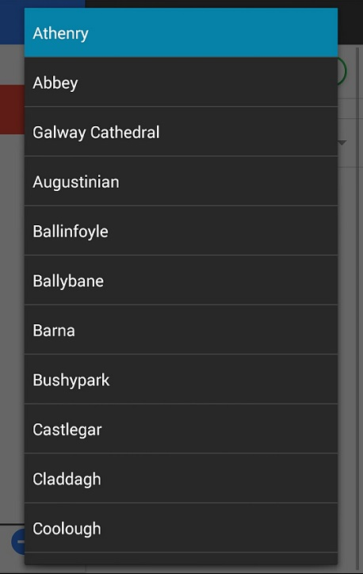

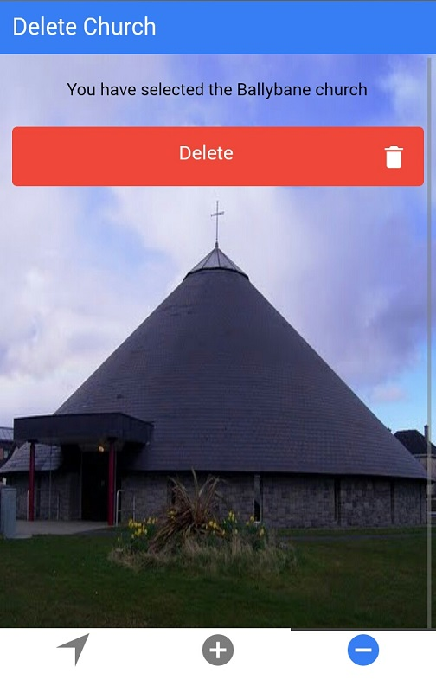Delete Church screen after selection.

Once selection is made user can then delete selected church by clicking delete. They will be warned and if they accept the warning the church is deleted from the list.

Church list is et at a minimum of 10 so user cannot delete if the church list is equal to 10.

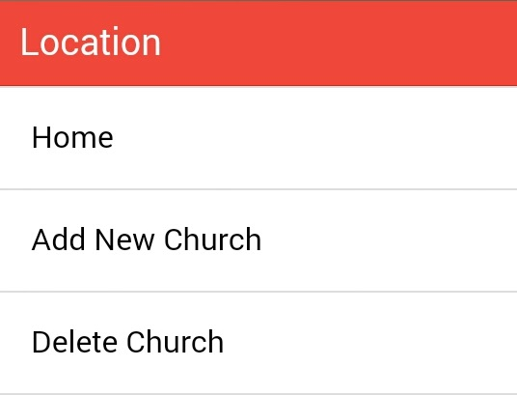Left Menu

Simply allows user to select a tab.

Known Issues:

The images will not appear if the application is ran through Ionic Serve. This apparently is a known issue with Ionic. As I am setting the background image of the home screen and the delete screen using CSS the Ionic Serve command does not like the use of “../www/img” as the path for the image files. However this works fine in the application(apk) itself.