HOW TO BUILD THE BASE
G. Bugmann, Nov 2016
|---------------------------------|

Licence: To insert
|---------------------------------
Contents
- Base plate
- Servo mount (3D printed)
- Wheel assembly
|---------------------------------|
- Base plate.
The shape was designed initially as a simple rounded square surrounding the three wheels (fig 1.1).
Figure 1.1
Later it was modified to use less space and included and indentation at the front, that enable approaching pieces of furniture more closely (fig 1.2).
Figure 1.2
The key elements are i) the three groups of holes for the motor housings, ii) the four holes roughly forming a square for attaching the four cables from the top of the mast, iii) the central hole for passing cables to the motors, iv) the two holes for the mast holder and v) some area at the back to support the counterweight. Any other shape keeping these elements would be fine.
Note that the axes of the three wheel are aligned with the front of the base of the mast wheels (red dashed lines in fig 1.2). This point is placed 10cm behind the line linking the centres of the front wheels. When all three wheels turn in the same direction, the CHAP rotates around that point.
The dimension in fig 1.2 are used in calculations of torques, lifting forces, counterweight, etc.
The base was initially laser cut from a 9mm MDF board, but ended up bending upwards under the force of the weight and the four mast cables. The latest version has been made of 20mm plywood.
It is difficult to laser cut such thickness and you could print the baseplate outline on a poster, mark a plywood board with it, then cut the shape out using a jigsaw. All holes are 4mm in diameter, except the four hole for the mast cable that are 5mm.
Files: v1\1-BASE\2D\Baseplate.dxf
Notes : i) to rescale before printing/cutting ii) Baseplate.svg has the central hole oriented differently.

- Servo mounts
The servo motors and wheels are held together in a 3D printed mount. Figure 2.1 shows all the parts of the wheel assembly in various stages of assembly.
A proper 3D CAD picture should show all the parts – TODO --
Figure 2.2 shows nylon screws being used to attach the wheel shaft to the servo. This screw acts as a weak point that should break before the gears of the servo.
All the parts to purchase are listed in the cost spreadsheet
All the file to 3D print are:
Housing: v1\1-BASE\CAD\wheel-housing.stl and WheelHousing.stp
Inside shaft: v1\1-BASE\ Coupler.stp
Sleeve: v1\1-BASE\ WheelMount.stp
End stop ring: v1\1-BASE\2D\ring.dxf (this was laser cut out of 4mm Perspex) or v1\1-BASE\CAD\axle-cap.stl
BIG PROBLEM HERE: There is a set of new pieces with two longitudinal groves, but are they correct enough to let someone else 3D print them? How to find out?
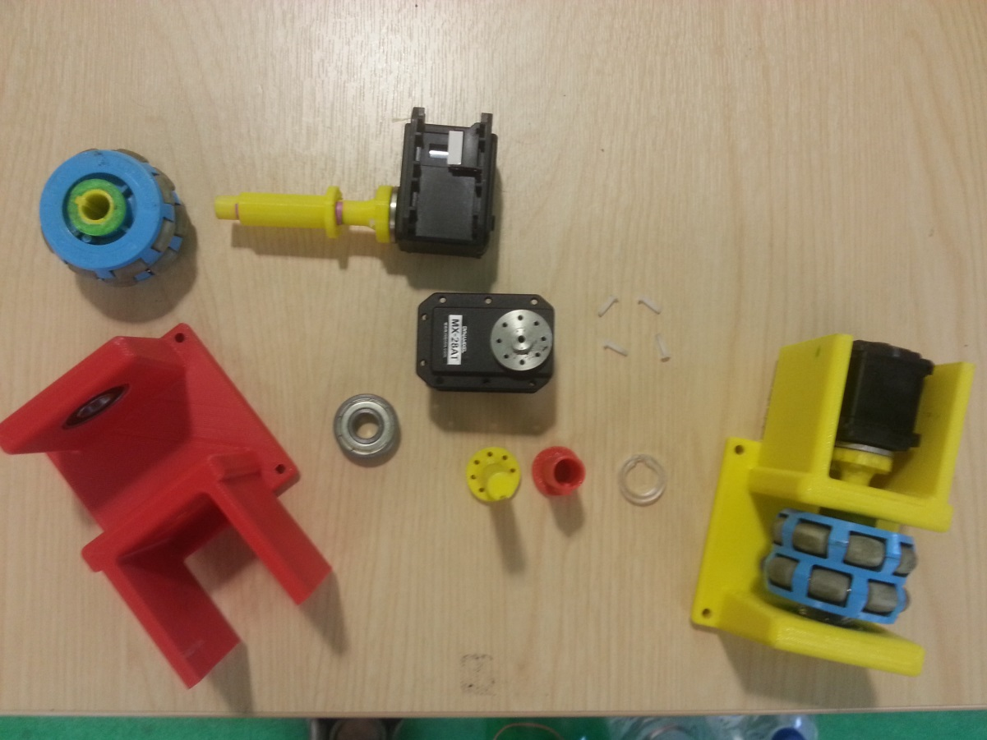 Fig 2.1
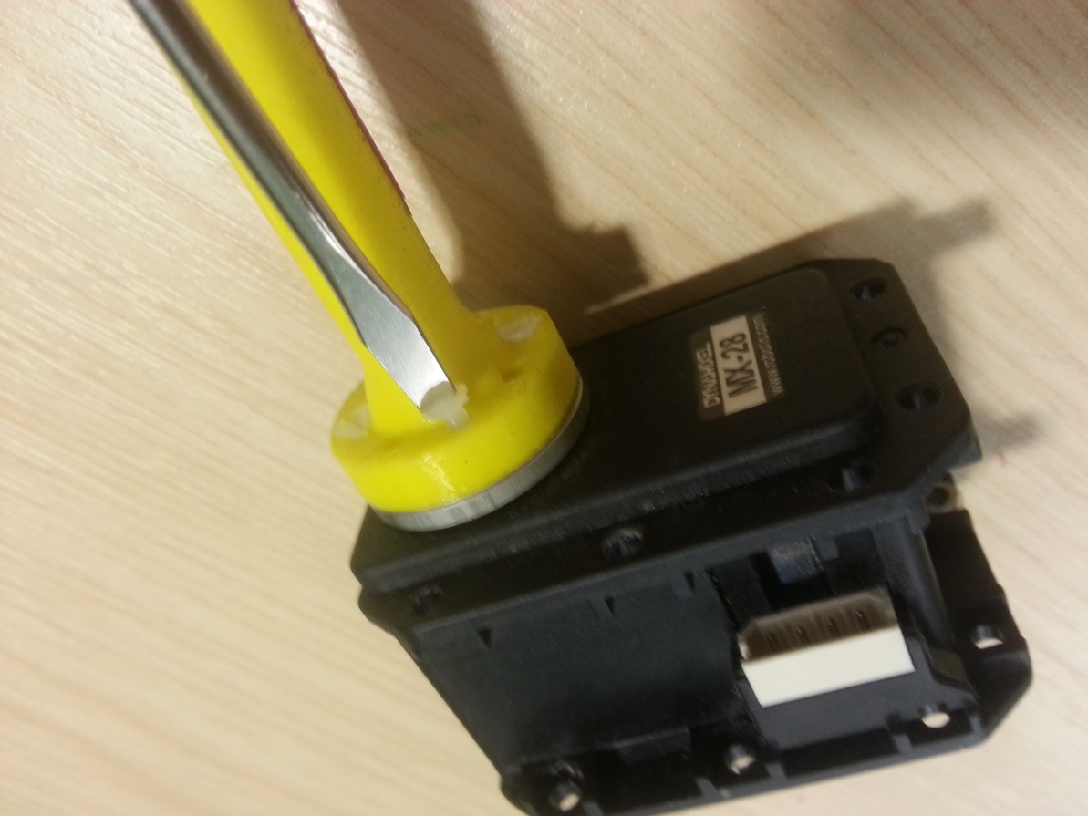 Fig 2.2

The assembled base is shown in the figure below:
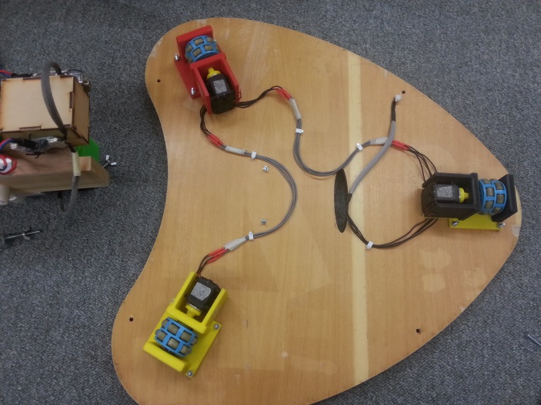 Fig. Base bottom view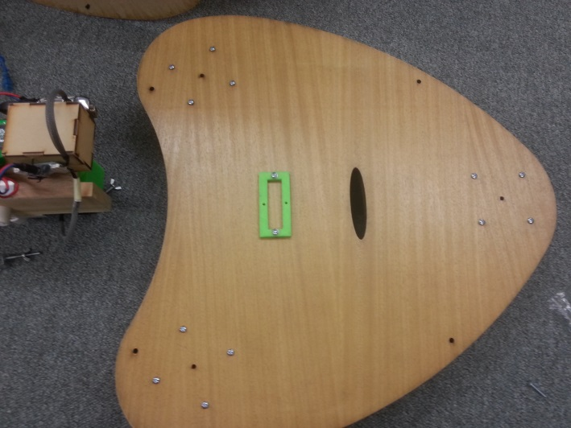 Fig. Base top view

Note: CAD file for the green holder are missing.

