|  |  |
| --- | --- |
| **Assignment** | Mobile App |
| **Title** | Cumulative modification of code |
| **Project Name** | Monitoring App |
| **Due Date** | 26/10/2018 |
| **Unit** | Introduction to Mobile Applications Development |
| **Unit Code** | CSP2108 |

**Group Details:**

|  |  |  |
| --- | --- | --- |
| **No.** | **Student Name** | **Student Number** |
| 1. | Ami Ganeshbhai Patel | 10456172 |
| 2. | Rohit Hazara | 10406924 |
| 3. | Rajwinder Kaur | 10456796 |
| 4. | Sam Eaton | 10447799 |

**Client Details**:

|  |  |
| --- | --- |
| **No.** | **Student Name** |
| 1. | Lauren Doorn |
| 2. | Imman Khan |
| 3. | Rose Neil-Smith |
| 4. | Jordyn McLaren |

### **Evidence of Configuration Management:**

**Pair Programming:**

In this project, there are four main parts that needs to be developed by our group for monitoring app. Our group consists of four members, as per pair programming methodology, our group is divided into two pairs so, each pair worked on two parts. Within the pairs, one programmer worked as a navigator while the other worked as the driver where the driver wrote the code as per requirement and the written code is reviewed by the navigator. Moreover, once the functionality is implemented both navigator and driver swapped their roles to provide better quality of work. The table below shows exactly who is the navigator, driver for a specific task and what work done they have done throughout the project.

**Pair 1 (Ami Patel & Rohit Hazara):**

|  |  |  |  |
| --- | --- | --- | --- |
| **Task** | **Navigator** | **Driver** | **Where, When and How long** |
| SQLite Database Implementation for Login | Ami | Rohit | 03/10/2018, at Library ECU Joondalup, 10:30 – 11:00 |
| SQLite Database Implementation for Register | Rohit | Ami | 03/10/2018, at Library ECU Joondalup, 11:00 – 11:30 |
| Login Setup and Database Connection (Login) | Ami | Rohit | 04/10/2018, at Library ECU Joondalup, 10:00 – 11:30 |
| Error messages and Authorization (Login) | Rohit | Ami | 04/10/2018, at Library ECU Joondalup, 1:00- 2:00 |
| Register Setup and Database Connection (Register) | Rohit | Ami | 08/10/2018, at Library ECU Joondalup, 10:30 – 12:30 |
| Error messages and Authorization (Register) | Ami | Rohit | 10/10/2018, at Library ECU Joondalup, 2:00 – 3:00 |
| Buttons and scene (Legal Rights) | Rohit | Ami | 24/09/2018, at Elab ECU Joondalup |
| Buttons and scene (Legal Rights) | Ami | Rohit | 25/09/2018, at Elab ECU Joondalup |
| Scroll down function (Legal Rights) | Ami | Rohit | 27/09/2018, at Library ECU Joondalup |
| Scroll down function (Legal Rights) | Rohit | Ami | 28/09/2018, at Library ECU Joondalup |

**Pair 2 (Sam Eaton & Rajwinder Kaur):**

|  |  |  |  |
| --- | --- | --- | --- |
| **Task** | **Navigator** | **Driver** | **Where and When** |
| Buttons (Complain) | Rajwinder | Sam | 23/09/2018, on Skype |
| Buttons (Complain) | Sam | Rajwinder | 25/09/2018, at Elab ECU Joondalup |
| Online links (Complain) | Sam | Rajwinder | 27/09/2018, at Library ECU Joondalup |
| Online links (Complain) | Rajwinder | Sam | 28/09/2018, at Library ECU Joondalup |
| Microphone | Rajwinder | Sam | 03/10/2018, at Library ECU Joondalup |
| Microphone | Sam | Rajwinder | 04/10/2018, at Library ECU Joondalup |

**Record of meetings:**

**Group Meeting: 1 (On Campus)**

|  |
| --- |
| **Project Name**: Mobile App  **Date:** 01/10/2018  **Location:** library, ECU Joondalup  **Time**: 11:30 – 3:30 |
| **Team member names and student ID numbers:**  Ami Patel: 10456172  Rohit Hazara: 10406924  Rajwinder Kaur: 10456796  Sam Eaton: 10447799 |
| **Main Point discussed:**   * Legal rights and complaint parts reviewed by all group members. * Decided to use SQLite database for login.   **Changes made:**   * App Design * Added few more functionalities in the complaint part. * Deleting two parts of legal rights as they were replicate of the other rights. |

**Client meeting: 1 (On campus by Group Leader)**

|  |
| --- |
| **Project Name**: Mobile App  **Date:** 03/10/2018  **Location:** Building 18, ECU Joondalup  **Time:** 11:45 – 12:15 |
| **Team member names and student ID numbers:**  Sam Eaton: 10447799 |
| **Main Point discussed:**   * Legal rights and complaint parts has been shown to client * Discussion about rest of work   **Change made:**   * No change was made as client was satisfied with the app progress. |

**Group meeting: 2 (On Campus)**

|  |
| --- |
| **Project Name**: Mobile App  **Date:** 08/10/2018  **Location:** elab, ECU Joondalup  **Time:** 11:30 – 3:30 |
| **Team member names and student ID numbers:**  Ami Patel: 10456172  Rohit Hazara: 10406924  Sam Eaton: 10447799  Rajwinder Kaur: 10456796 |
| **Main Point discussed:**   * Discussion about notification with the tutor. * Decided to communicate with the client regrading Corona SDK limitation and providing them with any other alternative.   **Change made:**   * No Changes has been made. |

**Client Meeting: 2 (On campus)**

|  |
| --- |
| **Project Name**: Mobile App  **Date:** 15/10/2018  **Location:** Building 18, ECU Joondalup  **Time:** |
| **Team member names and student ID numbers:**  Ami Patel: 10456172  Rohit Hazara: 10406924  Sam Eaton: 10447799  Rajwinder Kaur: 10456796 |
| **Main Point discussed:**   * Discussion regarding out of scope requirements   **Change made:** |

**Client Meeting: 3 (On Campus)**

|  |
| --- |
| **Project Name**: Mobile App  **Date:**  **Location:** Building 18, ECU Joondalup  **Time:** |
| **Team member names and student ID numbers:**  Ami Patel: 10456172  Rohit Hazara: 10406924  Sam Eaton: 10447799  Rajwinder Kaur: 10456796 |
| **Main Point discussed:**  **Change made:** |

**User manual/ Readme Files:**

Monitoring is a mobile application that allows you to view all the legislations and rights that provides protection from privacy breaches against Australian government agencies and outside hackers. This application also preventing other mobile applications to accessing the microphone and it also guide you to make complaint for different types of breaches.

**Which devices does the mobile app support?**

You can install Monitoring app on any mobile devices that supports Android (mobile phones and tablets) operating systems.

**Instructions to use**

1. To use the app, you need to sign in using the Name and number of your monitoring App Account.

If you do not have a monitoring App account yet, click register and Create new account by filling your details.

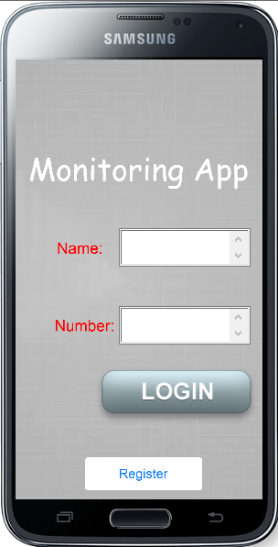

1. **App Overview**:
   1. Monitoring app consist of three options on the homepage.

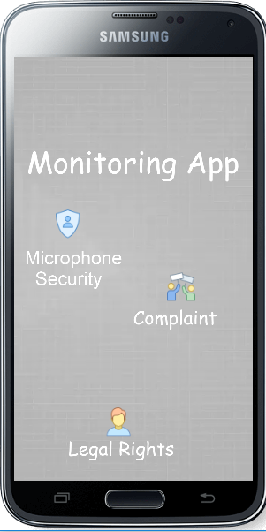

* 1. Microphone Security option will be for you to manually enable or disable the microphone access.

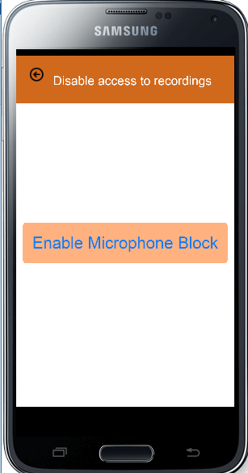

* 1. Legal rights option click will direct you to the information about the Acts and rights you have for your protection. It will allow you to read the information about the Acts in the app or online on the official website for every Act.

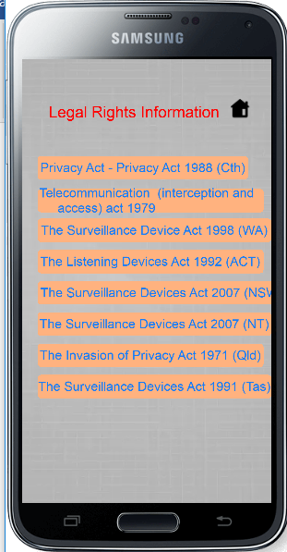

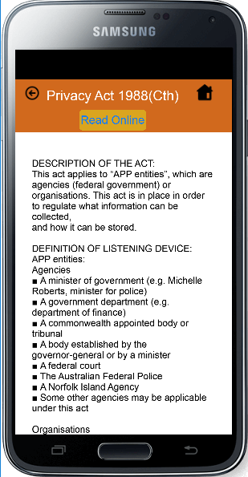

* 1. Complaint function will allow you to complaint for Breaches from government agencies and breaches from unknown sources. It will direct you to the website where you can complaint.

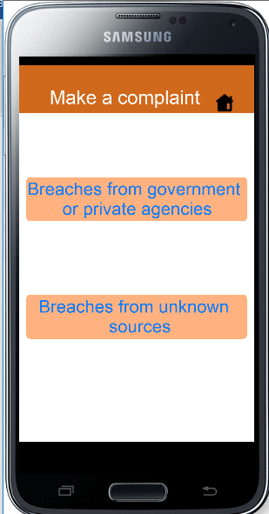

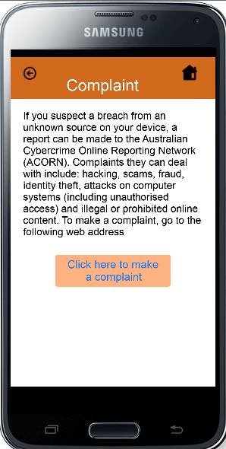

**Black Box Testing:**

|  |  |  |
| --- | --- | --- |
| **Test Objective** | **Input** | **Expected Output** |
| To ensure if user can register accessing the services provided. | 1. Registration button is clicked.    1. If any of those field is empty .    2. If all fields are provided | 1.1.Registration page will open and prompt for enter Name, contact no. and email of user.  1.1.1.It will show error message ’please enter details’.  1.2.1. User will be registered and redirect to homepage. |
| To check the login function. | 1. If any of those field is empty . 2. If all fields are provided | * 1. It will show error message ’Wrong details try again’.   2. User logged in successfully and direct to homepage. |
| To check the legal rights function is working as intended | 1. Legal rights icon is clicked.    1. If any of the act from the list is clicked.       1. If user click on that link. | 1.1.Legal rights will open with the list of Legal rights.   * + 1. It will show the detailed information of that act and ‘read online’ link.     2. It will redirect to the webpage showing more detailed information of the act. |
| To check the Complaint function is working as intended | 1. Complaint icon is clicked.    1. If ‘breaches from government agencies’ is clicked.    2. If ‘breaches from unknown sources’is clicked.    3. If user click on these links. | * 1. It will open with two options ‘breah from government agencies’ and ‘breach from unknown resources’ .   1.1.2. It will direct to the page where user can see the instructions to make a complaint and ‘Make a complaint’ button.  1.2.1. It will direct to the page where user can see the instructions to make a complaint and ‘Make a complaint’ button.   * + 1. It will redirect to the webpage where they can make complaint. |

**Unit Testing:**

For many of the new functions created for the program the luaUnit cannot properly test them as it is difficult to create a proper success or fail output.

The hyper link functions in the complaint and legal rights section are successful when the user is redirected to a webpage on a separate application. It isn’t reasonable to expect the unit test to detect whether an external source opened the page or not.

Most of the code is related to the user interface of the application which is difficult to create unit tests for and instead we opted for simply human observation to check the formatting and contents of the user interface.

Most of the inputs are simple taps which directs the user to a different scene. The functionality to find if another scene was opened or not in luaUnit was not found so we didn’t create unit tests for these functions

|  |  |
| --- | --- |
| **Security** | |
| Details | Test |
| **Test:**  **Creation Date:** 11 10 18 5:10PM  **Description**: Check if camera is recording  **Test Completion:** 11 10 18 5:20PM | function testRecNow()  luaUnit.assertTrue(r:isRecording())  end |
| **Test**: recordnow2  **Creation Date:** 11 10 18 5:24PM  **Description:** Check camera is running at lowest possible setting  **Test Completion:** unable to complete  **Note:** Corona simulator is unable to have the microphone run at the lowest possible setting of 8000hz. | function testRecNow()  luaUnit.assertTrue(r:isRecording())  luaUnit.assertIs(r:getSampleRate(),8000)  end |
| **Test:** recordnow3  **Creation Date**: 11 10 18 6:00PM  **Description:** Check microphone is running at lowest possible setting for system  **Test Completion:** 11 10 18 6:10PM  **Note:** It was determined that 11025hz was the lowest sample rate for the corona simulator. However most new android phones will be able to record in 8000hz | function testRecNow()  luaUnit.assertTrue(r:isRecording())  luaUnit.assertIs(r:getSampleRate(),11025)  end |

**/**