**Monitoring App**

|  |  |
| --- | --- |
| **Assignment** | Mobile App |
| **Title** | Cumulative modification of code |
| **Project Name** | Monitoring App |
| **Due Date** | 26/10/2018 |
| **Unit** | Introduction to Mobile Applications Development |
| **Unit Code** | CSP2108 |

**Group Details:**

|  |  |  |
| --- | --- | --- |
| **No.** | **Student Name** | **Student Number** |
| 1. | Ami Ganeshbhai Patel | 10456172 |
| 2. | Rohit Hazara | 10406924 |
| 3. | Rajwinder Kaur | 10456796 |
| 4. | Sam Eaton | 10447799 |

**Client Details**:

|  |  |
| --- | --- |
| **No.** | **Student Name** |
| 1. | Lauren Doorn |
| 2. | Imman Khan |
| 3. | Rose Neil-Smith |
| 4. | Jordyn McLaren |

Contents

Evidence of Configuration Management: 2

Pair Programming: 4

Pair 1 (Ami Patel & Rohit Hazara): 5

Pair 2 (Sam Eaton & Rajwinder Kaur): 6

Record of meetings: 8

Group Meeting: 1 (On Campus) 8

Client meeting: 1 (On campus by Group Leader) 9

Group meeting: 2 (On Campus) 10

Client Meeting: 2 (On campus) 10

Client Meeting: 3 (On Campus) 11

Client Meeting: 4 (On Campus) 12

Black Box Testing: 12

Unit Testing: 15

Appendix: 17

# 

# Evidence of Configuration Management:

GitHub used as configuration management support tool in this project. We managed our tasks, viewed code to fulfil client’s requirement by using access control and collaboration features of GitHub. We used repository for this project and once the repository is made then we downloaded our files from the repository and opened it in our GitHub desktop app to keep track of our work that make our work easy and effective because we don’t need to download those files every time and we can keep track of the changes in our code across the version and easily understood that who changed what and when as those files are stored in repository. As well as, whenever team member uploaded files that has been done by commit changes directly form edit option on GitHub. Each different Section of the application was given its own repository and integrated into a master repository. Sometimes, we leave comments in commit section. For example: someone finished code but still needs to work on designing so he left comment that what needs to be done on that specific part, so others can able to see that part and can work on rest of part. Repository, access control, commit and some other features of GitHub used by our group and that made our work easy and we able to finish our work on time.

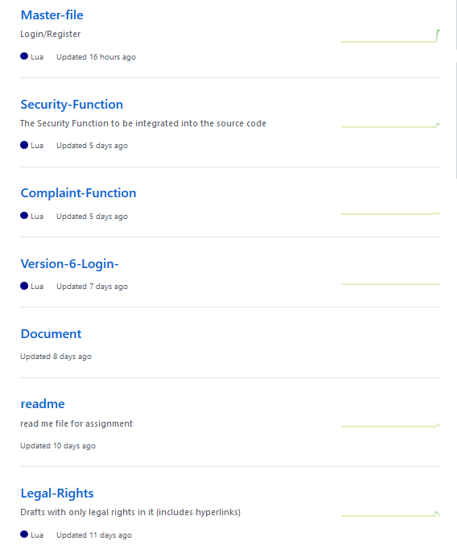

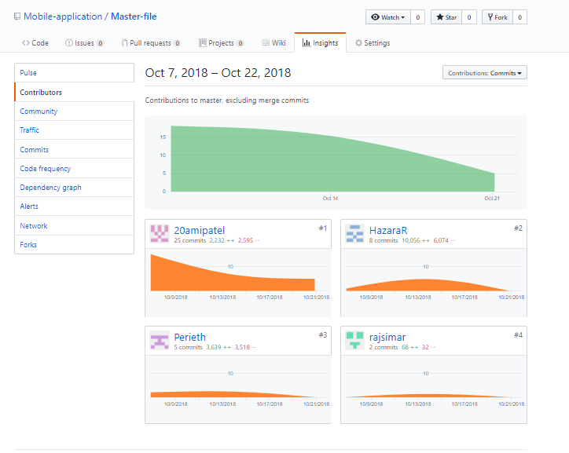

# Pair Programming:

Pair programming is a development technique where two programmers work on the same program at one machine. Our group consists of four members, as per pair programming methodology, our group is divided into two pairs, each pair worked simultaneously on different sections of the project. In this project, there are four main parts that needs to be developed by our group for monitoring app, each pair worked on two different parts. For every part a separate repository has been made for example Login repository, Complain repository, Legal Rights, Security has been created. Within the pairs, one programmer worked as a navigator while the other worked as the driver where the driver wrote the code as per requirement and the written code is reviewed by the navigator. Moreover, once the functionality is implemented both navigator and driver swapped their roles. The table below shows exactly who is the navigator, driver for a specific task and what work done they have done throughout the project.

## Pair 1 (Ami Patel & Rohit Hazara):

|  |  |  |  |
| --- | --- | --- | --- |
| **Task** | **Navigator** | **Driver** | **Where, When and How long** |
| SQLite Database Implementation for Login | Ami | Rohit | 03/10/2018, at Library ECU Joondalup, 10:30 – 11:00 |
| SQLite Database Implementation for Register | Rohit | Ami | 03/10/2018, at Library ECU Joondalup, 11:00 – 11:30 |
| Login Setup and Database Connection (Login) | Ami | Rohit | 04/10/2018, at Library ECU Joondalup, 10:00 – 11:30 |
| Error messages and Authorization (Login) | Rohit | Ami | 04/10/2018, at Library ECU Joondalup, 1:00- 2:00 |
| Register Setup and Database Connection (Register) | Rohit | Ami | 08/10/2018, at Library ECU Joondalup, 10:30 – 12:30 |
| Error messages and Authorization (Register) | Ami | Rohit | 10/10/2018, at Library ECU Joondalup, 2:00 – 3:00 |
| Buttons and scene (Legal Rights) | Rohit | Ami | 25/09/2018, at Elab ECU Joondalup |
| Buttons and scene (Legal Rights) | Ami | Rohit | 28/09/2018, at Elab ECU Joondalup |
| Scroll down function (Legal Rights) | Ami | Rohit | 27/09/2018, at Library ECU Joondalup |
| Scroll down function (Legal Rights) | Rohit | Ami | 28/09/2018, at Library ECU Joondalup |

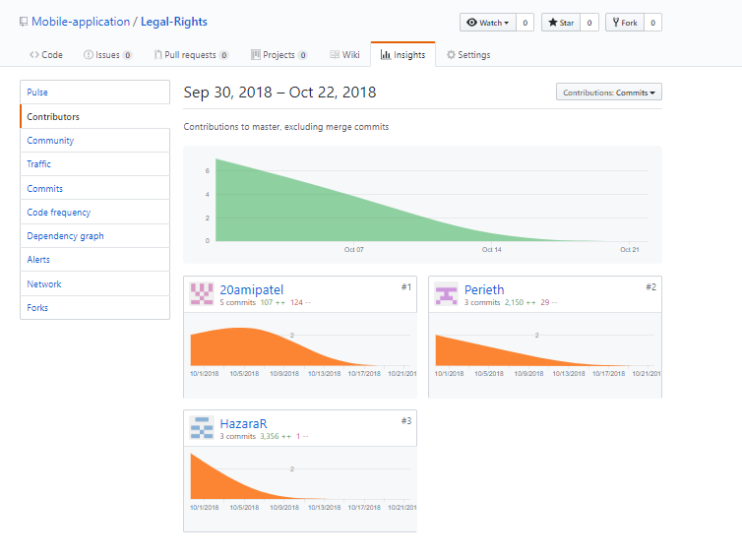

## Pair 2 (Sam Eaton & Rajwinder Kaur):

|  |  |  |  |
| --- | --- | --- | --- |
| **Task** | **Navigator** | **Driver** | **Where** **and** **When** |
| Complaint function options | **Rajwinder**  No reasonable progress made,juy6yy6 | **Sam**  No reasonable progress made | 23/09/2018, on Skype |
| Complaint function options | **Sam**  Checked inputted lines and provided feedback on interface | **Rajwinder**  Option screen for complaint choices created | 25/09/2018, at Elab ECU Joondalup |
| Complaint function details | **Sam**  Checked inputted lines and provided feedback on interface | **Rajwinder**  Composer screen and interface for | 27/09/2018, at Library ECU Joondalup |
| Complaint function details | **Rajwinder**  Checked inputted lines and checked formatting of information | **Sam**  Information and hyperlinks added | 28/09/2018, at Library ECU Joondalup |
| Microphone (Microphone blocker function) | **Rajwinder**  Analysed code and function logic as it was inputted | **Sam**  Created the Microphone blocking function | 03/10/2018, at Library ECU Joondalup |
| Microphone  (user interface and implementation) | **Sam**  Checked inputted lines and checked formatting of information | **Rajwinder**  Added user interface and implemented function to the system code | 04/10/2018, at Library ECU Joondalup |

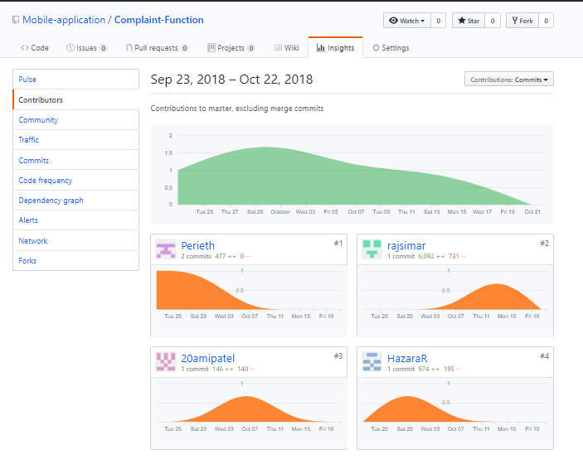

Record of meetings:

## Group Meeting: 1 (On Campus)

|  |
| --- |
| **Project Name**: Mobile App  **Date:** 01/10/2018  **Location:** library, ECU Joondalup  **Time**: 11:30 – 3:30 |
| **Team member names and student ID numbers:**  Ami Patel: 10456172  Rohit Hazara: 10406924  Rajwinder Kaur: 10456796  Sam Eaton: 10447799 |
| **Main Point discussed:**   * Legal rights and complaint parts reviewed by all group members. * Decided to use SQLite database for login.   **Changes made:**   * App Design * Added few more functionalities in the complaint part. * Deleting two parts of legal rights as they were replicate of the other rights. |

## Client meeting: 1 (On campus by Group Leader)

|  |
| --- |
| **Project Name**: Mobile App  **Date:** 03/10/2018  **Location:** Building 18, ECU Joondalup  **Time:** 11:45 – 12:15 |
| **Team member names and student ID numbers:**  Sam Eaton: 10447799 |
| **Main Point discussed:**   * Legal rights and complaint parts has been shown to client * Discussion about rest of work   **Change made:**   * No change was made as client was satisfied with the app progress. |

## Group meeting: 2 (On Campus)

|  |
| --- |
| **Project Name**: Mobile App  **Date:** 08/10/2018  **Location:** elab, ECU Joondalup  **Time:** 11:30 – 3:30 |
| **Team member names and student ID numbers:**  Ami Patel: 10456172  Rohit Hazara: 10406924  Sam Eaton: 10447799  Rajwinder Kaur: 10456796 |
| **Main Point discussed:**   * Discussion about notification with the tutor. * Decided to communicate with the client regrading Corona SDK limitation and providing them with any other alternative.   **Change made:**   * No Changes has been made. |

## Client Meeting: 2 (On campus)

|  |
| --- |
| **Project Name**: Mobile App  **Date:** 15/10/2018  **Location:** Building 18, ECU Joondalup  **Time:** 2:30 – 2:50 |
| **Team member names and student ID numbers:**  Ami Patel: 10456172  Rohit Hazara: 10406924  Sam Eaton: 10447799  Rajwinder Kaur: 10456796 |
| **Main Point discussed:**   * Discussion regarding out of scope requirements * Discussion about alternative option (Microphone) * Discussion about rest of document   **Change made:**   * No change was made as client was satisfied with the app progress. |

## Client Meeting: 3 (On Campus)

|  |
| --- |
| **Project Name**: Mobile App  **Date:** 18/10/2018  **Location:** Building 18, ECU Joondalup  **Time:** 12:30 – 1:00 |
| **Team member names and student ID numbers:**  Ami Patel: 10456172  Rohit Hazara: 10406924  Sam Eaton: 10447799  Rajwinder Kaur: 10456796 |
| **Main Point discussed:**   * Explanation about Blackbox testing. * Test has been conducted according to Blackbox testing.   **Change made:**   * No change was made as client was satisfied with the app progress. |

## Client Meeting: 4 (On Campus)

|  |
| --- |
| **Project Name**: Mobile App  **Date:** 22/10/2018  **Location:** Building 18, ECU Joondalup  **Time:** 2:30 – 2:50 |
| **Team member names and student ID numbers:**  Ami Patel: 10456172  Rohit Hazara: 10406924  Sam Eaton: 10447799  Rajwinder Kaur: 10456796 |
| **Main Point discussed:**   * **Login and Registration function served no purpose in the application so a discussion was had if there was any functionality that could be added which would utilize the users inputted details** * **Design of the application**   **Change made:**   * Login and Registration function is to be removed * Design of the opening menu and legal rights selection screen is to be changed to be more elegant. |

# Black Box Testing:

|  |  |  |
| --- | --- | --- |
| **Test Objective** | **Input** | **Expected Output** |
| To check if the Security function is working as intended | Security monitoring icon is clicked. | It will direct the user to the two options ‘enable/disable microphone’ and ‘Camera Privacy’. |
| If microphone button is clicked. | Microphone of the device will be  enable and prevent other applications to access the microphone until disabled by user in the app. |
| If ‘Camera Privacy’ is clicked, | It will show the detailed information about how to enable or disable camera access from your device. |
| Microphone blocker button is pressed while a separate application is using the microphone | The button will display an error that states “Microphone blocker could not be activated” *1 |
| Microphone blocker button is pressed with microphone permissions revoked for application | The button will display an error that states “Microphone blocker could not be activated” |
| To check the legal rights function is working as intended | Legal rights icon is clicked. | Legal rights will open with the list of Legal rights. |
| If any of the act from the list is clicked. | It will show the detailed information of that act and ‘read online’ link. |
| If user click on “Read Online” Button | It will redirect to the webpage showing more detailed information of the act |
| To check the Complaint function is working as intended | Complaint icon is clicked. | It will open with two options ‘breaches from government agencies’ and ‘breaches from unknown resources’. |
| If ‘breaches from government agencies’ is clicked. | It will direct to the page where user can see the instructions to make a complaint and ‘Make a complaint’ link. |
| If “breaches from unknown sources” is clicked. | It will redirect to the webpage where they can make complaint about breaches from unknown sources. |
| If user click on these links. | It will direct the user to the web page to make a complaint. |
| To check whether home and Back buttons are working properly. | Back button is clicked. | It will send user to the back page of the current open page. For example, if you are on ‘’Privacy Act’ information page. The back button will direct you to the List of Legal Rights’. |
| Home button is clicked. | It will direct you to the homepage from any scene of the application. |
| Check if the Phone buttons are working properly | Phone back button is pressed | Application will go to it’s parent screen e.g. Camera privacy to Security monitoring screen, security monitoring screen to home screen *2 |
| Phone Home button is pressed | Application will be suspended |
|  |  |  |

**\***1: Test failed as application could not identify that the microphone wasn’t being used in this situation

*2: Test failed as pressing the back button on the phone would suspend the application.

# Unit Testing:

For many of the new functions created for the program the luaUnit cannot properly test them as it is difficult to create a proper success or fail output.

The hyper link functions in the complaint and legal rights section are successful when the user is redirected to a webpage on a separate application. It isn’t reasonable to expect the unit test to detect whether an external source opened the page or not.

The majority of the code is related to the user interface of the application which is difficult to create unit tests for and instead we opted for simply human observation to check the formatting and contents of the user interface.

The majority of the inputs are simple taps which directs the user to a different scene. The functionality to find if another scene was opened or not in luaUnit was not found so we didn’t create unit tests for these functions

|  |  |
| --- | --- |
| Security Function | |
| Details | Test |
| Test: record now test  Creation Date: 11 10 18 5:10PM  Description: Check if microphone is recording  Test Completion: 11 10 18 5:20PM | function testRecNow()  recNow  lu.assertTrue(isRecording())  end |
| Test: Sample Rate test  Creation Date: 11 10 18 5:24PM  Description: Check microphone is running at lowest possible setting  Test Completion: unable to complete  Note: Corona simulator is unable to have the microphone run at the lowest possible setting of 8000hz. | function testSampleRate()  lu.assertIs(r:getSampleRate(), 8000)  end |
| Test: Sample Rate test 2  Creation Date: 11 10 18 6:00PM  Description: Check microphone is running at lowest possible setting for system  Test Completion: 11 10 18 6:10PM  Note: It was determined that 11025hz was the lowest sample rate for the corona simulator. However most new android phones will be able to record in 8000hz | function testSampleRate()  lu.assertIs(r:getSampleRate(), 11025)  end |
| Test: Button label test  Creation Date: 11 10 18 6:20  Description: Check if button label is correctly changing as recording is activated and deactivated  Test completion: 11 10 18 6:40PM | Function testButtonLabel()  lu.asssertIs( recButton:label, "Enable recorder block")  recNow  lu.assertIs( recButton:label, "Disable recorder block")  recNow  lu.assertIs( recButton:label, "Enable recorder block")  end |

|  |  |
| --- | --- |
| Login Function (No longer in Application) | |
| Details | Test |
| Test: Register test  Creation Date: 3 10 18 10:10AM  Description: Tests if register details are correctly being inputted into database  Test Completion: 3 10 18 1:10PM | Function testRegister()  regNameBox.text = "tester"  regNumberbox.test = "123"  handleButtonEvent()  assertIs( row.Name, "tester")  assertIs( row.Number, "123"  end |
| Test: Login Test  Creation Date: 14 10 18 10:15AM  Description: Tests if the correctly inputted details will log the user in  Test Completion: 14 10 18 11:03 | Function testLogin()  lu.logNameBox.test = "tester"  lu.logNumberBox.test = "123"  lu.handleButtonEvent()  lu.lu.assertTrue(loginTest)  end |
| Test: Incorrect Login Test  Creation Date: 14 19 18 11:15  Description:Tests if incorrectly inputted login details will not log the user in.  Test Completion:14 10 18 11:16 | Function testWrongLogin()  lu.logNameBox.test = "testee"  lu.logNumberBox.test = "0123"  lu.handleButtonEvent()  lu.lu.assertFalse(loginSuccess)  end |

Self- Reflection:

Test Driven Development: Test driven development was only adopted for a small portion of the code as it was found to be very difficult to create unit tests for certain functions of the code. The knowledge of unit-testing frameworks was also quite low so it was found to be very difficult to create the initial tests for the code.

Two members of the group could be considered at best amateurs at creating lua code. Because of this much of the aspects of the extreme programming methodology couldn’t work to its fullest potential. For example when conducting pair programming, the inexperienced driving coder would be , rather than writing up code, searching for functions in the corona sdk or searching for help on stack overflow leaving the navigator to mentor the driver on the required function or if they are inexperienced as well searching up solutions.

Capabilities of Corona: When choosing the program that was to be developed, much of the group had severely overestimated the capabilities of corona sdk. Some of the requirements required functions to be created with Android studios which is outside the expertise of our group. Because of this we had to discuss changing the scope with the client to something that was doable in corona.

Scope of the application: Due to the limited capabilities of Corona discussed above many of the changes to the application severely reduced the scope of the application to one that may be considered unacceptable to the marker. The security function had to be greatly simplified from a feature that detects camera, microphone use and stores a history of access to one that prevents other applications from using the microphone. Because of this change not only was there less to show for the security function but the registration of the user was suddenly deemed unnecessary as the application couldn’t detect if other application were attempting to use the camera or microphone in which case it would’ve sent a sms to the user

# 

# Appendix:

## Confirmation email sent by client: -

Login functionality has been removed

