# Emoji App Sample Code (Swift)

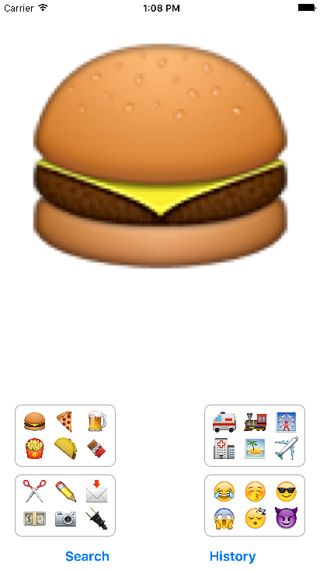 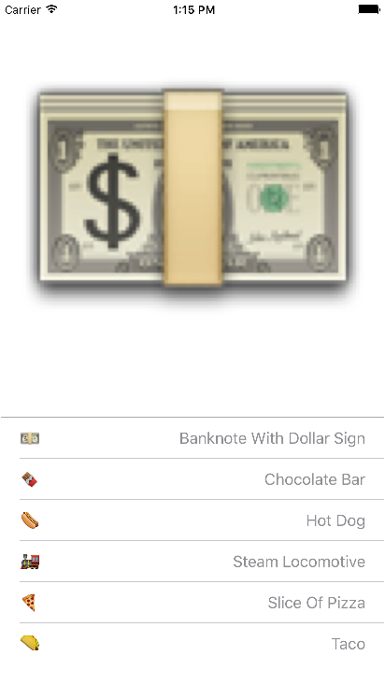

# Contribution

For the latest version, please check develop branch. Change from this branch will be merged into the master branch at some point.

- If you want to contribute, submit a pull request against a development develop branch.

- If you found a bug, open an issue.

- If you have a feature request, open an issue.