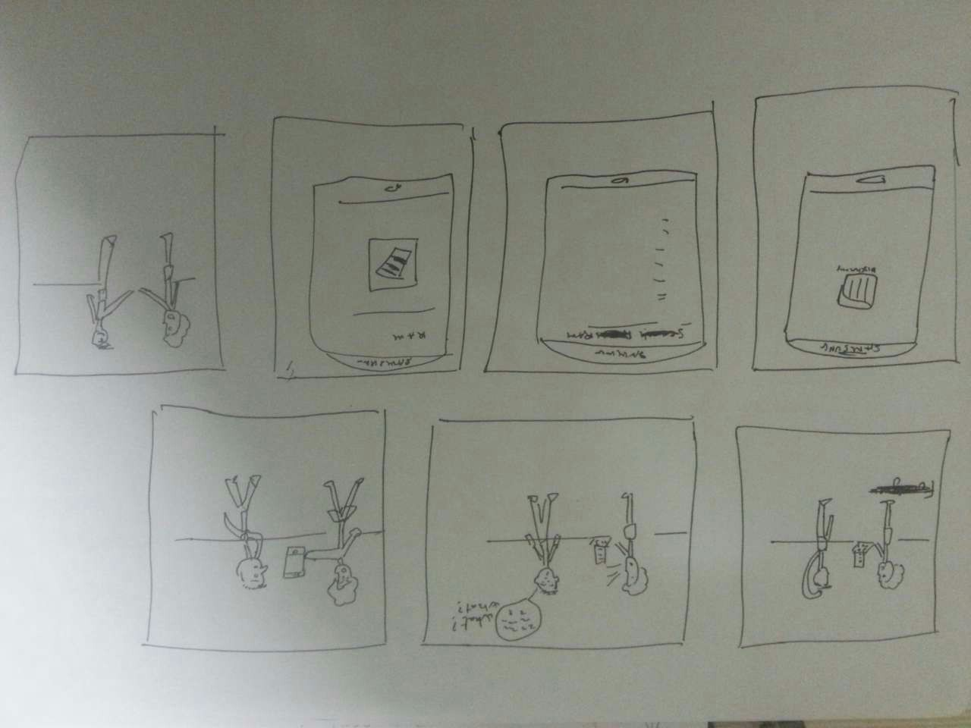SCENARIO 1:

1. A friend asking another to help him with his computer problem
2. The second one doesn’t understand because he doesn’t know what the other one is talking about
3. Then the first one show an dictionary app on his phone
4. He zooms it until the second one sees clearly
5. A display of words appear after a search
6. He finds the word with an explanation and a picture of it
7. The second friends knows what the other one is talking about then agrees to help him.

SCENARIO 2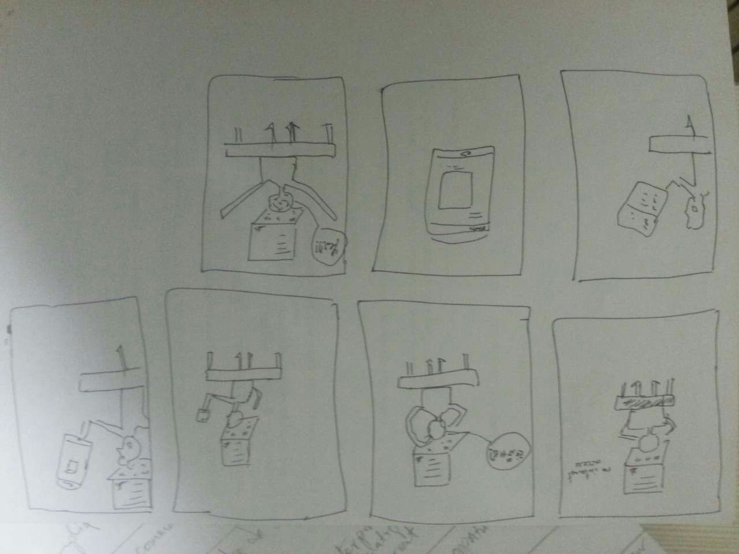

1. A student studying with his computer but having no access to the internet
2. Then he finds a word that he doesn’t understand
3. After a long time he decide to use the app on his phone
4. Zooms to see clearly
5. Perform a search, finds the word
6. Then an explanation with a photo
7. He’s happy and can go back to study

USE CASE 1:

Precondition – searches have been saved in history

Description:

When the layout search is refreshed, all saved searches in the search tag view.

PostCondition:

All saves search queries show in time order in the search tag area

USE CASE 2:

Precondition – searches results

Description:

All the searches are displayed after enter a word

PostCondition:

Results are shown after click to a word

USE CASE 3:

Precondition – photo

Description:

A photo icon is shown after a word result

PostCondition:

A photo of a word is shown after a click on it

USE CASE 4:

Precondition – Settings

Description:

After click on setting icon, a display is showed

PostCondition:

Settings about display of the app are showed

USE CASE 5:

Precondition: google search

Description:

After results a Google icon is showed so we can navigate in case we are not satisfied

PostCondition:

After a click, a Google website is displayed and the explanation of the word that you are looking for is on it

USE CASE 6:

Preconditon: Wikipedia search

After results a Wikipedia icon is showed so we can navigate in case we are not satisfied

PostCondition:

After a click, a Wikipedia website is displayed and the explanation of the word that you are looking for is on it