Scenarios
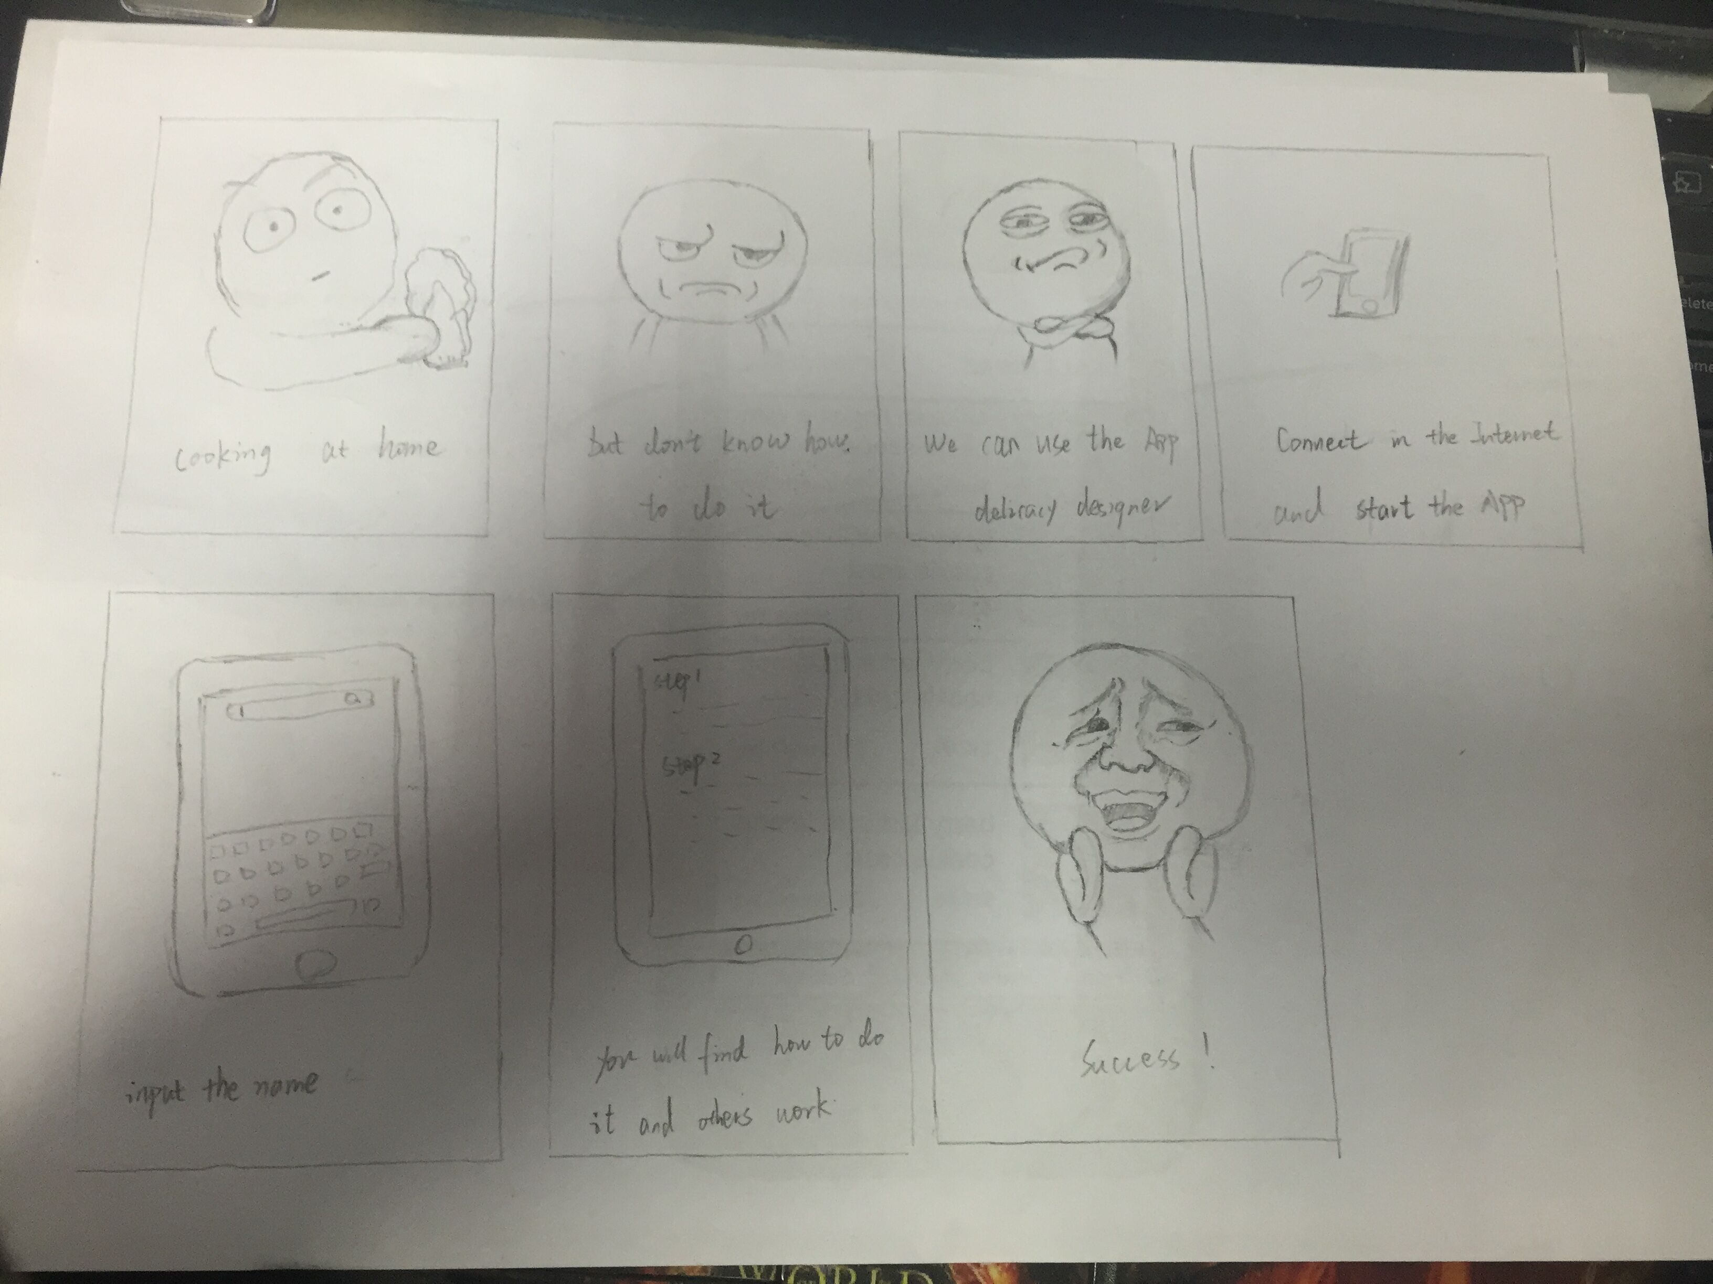

- cooling at home
- but don’t know how to do it
- we can use the app delicacy designer
- connect in the internet and start the App
- input the name
- you will find how to do it and others work
- success!

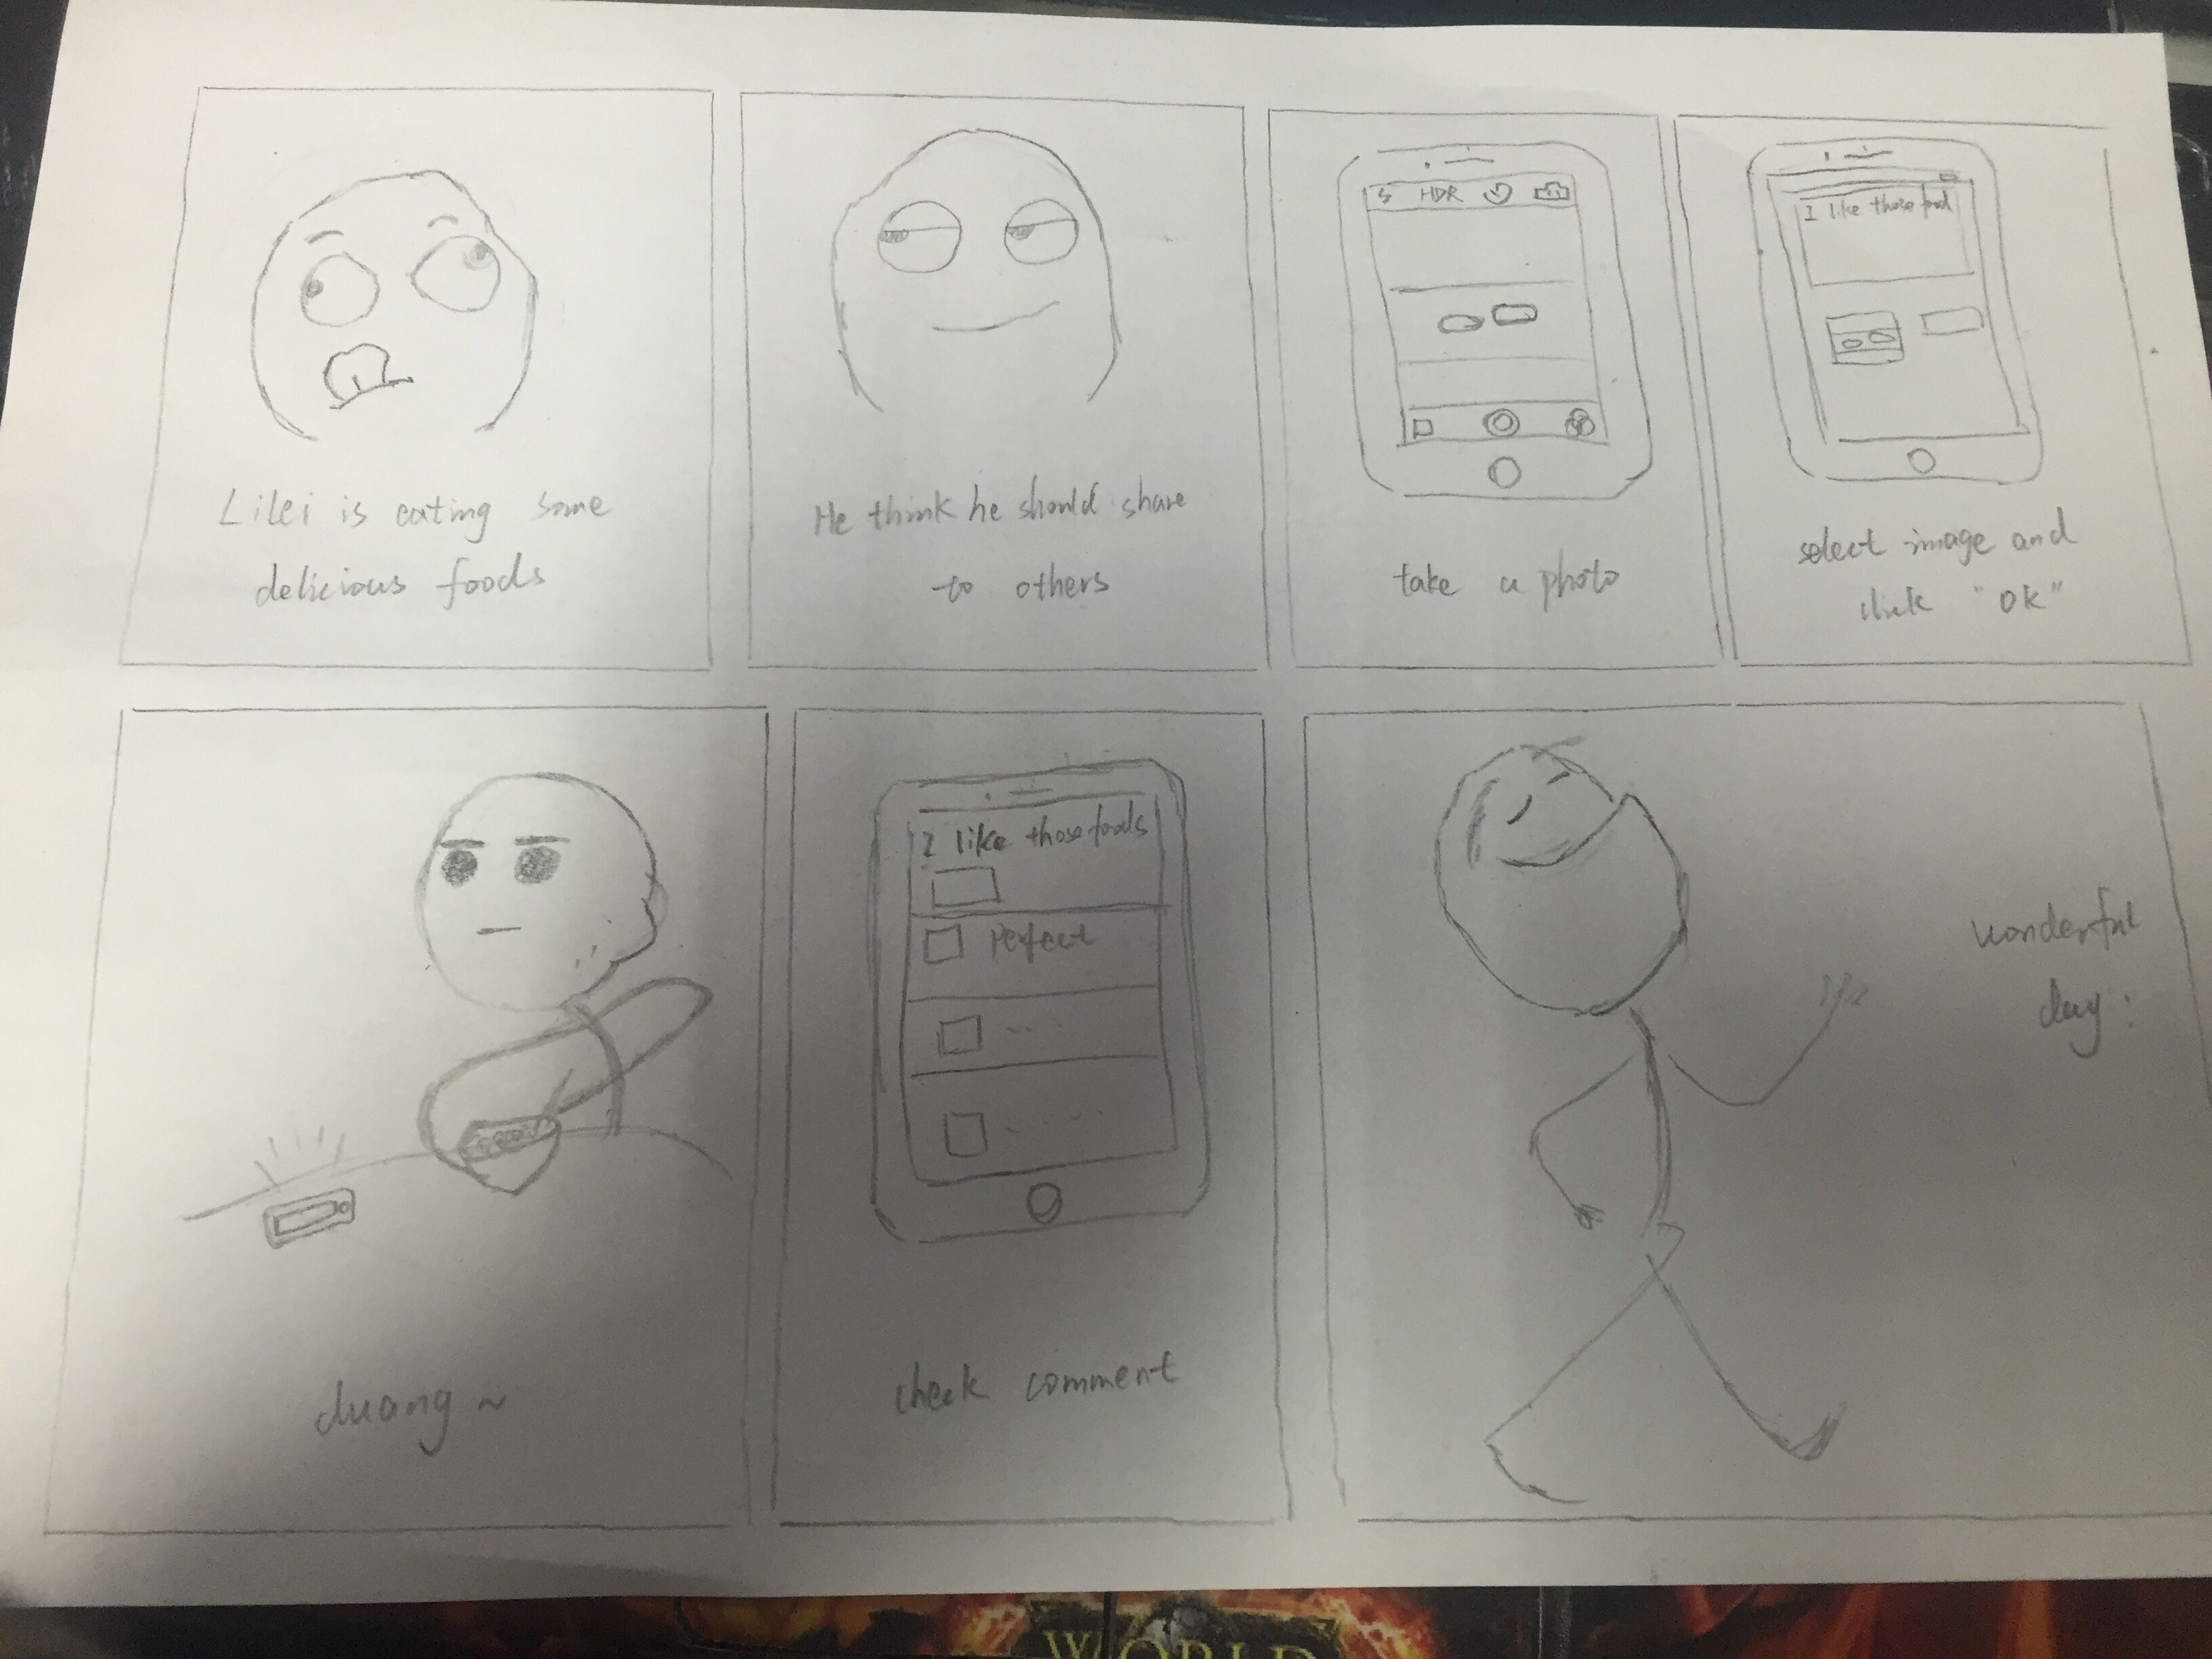
- Lilei is eating some delicious foods
- He think he shoule show to others
- Take a photo
- Select image and click ‘OK’
- Duang~
- Check commect
- Wonderful day!

Share delicacy
Use Case Name: | Share delicacy | Use Case Type:  Business Use Case
Use Case ID: | DD001 | Use Case Type:  Business Use Case
Main Actors | User
Pre-condition | The user has taste some food very delicious, he (she) want to share this food to the internet. .
Post-condition | The information of this delicious food will be upload to the server, and the data will be handled, the other users who have been the fans of this user will see the new message
Description | User upload the delicious food to the server, the fans can see this new message in time.
Exception
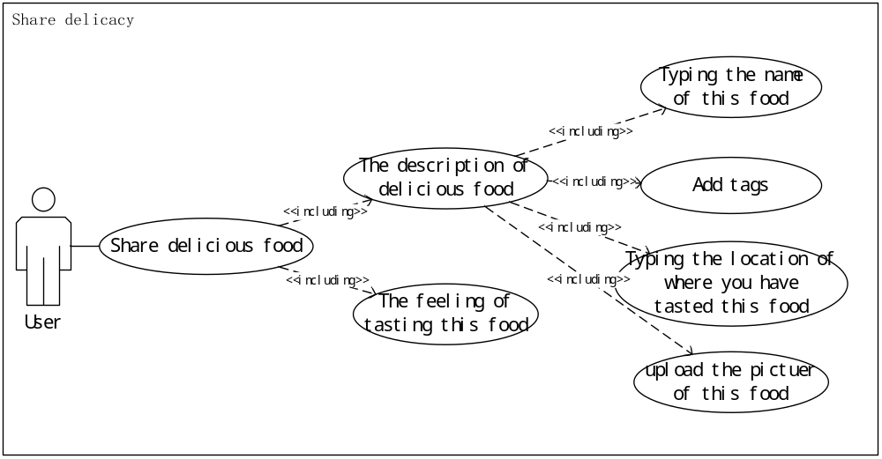
Create cookbook
Use Case Name: | Create cookbook | Use Case Type:  Business Use Case
Use Case ID: | DD002 | Use Case Type:  Business Use Case
Main Actors | User
Pre-condition | The user can cook some delicious food by himself, he want to show the way of cooking this food .
Post-condition | The cookbook will be upload to the server, including the makings list of this food、every step of cook. The other user who have been the fans of this user will see this message in time.
Description | User upload the cookbook to the server, the fans can see this cookbook’s detail as they want.
Exception
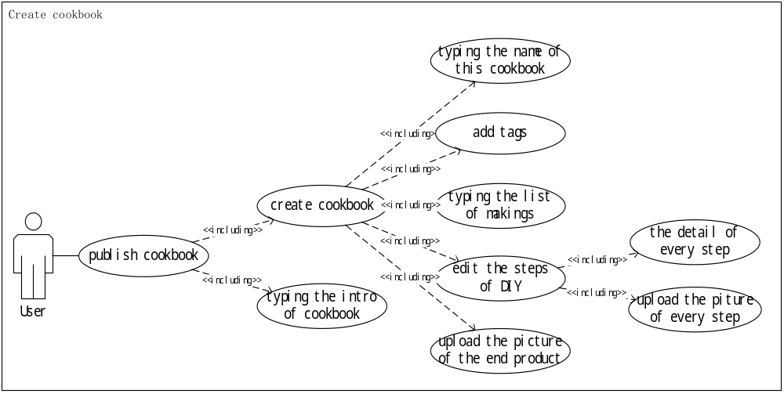
Browse cookbooks List
Use Case Name: | Browse cookbooks list | Use Case Type:  Business Use Case
Use Case ID: | DD003 | Use Case Type:  Business Use Case
Main Actors | User
Pre-condition | The user want to see some cookbooks made by others .
Post-condition | The user browse the cookbooks list made by others
Description | The user browse the cookbooks list by search them in different ways
Exception
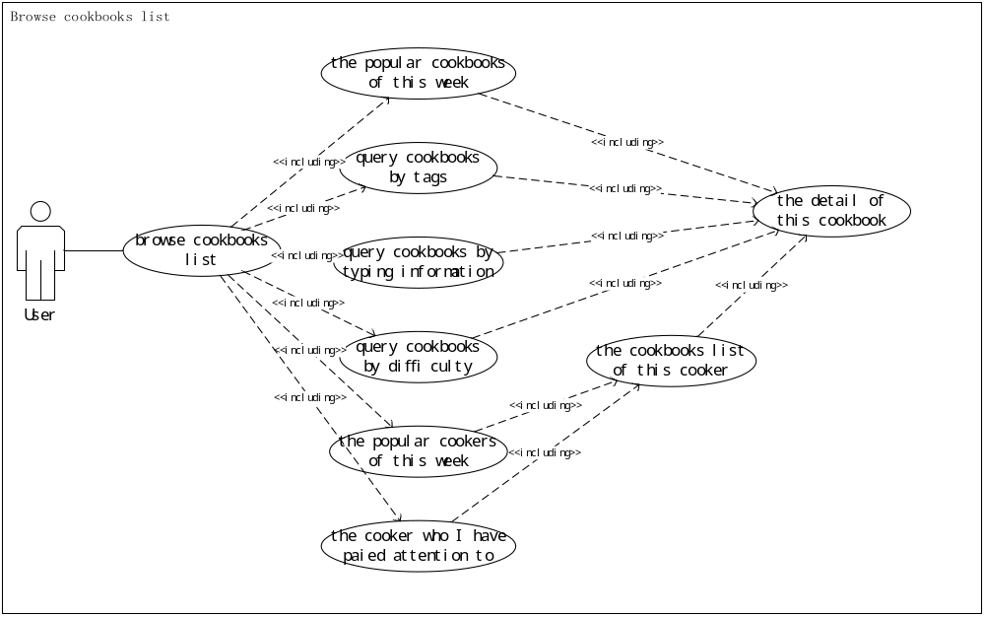

Read the cookbook’s information
Use Case Name: | Read the cookbook’s information | Use Case Type:  Business Use Case
Use Case ID: | DD004 | Use Case Type:  Business Use Case
Main Actors | User
Pre-condition | The user want to see the information of one cookbook .
Post-condition | The information of this cookbook will be showed to user, the list of makings、the detail of every step、the information of cooker and so on.
Description | The users can read the information of this cookbook as he want, they can also evaluate current cookbook
Exception
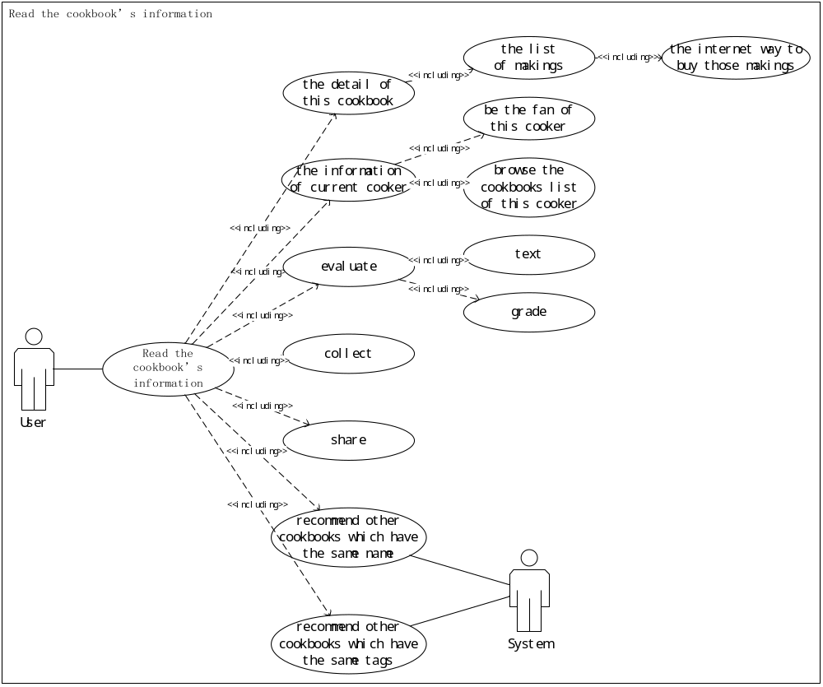
Create menu
Use Case Name: | Create menu | Use Case Type:  Business Use Case
Use Case ID: | DD005 | Use Case Type:  Business Use Case
Main Actors | User
Pre-condition | The user want to create menu including several cookbooks
Post-condition | The menu will be upload to the server, including several different cookbooks. The other user who have been the fans of this user will see this message in time.
Description | The menu will be upload to the server, add tags for this menu, not only the user can add new cookbooks, but also existing ones.
Exception
