JENNIFER BRONSON Exercises from Chapter 4

Prior to Exercise 1

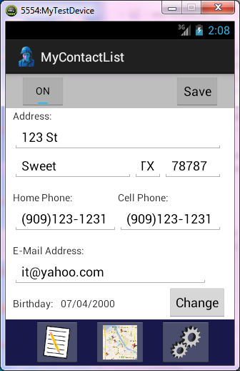

Exercise 1:

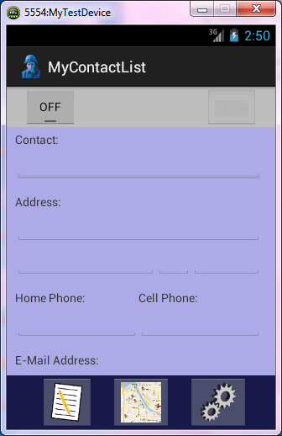

Exercise 2:

Here is a picture of the Settings page. I can link from page to page ok from each page, but the disable feature does not seem to be working. I set the function for the respective button to (Boolean enabled) and in the onload function it is (false) for each page, but it still seems to be responsive.

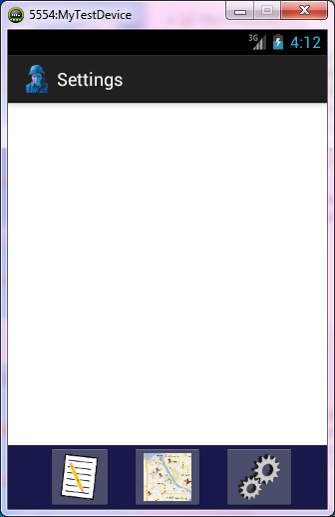

Exercise 3:

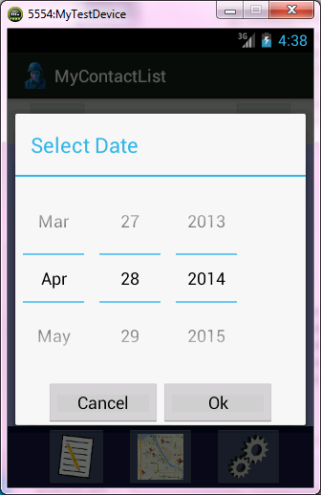

Exercise 4:

I added the code for removing focus to the setForEditing() method (I assumed that setForView() was a typo or something since I didn’t have that method in ContactActivity.java).