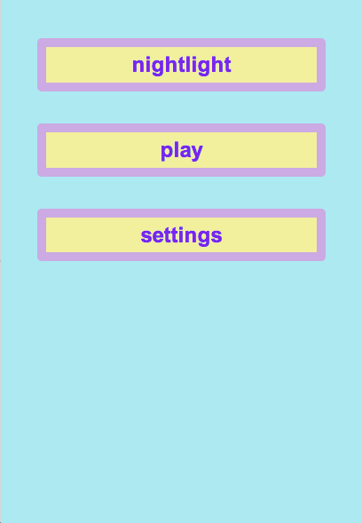

This is the home screen.

This will be a toggle switch to make the background a lullaby.

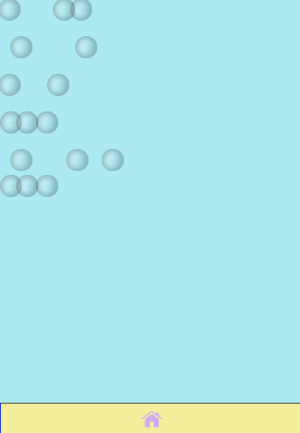  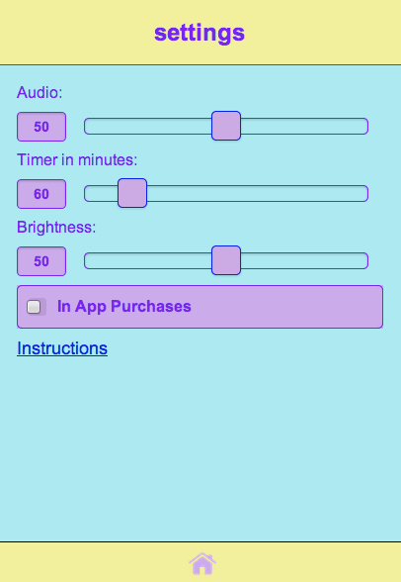

This is the settings screen where preferences can be changed.

This is the Nightlight setting where the app stays on according to the timer setting.

This is the play setting where lack of interaction shuts off the app and widgets disappear in a few seconds.

This brings up pop-up stating instructions

This enables purchases.

This sets brightness.

This determines timer length for nightlight