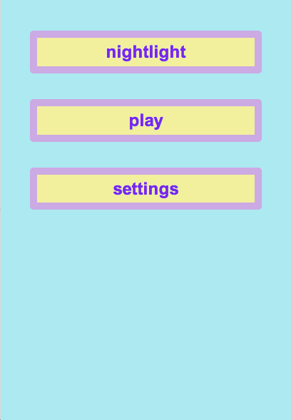 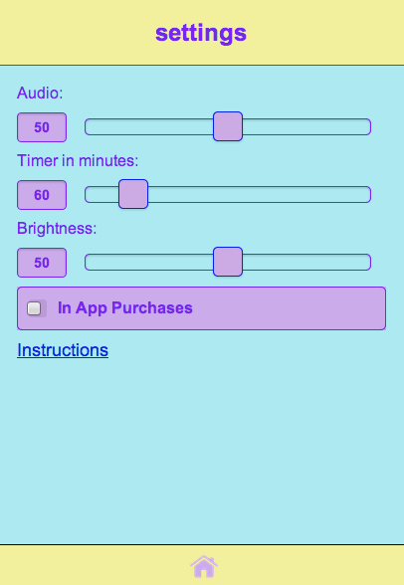  

If chosen, a lullaby plays and the brightness of the screen could be different.

App shuts off according to the timer feature in Settings.

Other possibilities on the settings screen is to change the brightness of the screen and an audio toggle switch that lets the user choose to have a lullaby play in the nightlight setting.

On the Settings screen the user moves the slider under “timer” to 3 hours (or whatever amount of time they want). The Time setting is saved when they then click on the “home” button at the bottom of the screen.

The user then clicks on the screen randomly to create widgets that float around the screen.

On the Home screen the user then clicks on “nightlight” to be taken to the nightlight screen.

At the Home Screen the user clicks on the settings button.