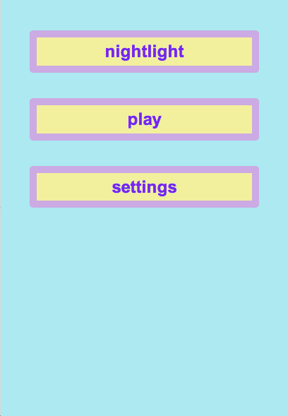 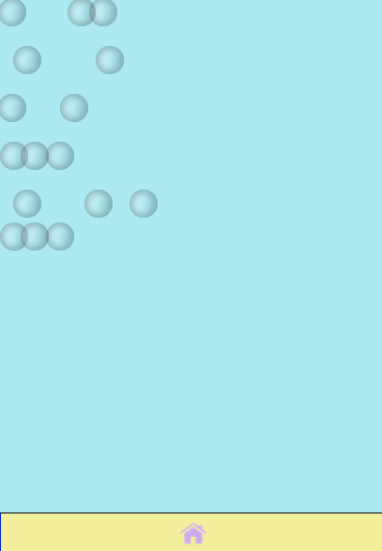

App shuts off automatically if interaction ceases (according to standard app feature for shutting down).

The user then clicks on the screen randomly to create widgets that float around the screen.

At the Home Screen the user clicks on the play button.