Mobile Communication – Group – Proposal

Contents

Mobile Communication – Group – Proposal 1

1. About This Document 1

2. Contributors 1

3. Technology 1

4. Implementation 2

DSSS 2

FHSS 2

## About This Document

A proposal describing the setup, implementation concept and test realisation for the practical assignment of the lecture Mobile Communication at the University of Berne in HS2014.

## Contributors

* Urs Gerber, 09-921-156
* Gian-Luca Mateo, 11-113-545 (Group leader)
* Niclas Scheuing, 09-127-812
* Roger Stebler, 08-928-343

## Technology

* Matlab and its object oriented features

## Implementation

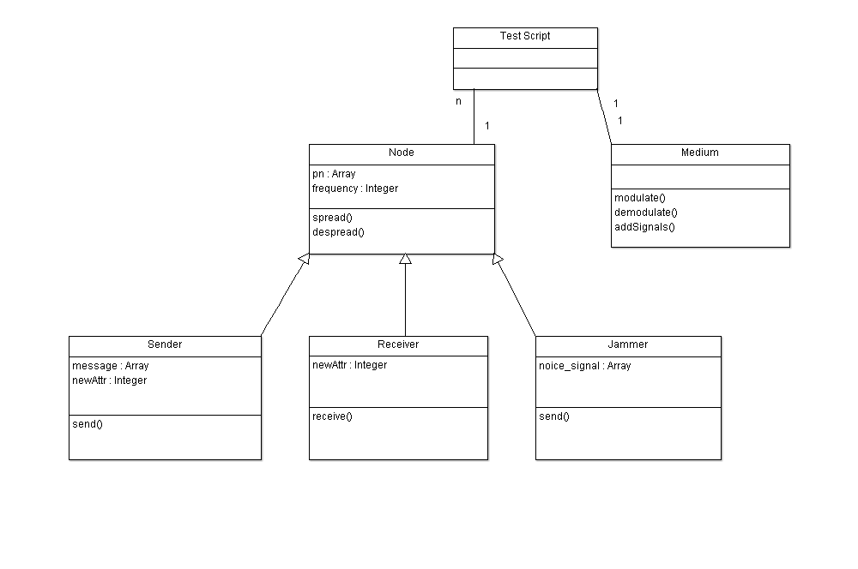

*UML Diagram of proposed implementation using MATLAB and its oo features.*

Using object-oriented Matlab code, our team is going to simulate the influence of bandwidth, narrow- and wideband interference, background noise and simultaneous channel usage on signal quality and transmission speed. In order to do this, the propagation medium is described as a frequency-domain, in which interferences and competing signals are added to the spectrum of the sender signal. The sender(s) and receiver will work in time-domain. We are yet undecided on whether to simulate signal attenuation, but will probably ignore it in our calculations.

### DSSS

We will apply FFT to the product of the data and pseudo-noise inputs as a way of “modulating” the signal for free space propagation. Before letting the receiver handle the signal, we will apply narrow- and wideband interference, gaussian noise and channel load from other senders in varying intensity. The receiver will demodulate the signal using IFFT and then despread it using the same pseudo-random sequence and for each segment corresponding to the length of a symbol choose the symbol which best matches the received signal. This will be done by integrating over the relevant time-slice and picking whatever is closest to the result, 1 or -1.

### FHSS

We will use a very similar procedure to DSSS, but will have to handle some aspects differently. As the signal is frequency modulated in FHSS, we will apply FFT to a signal of length Tc (1/Rc, the chipping rate) and frequency fhi+fsymbol. Then we will proceed equally as in DSSS by applying different forms and intensities of interference and channel load. The receiver will demodulate the signal by applying IFFT to the frequency spectrum and then matching the received signal to the corresponding possible frequencies by integrating 0Tcdt|finput-fexpected| and choosing the value closest to zero. We will investigate whether this is a good approach or not and adapt it if necessary.