###### Logo Black and White

PUCIT

Punjab University College of Information Technology

**Submitted To:**

**Sir Zain Aftab**

**Submitted By:**

**Bcsf14a005**

**Bcsf14a037**

**Date:**

**26-01-2018**

###### Android project: Photo Editor

**1) Launching screen :**

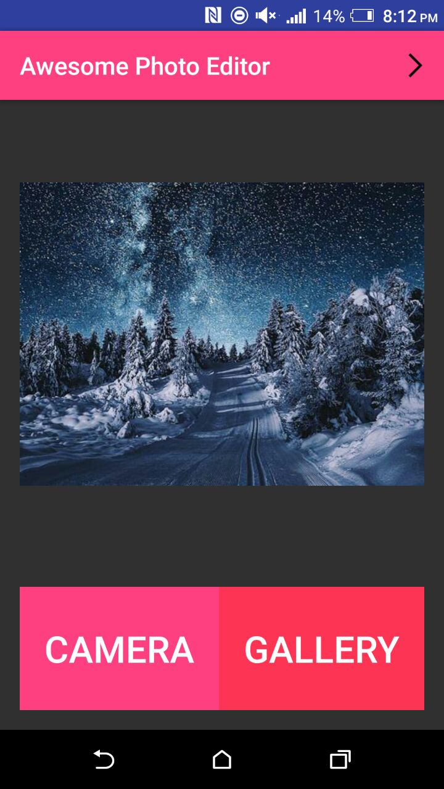

**2) By clicking camera :**

Camera opens to take pictures .

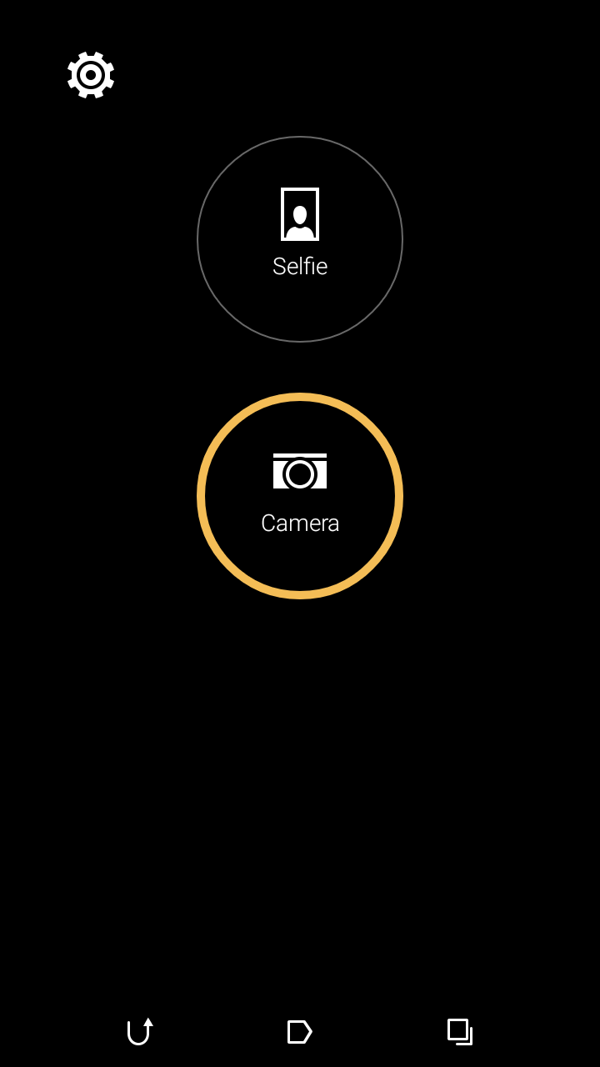

**3) Picture click :**

Picture is clicked using selecting camera mode .



**4) Panel for editing opens :**

An interface for editing opens to choose your selected features to be added.

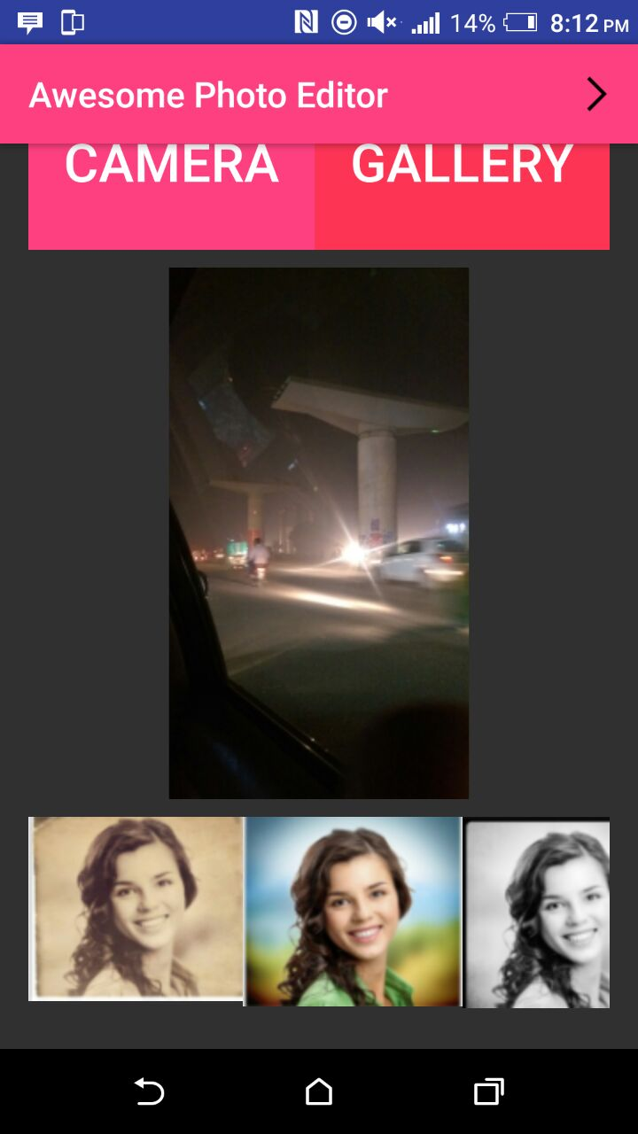

**5) Effect applied:**

The selected effect is applied in the same panel .

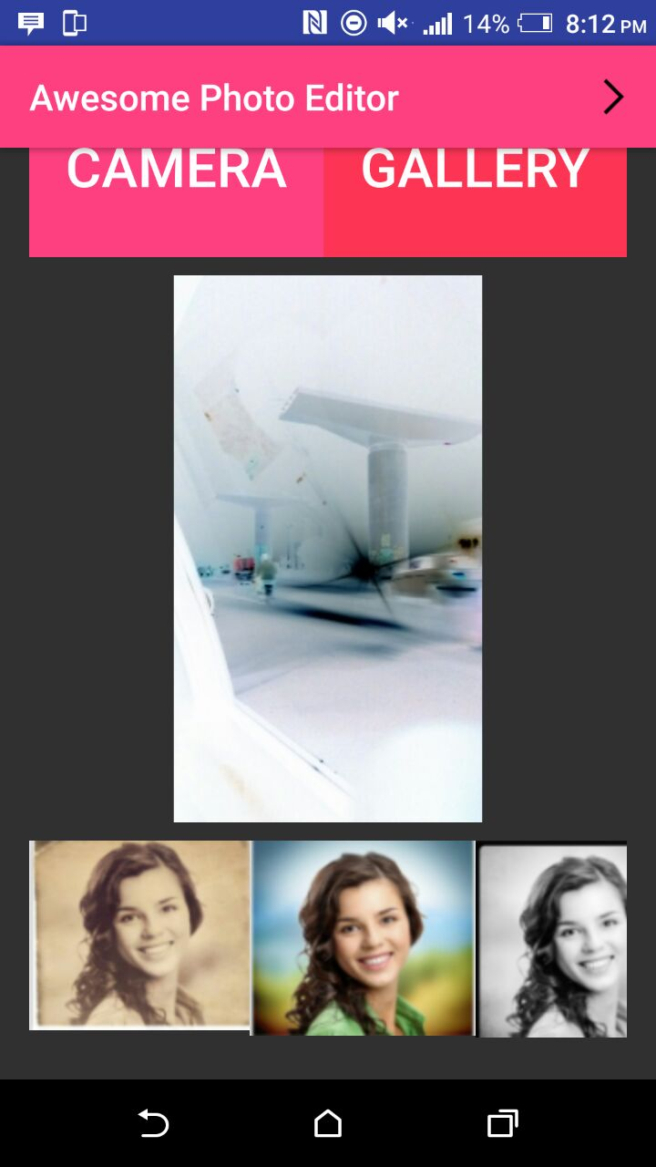

**6) Image saved in gallery:**

Toast is shown to save image in gallery.

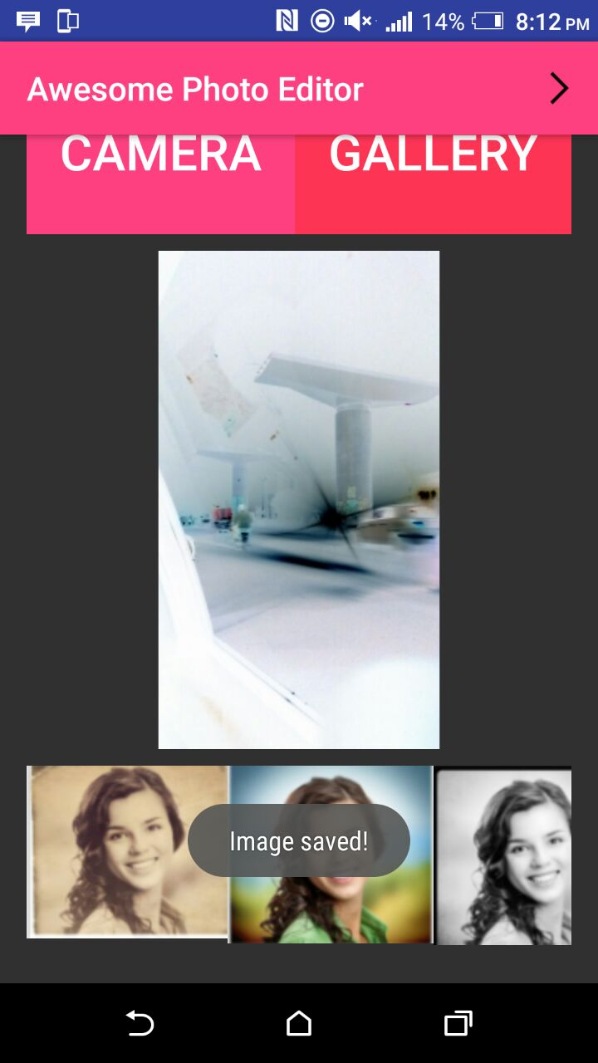

**7) Clicking on gallery option in launching screen:**

The gallery opens to select the pictures of your choice for editing .

