|  |  |  |
| --- | --- | --- |
| Republique du Cameroun |  | Republic of Cameroon |
| *************** | *************** |
| Paix-Travail-Patrie | Peace-Work-Fatherland |
| *************** | *************** |
| Ministere de enseigment superieure | Ministry of High Education |
| *************** | *************** |
| Universite de Buea | University of Buea |
| *************** | *************** |
|  | Faculty of Engineering and Technology |
|  |  |
|  | Department of Computer Engineering |
|  |  |

**CEF 440 INTERNET AND MOBILE PROGRAMMING**

**PROJECT REPORT**

**PRESENT BY:**

|  |  |  |
| --- | --- | --- |
| **NAMES** | | **MATRICULES** |
| **GUEGUIM SONNA ZITHA UNELLE** | | **FE20A045** |
| **MAKONDI THIERRY JUNIOR** | | **FE20A062** |
| **NGANKEP FANDIO ORDY BENIDI** | | **FE20A075** |
| **HIEGA EMMANUEL JOEL** | | **FE20A050** |
| **OMYOM KILLENG ZACHARIE FRANKLIN** | **FE20A096** | |

**Purpose**

The system we are working on is software that will help customers to view the price of different products on the market. This is to help them to better plan their move by providing them with the real price of the product and where they can get it. To achieve this, we will fist need to have the price of various product in all the market in Cameroon. Considering the number of members of our team and the cost of collecting all that information just in the city of Buea, we may end up in difficulty. So, for us to collect price of different product without increasing the cost and the work on the developer's team, we plan to build a software in which vendors upload their product and price plus their location on the software and customer can see those information.

Table of contents:

|  |  |
| --- | --- |
| Project description |  |
| 1. Presentation of requirements |  |
| 1. Functional requirement |  |
| 1. Non-functional requirement |  |
| 1. Analysis and modeling of requirements |  |
| 1. Requirement diagram |  |
| 1. Use case diagram |  |
| 1. Class diagram |  |
| 1. Activity diagram |  |
| 1. Sequence diagram |  |
| 1. Cost Evalution of the project |  |
| 1. High level module map |  |
| 1. Technology use for the project |  |
| 1. Billing |  |

Work Assignment

For this task that was to collect requirement and analyses them, where given a particular task to do.

|  |  |  |  |
| --- | --- | --- | --- |
| Role | Name | Task | Done or not |
| Project manager  front-end and backend developer | OMYOM KILLENG  ZACHARIE FRANKLIN | Collect requirement  Draw requirement diagram and activity diagram | Done  Done |
| Front-end developer | HIEGA EMMANUEL JOEL | Collect requirement  Draw use case diagram | Done  Done |
| UI/UX designer  Front-developer | GUEGUIM SONNA ZITHA UNELLE | Collect requirement  Power point presentation | Done  Done |
| Backend developer | MAKONDI THIERRY JUNIOR | Collect requirement  Draw class diagram | Done  Done |
| Backend developer | NGANKEP FANDIO ORDY BENIDI | Collect requirement  Draw sequence diagram | Done  Done |

Project description

The Local Product Pricing and Vendor Management System is a mobile application that will allow customers to view the prices of products in their local area and in different markets in Cameroon. The system will also allow vendors to upload their products and prices onto the platform, which can be accessed by customers.

The system is built with user-friendliness in mind, and all vendors will be required to create an account and login to perform all their operations such as adding a new product, updating the price of an existing product or delete a product. The system will keep track of all uploaded products and prices.

This system will be particularly beneficial for customers who are looking to make informed purchasing decisions without breaking the bank. They will be able to compare prices in different markets and make a choice based on their budget. On the other hand, vendors will be able to market their products more effectively across regions and increase their sales.

The key features of this Local Product Pricing and Vendor Management System include:

- A vendor management system that allows vendors to create, edit, and delete their account profile and product listings.

- A search and filtering system that allows users to easily navigate through the application and find the products they want.

- A notification system that alerts vendors when a product is sold, or when the price has been updated in a competing market.

- A feedback system that allows vendors to receive feedback from their customers and make adjustments to their products and prices accordingly.

This system will be ideal for small and medium scale businesses that want to expand their operations to different markets in Cameroon. It will also be beneficial for customers who are looking for competitively priced and high-quality products.

The system will also have an admin section where we can control the type of products that are been presented by the vendor and block them if they are not legal and where we can register vendors.

1. Requirement
2. Functional requirement

Vendor Management

- The system should have the ability to add, modify, and delete vendors.

- The system should allow vendors to upload their products and prices.

- The system should allow vendors to view their uploaded products and prices.

User Management

- The system should allow users to search for products in their locality.

- The system should enable users to view the prices of products in different markets.

- The system should allow users to filter the search results based on specific criteria.

Product Management

- The system should enable users to search for products based on product category.

- The system should allow users to sort search results based on price, location of market or vendor.

Authentication

- The system should require vendors to login to perform operations and ensure that they are authorized to perform the operation they want to execute.

1. Non-Functional requirement

Performance

- The system should have an average response time of fewer than 2 seconds.

- The system should be able to handle a maximum of 1000 concurrent users.

Availability

- The system should be available for use 24/7, with scheduled maintenance windows

Security

- The system should be secure, utilizing techniques like authentication and encryption to protect data privacy and prevent unauthorized access.

1. Analysis and modeling of requirement
2. Requirement diagram

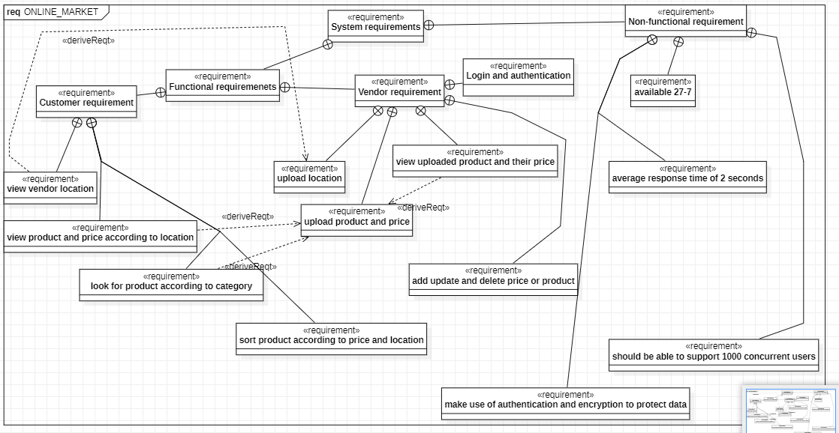

The requirement diagram is the modeling of all the requirements collected for this project. Functional requirements are separated into two categories (customer requirement: that are all the action or features that a customer can have and the vendor requirements: that are all action or features of the vendor).

1. Use case diagram

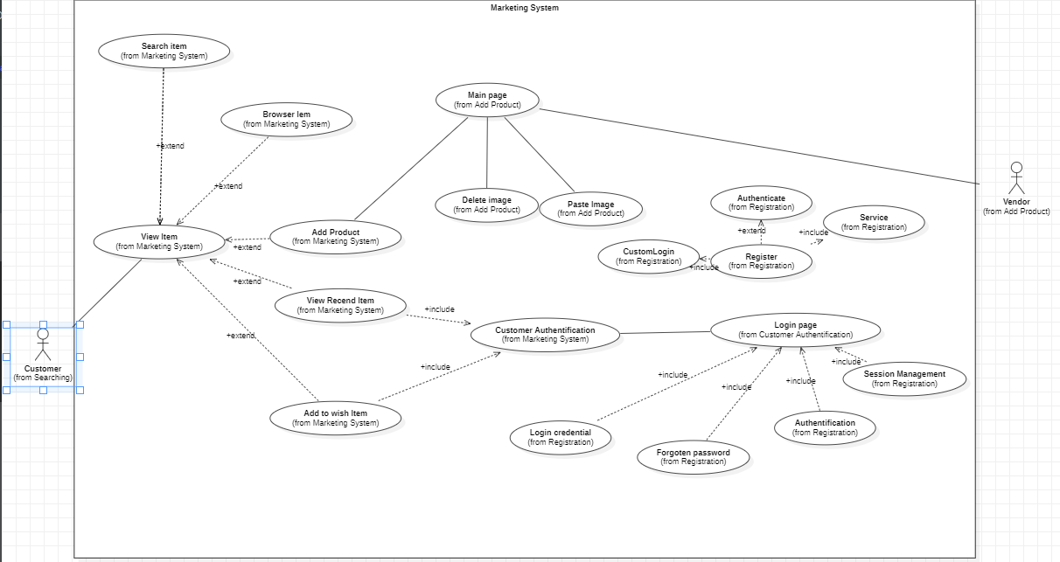

The use case diagram gives us an overview of the interactions in the software with more details from the login of the vendor to the selection of the product by the vendor

1. class diagram

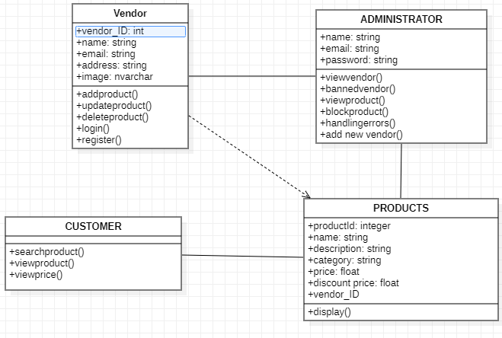

The class diagram represents all the classes of the software and all the tables of our database.

* Customer: in our application, the customer is consider as a guest user because he doesn’t create an account and can freely use the application to look for a product.
* Vendor: he is the one in charge of posting the product and price, he needs to sign in to be able to create, add, update or delete product and price
* Admin: he oversees the management system of the application. He supervises all the action done by vendor (validating registration, checking the conformity of a product and the vendor account)
* Products: they are all the articles sold by a vendor

1. Activity diagram

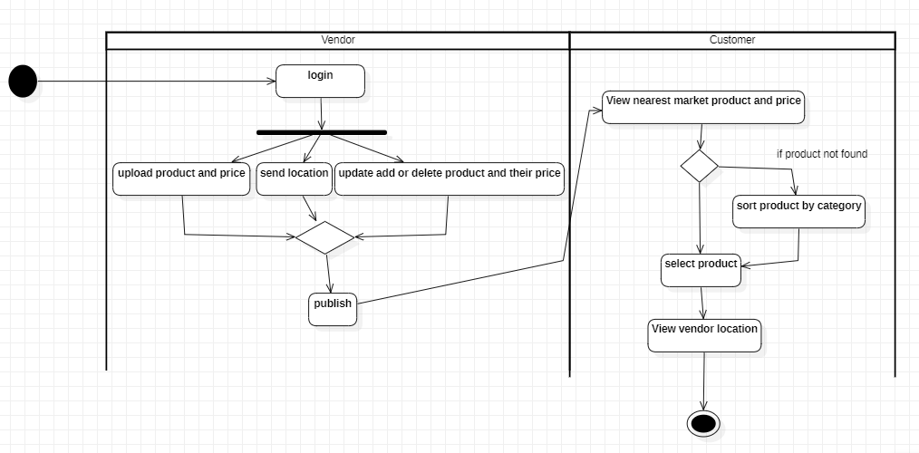

This activity diagram shows us the flow of action in the application.

1. Sequence diagram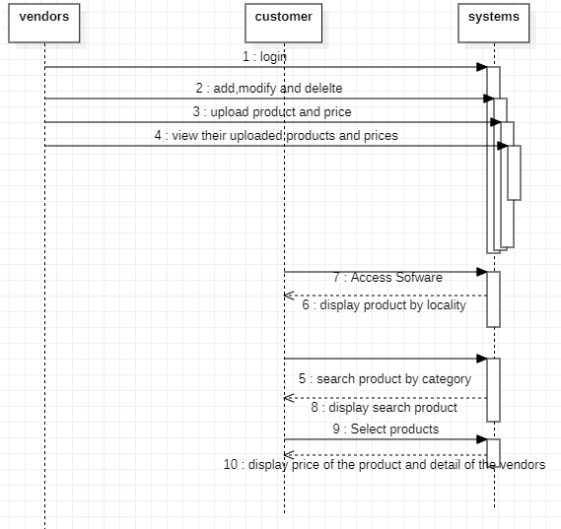

As the activity diagram, the sequence diagram helps us understand better the interactions that will take place in the application.

1. Cost Evaluation of the project
2. High level module map

User Authentication Module

- Responsible for user login and registration

- Ensures secure access to the system

Vendor Module

- Allows vendors to upload and update product information including name, description, quantity, and price.

- Enables vendors to set their location

Product Information Module

- Provides users with a search feature to find products and up-to-date prices in their locality.

- Allows users to filter by product, location or price range.

- Provides users with product information and price in different markets in Cameroon.

Reporting and Analytics Module

- Provides data visualization to help users understand trends and patterns.

These modules work together to provide customers with real-time information about product pricing in their area and the ability to purchase any product from their chosen location. Meanwhile, vendors have the ability to update and manage their product information, and a simplified way to participate in the market by assuming an online presence.

1. Technology use for the project

To technology we plan on using to build this software in an efficient way (taking in consideration the experience of the team) are:

* For front-end development:

We plan to build the software in a short period of time and for both Android and iOS devices. So, we have choosing FLUTTER for the front-end development because of his cross-platform advantage that will permit us to save time by editing code for Android and iOS device, his level of difficulty in terms of learning which is very low which make it easy to learn and the size of his community.

* For back-end development:

For the backend development, we plan on using PHP. The reason is that we won’t need to store sensitive data about the users (customer and vendor) like payment details,… so a very high level of security is not needed, however the level of security offer by PHP is appropriate for this project. Also, the scalability (capacity of handling heavy traffic without affecting the performance), flexibility (PHP is cross-platform compatible) and the property (PHP is an open-source scripting language, which mean the code is free therefore the cost will be reduce) make it the best choose for our project.

* For UI/UX design:

For the design of the application, we plan on using FIGMA.

1. Billing

|  |  |
| --- | --- |
| **Source of cost** | **Amount (in Franc CFA)** |
| Infrastructure (server) | 5 000 – 30 000 |
| Development team |  |
| Front-end development | 150 000 – 500 000 per page |
| Back-end development | 7000 – 40 000 per hour |
| UI/UX design | 10 000 - 40 000 per hour |