|  |  |  |
| --- | --- | --- |
| Republique du Cameroun |  | Republic of Cameroon |
| *************** | *************** |
| Paix-Travail-Patrie | Peace-Work-Fatherland |
| *************** | *************** |
| Ministere de enseigment superieure | Ministry of High Education |
| *************** | *************** |
| Universite de Buea | University of Buea |
| *************** | *************** |
|  | Faculty of Engineering and Technology |
|  |  |
|  | Department of Computer Engineering |
|  |  |

**CEF 440 INTERNET AND MOBILE PROGRAMMING**

**PROJECT REPORT**

**PRESENT BY:**

|  |  |  |
| --- | --- | --- |
| **NAMES** | | **MATRICULES** |
| **GUEGUIM SONNA ZITHA UNELLE** | | **FE20A045** |
| **MAKONDI THIERRY JUNIOR** | | **FE20A062** |
| **NGANKEP FANDIO ORDY BENIDI** | | **FE20A075** |
| **HIEGA EMMANUEL JOEL** | | **FE20A050** |
| **OMYOM KILLENG ZACHARIE FRANKLIN** | **FE20A096** | |

Abstract:

The system we are working on is a software that will help customers to view the price of different products on the market. This is to help them to better plan their move by providing them with the real price of the product and where they can get it. To achieve this, we will fist need to have the price of various product in all the market in Cameroon. So, for us to collect price of different product, we plan to build a software in which vendors upload their product and price plus their location on the software and customer can see those information. In the following line, we will present the UML diagram(activity diagram, data flow diagram, use case diagram, sequence diagram and class diagram) that we made for this project to better visualize the project for a better implementation.

Table of contents:

|  |  |
| --- | --- |
| Project description |  |
| 1. Data Flow Diagram |  |
| 1. Presentation |  |
| 1. Description |  |
| 1. Use case diagram |  |
| 1. Presentation |  |
| 1. Description |  |
| 1. Sequence diagram |  |
| 1. Presentation |  |
| 1. Description |  |
|  |  |

1. Class diagram

1- Presentation

2- Description

1. Activity diagram

1- Presentation

2- Description

Work Assignment

For this task that was to collect requirement and analyses them, where given a particular task to do.

|  |  |  |  |
| --- | --- | --- | --- |
| Role | Name | Task | Done or not |
| Project manager  front-end and backend developer | OMYOM KILLENG  ZACHARIE FRANKLIN | Activity diagram | Done |
| Front-end developer | HIEGA EMMANUEL JOEL | Use case diagram | Done |
| UI/UX designer  Front-developer | GUEGUIM SONNA ZITHA UNELLE | Data flow diagram | Done |
| Backend developer | MAKONDI THIERRY JUNIOR | Class diagram | Done |
| Backend developer | NGANKEP FANDIO ORDY BENIDI | Sequence diagram | Done |

Project description

The Local Product Pricing and Vendor Management System is a mobile application that will allow customers to view the prices of products in their local area and in different markets in Cameroon. The system will also allow vendors to upload their products and prices onto the platform, which can be accessed by customers.

The system is built with user-friendliness in mind, and all vendors will be required to create an account and login to perform all their operations such as adding a new product, updating the price of an existing product or delete a product. The system will keep track of all uploaded products and prices.

This system will be particularly beneficial for customers who are looking to make informed purchasing decisions without breaking the bank. They will be able to compare prices in different markets and make a choice based on their budget. On the other hand, vendors will be able to market their products more effectively across regions and increase their sales.

The key features of this Local Product Pricing and Vendor Management System include:

- A vendor management system that allows vendors to create, edit, and delete their account profile and product listings.

- A search and filtering system that allows users to easily navigate through the application and find the products they want.

- A notification system that alerts vendors when a product is sold, or when the price has been updated in a competing market.

- A feedback system that allows vendors to receive feedback from their customers and make adjustments to their products and prices accordingly.

This system will be ideal for small and medium scale businesses that want to expand their operations to different markets in Cameroon. It will also be beneficial for customers who are looking for competitively priced and high-quality products.

The system will also have an admin section where we can control the type of products that are been presented by the vendor and block them if they are not legal and where we can register vendors.

1. Data flow diagram

A Data Flow Diagram (DFD) is a graphical representation of the way data flows through an information system. It is a modeling technique that is used to describe Business Processes, Information Flows, Data Stores, and Entities

1. Presentation

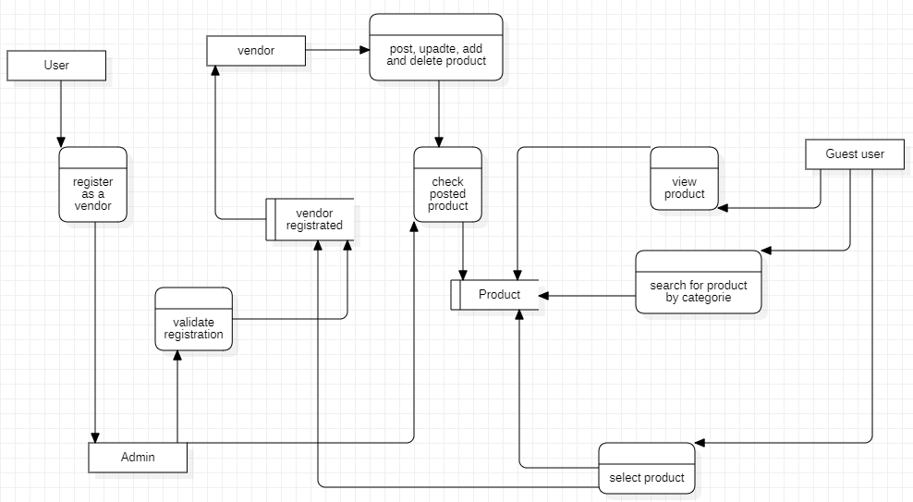

1. Description

In our Data flow diagram, we have 4 external entities, 7 processes, and 2 data stores.

1. External entity:

* Guest user: the guest user here represents the customer that will come and view the various product and details about it (vendor location, vendor contact, price of the product). As the customer doesn’t need to sign in, he is considered as guest user
* User: the user here is a person willing to be a vendor. So, he will have to register before he can be a vendor
* Vendor: the vendor is the main user of the system. He is the one in charge of posting product and their price on the system.
* Admin: the Admin in in charge of controlling the action of a vendor and he is the one validating the user registration for him to be a vendor.

1. Process:

It is any action that changes the data, producing an output. It might perform computations, or sort data based on logic, or direct the data flow based on business rules.

In our case, we have 7 processes. Which are:

* Register as vendor: this happens when a user fills in the form for him to be a vendor. The input comes from the user, and the output (user information) is sent to the admin
* Validate registration: it happens when the admin has received the information of the user and processed it. He will send the information to the database.
* Post, update, add and delete product: this represents all the action that a vendor can do. It receives as input the information about the product and sends it to the next process.
* Check posted product: this operation is done by the admin on the product sent by the vendor. His input is the information send by the vendor and the authorization of the admin. It will store the information in the database if everything is ok.
* View product: this operation permits the guest user to view the product according to his locality. It will sort the product by nearest location.
* Search for product by category: it permits the guest user to sort product by category.
* Select product: it permits to guest user to see information about the product (price, product name, vendor location, vendor contact etc...).

1. Data store:

* Product: it is the representation of the table product in the database.
* Registrated vendor: it is the representation of the table vendor in ther database

1. Use case diagram
2. Presentation
3. Description
4. Sequence diagram

Sequence diagrams are a type of interaction diagram used in Unified Modeling Language (UML) to represent the interactions between objects or entities in the system being modeled.

In our system, we have 4 entities interacting with the system. We have been able the represent most interaction in the following diagram.

1. Registration

A-presentation

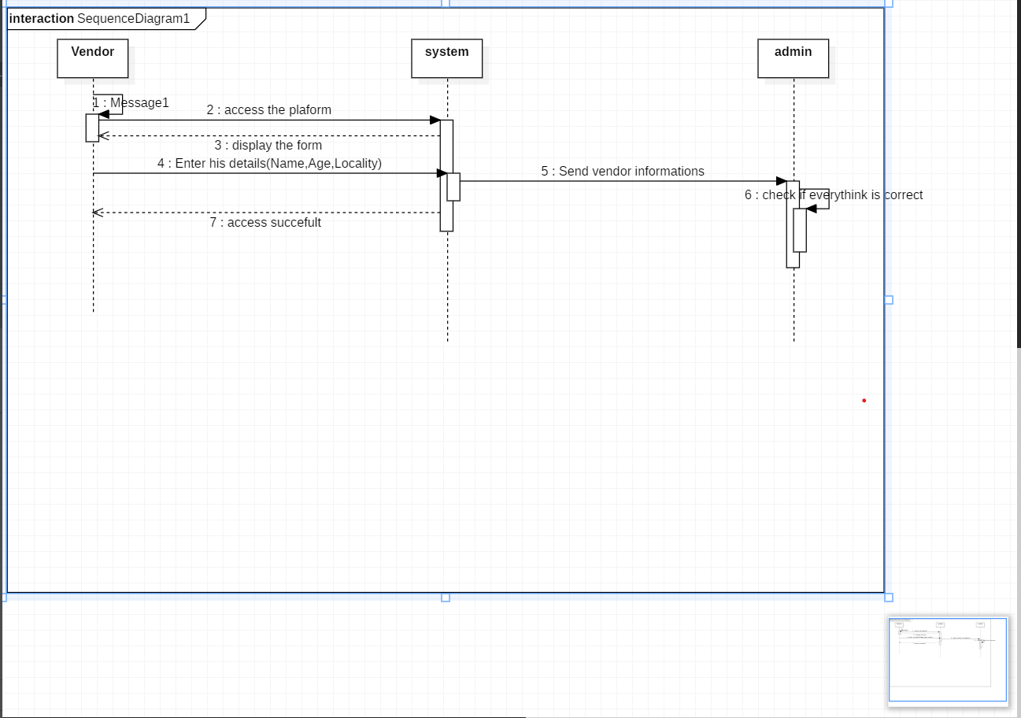

B-Description

In this part the vendor before accessing the platform, must insert this information into the system, then the system sends back to the admin, the latter checks if everything is ok.

1. Customer

A- Presentation

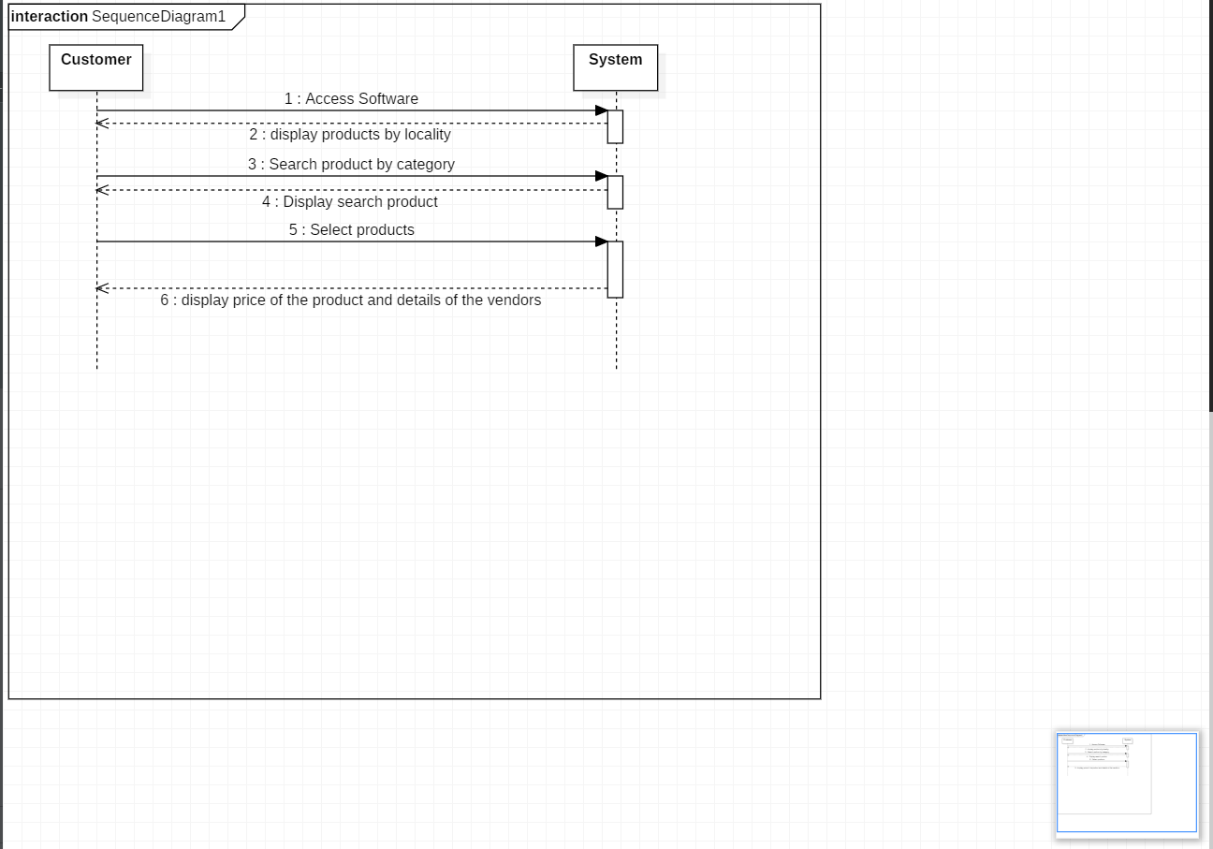

B-Description

In this part the customer accesses the platform and perform tasks (search, select, and view products), there after the system displays the products according to the locality.

1. Vendor

A-Presentation

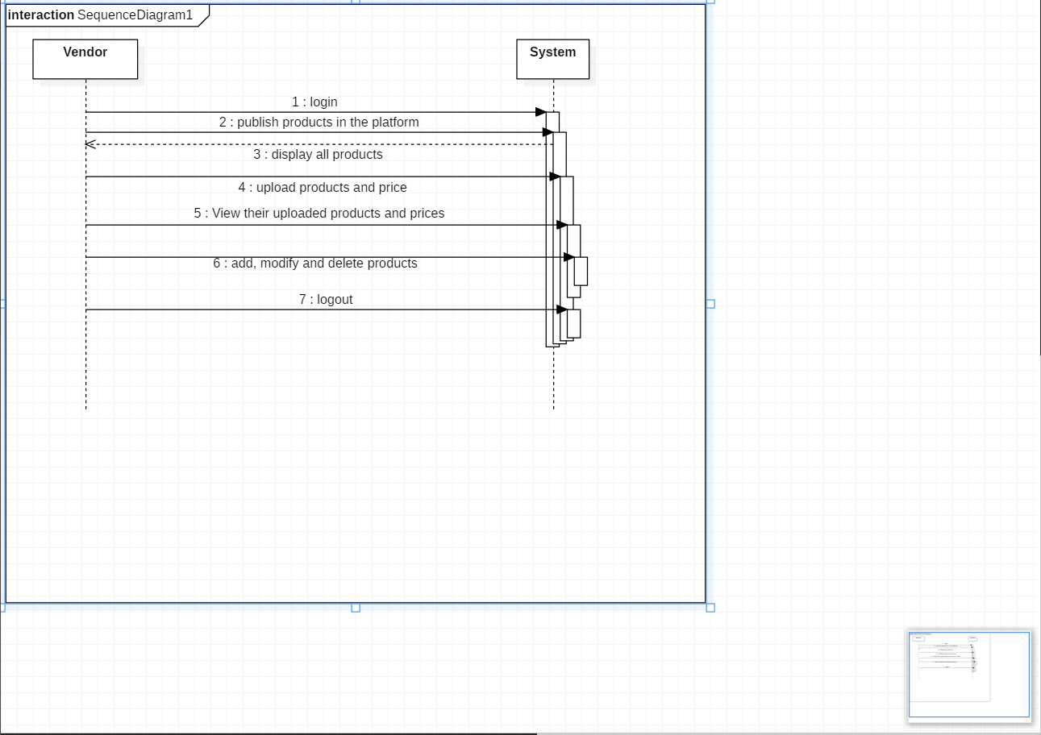

B-Description

In this part the vendor must first login the software, then he will have the possibility to upload and view the products. There after he will also have the possibility to publish, add, modify and delete the products and price uploaded.

1. Class diagram
2. Presentation

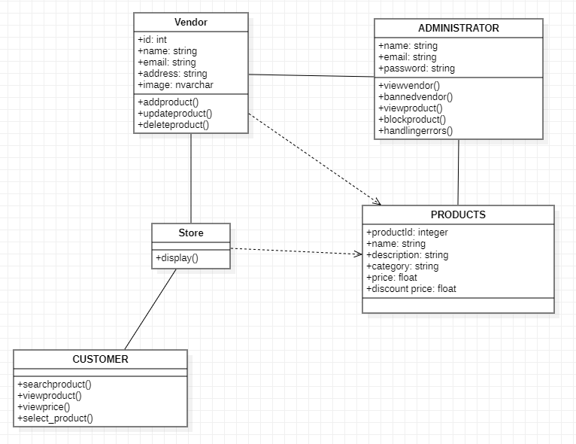

1. Description

A class diagram is a type of UML diagram that represents a system’s classes, interfaces, and their relationships. It is a static view of the system that shows the structure and behavior of objects in a system.

In our system, we have 5 classes, having an association relationship apart for vendor- product and store-product which is a dependency because vendor and store depend on product to exist.

* Customer: in our application, the customer is considered as a guest user because he doesn’t create an account and can freely use the application to look for a product.
* Vendor: he is the one in charge of posting the product and price, he needs to sign in to be able to create, add, update or delete product and price
* Admin: he is in charge of the management system of the application. He supervises all the action done by vendor (validating registration, checking the conformity of a product and the vendor account)
* Products: they are all the articles sold by a vendor
* Store: this is the collection of all the products of a vendor. It

1. Activity diagram
2. Presentation

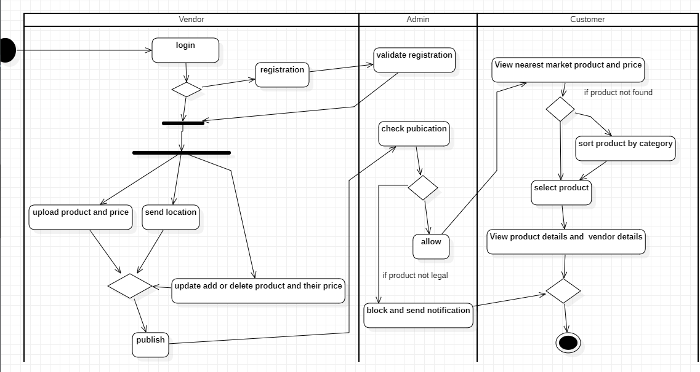

1. Description

Activity diagrams are part of the Unified Modeling Language (UML) and are used to model the flow of activity or dynamic behavior of a system or process. The purpose of an activity diagram is to model the steps and flow of a business process or software application

On the above diagram we can see how our actors interact in the system.