

**Mobiliya Fleet Management**

**Power BI Deployment - Version 1.1.0**

May 2018

Table of Contents

1. About this Guide 3

2. Intended Audience 3

3. Pre-requisites 3

4. Setup 3

a. Software Setup 3

5. Register with the Power BI App Registration Tool 3

6. Apply Permissions to your application within Azure AD 6

7. Publish Power BI Report 8

8. Retrieve Report ID of the published report 11

9. Schedule Refresh 12

# About this Guide

This guide is an admin guide for Fleet Management solution provided by Mobiliya. This will walk the user through the usage instructions required for deploying Power BI report.

# Intended Audience

This guide is intended for admin responsible for deploying Power BI.

# Pre-requisites

* + 1. Credentials for signing in to <https://app.powerbi.com>
    2. You need Microsoft Azure account. You need to have resources deployed using ARM template(as mentioned in Deployment document <https://github.com/MobiliyaTechnologies/MobiliyaFleetARMTemplate.git>).
    3. Power BI Template file.  
       To get powerbi template files, you need to clone git repository *MobiliyaFleetPowerBI.* (<https://github.com/MobiliyaTechnologies/MobiliyaFleetPowerBI>).Once cloned, you will get powerbi template files(.pbit) in *Templates* folder.

# Setup

## Software Setup

1. Power BI Desktop should be installed.

# Register with the Power BI App Registration Tool

You need to register your web application in Azure Active Directory to establish an identity for your application and specify permissions to Power BI REST resources. Following are the steps to register the application:

* 1. Go to <https://dev.powerbi.com/apps>
  2. Select Sign in with your existing account and use your Power BI Credentials  
     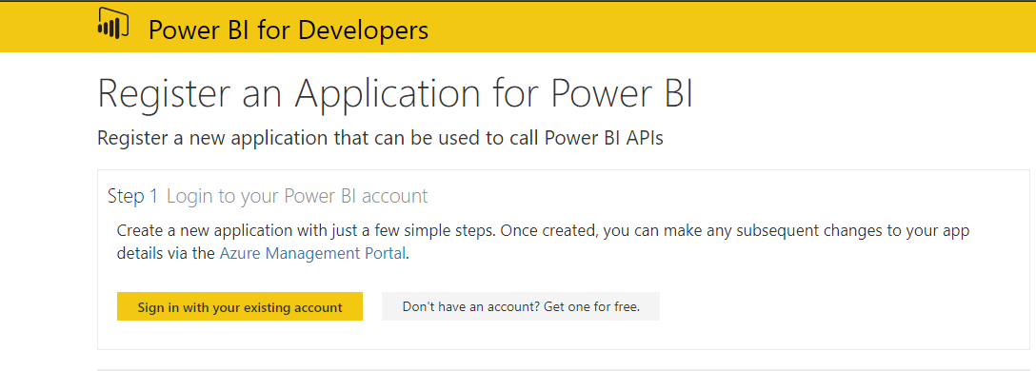
  3. Provide an App Name  
     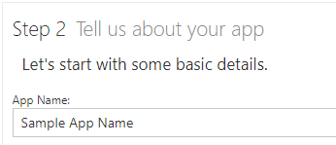
  4. Choose app type as Server-side Web app  
     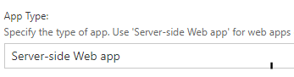
  5. Enter Redirect URL(You can use accelerator portal URL).   
     Example: <http://localhost:13526/>.  
     You can get accelerator portal service URL using azure portal (<https://portal.azure.com>).  
     Open portal in browser and go to  
     <Resource-group-name> -> < accelerator-portal-service-name> -> Overview-> Web App URL

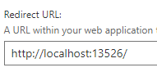

* 1. Enter HomePage URL(You can use accelerator portal URL).   
     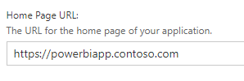
  2. Choose all the APIs and select Register App  
     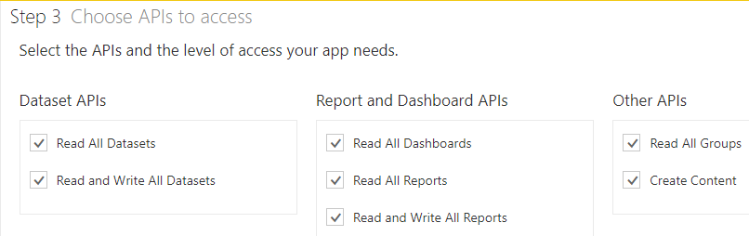
  3. Keep the generated Client ID and Client Secret safe as it is required in further steps.  
     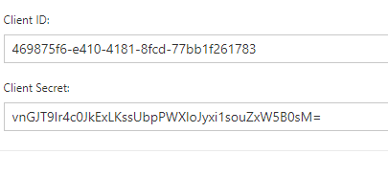  
      **Note:** You need to update *Client ID* and *Client Secret* in *fleet service.*(Refer below)
     1. Open <https://portal.azure.com> in browser.
     2. Navigate to <Resource-group-name> -> <Fleet-service-name>
     3. Update necessary fields in Application Settings(Left Panel) as shown below: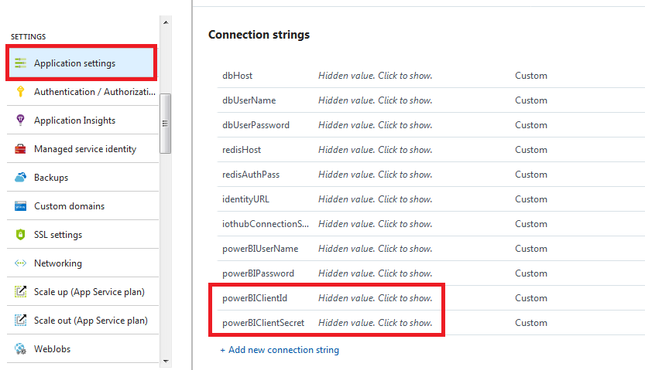

# Apply Permissions to your application within Azure AD

* 1. Go to <https://portal.azure.com> and sign in with your azure portal (the one where you are creating resources like web apps, database servers etc) credentials used to register the web app in previous step.  
     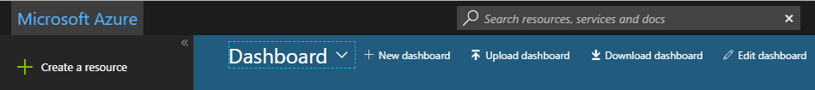
  2. Go to **Active Directory** and browse to **App registrations**, choose **All Apps** and search for the app created in Step 5.  
     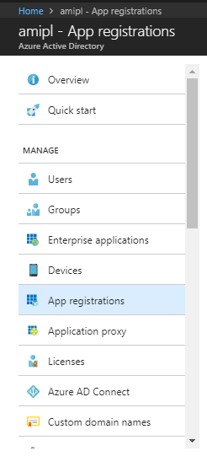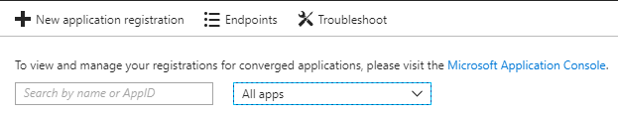
  3. Select the App, click on **Settings** and click on **Required Permissions** under **API Access**.  
       
     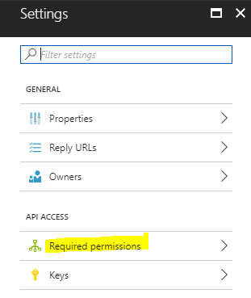
  4. Select **Windows Azure Active Directory** and then make sure **Access the directory as the signed-in user** is selected. Select **Save.**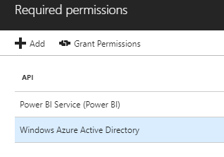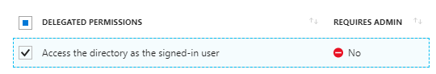
  5. Within **Required permissions**, select **Power BI Service (Power BI)**.  
     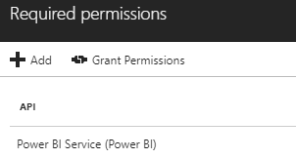
  6. Select required permissions under **Delegated Permissions**. Please **unselect** permissions that requires **admin access** if you are not admin. Select **Save** when done.  
     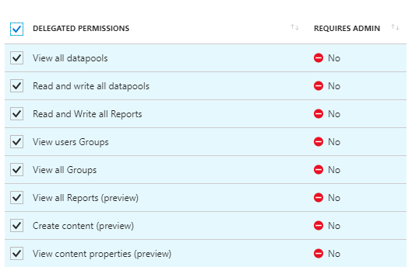
  7. Within **Required permissions**, select **Grant Permissions**.  
     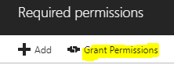

# Publish Power BI Report

Go to the folder you have cloned in prerequisites.  
MobiliyaFleetPowerBI-> Templates

* 1. Open the Power BI template file.
  2. Enter details to connect back-end with the report and click on **Load**.  
     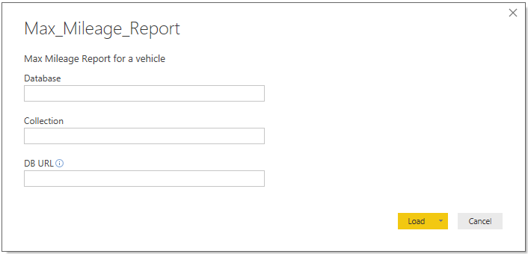

**Note:**Database name is of format ‘**trip_<your_tenant_id>_db**’.  
For database name, please visit <https://portal.azure.com>. Move to <Resource-group-name> -> <cosmosdb-name> -> Overview.   
Copy database name having prefix “**trip**” as shown below.  
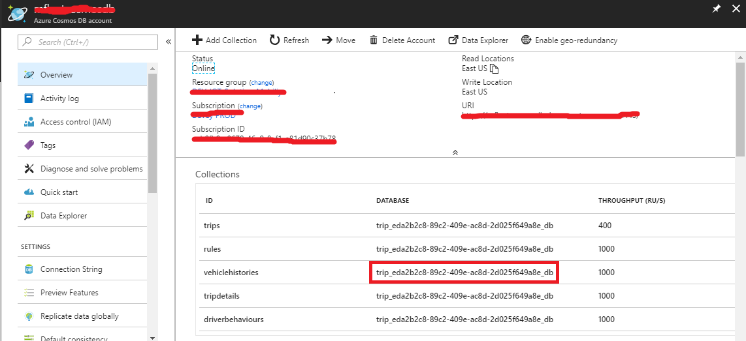  
Collection name can be one of the following based on what reports you are generating:   
**Note**: Collection may not exists, if data is not recorded/inserted into it. You can skip that report till some data is recorded. (To insert/record data you need to use Android application as mentioned in Userguide)  
i. faultdatas (For *fault_codes* report)  
ii. vehiclehistories (for all reports except *fault_codes* and *Dashboard_Inventory_Report* )  
DB URL : you can retrieve cosmosdb URL from portal. Visit <https://portal.azure.com>  
Go to <Resource-group> -> <cosmosdb-account-name>. (Refer below image)

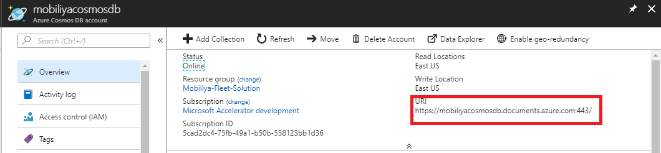

You can then copy *PRIMARY PASSWORD* from *Connection Strings* and use it as “**Account key**” in below steps. (refer image)



* 1. You will be prompted for **Account Key** of **Cosmos DB**, enter the key and click on **Connect**.  
     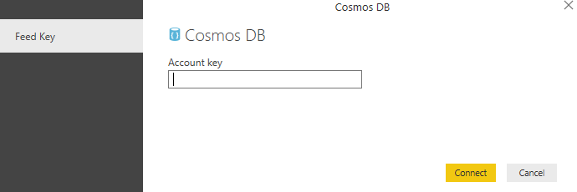  
       
     **Note** : For *Dashboard_Inventory_Report.pbit* file, you need to follow same steps to retrieve *DB URL*, *Database Name* and *Account Key* for sql server (<resource-group-name>-> <sql-server-name> -> <database-name-other-than-identitydb>) as below.   
     Server name will be db url.  
      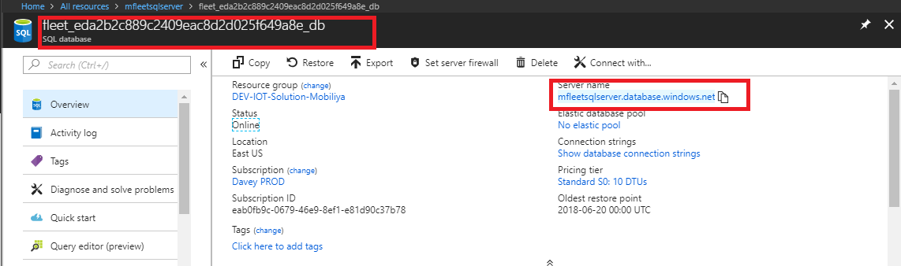

In next step, you have been prompted to enter credentials, Select 2nd Tab **“Database”** and enter your sql credentials. And load the data.

* 1. After the data has loaded successfully, click on File > Save and give any name to the file.
  2. Now click on **Publish**. You will be prompted to enter the Power Bi account credentials. Enter the same and choose a workspace where you want the report to be. Default is **My Workspace** if you have not created any.  
     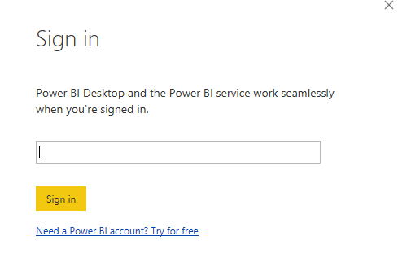

# Retrieve Report ID of the published report

* 1. Go to <https://app.powerbi.com> and sign in using your credentials.
  2. Go to reports section and open the report which was published in Step 7.
  3. Note down the Report ID shown in the browser URL window. Report ID starts after **../reports/** and before **/ReportSection**  
     

Eg report id in above url is ***19fea1c9-a304-4ba9-9491-8acff5097794***

* 1. Final URL which is used to **embed** the report has the following structure:  
     [https://app.powerbi.com/reportEmbed?reportId=<](https://app.powerbi.com/reportEmbed?reportId=19fea1c9-a304-4ba9-9491-8acff5097794)Your Report ID>

**Note:** You have to insert the report Id generated in above step in SQL Database(Detailed steps mentioned in document *Mobiliya_Fleet_Management_DeploymentGuide.pdf* *step 7.2. PowerBI Reports*)

# Schedule Refresh

To get to the schedule refresh screen, you can do the following.

* 1. Log in to <https://app.powerbi.com>
  2. Select the ellipsis (...) next to a dataset listed under Datasets.
  3. Select Schedule Refresh.   
       
     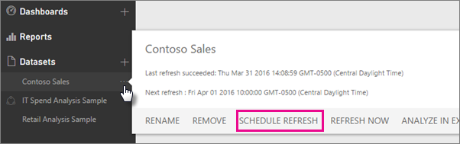
  4. Choose the schedule as per the requirement.  
       
     **Note:** Data in report is updated every 3 Hours at minimum.