

**Security & Surveillance**

**Power BI Deployment - Version 1.1.0**

April 2018

Table of Contents

1. About this Guide 3

2. Intended Audience 3

3. Pre-requisites 3

4. Setup 3

a. Software Setup 3

5. Register with the Power BI App Registration Tool 3

6. Apply Permissions to your application within Azure AD 5

7. Publish Power BI Report 8

8. Retrieve Report ID of the published report 9

9. Schedule Refresh 9

# About this Guide

This guide is an admin guide for Security & Surveillance solution provided by Mobiliya. This will walk the user through the usage instructions required for deploying Power BI report.

# Intended Audience

This guide is intended for admin responsible for deploying Power BI.

# Pre-requisites

* + 1. Credentials for signing in to <https://app.powerbi.com>
    2. Power Bi Desktop (Latest Version)
    3. Power BI Template file.

# Setup

## Software Setup

1. Power BI Desktop should be installed.

# Register with the Power BI App Registration Tool

You need to register your web application in Azure Active Directory to establish an identity for your application and specify permissions to Power BI REST resources. Following are the steps to register the application:

* 1. Go to <https://dev.powerbi.com/apps>
  2. Select Sign in with your existing account and use your Power BI Credentials  
     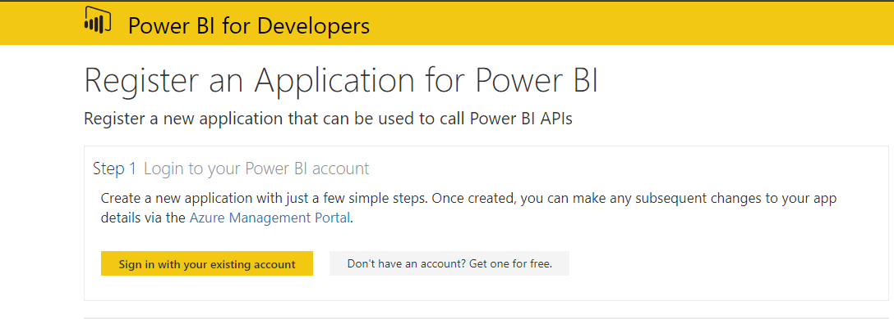
  3. Provide an App Name  
     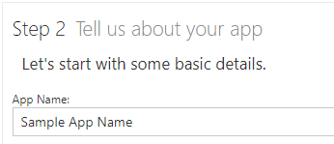
  4. Choose app type as Server-side Web app  
     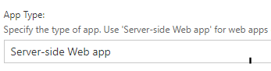
  5. Enter Redirect URL. Example: <http://localhost:13526/>   
     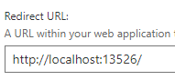
  6. Enter HomePage URL. Example: <https://powerbiapp.contoso.com>  
     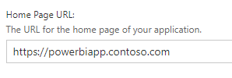
  7. Choose all the APIs and select Register App  
     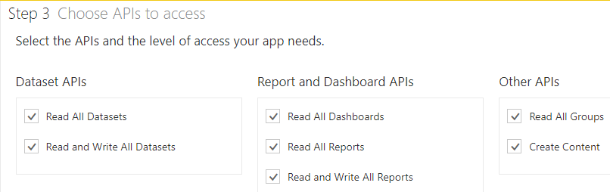
  8. Keep the generated Client ID and Client Secret safe as it is required in further steps.  
     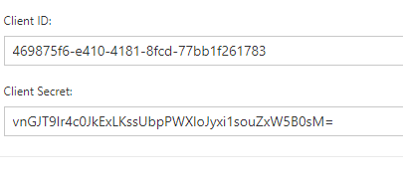

# Apply Permissions to your application within Azure AD

* 1. Go to <https://portal.azure.com> and sign in with same credentials used to register the web app in previous step.  
     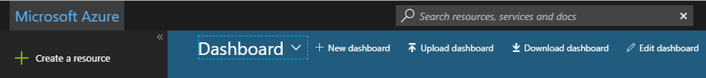
  2. Go to **Active Directory** and browse to **App registrations**, choose **All Apps** and search for the app created in Step 5.  
     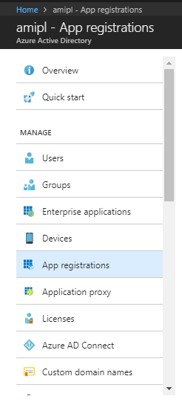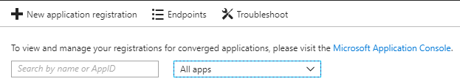
  3. Select the App, click on **Settings** and click on **Required Permissions** under **API Access**.  
     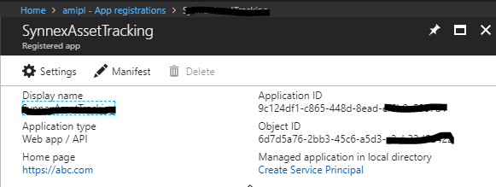  
     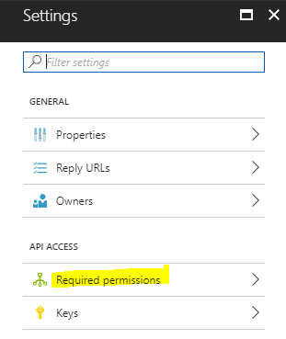
  4. Select **Windows Azure Active Directory** and then make sure **Access the directory as the signed-in user** is selected. Select **Save.**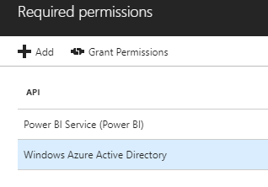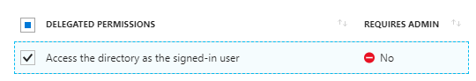
  5. Within **Required permissions**, select **Power BI Service (Power BI)**.  
     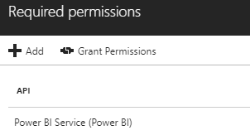
  6. Select all permissions under **Delegated Permissions**. Select **Save** when done.  
     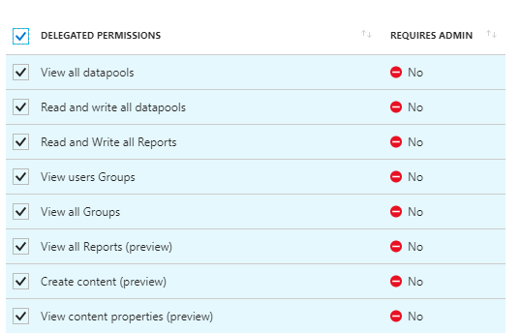
  7. Within **Required permissions**, select **Grant Permissions**.  
     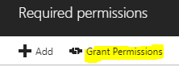

# Publish Power BI Report

* 1. Open the Power BI template file.
  2. Enter details to connect back-end with the report and click on **Load**.  
     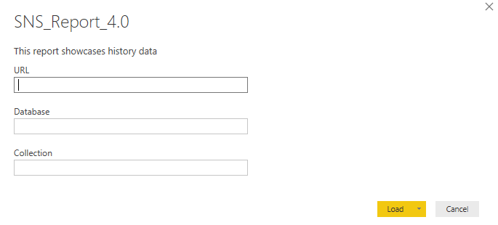
  3. You will be prompted for **Account Key** of **Cosmos DB**, enter the key and click on **Connect**.  
     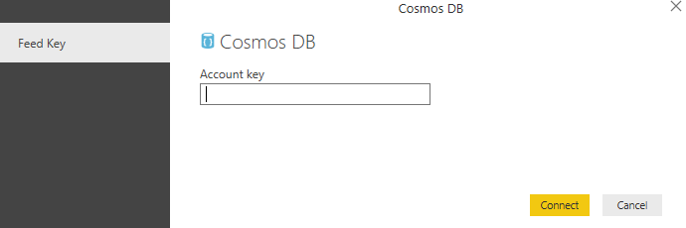
  4. After the data has loaded successfully, click on File > Save and give any name to the file.
  5. Now click on **Publish**. You will be prompted to enter the Power Bi account credentials. Enter the same and choose a workspace where you want the report to be. Default is **My Workspace** if you have not created any.  
     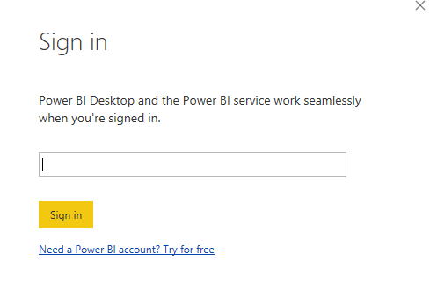

# Retrieve Report ID of the published report

* 1. Go to <https://app.powerbi.com> and sign in using your credentials.
  2. Go to reports section and open the report which was published in Step 7.
  3. Note down the Report ID shown in the browser URL window. Report ID starts after **../reports/** and before **/ReportSection**  
     
  4. Final URL which is used to **embed** the report has the following structure:  
     [https://app.powerbi.com/reportEmbed?reportId=<](https://app.powerbi.com/reportEmbed?reportId=19fea1c9-a304-4ba9-9491-8acff5097794)Your Report ID>

# Schedule Refresh

To get to the schedule refresh screen, you can do the following.

* 1. Log in to <https://app.powerbi.com>
  2. Select the ellipsis (...) next to a dataset listed under Datasets.
  3. Select Schedule Refresh.   
       
     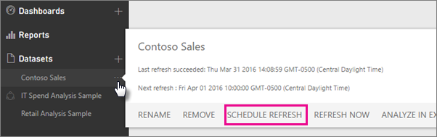
  4. Choose the schedule as per the requirement.  
       
     **Note:** Data in report is updated every 3 Hours at minimum.