**Congratulations!**

You have won free copy of e-book Android High Performance Programming by Enrique Lopez Manas a Mobilization speaker!



Discount code is

**AHPP100**

Please go to Packt Publishing website to claim it!

<http://bit.ly/mobilization6-ahp>

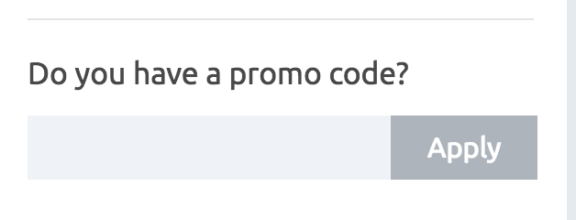

**Congratulations!**

You have won free copy of e-book

Reactive Programming with Swift



Discount code is

**RPWSE100**

Please go to Packt Publishing website to claim it!

<http://bit.ly/mobilization6-rps>

