1. Purpose
The purpose of this document is to describe standard operating procedure for aggregating products from the input sources provided by customer. All attempts have been made in using mostly business terminology and business language while describing the requirements in this document. The main intended audience for this document is the business owners of the project. This document should be readable by business owners of the project. They must be able to verify that their business rules have been documented here completely, accurately and unambiguously.

Scope
To automate the detection of anomalies in Product Online Price feature across different Combined-Input Id in the Frigginyeah Daily dump.

Procedure
Two major processes involved in the anomaly detection model.
- Train the model and save the Price properties of each Combined-Input Id using latest 3 months data
- Test the daily input data using the trained model parameters and upload the output.

Process Flow chart:

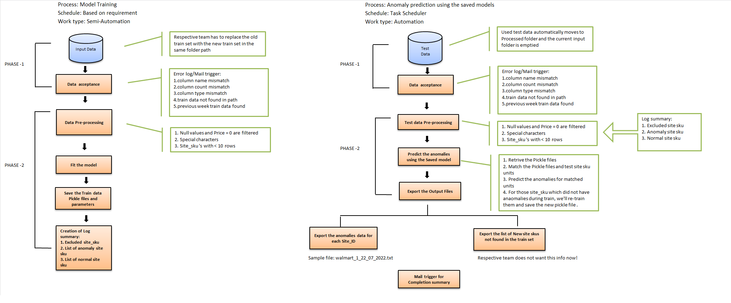

Training:

Train Input:

Mobius expects the pull the train data from the below given path found in
Server: 72.55.168.6
Train data path: /Frigginyeah_Daily/Script_Input/ML_input/3_months_data
The train input includes all the below entities data.

- Amazon.com
- Walmart.com
- Wayfair.com
- Overstock.com
- Homedepot.com
- Staples.com
- Officedepot.com

Train data format:

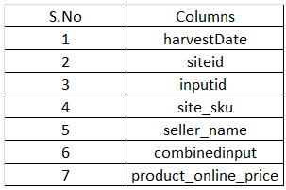

Data acceptance check:

The Train data is passed through Data acceptance. Below are list of items checked before proceeding to the next step.
- Data type and name of the columns
- Availability of data in each column
- Availability of any irrelevant columns or absence of required columns

The verified train input is then analyzed to get an overview about the data. An overview of the recent train set is pasted below.

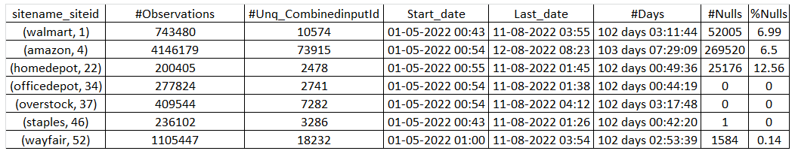

The below table gives an overview of number of Combined-input Id under each siteid with different Observations bins.

Example: Under Site- Walmart, there are 1710 Combined-input Id with only 1 observation.

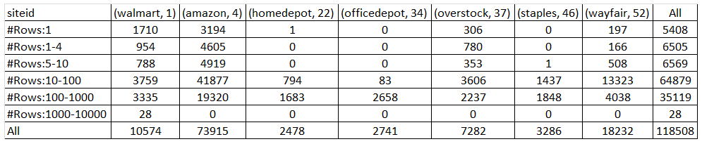

Data Pre-processing:

The below items are excluded from the train input.
- Special characters in the input
- The missing values under Product Online Price and Combined input columns
- Zeros in the Product online price
- The combined-input Id with less than 5 observations
These observations are maintained in a log summary. The below path contains all the excluded items.
Server name: 3.111.139.210
Path: C:\FTP\Data-Analytics\Anomaly\Train_summary

Model:

The edited Train input is then used for Anomaly detection model, the Pickle files and the Train input parameters are saved in the given path.
Server name: 3.111.139.210
Path: C:\FTP\Data-Analytics\Anomaly\Pickle_files
Path: C:\FTP\Data-Analytics\Anomaly\Train_data_properties

An additional column ‘Anomaly_tag’ which classifies the Product online price column as Normal and Anomaly is added to the train input and this consolidated file is saved in the given path.
Server name: 3.111.139.210
Path: C:\FTP\Data-Analytics\Anomaly\Train_Anomaly

The Summary report is maintained in the below given format and this is given to the concern team to get the feedback of the model.

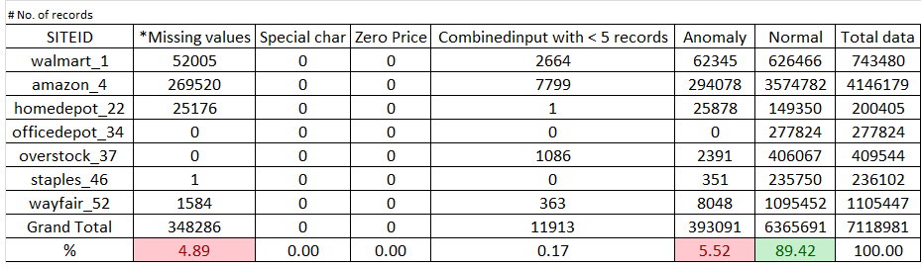

Testing:

The below listed entire testing process is automated and executed using Windows Task Scheduler. The task scheduler runs for every 15 minutes and on all weekdays.

Daily Input:

Mobius expects the pull the daily test input from the below given path found in
Server: 72.55.168.6
Train data path /Frigginyeah_Daily/Script_Input/ML_Input/Daily_Input
The daily test input includes all the below entities data.
- Amazon.com
- Walmart.com
- Wayfair.com
- Overstock.com
- Homedepot.com;
- Staples.com
- Officedepot.com

Daily Input format:



Data acceptance check:

The daily input data is passed through Data acceptance. Below are list of items checked before proceeding to the next step.
- Data type and name of the columns
- Presence of data in each column
- Presence of any irrelevant columns or absence of required columns
- Current date file or not
- Empty file or not

The verified daily input is then analyzed to get an overview about the data.

Data Pre-processing:

The below items are excluded from the daily input.
- Special characters in the input
- The missing values under Product Online Price and Combined input columns
- Zeros in the Product online price
These observations are maintained in a log summary. The missing values and Zeros in Product online price column are considered as anomalies. These records are tagged as Anomalies, appended to the final Anomalies output.

Model:

The edited daily input is then passed to the saved model. The model is executed to run in loops for all unique Combined-input Id and predicts the anomalies based on the Train data parameters.
An additional column ‘Anomaly_tag’ which classifies the Product online price column as Normal and Anomaly is added to the daily input data.
Along with this Missing values and Zeros in Product Online Price is tagged as anomalies and appended to final Output table.

Output:

The anomaly output file is uploaded to the Output path with below mentioned columns and in ‘.txt’ format.
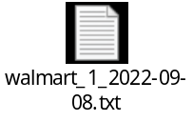

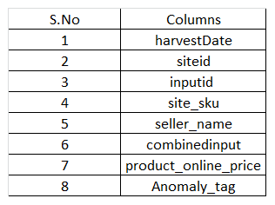

FTP Upload and FTP Mover:

The Anomaly output file is generated and uploaded to the below given path.
Server: 72.55.168.6
Path: /Frigginyeah_Daily/Scraped_Output/Anomaly_output/Dump

The processed daily input data is archived to the new folder and existing folder is kept empty untill the new data arrives.
Server: 72.55.168.6
Path: /Frigginyeah_Daily/Script_Input/ML_input/ML_Archive

Anomaly Model Performance overview:

Iteration 1:
- The 3 months train input was trained using the COPOD Model. The model requires contamination score (Outlier percentage) for each Combined-input Id.
- Using loop function the outlier fraction for each Combined-input Id was calculated and used in the model. The model performed good on train input.
- The model efficiency is checked manually and the >90% accuracy was achieved.
- However, this model failed to perform better on the Daily input data due to insuffient records under each Combined Input ID.

Iteration 2:

- For the second iteration Classification task was performed.
- For this a sample of 1000 Combined Input Id from all site ID was taken
- Using Statistical approach (Inter-Quartile Range) the train data was manually tagged as normal and anomaly.
- The train data with labels was used to build a Classification model using Random Forest Classifier.
- The classification model was built for each and every Combined Input.

Challenges:

- Target class imbalance under each Combined Input ID
- Encountered more False predictions
- High Computation time and memory - Frigginyeah_dump has almost 1 lakh Combined Input

Iteration 3:

- For the third iteration the Combined Input Id in the train data was Label Encoded.
- For this a sample of 30k Combined Input Id was taken
- The Label encoded data is later fitted to DB-Scan ML Model

Challenges:
- Model throwed memory error while training.
- A sub-sample of data was taken from the sample data and executed same procedure.
- However, predictions were not correct.

Iteration 4:

- For the fourth iteration DBSCAN model for executed in a loop for each Combined Input ID
- For this a sample of 1000 Combined Input Id from all site ID was taken

Challenges:
- Encountered false predictions
- Mobius expects to identify extreme anomalies in the price that are found outside the normal range.
- But the output from this iteration identified least frequent prices as anomalies even though found within the normal range.

Iteration 5:

- For Fifth iteration full set of train data was taken
- Median based Anomaly detection approach was performed.
- The lower threshold and the upper threshold for each Combined Input ID was captured saved.
- The test data was predicted using the train data parameters that is already saved.
- The evaluation was done manually and an accuracy of >95% was captured.
- The Frigginyeah anomaly detection is executed using this approach.
- Till date the day to day accuracy is >97%

Summary of Iterations:

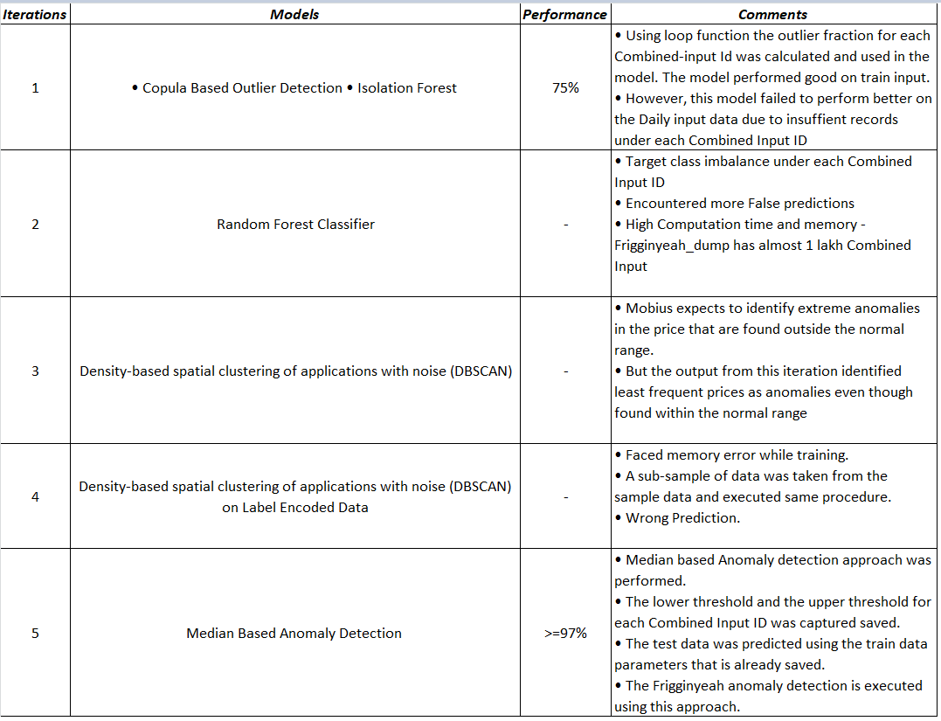

Maintenance Activity:

- Live monitoring of the Anomaly output and the Model performance in Power BI dashboard
- Updating the trained model based on the Feedback
- Using the revised parameters for daily input anomaly prediction

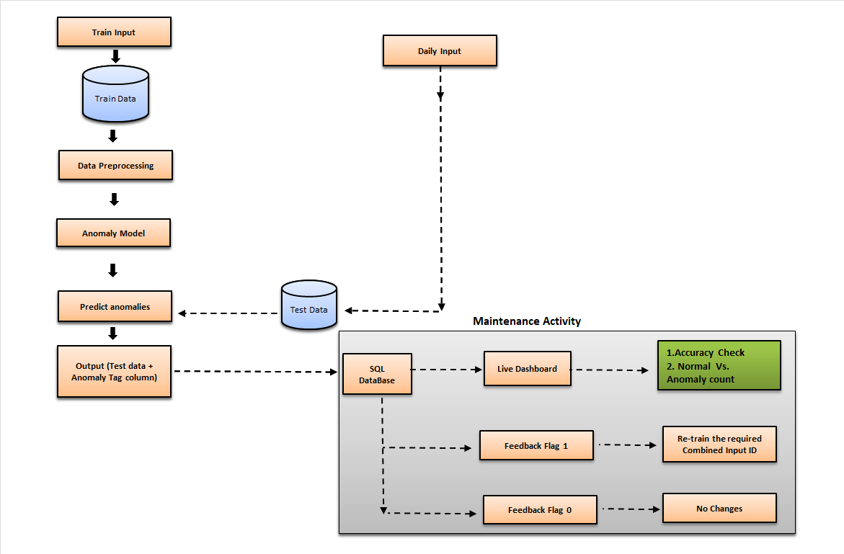

Live Dashboard:

- The anomaly output from the model is saved in SQL Database.
- Server: 72.55168.6 | Path:
- The mentioned table to used in Power BI using SQL Query - Direct Query mode.
- Use the below link to view the live dashboard

https://app.powerbi.com/view?r=eyJrIjoiZmY0OWNlOTgtNTQ4My00NjVmLThlODctZTcyNjYyY2UwN2ZiIiwidCI6ImY2ZDZjZDA0LWY1ZWEtNDhjMi05ZTYwLWU5OGZkYTFjMmQxNiJ9

Table Tbl_Anomaly from SQL Database format:

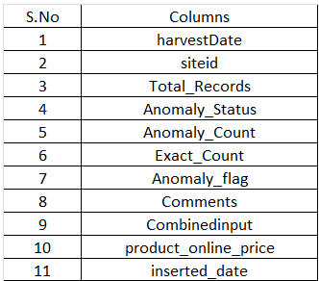

Feedback mechanism:

- The Tbl_Anomaly in the SQL Database contains Exact Anomaly count, Predicted Anomaly count and Anomaly Flag
- Accuracy of the model is arrived at by using the below calculations:

- If the Anomaly Flag is zero no need to make changes in the model paramters.
- If the Anomaly Flag is one for any of the Combined Input ID, the model re-trains that particular combined Input and appends it to the original trained models automatically.

Error and Mail alert:

Errors are captured at every stage and a mail alert system is created to send Critical mails to the respective persons. Below are mail Ids that will receive Critical and Process completion mails from "daalerts@mobiusservices.com"

- "eshwarraj.vimalraj@mobiusservices.com",
- "mariajasmine.francisxavier@mobiusservices.com",
- "surender.elangovan@mobiusservices.in",
- "bharani.govindharaj@mobiusservices.com",
- "eshwarraj.vimalraj@mobiusservices.com",
- "frigginyeahsupport@mobiusservices.com"

Challenges faced:
- A dataset with two or more categories can be trained using Classification ML Models. However, Frigginyeah data had >1 lakh Combined_Input ID.
- Executed multi-processing for all IDs using loop function.
- Availability of only Univariate data (Product Online Price) for the analysis. No other supporting predictors.

References:
- https://blog.floydhub.com/introduction-to-anomaly-detection-in-python/
- https://towardsdatascience.com/introduction-to-anomaly-detection-in-python-with-pycaret-
- 2fecd7144f87
- https://towardsdatascience.com/anomaly-detection-with-isolation-forest-visualization-23cd75c281e2
- https://www.infoq.com/articles/fraud-detection-random-forest/

- https://www.analyticsvidhya.com/blog/2021/12/anomaly-detection-model-using-facebook-prophet/
- https://analyticsindiamag.com/a-hands-on-guide-to-anomaly-detection-in-time-series-using-adtk/
- https://pyod.readthedocs.io/en/latest/pyod.models.html

Glossary:
- Combined_Input ID: Combined name which includes InputId, Seller name and Site Sku

- COPOD: Copula-Based Outlier Detection — COPOD — is a new algorithm for anomaly detection. It has been implemented in the PyOD python package.
Reference: https://towardsdatascience.com/fast-accurate-anomaly-detection-based-on-copulas-
copod-3133ce9041fa

- DBSCAN: It can identify clusters in large spatial datasets by looking at the local density of the data points.
Reference: https://medium.com/@dilip.voleti/dbscan-algorithm-for-fraud-detection-outlier-
detection-in-a-data-set-60a10ad06ea8

- Label Encoding: Label Encoding refers to converting the labels into a numeric form so as to convert them into the machine-readable form

- Random Forest Classifier: Random forest, like its name implies, consists of a large number of individual decision trees that operate as an ensemble. Each individual tree in the random forest spits out a class prediction and the class with the most votes becomes our model's prediction

- Isolation Forest: The Isolation Forest algorithm is a fast tree-based algorithm for anomaly detection. The algorithm uses the concept of path lengths in binary search trees to assign anomaly scores to each point in a dataset
Reference: https://www.analyticsvidhya.com/blog/2021/07/anomaly-detection-using-isolation-
forest-a-complete-guide/
- Median: The median is the value separating the higher half from the lower half of a data sample, a population. The median more accurately describes data with an outlier

7. Revision History
S. No | Details of Revision | Rev. No. | Date | Revised by | Approved By | Approved Date
1 | Initial draft | 00 | 08-09-2022 | Maria | Eshwaraj
2 |  | 01
3 |  | 02
4 |  | 03

