1. Purpose
The purpose of this document is to describe standard operating procedure for aggregating products from the input sources provided by customer. All attempts have been made in using mostly business terminology and business language while describing the requirements in this document. The main intended audience for this document is the business owners of the project. This document should be readable by business owners of the project. They must be able to verify that their business rules have been documented here completely, accurately and unambiguously.

Scope
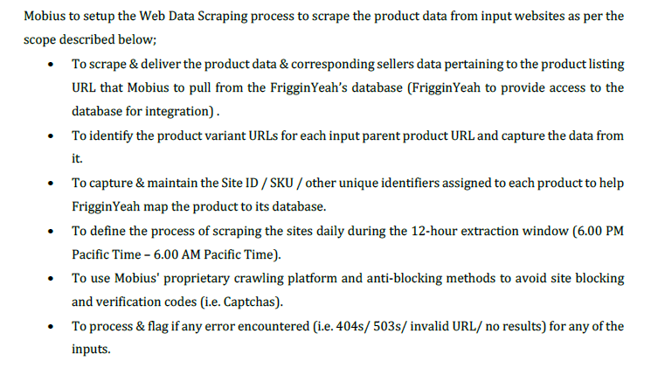

Procedure
Input

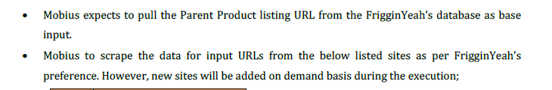

- Amazon.com;
- Walmart.com;
- Wayfair.com;
- Overstock.com;
- Homedepot.com;
- Staples.com;
- Officedepot.com.

Steps

- Open input URLs
- Collect the respective detail page product information from the websites.
- Deliver the output via DB.

Output

Mobius shall aggregate the following data points from the given website.

S. No | Data Points | S. No | Data Points
1 | inputId | 16 | product_shipping_cost
2 | SiteName | 17 | product_size
3 | seller_name | 18 | product_inStock_Flag
4 | brand | 19 | product_review_count
5 | manufacturer_sku | 20 | product_rating
6 | site_sku | 21 | product_image_count
7 | extracted_upc | 22 | product_description
8 | product_online_price | 23 | customerId
9 | product_list_price | 24 | product_buyBox
10 | product_sales_price | 25 | product_prime
11 | product_color | 26 | product_fulfillment
12 | is_collection | 27 | seller_url
13 | product_name | 28 | sellerId
14 | product_DetailUrl | 29 | error_message
15 | harvestDate

3.1 Escalation Matrix (SPOC)
Escalation Matrix details are available in SVN in the following path:

http://svn.mobiusservices.co.in/software/Crawl Projects/Frigginyeah/Data_Services

3.2 Sample Output (POC – Paid/Unpaid)
Paid POC was done for this project for all 5 sources & same got into LIVE work with additional 2 sources for implementation.

3.3 Project Duration
Contract duration of the project is from 04th October 2021 & it remains active until 03rd October 2022.

3.4 Effort Estimation
Input Analysis:

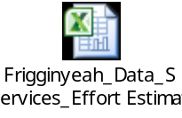

Resource Plan:

Resource Plan details are available in SVN in the following path:

http://13.126.60.33/software/Project Management/Document/Auding_Docs

Delivery Plan:

Setup completed for 7 sources & currently refresh output is delivered on a daily basis.

3.5 Roles and Responsibilities

Roles & Responsibilities details are available in SVN in the following path:

http://svn.mobiusservices.co.in/software/Crawl Projects/Frigginyeah/Data_Services

3.6 RBACL (Role Based Access Control List)
RBACL access is via SVN from the following link - http://13.126.60.33/software/Project Management/Document/Auding_Docs

3.7 Risk Assessment
Risk Assessment path - http://13.126.60.33/software/Project Management/Document/Auding_Docs

Risk assessment meeting is held on a weekly basis by DA leads in a joint meet along with pipeline projects discussion.

3.8 Process Work Flow /steps

Input

Site Analysis + Spec Creation

Crawler
Development

Sample Output
No
No

Internal Sign-off

Yes

Data Acquisition
No
No
Quality & Coverage >=SLA%

QC & QA
Yes
No
Output Delivery
No
No
Accuracy >=98% & Coverage >=100 %.

“QC & QA – QC & QA are two stages followed for doing output validation.

QC is done by Business Analyst within DA to find errors if any. Once QC user is satisfied with output – the same is shared to PEG user who acts as a QA here & validates output based on accuracy & coverage mentioned – depending on validation – observations & recommendations along with validation report is shared. Both of them does task for validating output & hence have mentioned in single stage in process flow.

3.9 Output Format
Mobius will deliver the output via DB as client’s schema.

3.10 Metrics (People/Process)
Process Metrics

Mobius will provide the output with an accuracy of 98% & coverage of 100 % .

Criteria | SLA
Quality | >=98%
Coverage | >=100%
People Metrics

People Metrics are available in SVN in the following path:

http://13.126.60.33/software/Project Management/Document/Auding_Docs

3.11 Quality Methodology
PEG Engagement document is available in the following path:

\\10.101.11.13\PEG-BT-File Sharing\Data & Analytics

3.12 SLA/Penalty, if any

Accuracy >= 98% ; Coverage >=100 %

Penalty – NA- As not mentioned in SOW.

3.13 Acceptance criteria

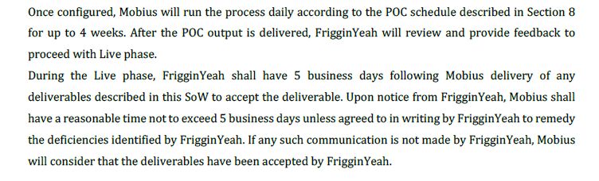

3.14 Deliverable:

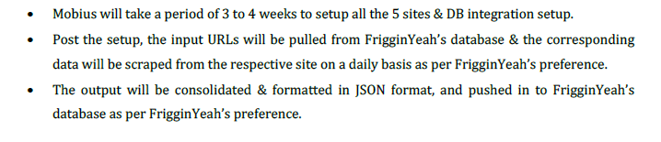

3.15 Deployment procedure

- Once the scripts are developed – baseline output will be validated internally ;
- Upon feedback – tweaking will be done in script – if any & revised output will be shared;
- Until the revised output is good – iterations will flow internally & send it to PEG for certification;
- If there is feedback – the same will be addressed & shared to customer after PEG re-signs the same;
- The final version of bot is now scheduled in server to initiate crawl ;
- If there is more than one bot – the same will be scheduled using task manager giving necessary credentials;
- In this way bot is deployed in server to initiate crawl.

3.16 Configuration Management Procedure

Bots & Artifacts are configured using SVN configuration (Sub-Version Repository).

3.16.1 Change Management

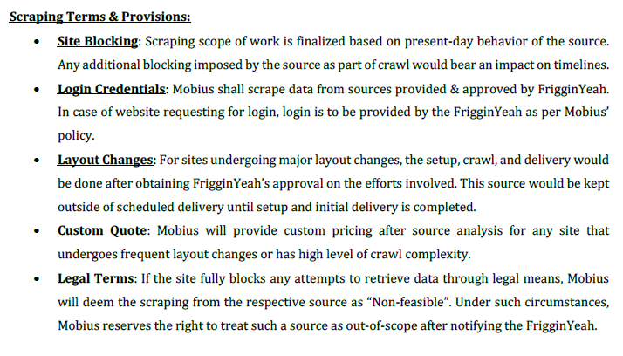

3.16.2 Version Management

SVN will be used to save the artifacts of this project.

Path - http://svn.mobiusservices.co.in/software/Crawl Projects/Frigginyeah/Data_Services

3.16.3 Backup/Recovery Procedure

Project Backup happens via SVN & backup procedure for same is Weekly by IT support

3.16.4 Data Retention and disposal

IT support will follow Retention policy as per Mobius norms once project gets inactive.
3.16.5 Project Status Reviews

Project status review happens on a fortnightly basis with senior Management, if it is active.

3.16.6 Cause Analysis Plan

Customer Feedback tracker available in the following path -- http://13.126.60.33/software/Project Management/Document/Auding_Docs

BCP (Business Continuity Plan) if applicable
BCP Details are available in below path :

http://svn.mobiusservices.co.in/software/Crawl Projects/Frigginyeah/Data_Services

3.18 Automation component & related scripts review procedure (automation component name, prepared by, reviewed by), if any

Script review document is placed in following path in SVN - http://13.126.60.33/software/Project Management/Document/Auding_Docs

3.19 Business dependency and constraints

- Site getting blocked may pose a threat in delivering output to customer ;
- Scheduled crawlers getting disrupted from server when doing crawl may delay output deliverable internally to support groups / externally.
- Site getting updated may pose delay in delivering output to customer.

3.20 CSAT Survey Frequency:
- CSAT would be managed at an account/customer engagement level rather than at project level.

4. Reference
Spec Details:

http://13.126.60.33/software/Crawl Projects/Frigginyeah/Project Management/Documents

SOW Details - http://13.126.60.33/software/Project Management/SOW_Contracts/Frigginyeah

Revision History
S. No | Details of Revision | Rev. No. | Date | Revised by | Approved By | Approved Date
1 | Initial Draft | 00 | 13-Jun-22 | Bharani G | Shankar | 13-Jun-22

