TP Dreem-ESPCI: data pre-processing

# Update for 2023

As I do not have the same access as before and because there is no ppg sensor, these signals will not be available this year:

* Heart rate
* Pulse Oximeter
* Hypnodensity

**You may have to update the TP manuscript.**

Directories where to find the scripts and data:

* Processing: ***Dropbox\Kteam\PrgMatlab\TP_Dreem_physio***
* TP: ***Dropbox\DataKJ\TP_Dreem_2023***

# Create/update the list of records

Here is what you see when in the DREEM portal

* **The first step** is to list all the nights (of a TP) in an excel file. One way to do it to select all the lines, copy and paste them in an excel files:

* In the ‘User’ column, you will note that the email/pseudo has been cropped during the paste operation. You may have to correct them manually (sorry…)
* Same thing for ‘Device’

Then you get an excel file like this:

* Among all these nights, some can be excluded (by removing them from the table or coloring the line in red) if they are not suitable for the TP because:
* Quality: among channel 1 and 2, no one is above 50 (it is up to you to choose the threshold, it corresponds to a percentage of the night of good quality)
* Duration: shorter than 3-4h (the same, it is up to you)
* Off Head: a too high percentage of Off head
* Cannot be downloaded: you cannot download it on the portal (this happens when the headband was not plugged in in the morning)
* …

Please find more information about quality metric: <https://support.dreem.com/hc/en-us/articles/360021347760-How-to-interpret-EEG-Channel-Quality-metrics>

* Save the file (it will be used in the following step, as *original_filename*)
* **When it is done**, you can use the script *FormatNuitsTableFile.m*
* Go inside the script and change the path for *original_filename* and *output_filename*
* Launch the script
* You will get your new Excel file, that you can name *nuits_tp_dreem.xlsx*

# Download and store the data

Today there is no way to download everything at once. This phase is therefore quite laborious and requires downloading, for each night, the recording (h5 file) and the hypnogram (txt file) and renaming them with the reference (Ref = 7-digit identifier).

I recommend renaming each file that is going to be downloaded before downloading it, otherwise it will be difficult to keep track of the portal's nomenclature. To do this, go to the settings (here are examples for Chrome and Edge):

* First, create a folder to store all the data (it will be input_folder)

Now, here are the steps to be taken **for each night**:

* Select a night and copy the Ref (below *2842381*)
* Download the h5, and name it *2842381* (or *2842381.h5* if you have to write the extension)
* Download the text hypnogram, and name it *2842381* (or *2842381.txt* if you have to write the extension)

Now, you should have all the data in your folder like this:

Once you have downloaded the data, you could eventually change the **Status** to “downloaded” in the excel file (*nuits_tp_dreem.xlsx*).

# Description of the MATLAB code

All the functions and scripts are in ***Dropbox\Kteam\PrgMatlab\TP_Dreem_physio***:

ProcessingTP_AllDreemRecords

The script you will use to process all the nights

FormatNuitsTableFile

The script you will use to format the Excel file

ParseHypnogramFromText

A function to process the hypnogram file (you normally do not have to use it, it is used inside ProcessingTP_AllDreemRecords)

GetRecordDreemTP

A function to load a DREEM record (used in the processing and during the TP)

# Run the processing script

Once the Excel file has been done and formatted (see previous steps), we can run the processing script ProcessingTP_AllDreemRecords:

* You will have to update the first lines with the path in your computer:

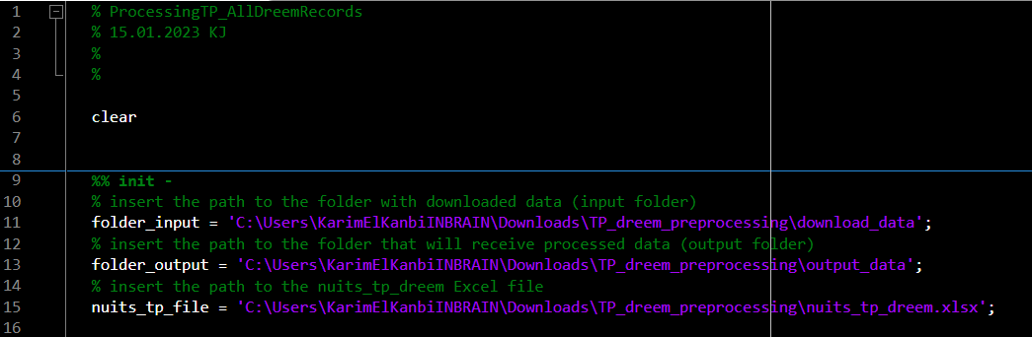

* *folder_input* is where you store the downloaded data
* *folder_ouput* is where you want to store the processed data
* *nuits_tp_file* is the path to the Excel file (should be the same as *output_file* in 3.)
* Then you can run this script and wait. Error message will appear if there is an error for a record.

NB: In case there is an error for a record that you cannot solve, you can just remove the night from the list and the student will work with another of his/her night.

# Test and TP preparation

At the end you may have to test that it works (maybe not on all nights).

For this you can use the correction: TP_Dreem_Sleep_CORRECTION

**Do not forget to remove the CORRECTION from the folder!!**

**Have fun!**