实验四：工厂模式

(1) 简单工厂方法（50分）
保险理赔包含几个基本类型：驾驶员身体受伤、汽车损坏、人员伤亡、多种事故。使用简单工厂方法模式设计并实现一个可以创建不同保险理赔对象的应用。具体界面要求如下。

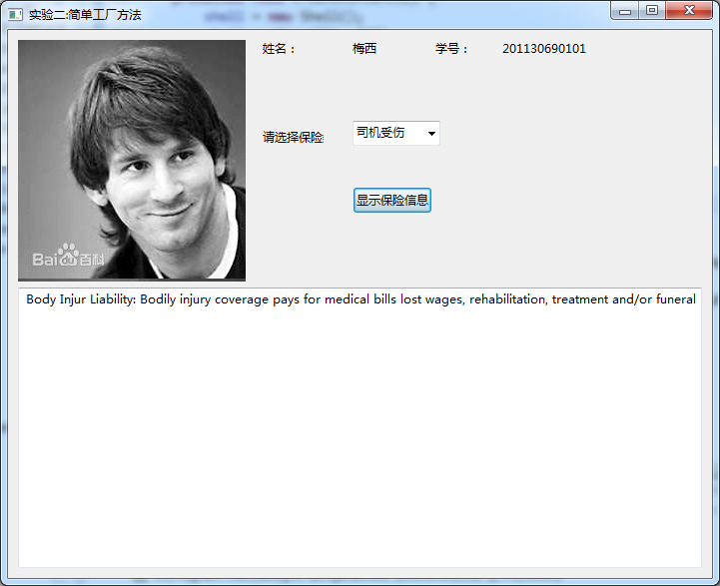
实验名称
本人的自拍照
姓名
学号

1.1 UML图

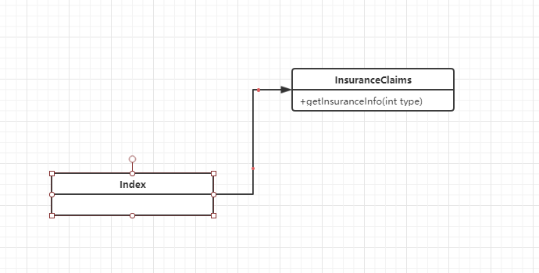

1.2 代码
// InsuranceClaims.java
package cn.edu.scau.cmi.mayiming.simpleFactoryMethod;

/**
* 根据保险理赔的类型返回相应的理赔信息 （简单工厂方法）
* @author cry
*
*/
public class InsuranceClaims {
public static String getInsuranceInfo (int type) {
switch (type) {
case 1: // 驾驶员身体受伤
return "这是一个身体受伤类型";
case 2: // 汽车损坏
return "这是一个汽车损坏类型.";
case 3: // 人员伤亡
return "这是一个人员伤亡类型";
case 4: // 多种事故
return "这是多种事故类型";
default:
return null;
}
}
}

// Index.java
public class Index extends Application {

private static String studentName = "马一鸣";
private static String studentId = "201627010418";
private static String[] insurancesType = {"-请选择-","驾驶员身体受伤", "汽车损坏", "人员伤亡", "多种事故"};

public static void main (String[] args) {
Application.launch(args);
}

@Override
public void start(Stage primaryStage) throws Exception {
// ---------------------上左--------------------------
String imgPath = System.getProperty("user.dir") + "/imgs/test.jpg";
InputStream is = new FileInputStream(new File(imgPath));
Image img = new Image(is);
ImageView imageView = new ImageView(img);
// ---------------------------------------------------

//----------------------上右--------------------------
GridPane gridPane = new GridPane();
gridPane.setAlignment(Pos.CENTER);
gridPane.setPadding(new Insets(10, 10, 10, 10));
gridPane.setHgap(5);
gridPane.setVgap(5);

gridPane.add(new Label("姓名:"), 0, 0);
Label name = new Label(studentName);
gridPane.add(name, 1, 0);
gridPane.add(new Label("学号:"), 2, 0);
Label id = new Label(studentId);
gridPane.add(id, 3, 0);

ComboBox<Object> cbo = new ComboBox<>();
ObservableList<String> items = FXCollections.observableArrayList(insurancesType);
cbo.getItems().addAll(items);
cbo.setPrefWidth(200);
cbo.setValue("-请选择-");
gridPane.add(new Label("请选中保险"), 0, 1);
gridPane.add(cbo, 1, 1);

Button btn = new Button("显示保险信息");
gridPane.add(btn, 1, 2);
// -----------------------------------------------------

// ------------------------下---------------------------
TextArea textArea = new TextArea();
// -----------------------------------------------------

// 上部面板
BorderPane center = new BorderPane();
center.setLeft(imageView);
center.setRight(gridPane);

// 主面板
BorderPane pane = new BorderPane();
pane.setTop(center);
pane.setCenter(textArea);

// 事件
btn.setOnAction(new EventHandler<ActionEvent>() {

@Override
public void handle(ActionEvent event) {
// 简单工厂模式的使用
int i = items.indexOf(cbo.getValue());
String text = InsuranceClaims.getInsuranceInfo(i);
if (null != text && text.length() > 0) {
textArea.setText(text);
}
}
});

Scene scene = new Scene(pane);
primaryStage.setTitle("实验二：简单工厂方法");
primaryStage.setScene(scene);
primaryStage.show();
}

}

(3) 工厂方法模式（30分）
利用工厂方法实现上面的要求。

2.1 UML图

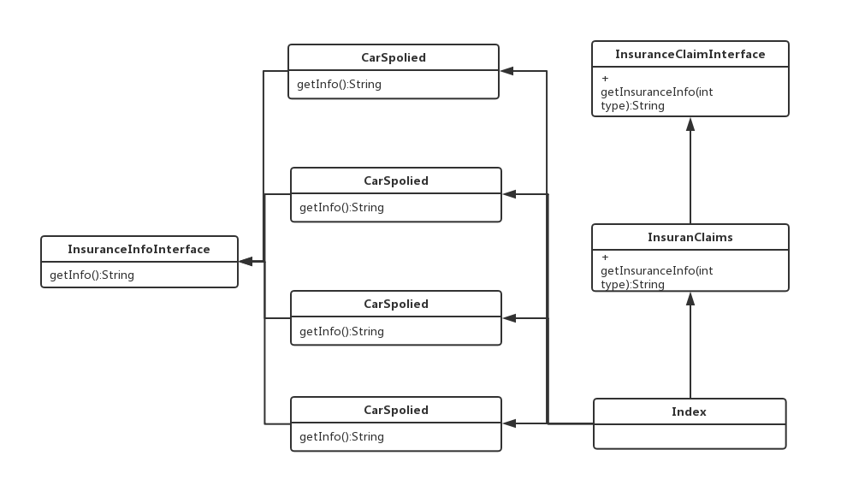

2.2 代码
// InsuranceInfoInterface.java
package cn.edu.scau.cmi.mayiming.FactoryMethod;

public interface InsuranceInfoInterface {
String getInfo ();
}

// CarSpolied.java
package cn.edu.scau.cmi.mayiming.FactoryMethod;

public class CarSpolied implements InsuranceInfoInterface {

@Override
public String getInfo() {
return "这是一个汽车损坏类型";
}

}

// 其余三个实现InsuranceInfoInterface.java 的同理

// InsuranceClaimsInterface.java
package cn.edu.scau.cmi.mayiming.FactoryMethod;

/**
* 根据保险理赔的类型返回相应的理赔信息 （工厂方法）
* @author cry
*
*/
public interface InsuranceClaimsInterface {
String getInsuranceInfo (int type);
}

// InsuranceClaims.java
package cn.edu.scau.cmi.chengruyuan.FactoryMethod;

public class InsuranceClaims implements InsuranceClaimsInterface {

@Override
public String getInsuranceInfo(int type) {
switch (type) {
case 1: // 驾驶员身体受伤
return new DriverInjuried().getInfo();
case 2: // 汽车损坏
return new CarSpolied().getInfo();
case 3: // 人员伤亡
return new PeopleDead().getInfo();
case 4: // 多种事故
return new MultiAccidents().getInfo();
default:
return null;
}
}

}

// Index.java
public class Index extends Application {

private static String studentName = "程如愿";
private static String studentId = "201621170106";
private static String[] insurancesType = {"-请选择-","驾驶员身体受伤", "汽车损坏", "人员伤亡", "多种事故"};

public static void main (String[] args) {
Application.launch(args);
}

@Override
public void start(Stage primaryStage) throws Exception {
// ---------------------上左--------------------------
String imgPath = System.getProperty("user.dir") + "/imgs/test.jpg";
InputStream is = new FileInputStream(new File(imgPath));
Image img = new Image(is);
ImageView imageView = new ImageView(img);
// ---------------------------------------------------

//----------------------上右--------------------------
GridPane gridPane = new GridPane();
gridPane.setAlignment(Pos.CENTER);
gridPane.setPadding(new Insets(10, 10, 10, 10));
gridPane.setHgap(5);
gridPane.setVgap(5);

gridPane.add(new Label("姓名:"), 0, 0);
Label name = new Label(studentName);
gridPane.add(name, 1, 0);
gridPane.add(new Label("学号:"), 2, 0);
Label id = new Label(studentId);
gridPane.add(id, 3, 0);

ComboBox<Object> cbo = new ComboBox<>();
ObservableList<String> items = FXCollections.observableArrayList(insurancesType);
cbo.getItems().addAll(items);
cbo.setPrefWidth(200);
cbo.setValue("-请选择-");
gridPane.add(new Label("请选中保险"), 0, 1);
gridPane.add(cbo, 1, 1);

Button btn = new Button("显示保险信息");
gridPane.add(btn, 1, 2);
// -----------------------------------------------------

// ------------------------下---------------------------
TextArea textArea = new TextArea();
// -----------------------------------------------------

// 上部面板
BorderPane center = new BorderPane();
center.setLeft(imageView);
center.setRight(gridPane);

// 主面板
BorderPane pane = new BorderPane();
pane.setTop(center);
pane.setCenter(textArea);
InsuranceClaimsInterface insuranceClaims = new InsuranceClaims();
// 事件
btn.setOnAction(new EventHandler<ActionEvent>() {

@Override
public void handle(ActionEvent event) {
// 简单工厂模式的使用
int i = items.indexOf(cbo.getValue());
String text = insuranceClaims.getInsuranceInfo(i);
if (null != text && text.length() > 0) {
textArea.setText(text);
}
}
});

Scene scene = new Scene(pane);
primaryStage.setTitle("实验二：工厂方法");
primaryStage.setScene(scene);
primaryStage.show();
}

}

(3) 抽象工厂模式（20分）
现有两大保险公司：中国人寿保险(PICC)和平安保险(PingAn)，每个保险公司又分别有驾驶员身体受伤、汽车损坏、人员伤亡、多种事故这四种保险。请利用抽象工厂模式方法设计并实现创建不同保险公司的不同保险理赔对象。界面根据实际情况，在工程方法模式的界面基础上进行适当修改。
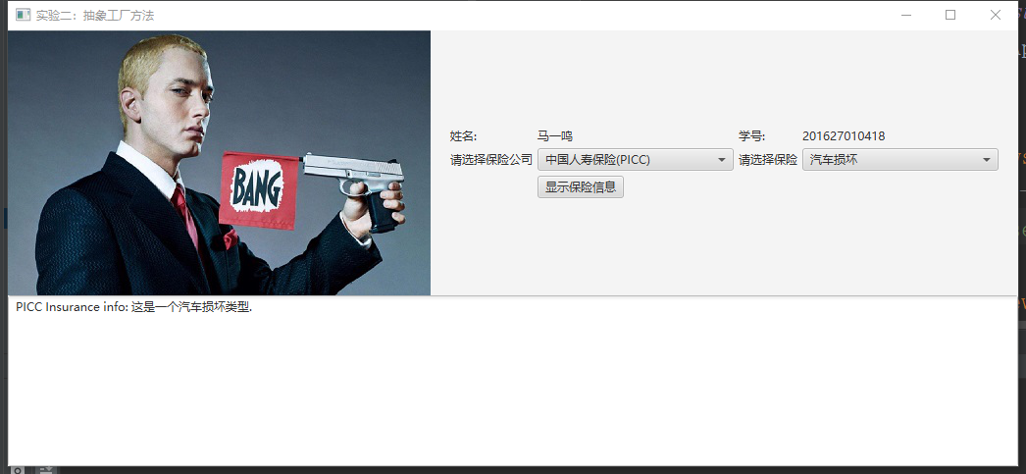

3.1 UML图

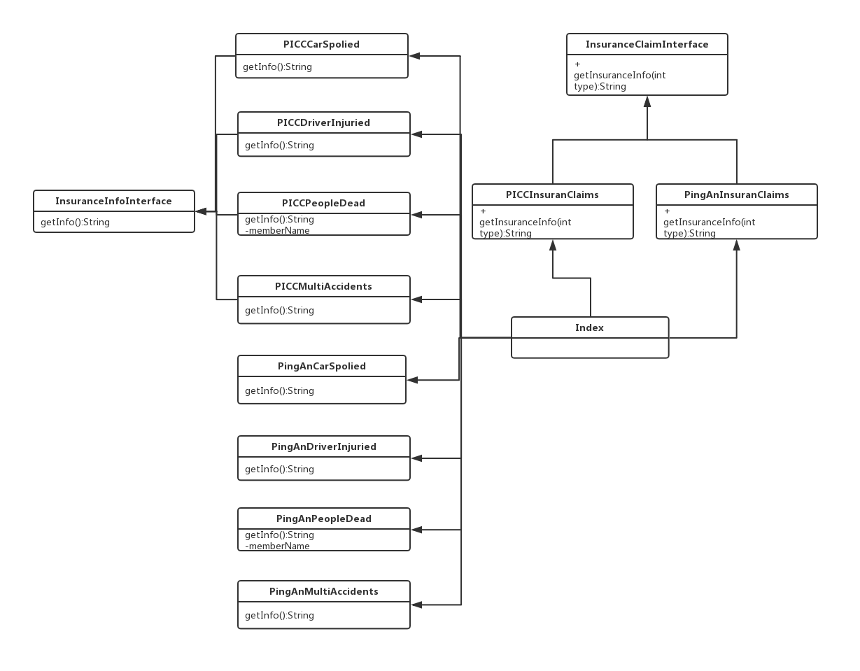

3.2 代码
// InsuranceInfoInterface.java
package cn.edu.scau.cmi.mayiming.abstractFactory.insuranceInfo;

public interface InsuranceInfoInterface {
String getInfo ();
}

// PICCCarSpolied.java
package cn.edu.scau.cmi.mayiming.abstractFactory.insuranceInfo;

public class PICCCarSpolied implements InsuranceInfoInterface {

@Override
public String getInfo() {
return "PICC Insurance info: 这是一个汽车损坏类型.";
}

}

// PingAnCarSpolied.java
package cn.edu.scau.cmi.mayiming.abstractFactory.insuranceInfo;

public class PingAnCarSpolied implements InsuranceInfoInterface {

@Override
public String getInfo() {
return "PingAn Insurance info: 这是一个汽车损坏类型.";
}

}

// 其他实现InsuranceInfoInterface.java 的类似
// InsuranceClaimsInterface.java
package cn.edu.scau.cmi.mayiming.abstractFactory;

/**
* 根据保险理赔的类型返回相应的理赔信息 （工厂方法）
* @author cry
*
*/
public interface InsuranceClaimsInterface {
String getInsuranceInfo (int type);
}

// PICCInsuranceClaims.java
public class PICCInsuranceCliams implements InsuranceClaimsInterface {

@Override
public String getInsuranceInfo(int type) {
switch (type) {
case 1: // 驾驶员身体受伤
return new PICCDriverInjuried().getInfo();
case 2: // 汽车损坏
return new PICCCarSpolied().getInfo();
case 3: // 人员伤亡
return new PICCPeopleDead().getInfo();
case 4: // 多种事故
return new PICCMultiAccidents().getInfo();
default:
return null;
}
}

}

// PingAnInsuranceClaims.java
public class PingAnInsuranceCliams implements InsuranceClaimsInterface {

@Override
public String getInsuranceInfo(int type) {
switch (type) {
case 1: // 驾驶员身体受伤
return new PingAnDriverInjuried().getInfo();
case 2: // 汽车损坏
return new PingAnCarSpolied().getInfo();
case 3: // 人员伤亡
return new PingAnPeopleDead().getInfo();
case 4: // 多种事故
return new PingAnMultiAccidents().getInfo();
default:
return null;
}
}

}

// Index.java
public class Index extends Application {

private static String studentName = "马一鸣";
private static String studentId = "201627010418";
private static String[] insurancesType = {"-请选择-","驾驶员身体受伤", "汽车损坏", "人员伤亡", "多种事故"};
private static String[] insurancesCompanyType = {"-请选择-","中国人寿保险(PICC)", "平安保险"};
private static InsuranceClaimsInterface insuranceClaims = null;
public static void main (String[] args) {
Application.launch(args);
}

@Override
public void start(Stage primaryStage) throws Exception {
// ---------------------上左--------------------------
String imgPath = System.getProperty("user.dir") + "/imgs/test.jpg";
InputStream is = new FileInputStream(new File(imgPath));
Image img = new Image(is);
ImageView imageView = new ImageView(img);
// ---------------------------------------------------

//----------------------上右--------------------------
GridPane gridPane = new GridPane();
gridPane.setAlignment(Pos.CENTER);
gridPane.setPadding(new Insets(10, 10, 10, 10));
gridPane.setHgap(5);
gridPane.setVgap(5);

gridPane.add(new Label("姓名:"), 0, 0);
Label name = new Label(studentName);
gridPane.add(name, 1, 0);
gridPane.add(new Label("学号:"), 2, 0);
Label id = new Label(studentId);
gridPane.add(id, 3, 0);

ComboBox<Object> cbo2 = new ComboBox<>();
ObservableList<String> items2 = FXCollections.observableArrayList(insurancesCompanyType);
cbo2.getItems().addAll(items2);
cbo2.setPrefWidth(200);
cbo2.setValue("-请选择-");
gridPane.add(new Label("请选择保险公司"), 0, 1);
gridPane.add(cbo2, 1, 1);

ComboBox<Object> cbo = new ComboBox<>();
ObservableList<String> items = FXCollections.observableArrayList(insurancesType);
cbo.getItems().addAll(items);
cbo.setPrefWidth(200);
cbo.setValue("-请选择-");
gridPane.add(new Label("请选择保险"), 2, 1);
gridPane.add(cbo, 3, 1);

Button btn = new Button("显示保险信息");
gridPane.add(btn, 1, 2);
// -----------------------------------------------------

// ------------------------下---------------------------
TextArea textArea = new TextArea();
// -----------------------------------------------------

// 上部面板
BorderPane center = new BorderPane();
center.setLeft(imageView);
center.setRight(gridPane);

// 主面板
BorderPane pane = new BorderPane();
pane.setTop(center);
pane.setCenter(textArea);

// 事件
btn.setOnAction(new EventHandler<ActionEvent>() {

@Override
public void handle(ActionEvent event) {
// 抽象工厂模式的使用
int insuranceCompanyIndex = items2.indexOf(cbo2.getValue());
System.out.println(insuranceCompanyIndex);
int insuranceIndex = items.indexOf(cbo.getValue());
if (1 == insuranceCompanyIndex) {
insuranceClaims = new PICCInsuranceCliams();
} else if (2 == insuranceCompanyIndex) {
insuranceClaims = new PingAnInsuranceCliams();
}

if (null != insuranceClaims) {
String text = insuranceClaims.getInsuranceInfo(insuranceIndex);
if (null != text && text.length() > 0) {
textArea.setText(text);
}
}
}
});

Scene scene = new Scene(pane);
primaryStage.setTitle("实验二：抽象工厂方法");
primaryStage.setScene(scene);
primaryStage.show();
}

}

