实验七：组合模式
个人与组织：个人必定属于每一个组织，组织可以组合成更大的组织。

(1) 安全组合模式

1.1 UML图
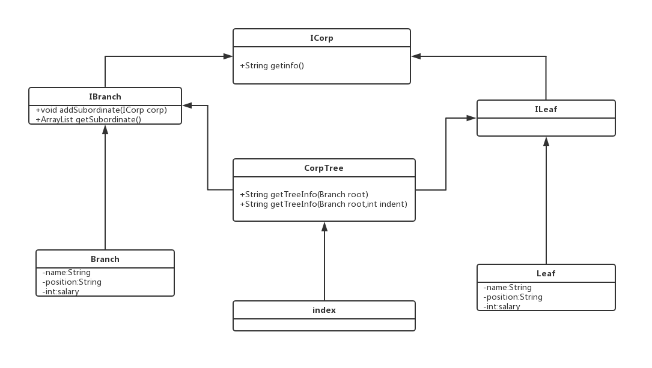

1.2 代码
// ICorp.java
interface ICorp {
//能够增加小兵（树叶节点）或
String getInfo();
}
// IBranch.java
public interface IBranch extends ICorp{

//能够增加小兵（树叶节点）或者是经理（树枝节点）—— 不管传什么都是向上造型
void addSubordinate(ICorp corp);

//我还要能够获得下属的信息
ArrayList<ICorp> getSubordinate();

}
// ILeaf.java
interface ILeaf extends ICorp{
}
// Branch.java
public class Branch implements IBranch{
//存储子节点的信息
private ArrayList<ICorp> subordinateList = new ArrayList<>();
//树枝节点的名称
private String name = "";
//树枝节点的职位
private String position = "";
//树枝节点的薪水
private int salary = 0;
//通过构造函数传递树枝节点的参数
public Branch(String name, String position,int salary) {
this.name = name;
this.position = position;
this.salary = salary;
}
//增加一个下属，可能 是小头目，也可能是个小兵
public void addSubordinate(ICorp corp) {
this.subordinateList.add(corp);
}
//我有哪些下属
public ArrayList<ICorp> getSubordinate() {
return this.subordinateList;
}
//得到自己的信息
public String getInfo() {
String info = "";
info = "名称:"+this.name;
info = info + "\t职位:"+this.position;
info = info + "\t薪水:"+this.salary;
return info;
}
}

// Leaf.java
public class Leaf implements ILeaf{
//叶子叫什么名字
private String name = "";
//叶子的职位
private String position = "";
//叶子的薪水
private int salary = 0;
//通过构造函数传递信息
public Leaf(String name, String position, int salary) {
this.name = name;
this.position = position;
this.salary = salary;
}
//最小的小兵只能获得自己的信息了
public String getInfo() {
String info = "";
info = "名称:"+this.name;
info = info + "\t职位:"+this.position;
info = info + "\t薪水:"+this.salary;
return info;
}
}
// CorpTree.java
public class CropTree {

public static Branch compositeCorpTree() {
// 首先产生总经理CEO
Branch root = new Branch("王大麻子", "总经理", 100000);
// 把三个部门经理产生出来
Branch developDep = new Branch("刘大瘸子", "研发部门经理", 10000);
Branch salesDep = new Branch("马二拐子", "销售部门经理", 20000);
Branch financeDep = new Branch("赵三驼子", "财务部门经理", 30000);
// 再把三个小组长产生出来
Branch firstDevGroup = new Branch("杨三也斜", "开发一组组长", 5000);
Branch secondDevGroup = new Branch("吴大植株", "开发二组组长", 6000);
// 把所有的小兵都产生出来
Leaf a = new Leaf("a", "开发人员", 2000);
Leaf b = new Leaf("b", "开发人员", 2000);
Leaf c = new Leaf("c", "开发人员", 2000);
Leaf d = new Leaf("d", "开发人员", 2000);
Leaf e = new Leaf("e", "开发人员", 2000);
Leaf f = new Leaf("f", "开发人员", 2000);
Leaf g = new Leaf("g", "开发人员", 2000);
Leaf h = new Leaf("h", "销售人员", 5000);
Leaf i = new Leaf("i", "销售人员", 4000);
Leaf j = new Leaf("j", "财务人员", 5000);
Leaf k = new Leaf("k", "CEO秘书", 8000);
Leaf zhengLaoLiu = new Leaf("郑老六", "研发部副经理", 20000);
// 开始组装
// CEO下有三个部门经理和一个秘书
root.addSubordinate(developDep);
root.addSubordinate(salesDep);
root.addSubordinate(financeDep);
root.addSubordinate(k);
// 研发部经理
developDep.addSubordinate(firstDevGroup);
developDep.addSubordinate(secondDevGroup);
developDep.addSubordinate(zhengLaoLiu);
// 看看两个开发小组下有什么
firstDevGroup.addSubordinate(a);
firstDevGroup.addSubordinate(b);
firstDevGroup.addSubordinate(c);
secondDevGroup.addSubordinate(d);
secondDevGroup.addSubordinate(e);
secondDevGroup.addSubordinate(f);
// 再看销售部下的人员情况
salesDep.addSubordinate(h);
salesDep.addSubordinate(i);
// 最后一个财务
financeDep.addSubordinate(j);
return root;
}

// 遍历整棵树，只要给我根节点，我就能遍历出所有的节点
public static String getTreeInfo(Branch root) {
return getTreeInfo(root, 0);
}

public static String getTreeInfo(Branch root, int indent) {
String info = "";

// 当前节点信息
for (int i = 0; i < indent - 1; i++) {
if (i % 4 == 0) {
info += "|";
} else {
info += " ";
}
}
info += "+";
info += root.getInfo() + "\n";

// 子节点信息
List<ICorp> subordinateList = root.getSubordinate();
for (ICorp s : subordinateList) {
if (s instanceof Leaf) {
// 打印缩进
for (int i = 0; i < indent - 1; i++) {
if (i % 4 == 0) {
info += "|";
} else {
info += " ";
}
}
info += "-";
info = info + s.getInfo() + "\n";
} else { // 是个小头目
// 打印缩进
for (int i = 0; i < indent - 1; i++) {
if (i % 4 == 0) {
info += "|";
} else {
info += " ";
}
}
info += "+";
info = info + s.getInfo() + "\n" + getTreeInfo((Branch) s, indent + 4);
}
}
return info;
}
}

// Index.java
public class Index extends Application {

private static String studentName = "马一鸣";
private static String studentId = "201627010418";

public static void main (String[] args) {
Application.launch(args);
}

@Override
public void start(Stage primaryStage) throws Exception {
// ---------------------上左--------------------------
String imgPath = System.getProperty("user.dir") + "/imgs/test.jpg";
InputStream is = new FileInputStream(new File(imgPath));
Image img = new Image(is);
ImageView imageView = new ImageView(img);
// ---------------------------------------------------

//----------------------上右--------------------------
GridPane gridPane = new GridPane();
gridPane.setAlignment(Pos.CENTER);
gridPane.setPadding(new Insets(10, 10, 10, 10));
gridPane.setHgap(5);
gridPane.setVgap(5);

gridPane.add(new Label("姓名:"), 0, 0);
Label name = new Label(studentName);
gridPane.add(name, 1, 0);
gridPane.add(new Label("学号:"), 2, 0);
Label id = new Label(studentId);
gridPane.add(id, 3, 0);

Button btn = new Button("安全组合模式");
gridPane.add(btn, 1, 2);
// -----------------------------------------------------

// ------------------------下---------------------------
TextArea textArea = new TextArea();
// -----------------------------------------------------

// 上部面板
BorderPane center = new BorderPane();
center.setLeft(imageView);
center.setRight(gridPane);

// 主面板
BorderPane pane = new BorderPane();
pane.setTop(center);
pane.setCenter(textArea);
// 事件
btn.setOnAction(new EventHandler<ActionEvent>() {

@Override
public void handle(ActionEvent event) {
// 安全组合模式的使用
Branch corpTree = CropTree.compositeCorpTree();
String corpTreeInfo = CropTree.getTreeInfo(corpTree);
String text = "安全组合模式:\n" + corpTreeInfo;
textArea.setText(text);
}
});

Scene scene = new Scene(pane);
primaryStage.setTitle("实验五：安全组合模式");
primaryStage.setScene(scene);
primaryStage.show();
}

}

(2) 一致性组合模式

2.1 UML图
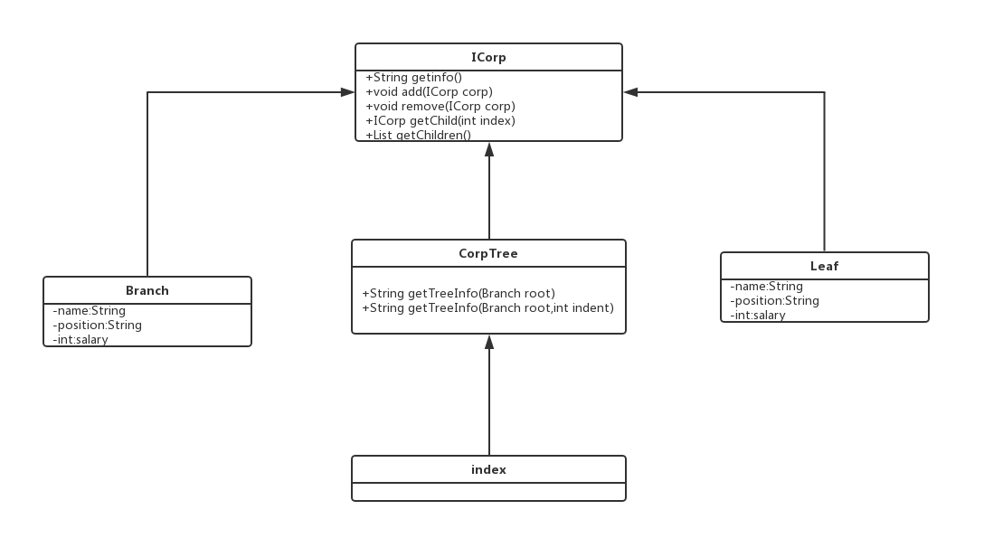

2.2 代码
// ICorp.java
interface ICorp {

void add(ICorp c);

void remove(ICorp c);

ICorp getChild(int i);

List getChildren();

String getInfo();
}
// Branch.java
public class Branch implements ICorp{
//存储子节点的信息
private ArrayList<ICorp> subordinateList = new ArrayList<>();
//树枝节点的名称
private String name = "";
//树枝节点的职位
private String position = "";
//树枝节点的薪水
private int salary = 0;

//通过构造函数传递树枝节点的参数
public Branch(String name, String position,int salary) {
this.name = name;
this.position = position;
this.salary = salary;
}
//增加一个下属，可能 是小头目，也可能是个小兵
public void add(ICorp corp) {
this.subordinateList.add(corp);
}

public void remove (ICorp corp) {
this.subordinateList.remove(corp);
}

public ICorp getChild(int i) {
return this.subordinateList.get(i);
}

//得到自己的信息
public String getInfo() {
String info = "";
info = "名称:"+this.name;
info = info + "\t职位:"+this.position;
info = info + "\t薪水:"+this.salary;
return info;
}

@Override
public List getChildren() {
return subordinateList;
}
}

// Leaf.java
public class Leaf implements ICorp{
//叶子叫什么名字
private String name = "";
//叶子的职位
private String position = "";
//叶子的薪水
private int salary = 0;

//通过构造函数传递信息
public Leaf(String name, String position, int salary) {
this.name = name;
this.position = position;
this.salary = salary;
}

//最小的小兵只能获得自己的信息了
public String getInfo() {
String info = "";
info = "名称:"+this.name;
info = info + "\t职位:"+this.position;
info = info + "\t薪水:"+this.salary;
return info;
}

@Override
public void add(ICorp c) {
// do nothing
}

@Override
public void remove(ICorp c) {
// do nothing
}

@Override
public ICorp getChild(int i) {
return null;
}

@Override
public List getChildren() {
return null;
}
}

// CorpTree.java
public class CropTree {

public static Branch compositeCorpTree(){
//首先产生总经理CEO
Branch root = new Branch("王小麻子", "总经理", 100000);
//把三个部门经理产生出来
Branch developDep = new Branch("刘大瘸子", "研发部门经理", 10000);
Branch salesDep = new Branch("马二拐子", "销售部门经理", 20000);
Branch financeDep = new Branch("赵三驼子", "财务部门经理", 30000);
//再把三个小组长产生出来
Branch firstDevGroup = new Branch("杨三也斜","开发一组组长",5000);
Branch secondDevGroup = new Branch("吴大植株","开发二组组长",6000);
//把所有的小兵都产生出来
Leaf a = new Leaf("a","开发人员",2000);
Leaf b = new Leaf("b","开发人员",2000);
Leaf c = new Leaf("c","开发人员",2000);
Leaf d = new Leaf("d","开发人员",2000);
Leaf e = new Leaf("e","开发人员",2000);
Leaf f = new Leaf("f","开发人员",2000);
Leaf g = new Leaf("g","开发人员",2000);
Leaf h = new Leaf("h", "销售人员", 5000);
Leaf i = new Leaf("i", "销售人员", 4000);
Leaf j = new Leaf("j", "财务人员", 5000);
Leaf k = new Leaf("k", "CEO秘书", 8000);
Leaf zhengLaoLiu = new Leaf("郑老六", "研发部副经理", 20000);
//开始组装
//CEO下有三个部门经理和一个秘书
root.add(developDep);
root.add(salesDep);
root.add(financeDep);
root.add(k);
//研发部经理
developDep.add(firstDevGroup);
developDep.add(secondDevGroup);
developDep.add(zhengLaoLiu);
//看看两个开发小组下有什么
firstDevGroup.add(a);
firstDevGroup.add(b);
firstDevGroup.add(c);
secondDevGroup.add(d);
secondDevGroup.add(e);
secondDevGroup.add(f);
//再看销售部下的人员情况
salesDep.add(h);
salesDep.add(i);
//最后一个财务
financeDep.add(j);
return root;
}

//遍历整棵树，只要给我根节点，我就能遍历出所有的节点
public static String getTreeInfo(Branch root){
return getTreeInfo(root, 0);
}

public static String getTreeInfo(Branch root, int indent){
String info = "";

// 当前节点信息
for (int i = 0; i < indent-1; i++) {
if (i % 4 == 0) {
info += "|";
} else {
info += " ";
}
}
info += "+";
info += root.getInfo() + "\n";

// 子节点信息
List<ICorp> subordinateList = root.getChildren();
if (subordinateList == null) {
return "";
}

for(ICorp s : subordinateList){
if(s instanceof Leaf){
// 打印缩进
for(int i = 0; i < indent+4-1; i++) {
if (i % 4 == 0) {
info += "|";
} else {
info += " ";
}
}
info += "-";
info = info + s.getInfo() + "\n";
}else{ //是个小头目
// 打印缩进
for(int i = 0; i < indent+4-1; i++) {
if (i % 4 == 0) {
info += "|";
} else {
info += " ";
}
}
info += "+";
info = info + s.getInfo() + "\n" + getTreeInfo((Branch)s, indent+4+4);
}
}
return info;
}
}

// Index.java
public class Index extends Application {

private static String studentName = "程如愿";
private static String studentId = "201621170106";

public static void main (String[] args) {
Application.launch(args);
}

@Override
public void start(Stage primaryStage) throws Exception {
// ---------------------上左--------------------------
String imgPath = System.getProperty("user.dir") + "/imgs/128830372.jpg";
InputStream is = new FileInputStream(new File(imgPath));
Image img = new Image(is);
ImageView imageView = new ImageView(img);
// ---------------------------------------------------

//----------------------上右--------------------------
GridPane gridPane = new GridPane();
gridPane.setAlignment(Pos.CENTER);
gridPane.setPadding(new Insets(10, 10, 10, 10));
gridPane.setHgap(5);
gridPane.setVgap(5);

gridPane.add(new Label("姓名:"), 0, 0);
Label name = new Label(studentName);
gridPane.add(name, 1, 0);
gridPane.add(new Label("学号:"), 2, 0);
Label id = new Label(studentId);
gridPane.add(id, 3, 0);

Button btn = new Button("透明组合模式");
gridPane.add(btn, 1, 2);
// -----------------------------------------------------

// ------------------------下---------------------------
TextArea textArea = new TextArea();
// -----------------------------------------------------

// 上部面板
BorderPane center = new BorderPane();
center.setLeft(imageView);
center.setRight(gridPane);

// 主面板
BorderPane pane = new BorderPane();
pane.setTop(center);
pane.setCenter(textArea);
// 事件
btn.setOnAction(new EventHandler<ActionEvent>() {

@Override
public void handle(ActionEvent event) {
// 安全组合模式的使用
Branch corpTree = CropTree.compositeCorpTree();
String corpTreeInfo = CropTree.getTreeInfo(corpTree);
String text = "透明组合模式:\n" + corpTreeInfo;
textArea.setText(text);
}
});

Scene scene = new Scene(pane);
primaryStage.setTitle("实验五：透明组合模式");
primaryStage.setScene(scene);
primaryStage.show();
}

}

实验效果
