实验4：适配器模式

(1) 类适配器

1.1 UML图
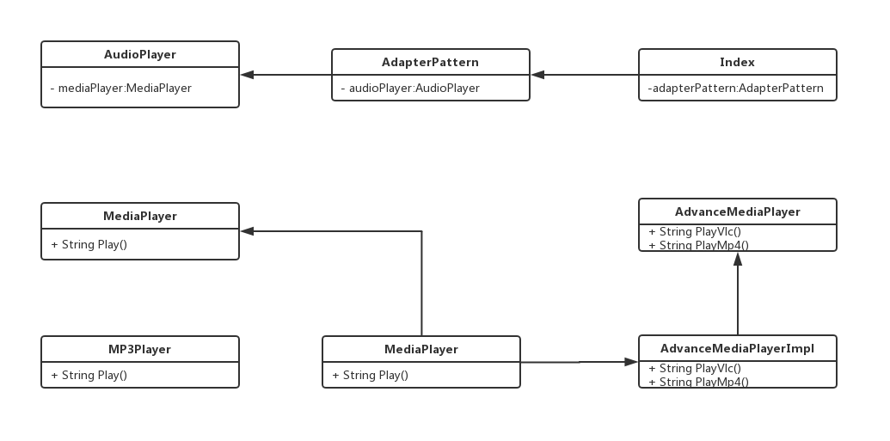

1.2 代码
MediaPlayer.java
public interface MediaPlayer {
public String play(String audioType, String fileName);
}

Mp3Player.java
public class Mp3Player implements MediaPlayer{
@Override
public String play(String audioType, String fileName) {
if ("mp3".equalsIgnoreCase(audioType)) {
return "播放MP3文件: " + fileName;
} else {
return "Not mp3 file!";
}
}

MediaAdapter.java
/**
* 类适配器方式：通过继承实现
* @author cry
*
*/
public class MediaAdapter extends AdvancedMediaPlayerImpl implements MediaPlayer {

@Override
public String play(String audioType, String fileName) {
if (audioType.equalsIgnoreCase("vlc")) {
return playVlc(fileName);
} else if (audioType.equalsIgnoreCase("mp4")) {
return playMp4(fileName);
} else {
return "无法找到该类型.";
}
}

}

AdvancedMediaPlayer.java
public interface AdvancedMediaPlayer {
public String playVlc(String fileName);

public String playMp4(String fileName);
}

AdvancedMediaPlayerImpl.java
public class AdvancedMediaPlayerImpl implements AdvancedMediaPlayer {

@Override
public String playVlc(String fileName) {
return "播放vlc文件: " + fileName;
}

@Override
public String playMp4(String fileName) {
// TODO Auto-generated method stub
return "播放mp4文件: " + fileName;
}

}

AudioPlayer.java
public class AudioPlayer implements MediaPlayer {
private MediaPlayer mediaPlayer = null;

@Override
public String play(String audioType, String fileName) {

if (audioType.equalsIgnoreCase("mp3")) {
mediaPlayer = new Mp3Player();
} else if (audioType.equalsIgnoreCase("vlc") || audioType.equalsIgnoreCase("mp4")) {
mediaPlayer = new MediaAdapter();
}

if (mediaPlayer != null) {
return mediaPlayer.play(audioType, fileName);
} else {
return "无效的. " + audioType + " 类型不支持";
}
}
}

AdapterPattern.java
public class AdapterPattern {

AudioPlayer audioPlayer = new AudioPlayer();

public String getMediaPlayingInfo(int type) {
switch (type) {
case 1:
return audioPlayer.play("mp3", "邓紫棋.mp3");
case 2:
return audioPlayer.play("mp4", " Kb.mp4");
case 3:
return audioPlayer.play("vlc", " many.vlc ");
case 4:
return audioPlayer.play("avi", " go.avi ");
default:
return null;
}
}

}

Index.java
public class Index extends Application {

private static String studentName = "马一鸣";
private static String studentId = "201627010418";
private static String[] mediaType = {"---------","邓紫棋.mp3", "Kb.mp4", "many.vlc", "go.avi"};

public static void main (String[] args) {
Application.launch(args);
}

@Override
public void start(Stage primaryStage) throws Exception {
// ---------------------上左--------------------------
String imgPath = System.getProperty("user.dir") + "/imgs/test.jpg";
InputStream is = new FileInputStream(new File(imgPath));
Image img = new Image(is);
ImageView imageView = new ImageView(img);
// ---------------------------------------------------

//----------------------上右--------------------------
GridPane gridPane = new GridPane();
gridPane.setAlignment(Pos.CENTER);
gridPane.setPadding(new Insets(10, 10, 10, 10));
gridPane.setHgap(5);
gridPane.setVgap(5);

gridPane.add(new Label("姓名:"), 0, 0);
Label name = new Label(studentName);
gridPane.add(name, 1, 0);
gridPane.add(new Label("学号:"), 2, 0);
Label id = new Label(studentId);
gridPane.add(id, 3, 0);

ComboBox<Object> cbo = new ComboBox<>();
ObservableList<String> items = FXCollections.observableArrayList(mediaType);
cbo.getItems().addAll(items);
cbo.setPrefWidth(200);
cbo.setValue("-请选择媒体播放-");
gridPane.add(new Label("作品"), 0, 1);
gridPane.add(cbo, 1, 1);

Button btn = new Button("播放");
gridPane.add(btn, 1, 2);
// -----------------------------------------------------

// ------------------------下---------------------------
TextArea textArea = new TextArea();
// -----------------------------------------------------

// 上部面板
BorderPane center = new BorderPane();
center.setLeft(imageView);
center.setRight(gridPane);

BorderPane pane = new BorderPane();
pane.setTop(center);
pane.setCenter(textArea);
AdapterPattern adapter = new AdapterPattern();
btn.setOnAction(new EventHandler<ActionEvent>() {

@Override
public void handle(ActionEvent event) {
int i = items.indexOf(cbo.getValue());
String text = adapter.getMediaPlayingInfo(i);
if (null != text && text.length() > 0) {
textArea.setText(text);
}
}
});

Scene scene = new Scene(pane);
primaryStage.setTitle("实验四：类适配器模式");
primaryStage.setScene(scene);
primaryStage.show();
}

}

1.3 实现效果
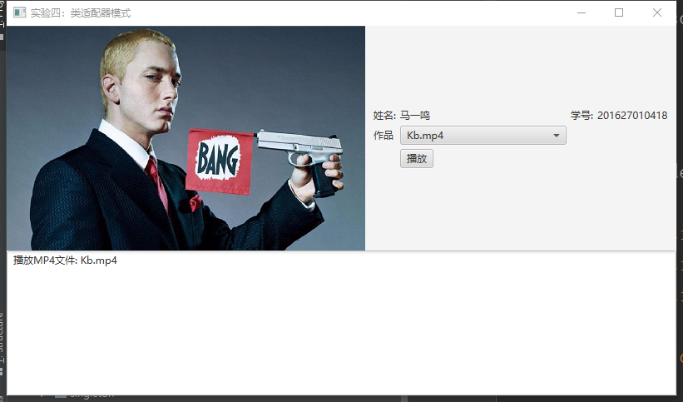

(2) 对象适配器

2.1 UML图

2.2 代码
MediaPlayer.java
public interface MediaPlayer {
public String play(String audioType, String fileName);
}

Mp3Player.java
public class Mp3Player implements MediaPlayer{
@Override
public String play(String audioType, String fileName) {
if ("mp3".equalsIgnoreCase(audioType)) {
return "播放MP3文件. Name: " + fileName;
} else {
return "Not mp3 file!";
}
}

MediaAdapter.java
/**
* 对象适配器方式：通过关联实现
* @author cry
*
*/
public class MediaAdapter implements MediaPlayer {

private AdvancedMediaPlayer advancedMediaPlayer;

public MediaAdapter (AdvancedMediaPlayer advancedMediaPlayer) {
this.advancedMediaPlayer = advancedMediaPlayer;
}

@Override
public String play(String audioType, String fileName) {
if (audioType.equalsIgnoreCase("vlc")) {
return advancedMediaPlayer.playVlc(fileName);
} else if (audioType.equalsIgnoreCase("mp4")) {
return advancedMediaPlayer.playMp4(fileName);
} else {
return "Sorry! I haven't the function of playing such kind of media.";
}
}

}
AdvancedMediaPlayer.java
public interface AdvancedMediaPlayer {
public String playVlc(String fileName);

public String playMp4(String fileName);
}

AdvancedMediaPlayerImpl.java
public class AdvancedMediaPlayerImpl implements AdvancedMediaPlayer {

@Override
public String playVlc(String fileName) {
//System.out.println("Playing vlc file. Name: " + fileName);
return "播放vlc文件: " + fileName;
}

@Override
public String playMp4(String fileName) {
// TODO Auto-generated method stub
return "播放MP4文件: " + fileName;
}

}

AudioPlayer.java
public class AudioPlayer implements MediaPlayer {
private MediaPlayer mediaPlayer = null;

@Override
public String play(String audioType, String fileName) {

// 播放 mp3 音乐文件的内置支持
if (audioType.equalsIgnoreCase("mp3")) {
mediaPlayer = new Mp3Player();
} else if (audioType.equalsIgnoreCase("vlc") || audioType.equalsIgnoreCase("mp4")) {
// mediaAdapter 提供了播放其他文件格式的支持
mediaPlayer = new MediaAdapter();
}

if (mediaPlayer != null) {
return mediaPlayer.play(audioType, fileName);
} else {
return "无效的 " + audioType + " 类型不支持";
}
}
}

AdapterPattern.java
public class AdapterPattern {

AudioPlayer audioPlayer = new AudioPlayer();

public String getMediaPlayingInfo(int type) {
switch (type) {
case 1:
return audioPlayer.play("mp3", "邓紫棋.mp3");
case 2:
return audioPlayer.play("mp4", "Kb.mp4");
case 3:
return audioPlayer.play("vlc", "many.vlc");
case 4:
return audioPlayer.play("avi", "go.avi");
default:
return null;
}
}

}

Index.java
public class Index extends Application {

private static String studentName = "马一鸣";
private static String studentId = "201627010418";
private static String[] mediaType = {"---------","邓紫棋.mp3", "Kb.mp4", "many.vlc", "go.avi"};

public static void main (String[] args) {
Application.launch(args);
}

@Override
public void start(Stage primaryStage) throws Exception {
// ---------------------上左--------------------------
String imgPath = System.getProperty("user.dir") + "/imgs/128830372.jpg";
InputStream is = new FileInputStream(new File(imgPath));
Image img = new Image(is);
ImageView imageView = new ImageView(img);
// ---------------------------------------------------

//----------------------上右--------------------------
GridPane gridPane = new GridPane();
gridPane.setAlignment(Pos.CENTER);
gridPane.setPadding(new Insets(10, 10, 10, 10));
gridPane.setHgap(5);
gridPane.setVgap(5);

gridPane.add(new Label("姓名:"), 0, 0);
Label name = new Label(studentName);
gridPane.add(name, 1, 0);
gridPane.add(new Label("学号:"), 2, 0);
Label id = new Label(studentId);
gridPane.add(id, 3, 0);

ComboBox<Object> cbo = new ComboBox<>();
ObservableList<String> items = FXCollections.observableArrayList(mediaType);
cbo.getItems().addAll(items);
cbo.setPrefWidth(200);
cbo.setValue("-请选择媒体播放-");
gridPane.add(new Label("作品"), 0, 1);
gridPane.add(cbo, 1, 1);

Button btn = new Button("播放");
gridPane.add(btn, 1, 2);
// -----------------------------------------------------

// ------------------------下---------------------------
TextArea textArea = new TextArea();
// -----------------------------------------------------

// 上部面板
BorderPane center = new BorderPane();
center.setLeft(imageView);
center.setRight(gridPane);

// 主面板
BorderPane pane = new BorderPane();
pane.setTop(center);
pane.setCenter(textArea);
AdapterPattern adapter = new AdapterPattern();
// 事件
btn.setOnAction(new EventHandler<ActionEvent>() {

@Override
public void handle(ActionEvent event) {
// 适配器模式的使用
int i = items.indexOf(cbo.getValue());
String text = adapter.getMediaPlayingInfo(i);
if (null != text && text.length() > 0) {
textArea.setText(text);
}
}
});

Scene scene = new Scene(pane);
primaryStage.setTitle("实验四：类适配器模式");
primaryStage.setScene(scene);
primaryStage.show();
}

}

2.3 实验效果
