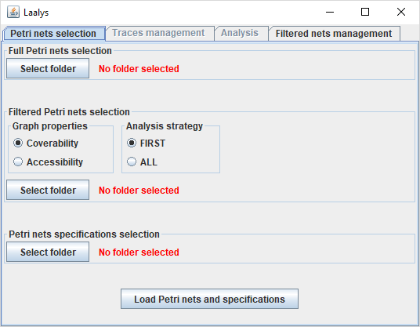

bt_loadPnAndSpecif

lab_specificationsFolder

bt_specificationsFolder

pan_specificationsFolder

bt_filteredPnFolder

lab_filteredPnFolder

pan_filteredPnFolder

bt_fullPnFolder

lab_fullPnFolder

pan_fullPnFolder

tab_pnFoldersSelection

jTabbedPane

pan_graphProperties

pan_analysisStrategy

opt_coverability

opt_first

opt_accessibility

opt_all

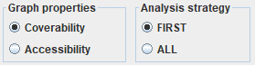

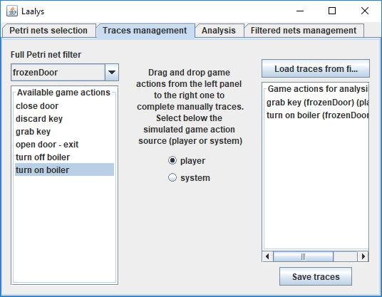

bt_saveTraces

list_tracesActions

scrollPan_tracesActions

bt_loadTracesFromFile

opt_player

opt_system

lab_dragDropInfo

list_fullPnActions

scrollPan_fullPnActions

combo_fullPnSelection

lab_fullPnSelection

tab_tracesManagement

tab_analysis

scrollPan_labelsComputed

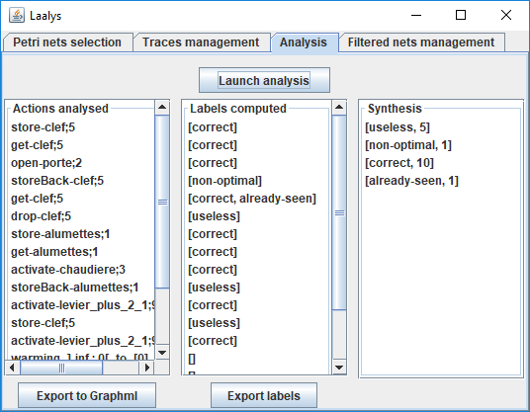

list_synthesis

scrollPan_synthesis

list_labelsComputed

bt_exportLabels

bt_exportGraphml

list_analysedActions

scrollPan_analysedActions

bt_launchAnalysis

pan_expertTraceFile

pan_fullPnFile

tab_filteredPnManagement

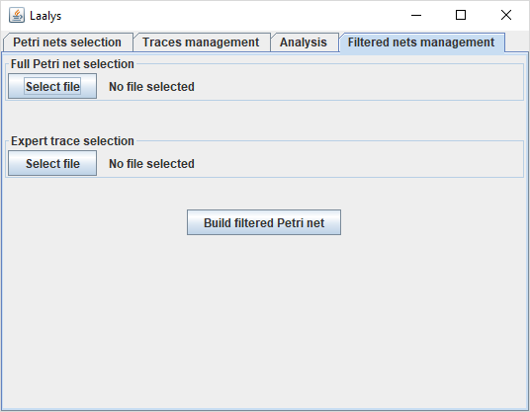

bt_BuildFilteredPn

lab_expertTraceFile

bt_expertTraceFile

lab_fullPnFile

bt_fullPnFile