SEQUENTIAL

CLASSIC

Degree 1.000 Elapsed running time: 0.0409726s

10.000 Elapsed running time: 1.1475801s

50.000 Elapsed running time: 27.8570995s

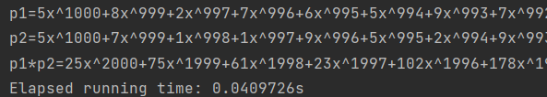

KARATSUBA

Degree 1.000 Elapsed running time: 0.2309939s

10.000 Elapsed running time: 1.5707741s

50.000 Elapsed running time: 8.4325651s

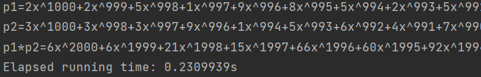

PARALLEL

CLASSIC

Degree 1.000 Elapsed running time: 0.0665476s

10.000 Elapsed running time: 0.6354293s

50.000 Elapsed running time: 13.3998066s

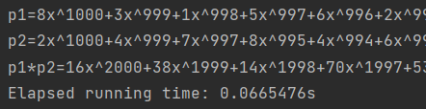

KARATSUBA

Degree 1.000 Elapsed running time: 0.1814895s

10.000 Elapsed running time: 0.6107534s

50.000 Elapsed running time: 7.3545267s

