**Mocean Broadcast for OnlyOffice**

**Instalation**

Step 1.

Log in to server directory with Filezilla or another program

Step 2.

Open directory “Source” and move sub directory “moceanbroadcast” to remote directory on server “sdkjs-plugins”

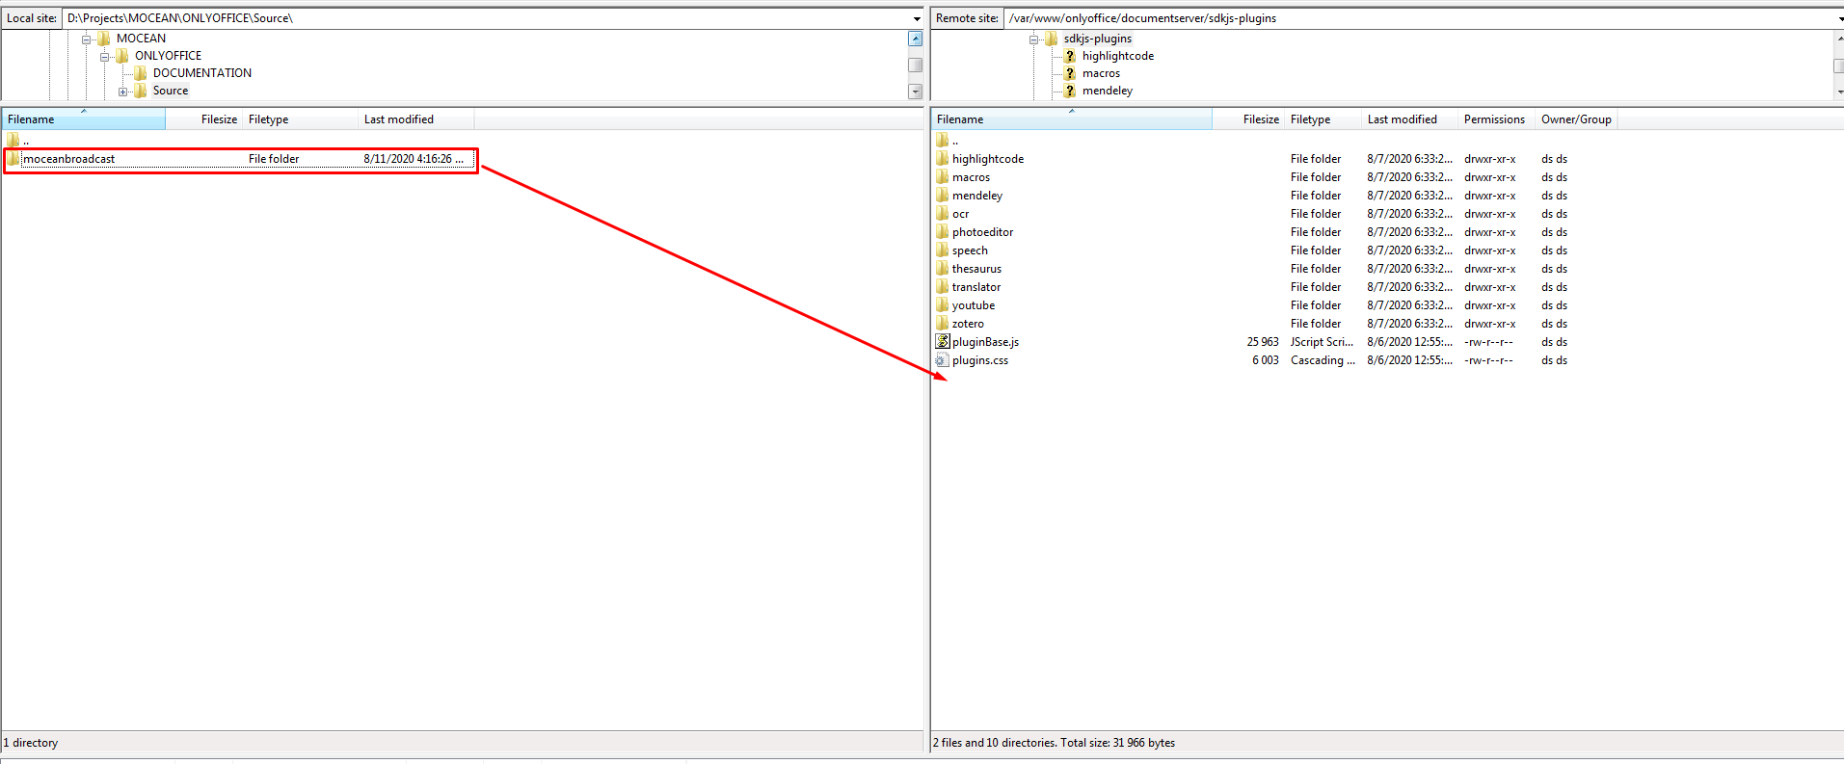

**Configuration**

Step 1.

Open your web interface.

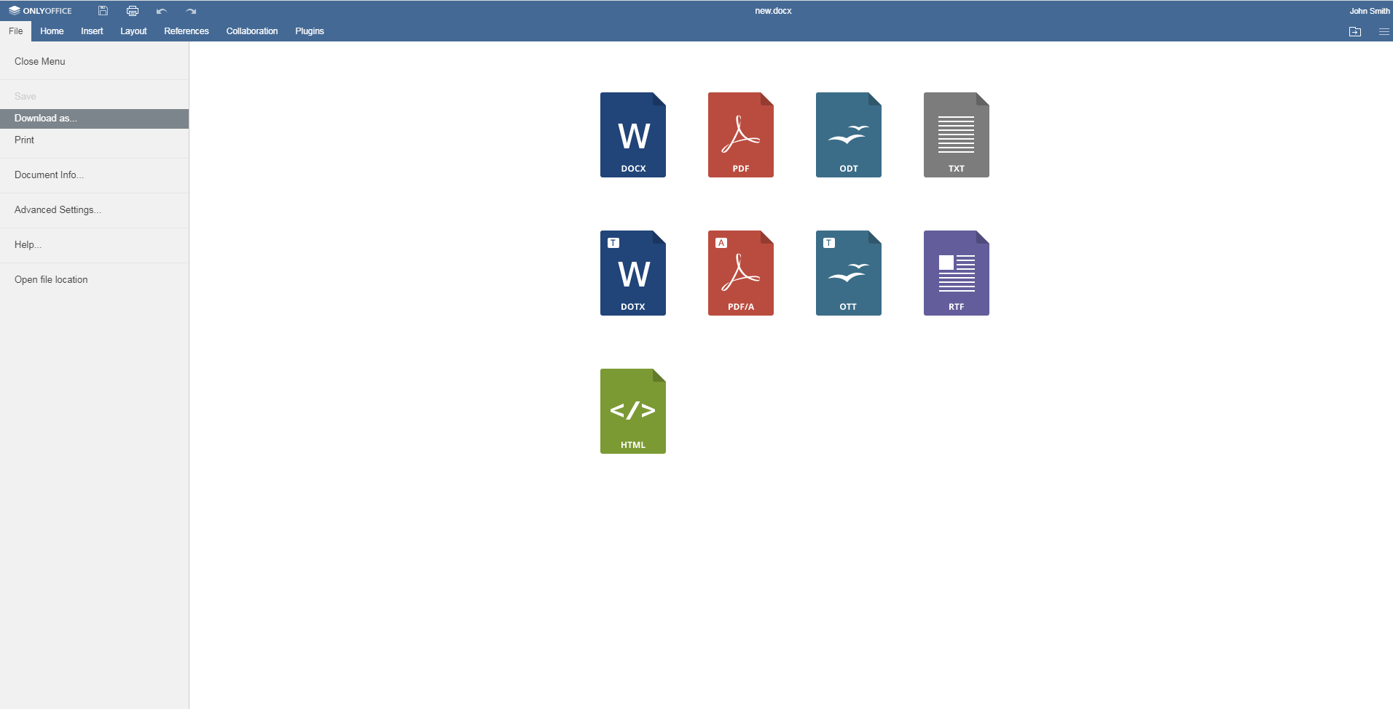

Step 2.

Click on Plugins.

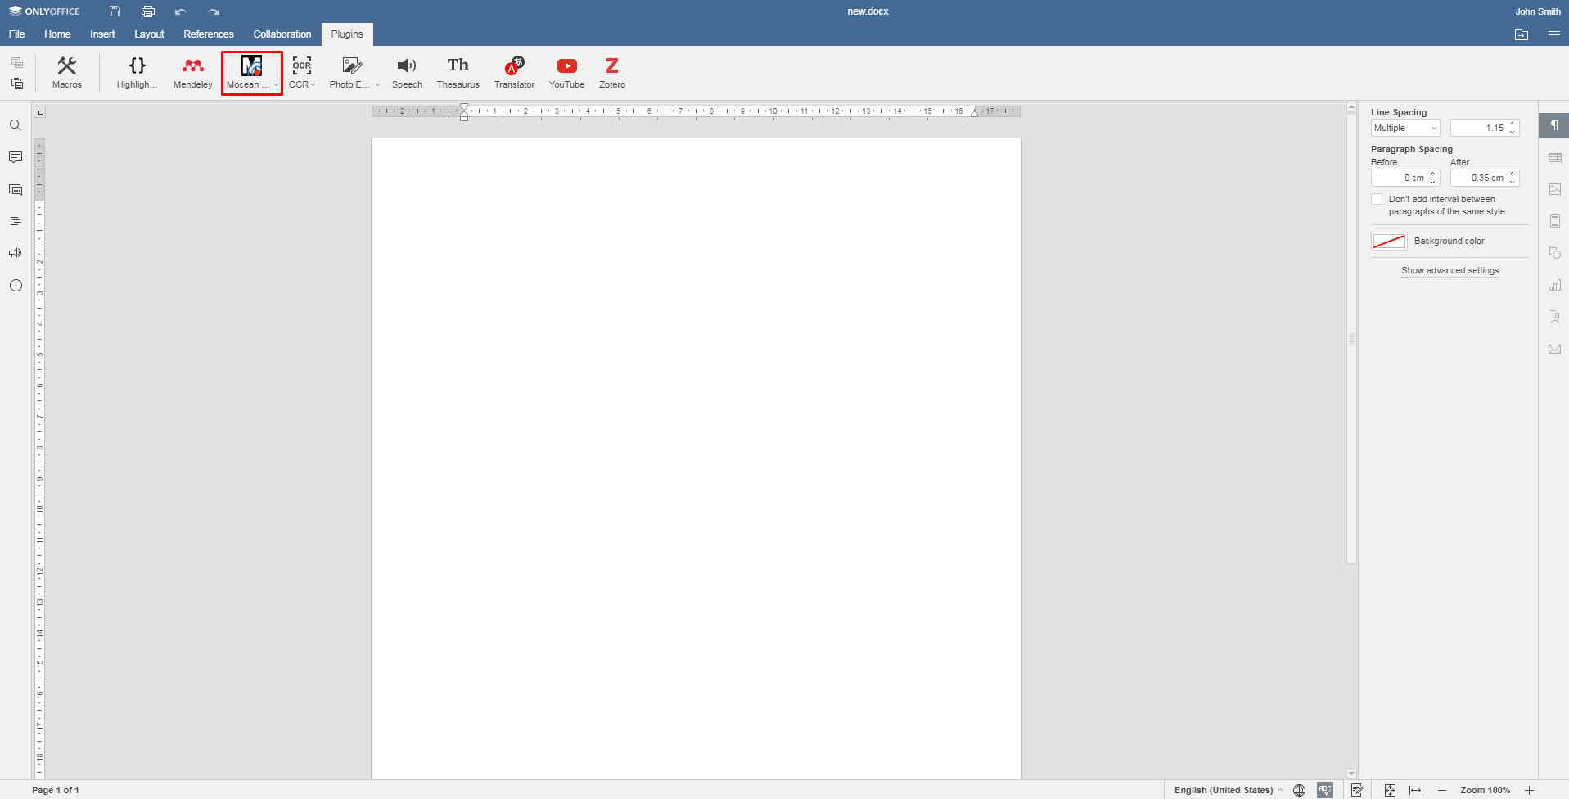

Step 3.

Click on submenu “Configuration”

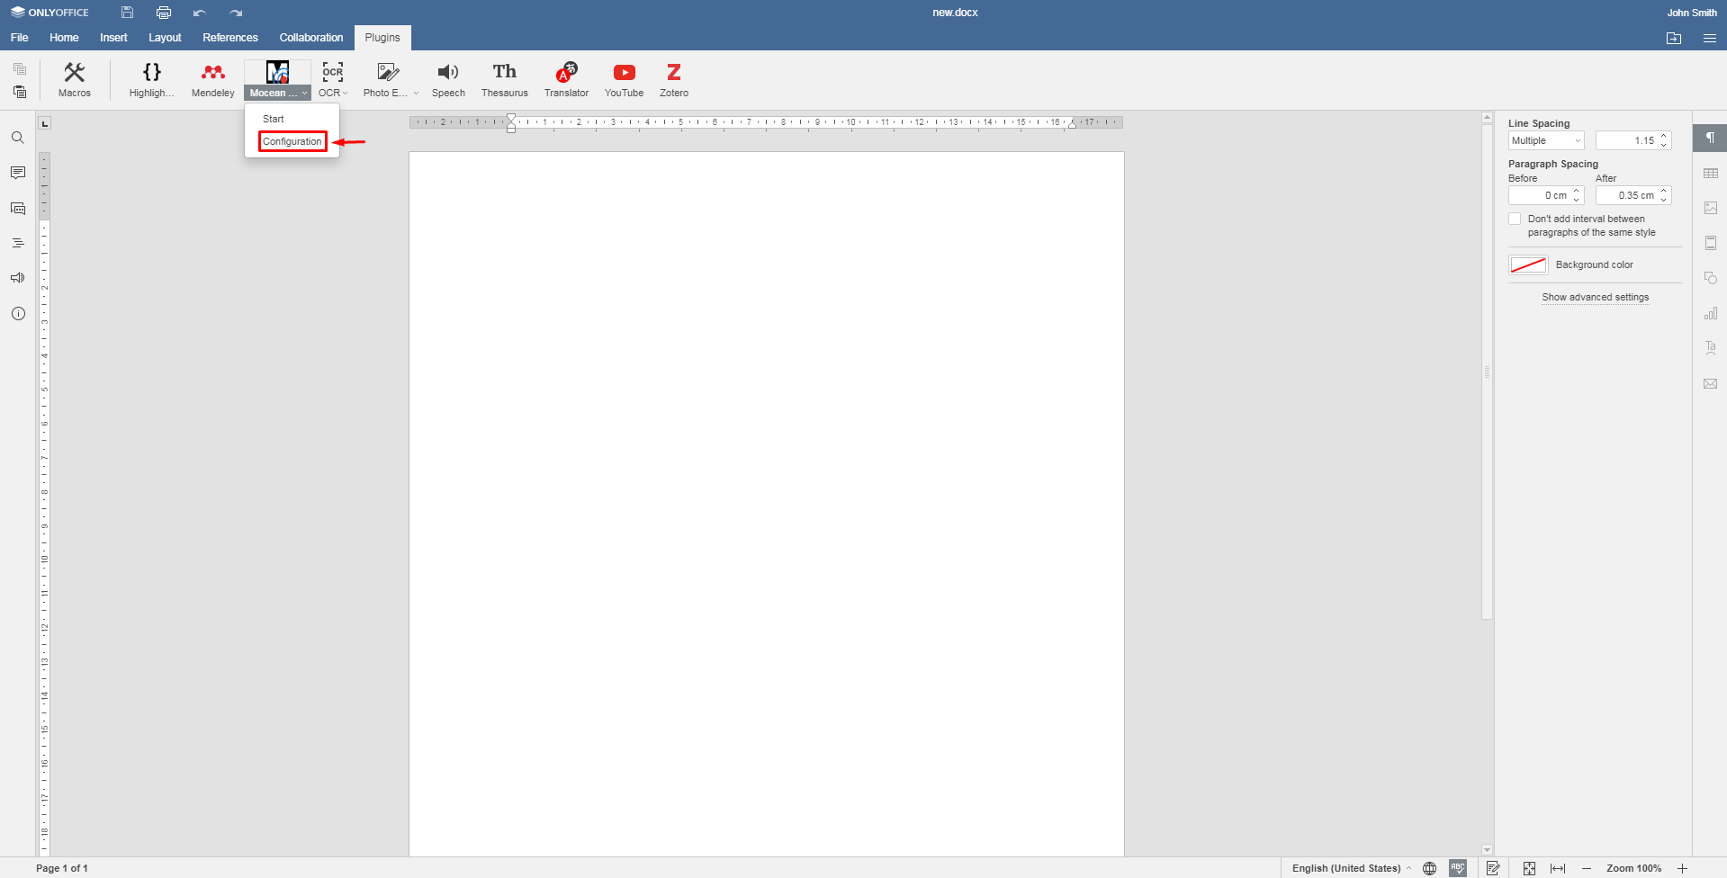

Step 4.

Enter your “Mocean API Key” and “Mocean API Secret” and click button “Save”.

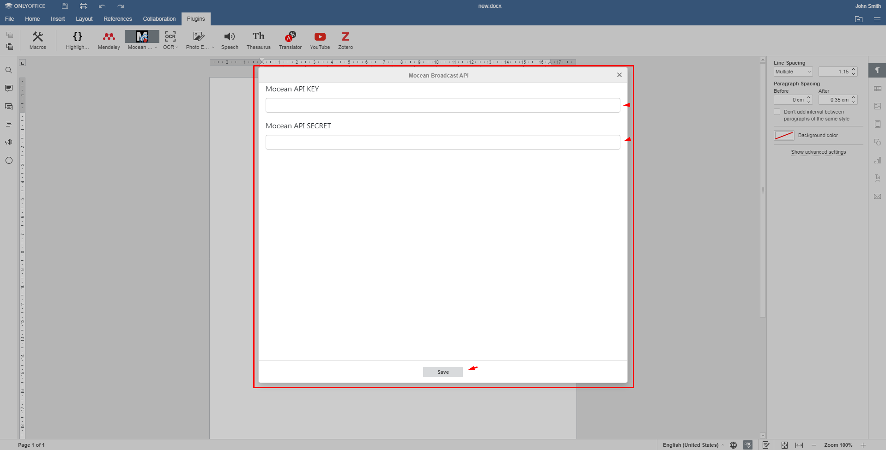

**Send Phones**

Step 1.

Click on Mocean Icon

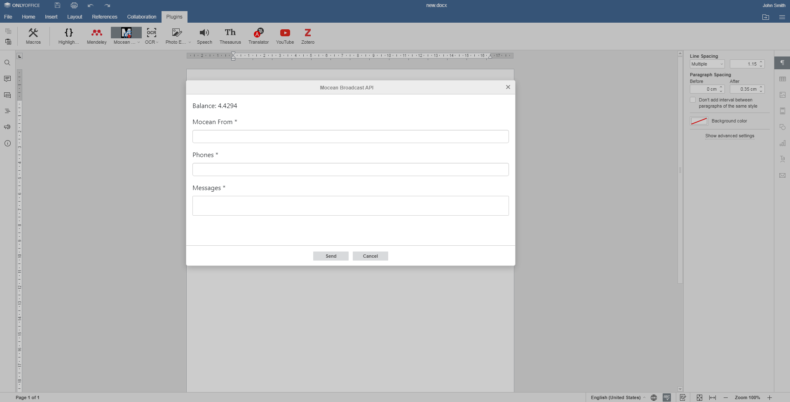

Step 2.

Enter your “Mocean From”, “Phone numbers”, “Message” and click Send button