## MEMBUAT LOGO SEDERHANA

|  |
| --- |
| **HTML** |
|  |
| **CSS** |
|  |
| **HASIL** |
|  |

## MEMEBUAT FORM INPUT PENDATAAN PENDUDUK

|  |
| --- |
| **HTML** |
|  |

|  |
| --- |
|  |
|  |

|  |
| --- |
| **CSS** |
|  |

|  |
| --- |
| **HASIL** |
| Warna Background berubah Ketika ada mouse |
|  |
|  |
|  |

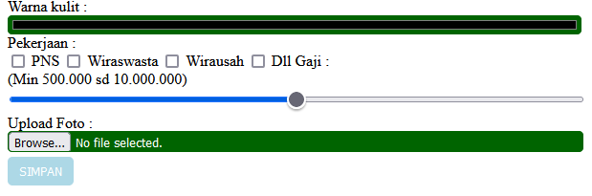

Warna Tombol berubah Ketika ada mouse

## MEMBUAT LAYOUT GRID

|  |
| --- |
| **HTML** |
|  |
| **CSS** |
|  |

**HASIL**

|  |
| --- |
|  |